Final Term Assignment (2020)
Course Title: Basic Physiology (DT– 2nd) Instructor: Dr. Irfan Ali Khan

Question Paper Time: 48 hours
Class Code. __________________________ section: A Name: Mehran Ali /
Class Rollno: 16322
Note:
- Attempt all questions from this section.
- Use Blue / Black Ink only. Do not use red color.
- Tick or encircle only one option in each given question.
It’s an open book Conceptual Assignment paper. Time to Use your brain now.

- Briefly explain the process of hematopoiesis along with diagrammatic illustration. (Marks 10)
Ans: Definition:
Hematopoieses is the production of all of the cellular components of blood and blood plasma .it occur with in hemopoteic system which include organ and tissue such as bone marrow liver and spleen simply hemapotosises is the process through which the body manufacture blood cells.
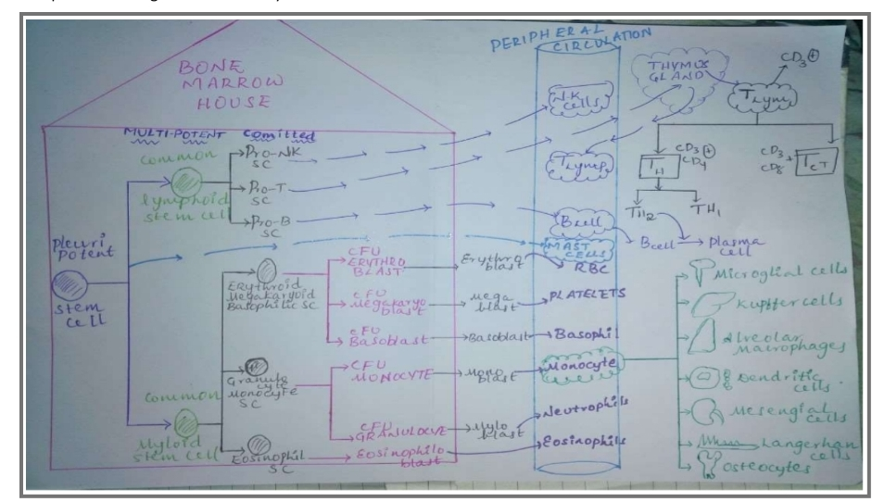
 It starts with first generation stem cell called as Pleuripotent stem cell and the term pleuripotent stem cell refers that they have a potency to convert into many different types of tissues
 Pleuripotent stem cells divides into two different types of
multipotent stem cells
 Multipotent stem cells are cells that have a capacity to self renew by dividing and to develop into multiple specialised cell types present in a specific tissue or organ
 The two types of multipotent stem cells are: 1) cells related to lymphoid system are known as Common Lymphoid Stem Cells and 2) the cells related to myeloid system are known as Common Myeloid Stem Cells
 Myeloid system refers to all blood cells other than lymphoid cells( lymphocytes) .
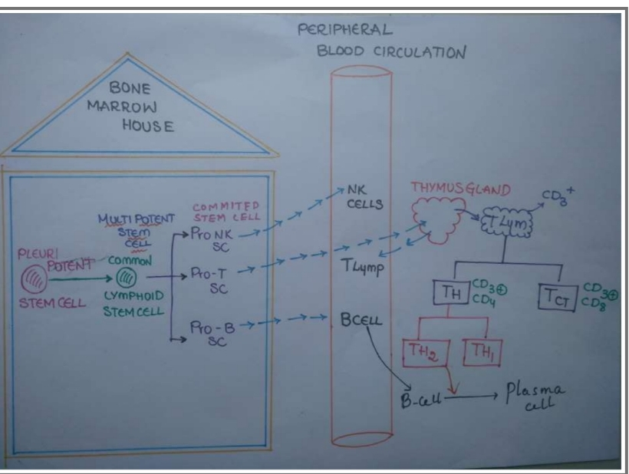
1) COMMON LYMPHOID STEM CELLS
 Multipotent stem cells
 Further divided into three types of committed lymphoid stem cells:
A) PRO-NK CELLS:
which multiply and differentiate, when enter into blood circulation called as Natural killer Cells
 These are not B or T lymphocytes
B) PRO-T CELLS: which multiply and differentiate and pre mature cells which are derivatives of pro-T cells enter into peripheral circulation and through circulation enters into thymus gland where maturity takes place and after maturation come back to peripheral circulation as T-Lymphocytes
 T-lymphocytes are called as CD-3 positive cells
 T-Lymphocytes are divided into 2 types: > cells which are CD- 3 and CD-4 positive are called as T-HELPER CELLS and are again divided into 2 types T-H1 and T-H2
 Major function of T-H1 is that they produces gamma- interpherons, TNF(tumour necrotic factor) and they act on monocytes which in presence of T-H1 converted into active macrophages, epithelioid cells and giant cells
 Major function of T-H2 is that they stimulate B-Cells to get converted into PLASMA CELLS by the cytokines, IL-4 and IL-5 produced by it
 IL-4 work as B cell growth factor and IL-5 work as B cell differentiation factor-----these help B cell to convert into plasma cells which produce antibodies
 T-H1 help in cellular immunity and T-H2 help in humoral immunity
 > Cells which are CD-3 and CD-8 positive cells called as T- CYTOTOXIC CELLS which also take an active part in cellular immunity
C) PRO-B CELLS: which get multiplied and differentiated into B-CELLS which get converted into plasma cells in action of TH-2 cells to produce anti bodies
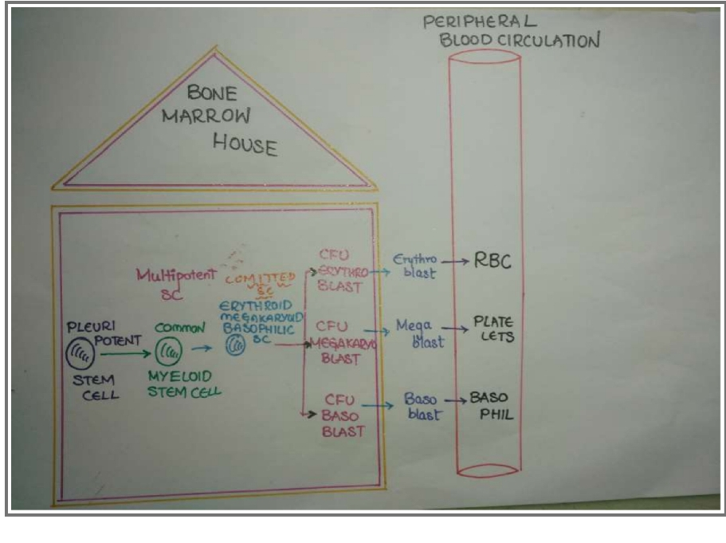
2) COMMON MYLOID STEM CELL
 Multipotent stem cells
 Divided into types of committed stem cells:
A) ERYTHROID MEGAKARYOID BASOPHILIC STEM CELL
 Has a potential to go into morphologically recognisable precursors of 3 types:
> CFU ERYTHROID SYSTEM
 Gets converted into erythroblast and passes to different stages to form reticuloblast which later on produces Mature RBC
 This is a morphologically recognisable precursor cell for erythropoiesis
> CFU MEGAKARYOID SYSTEM
 Gets converted into megakaryoblast which passes on different stages and enter into blood circulation as PLATELETS
 Morphologically recognisable precursor cell for
megakaryopoesis
> CFU BASOPHILS SYSTEM
 Gets converted into basoblast which passes on different stages and enter peripheral circulation as basophils
 On surface of basophils there are surface receptors for IgE antibodies
 Pleuripotent cells are also responsible for production of MAST CELLS and have receptors for IgE anti-bodies and play a major role in type-1 hypersensitivity
 This is morphologically recognisable precursor cells for basophils
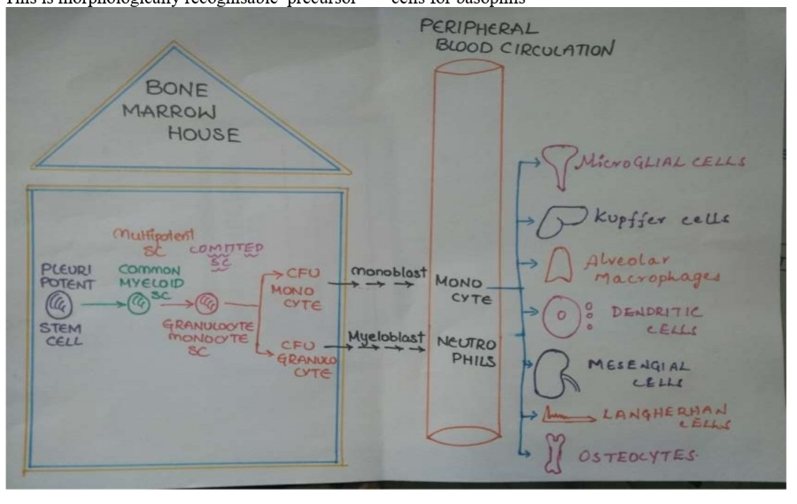

GRANULOCYTE MONOCYTE STEM CELLS
 It is divided into 2 types of morphologically precursor cells:
CFU FOR GRANULOCYTE:
after series of divisions myloblast is formed and enters into peripheral circulation as Neutrophils
 Neutrophils has granules of red and blue colour
CFU FOR MONOCYTE:
convert into Monoblast after series of divisions and enters into peripheral circulation as Monocytes
 Monocytes also have granules but these are agranulocytes
 Monocytes when shifted to tissue where inflammation occurs are called as inflammatory macrophages
 Monocytes when shifted to CNS during early phase of development are called as Microglial cells
 Monocytes when shifted to liver are called as Kupfer cells
 Monocytes when shifted to lung are called as Alveolar Macrophages
 When monocytes shifted to spleen and lymph nodes are called as Dendritic cells or Histiocytes
 Monocytes when shifted to kidney are called as Mesengial
cells
 Monocytes under skin are called as Langerhan cells
 Monocytes that are shifted to bone Osteocy
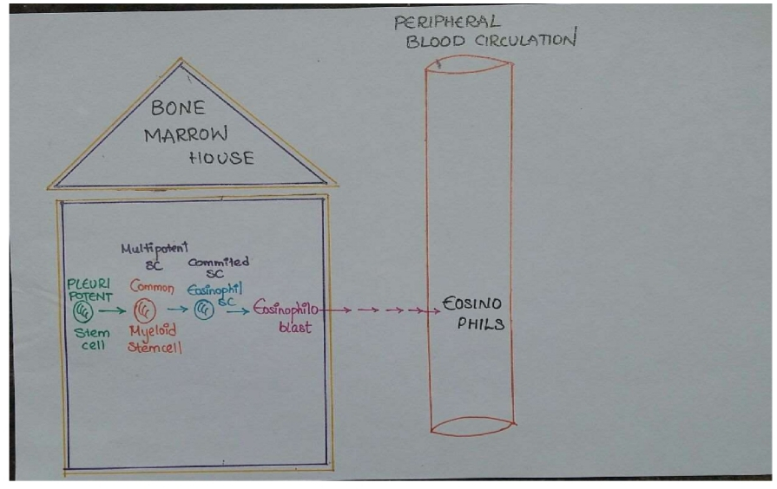
C) EOSINOPHILOID STEM CELLS
 Produce precursor cell called as EOSINOPHIOLOBALST and enter blood circulation to give rise to Eosinophills
 Eosinophills have red granules
 The condition in which the stem cells cannot multiply with enough speed to maintain RBC’S, WBC’S, and platelets number in peripheral circulation is called as Aplastic Anaemia , so blood cells number is reduced in blood
 In patient suffering with aplastic anaemia, bone marrow becomes hypocelluar and in peripheral blood pancytopenia is seen
 When stem cells are proliferating excessively, this condition is called as LEUKEMIAS

- What are the factors that influence the respiratory rate, explain in detail. (Marks 10)
Ans:
Factors Influencing Respiratory Rate Physical factors :
• Increased body temperature
• Exercise
• Talking
• Coughing
• Volition (conscious control)
• Emotional factors
• Chemical factors
• Carbon dioxide levels
• Level of carbon dioxide in the blood is the main regulatory chemical for respiration
• Increased carbon dioxide increases respiration
• Changes in carbon dioxide act directly on the medulla oblongata
• Chemical factors (continued)
• Oxygen levels
• Changes in oxygen concentration in the blood are detected by chemoreceptors in the aorta and carotid artery
• Information is sent to the medulla oblongata
• Exemplified by chronic bronchitis and emphysema
• Major causes of death and disability in the United States
• Features of these diseases
• Patients almost always have a history of smoking
• Labored breathing (dyspnea) becomes progressively more severe
• Coughing and frequent pulmonary infections are common .

- Enlist different layers of skin, write a detailed note on epidermis. (Marks 10)
Ans:.
Skin Definition :
The skin is the largest organ of the integumentary
system made up of multiple layers
of ectodermal tissue, and guards the
underlying muscles, bones, ligaments and internal
organs.
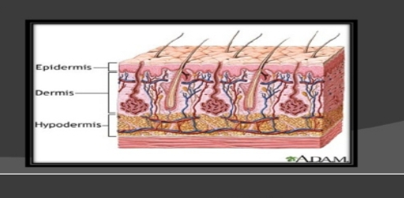

Layers of Skin:
The human akin is composed of two primary
layers:
. The epidermis. which provides waterproofing and
serves as a barrier to infection
. The dermis. wich is serves as location for the appenadegs of skin.

Epidermis:
The epidermis is the outermost layer of the skin. It
forms the waterproof, protective wrap over the
body's surface and is made uP of stratified
squamous epithelium with an underlying basal lamina.
It is divided in:
3. Stratum corneum
4, Stratum lucidum
5. Stratum granulosum
6. Stratum spinosum
7.. Stratum germinativum

Related Systems
The skin is related with the entire body, because it serves as a protective barrier for all the systems in the body: but it also maintains all the systems together. The hypodermis is the other System purpose related is to attach the skin to underlying bone and muscle as well as supplying it with blood vessels and nerves.

- Define lymphatic system, what are different components of lymphatic system? (Marks 10)
Ans:
Definition :
The lymphatic system is a system of capillaries, vessels, nodes and other organs that transport a fluid called lymph from the tissues as it returns to the bloodstream.
The lymphatic tissue of these organs filters and cleans the lymph of any waste, abnormal cells, or pathogens. The lymphatic system also
transports fatty acids from the intestines to the circulatory system.

Components of Lymphatic System :
The lymphatic system is a network of tissues and organs that primarily consists of
◦ lymph vessels (vasos linfáticos),
◦ lymph nodes (ganglio linfático)
◦ Lymph (linfa)
◦ the tonsils (amígdalas)
◦ Adenoids (amígdalas faríngeas o vegetaciones)
◦ spleen (bazo)
◦ Thymus (timo)
◦ There are 600 to 700 lymph nodes in the
◦ human body that filter the
◦ lymph before it returns to the circulatory system. All lymph nodes have the primary function of the production of lymphocytes.
◦ The spleen , which is largest lymphatic organ, is located on the left side of the body just above the kidney. Humans can live without a spleen, although they would be more prone to infections.
◦ Spongy inner tissue within the spleen contains many tiny blood vessels and hollow sinuses that store blood .
◦ The spleen can release its stored blood into circulation to replace
◦ blood lost during a traumatic injury.
◦ The thymus , despite containing glandular tissue and producing several hormones, is much more closely associated with the immune system than with the endocrine system.
◦ It stores immature lymphocytes and prepares them to become active T cells (an extremely important type of white blood cell). It is located in the chest just above the heart.
◦ Tonsils are large clusters of lymphatic cells found in the pharynx. The tonsils are thought to assist in protecting the body against respiratory and gastrointestinal infections.
◦ Each tonsil consists of a network of crypts that store cells used to fight infection; crypts where pathogens can be trapped and attacked by immunity cells.
◦ The primary function of the lymphatic system is to transport
lymph, a clear, colorless fluid containing white blood cells that helps rid the body of toxins, waste and other unwanted materials.
It also protects the body from infections .
And it keeps the fluid balance in the internal milieu.

- What is blood pressure? How will you check and record blood pressure of a patient? (Marks 10)
Ans:
Blood pressure:
Definition:
The pressure that is exerted on the vessel of blood is called blood pressure
( OR )
Blood pressure is the pressure of circulating blood which exerted a pressure on the wall of blood vessel that is called blood pressure .
Blood pressure usually refer to the pressure in large arties of the systemic circulation .
Instruments:
Sphygmomanometer which is used to measure the blood pressure.
Check and record blood pressure of patient:
Ask the patient to loosen any tight clothing or remove long sleveed germent to that is possible to accees the upper arm .
o Place the cuff around the upper arm and secure .
o Connect the cuff tubing of the spygnomo,eter tubind and secure .
o Rest the patient arm on a surface on the level with their arm.
o Place the stethoscope over the brachial artery and listen to the pluse.
o Start to deflate the cuff very slowly whilst watching the mercury level on the spygnometer .
o Record these to measure first the systolic and then dystolic (e.g 120/80),in the patients notes.
o Tell the patients the blood pressure reading.
o Dicinfact the stethoscope drum and ear piece with the alcohol wipe.
o Wash and dry your hand
o Report an extermly low or high reading to the clinically qualified person in charge of the patient care.

The End

Stay home, stay Safe

