Course Title: Prosthodontic Instructor: Ms. Salma Ishaq
Max Marks: 30
NOTE:
Mid term assignment
Name:Muhammad Saeed
id:13910
Bs Dental 6 SEMISTER

Q1: Label the below diagram and describe the component of RPD?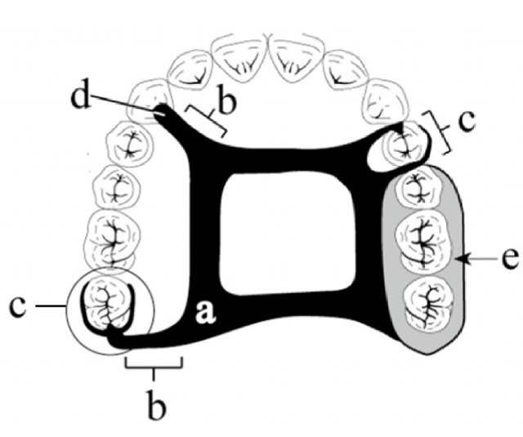
Q2: Why denture should be of low density? Give reasons.
Q3: Briefly explain the types of major connector?

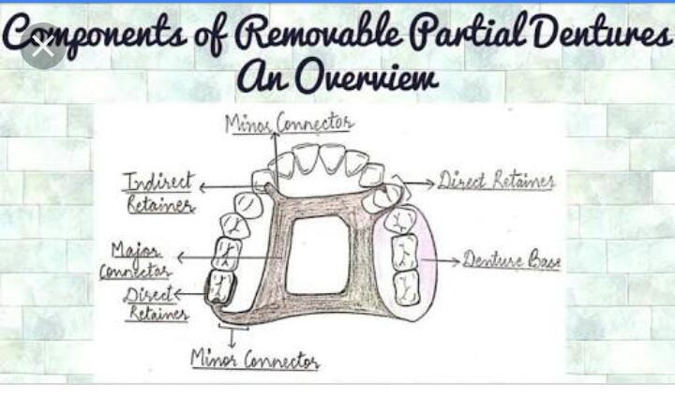
ANS 1

1) Anterior-Posterior palatal strap
2) Single palatal strap
3)U-shaped palatal connector horseshoe.
4Lingual bar
5)Lingual plate

______________________________________________________________________________
(Ans 2)
THESE ARE A FEW REASONS WHICH ARE GIVEN BELOW:

1)The density of a denture should be low as to reduce mtication for on denture brring areas.

2)The density of a denture should be low as to reduce mtication forces on denture brring areas.

3) Retention forces will be low if the density of denture is high.

4) If the density is high, the cohesion force is enable to retain the denture.

5) Do not sette for less.

6( These Artificial teeth are also easy to clean.

7( They help maintain shape of the face.

(ANS 3)
A major connector joins the components of removable partial denture from one side of the arch to the opposite side.
(TYPES OF MAXILLARY CONNECTORS)
1.(Borders-6mm from gingival margins)
2.(Anterior body should blend with the palatal anatomy)
3.(Border should cross the margins at right angles)
4.(Open Central connectors medial border should be located at the junction of the horizontal and vertical surfaces)
(SIX TYPES OF MAXILLARY CONNECTORS)
1.Palatal bar
2.Palatal strap
3.Antero-posterior palatal bar
4.Horse-Shoe shaped
5.Antero-posterior palatal strap
6.Complete palatal
(MANDIBULAR MAJOR CONNECTOR)
1.Rigid without being bulky
2.must not impinge on the movable floor of the mouth
3.Relief required between the rigid metal conductor and underying tissues.
(FOUR TYPES OF MANDIBULAR CONNECTOR)
1.Lungual bar
2.Lingual plate
3.Double lingual bar
4.Labia bar

