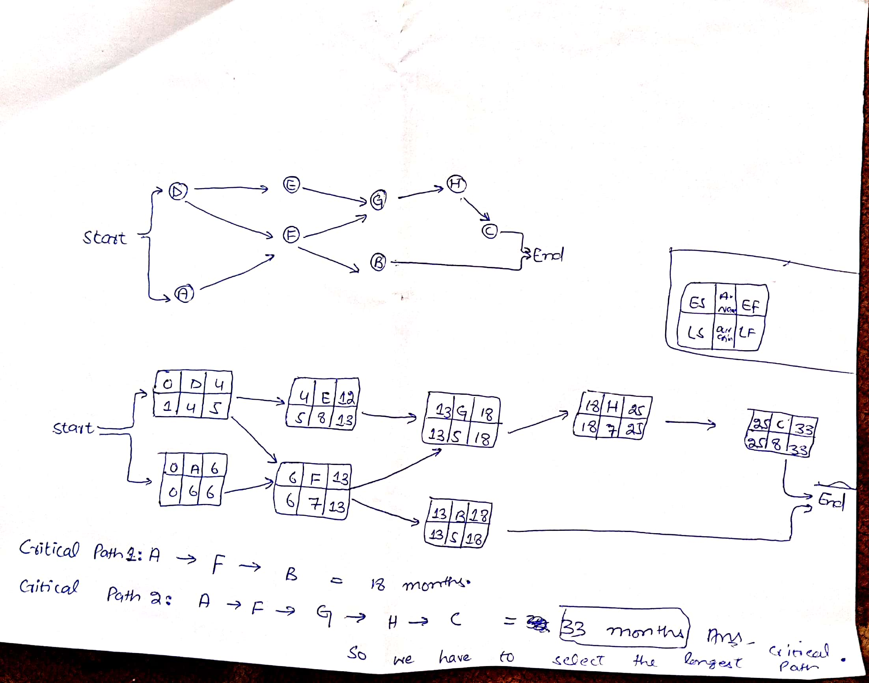

Farhad Khan id 13673
Project management Final Assignment

