Water budget assessment: A case study of residential area of Peshawar university campus
Presented by: HAMMAD Ali
ID number: 7686
Submitted To; ENGR Hamza Mustafa
Department of Civil Engineering
IQRA National University

INTRODUCTION
WATER
Water is an essential requirement of life on Earth. The history of human civilization is entangled with the history of the way’s human have learned to manipulate and use fresh water. The earliest agricultural communities depended on natural rainfall and runoff.
Initially, mankind, used water for simple domestic purposes such as drinking, cooking, bathing, and washing. However, the present uses of water are varying and they may be classified as domestic, public, commercial, and industrial.
Public use includes water required at public places and buildings such as public gardens, parks and fountains, public swimming pools, hospitals, schools, and other educational institutions, hostels, prisons, public sanitary places, street, and sewer flushing and firefighting. Commercial use includes water used in office buildings, hotels, and restaurants, for car washing, in laundries, at golf courses, shopping centers, bus railway and air terminals.
Domestic use includes water required not only for drinking, cooking, bathing, and washing, but also for heating, cooling, air conditioning, sanitary purposes, private swimming pools, and watering lawns and gardens.
WATER SUPPLY
Water supply is the process of self-provision or provision by 3rd party in the water industry commonly known as a public utility of water resources of various qualities to different users.
Or
Water supply is the distribution system of pipelines, pumps, storage, tanks, and appurtenances e.g. valves, meters etc.
PURPOSE OF THE STUDY
The basic purpose of the study was to assess the water budget i.e. the balance between water demand and water supply to save water by minimizing water losses and to make sure the efficient and just use of water.

STUDY AREA
The area selected for study is residential area of Peshawar University Campus.
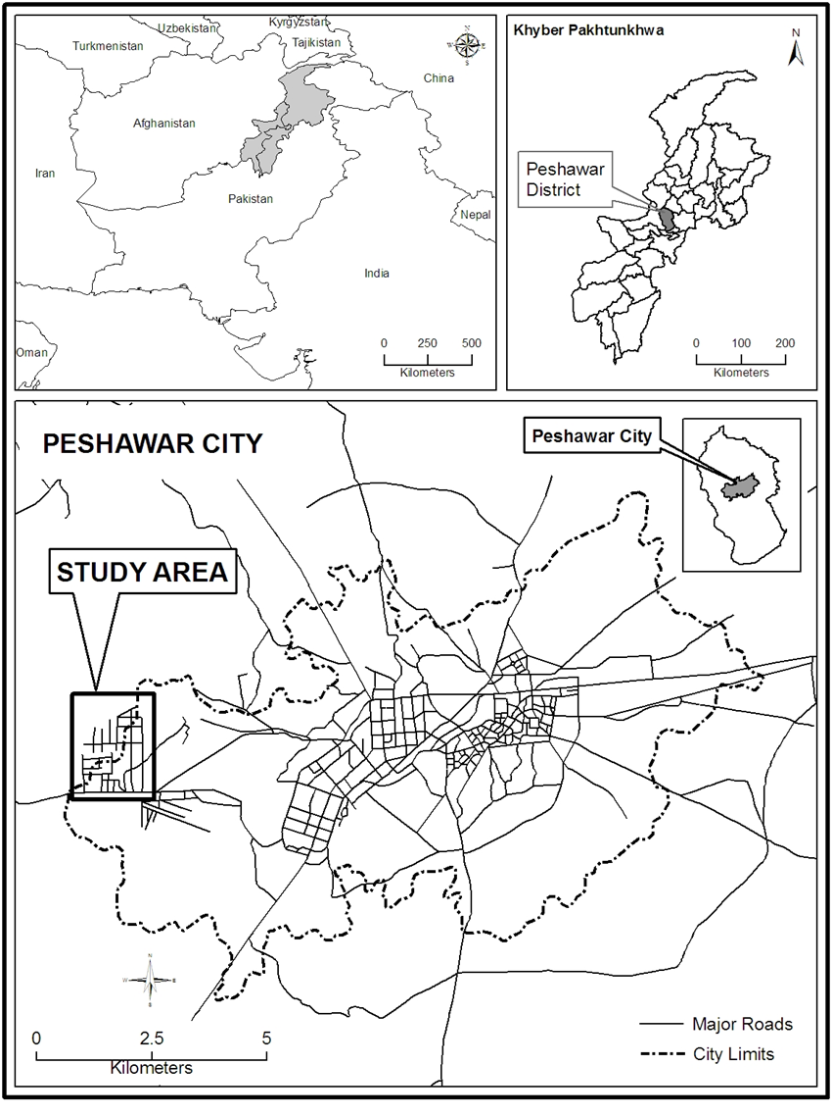

BRIEF HISTORY OF PESHAWAR UNIVERSITY
The University of Peshawar was established in Oct 1950 by the first Prime Minister of Pakistan (LIAQAT ALI KHAN). The University of Peshawar is an institution where education facilities exist from nursery to PhD located in Peshawar, KPK. It operates as a residential campus spread over one thousand acres. The University of Peshawar is ranked as the fourth best general-purpose university by the HEC.
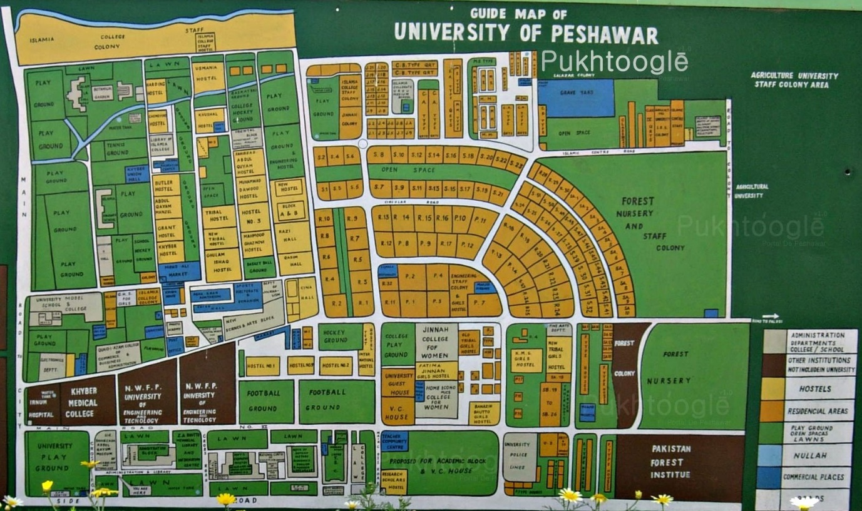
Source: University of Peshawar

ABSOLUTE LOCATION
Geographically Campus is located between:
33°59'20"N to 34°00'40"N latitudes and
71°29'00"E to 71°30'00"E longitudes.
RELATIVE LOCATION
University Campus is surrounded by PALOSI in the North, GHRIBABAD and RAHATABAD in East, Canal Town, and LALAZAR Colony in the West and main JAMRUD Road in the South. The Campus is spread over 1050 acres of land.
OBJECTIVES
Following are the objectives of this research
- To estimate the residential water demand and water consumption per capita per day in the study area.
- To calculate the residential water supply in the study area.
- To evaluate the water budget in the study area.
- To find out the possibilities of water conservation measures
Literature Review:
The first step of the project was to conduct a literature Review. Literature review consisted of studying literature related to similar problems and their solutions found in other
Locations and as a result a methodology to reach the objective of the project was adopted
RESEARCH METHODOLOGY
Research methodology consist of:
- Objectives
- Sampling
- Data collection and digitization
- Data analysis
- Data Output and Results

SAMPLING
Only the residential area within the University Campus was focused in this study. There is a total of 877 households in the study area. The questionnaire survey was conducted based on simple random sampling. A total of 60 questionnaires were filled in the study area making a sample size of 6.8%.
OTHER DATA SOURCES
University Directorate of Works (DOW) was consulted for information regarding tube wells data. Water supply timings, tank capacity, number of households and water pump data was collected from the DOW. Pipeline locations were drawn on the map of Peshawar University with the help of field staff of university. An image of the university was downloaded from Google Earth for accurate mapping. Some old reports were also consulted for some other information.
DATA ANALYSIS
For the location of tube wells and pipelines on the map GIS (Geographical Information System) software are used and for the presentation of data MS Office are used. And also for graph (SPSS) software are used.
CALCULAION OF HOUSEHOLD’S WATER CONSUMPTION
As there was no water meter installed at any household for calculation of a household’s daily water consumption, therefore, we must rely upon the estimation of various components of a household water use. The individual components of water use were added to find out the total water consumption of a household.
Two types of households were taken for this estimate:
- Higher class i.e. Class-I officers
- Lower class i.e. Class-III & Class-IV employees
- The per capita consumption was calculated through dividing the daily water consumption of a household by the household size (number of family members).
- For example, if a household consisting of 5 members, consumes a total of 600 liters, the per capita consumption will be 600÷5=120 LITERS.

COMPONENTS OF HOUSEHOLD WATER CONSUMPTION
- LAUNDRY
- Assumed water consumption for 5 suits: 60 liters
- 30 liters are used inside the washing machine while
- 30 liters are used for squeezing clothes
- The laundry consumption for all the households in both the high level and low-level classes was calculated following the above standards.
- If a low-class family has 5 members and they have 2 suits for each member than total suits are 10.
- If 60 liters of water is used by a machine while cleaning 5 suits, then for ten suits the amount used will be 120 liters.
- If suits are washed twice a week then the amount of water used will be 120×2=240 liters.
- To find daily consumption of a household it is divided by 7 (days in a week). 240÷7=34 LITERS.

2. DISH WASHING
- People were asked about the water consumption for dish washing. Different people were having different opinions e.g. 40 liters, 35 liters 25, liters etc.
- It was estimated that on average 30 LITERS water is consumed for dish washing twice a day.

3. COOKING
- The above procedure was repeated for cooking as well. The estimated average was 20 LITERS.

4. FLOOR WASHING
- It was estimated that 75 LITERS water is consumed for washing a floor if it takes a total of 10 minutes time.

5. SHOWER
- If a shower last for just 2 minutes it discharges 15 liters of water, which is a quite enough quantity. It means that a single shower will discharge 75 liters of water if it lasts for 10 minutes.
- It is estimated that if a person takes bath 4 times a week so he will consume 300 liters of water (75×4=300).
- If a family has five members so they will consume 1500 liters of water in week (300×5=1500).
- To find the daily consumption of a household divide 1500 by 7 (days in a week) is equal to 214 LITERS.
- The per capita consumption was calculated through dividing the daily consumption of a household by the household size (number of family members). i.e. 214÷5=42 LITERS

6. ABLUTION
- 37.5 liters of water is used by a single person for ablution. It was estimated that on average 7.5 liter is consumed for one time by a single person.
- One ewer (Lota) contains 2.5 liters of water and the average number of ewers for one time by a single person is 3. Which means a single person use 7.5 liters of water for one time and for five times the amount will be 15 ewers i.e. is 37.5 LITERS.

7. FLUSHING
The tank of a flush contains 5-6 liters of water and people use toilet 4 times a day, so the amount of water use for flushing by a single person is 10 LITERS per day.

8. DRINKING
People were asked about the water use for drinking. The average amount taken was 3 liters by a single person per day and multiplying 3 liters with the number of family members will give us the household use.

9. LAWN IRRIGATION
- Field survey was conducted to find the size of lawn for both classes. The average lawn size for higher class calculated was 10 MARLAS (110'×50') and the estimated time taken for 10 MARLAS was 30 minutes.
- Water discharges by a pipe in 10 minutes is 75 liters, in 30 minutes it will discharge 225 liters.
- So, if a lawn is irrigated twice a week so it will consume 450 liters of water.
- To find household consumption per day divide 450 by 7 this is equal to 64 liters
- Similarly, the average lawn size calculated for lower class was 2 MARLAS (18'×30') and the estimated time taken for 2 MARLAS was 10 minutes. According to the above calculations the amount of water used by lower class for lawn irrigation is 21 liters.
10. Car Wash
The average time taken for car wash is 10-12 minutes so 90 liters of water is used by a single car.

DATA ANALYSIS AND RESULTS;
Water supply system in Peshawar University
The major sources of Water Supply in Peshawar University are tube wells, these tube wells are linked with each other with the help of different pipes. These pipes are distributed throughout the university providing water to residential area, departments, and hostels etc.
There are six tube wells in Peshawar University which provide water to the whole university.

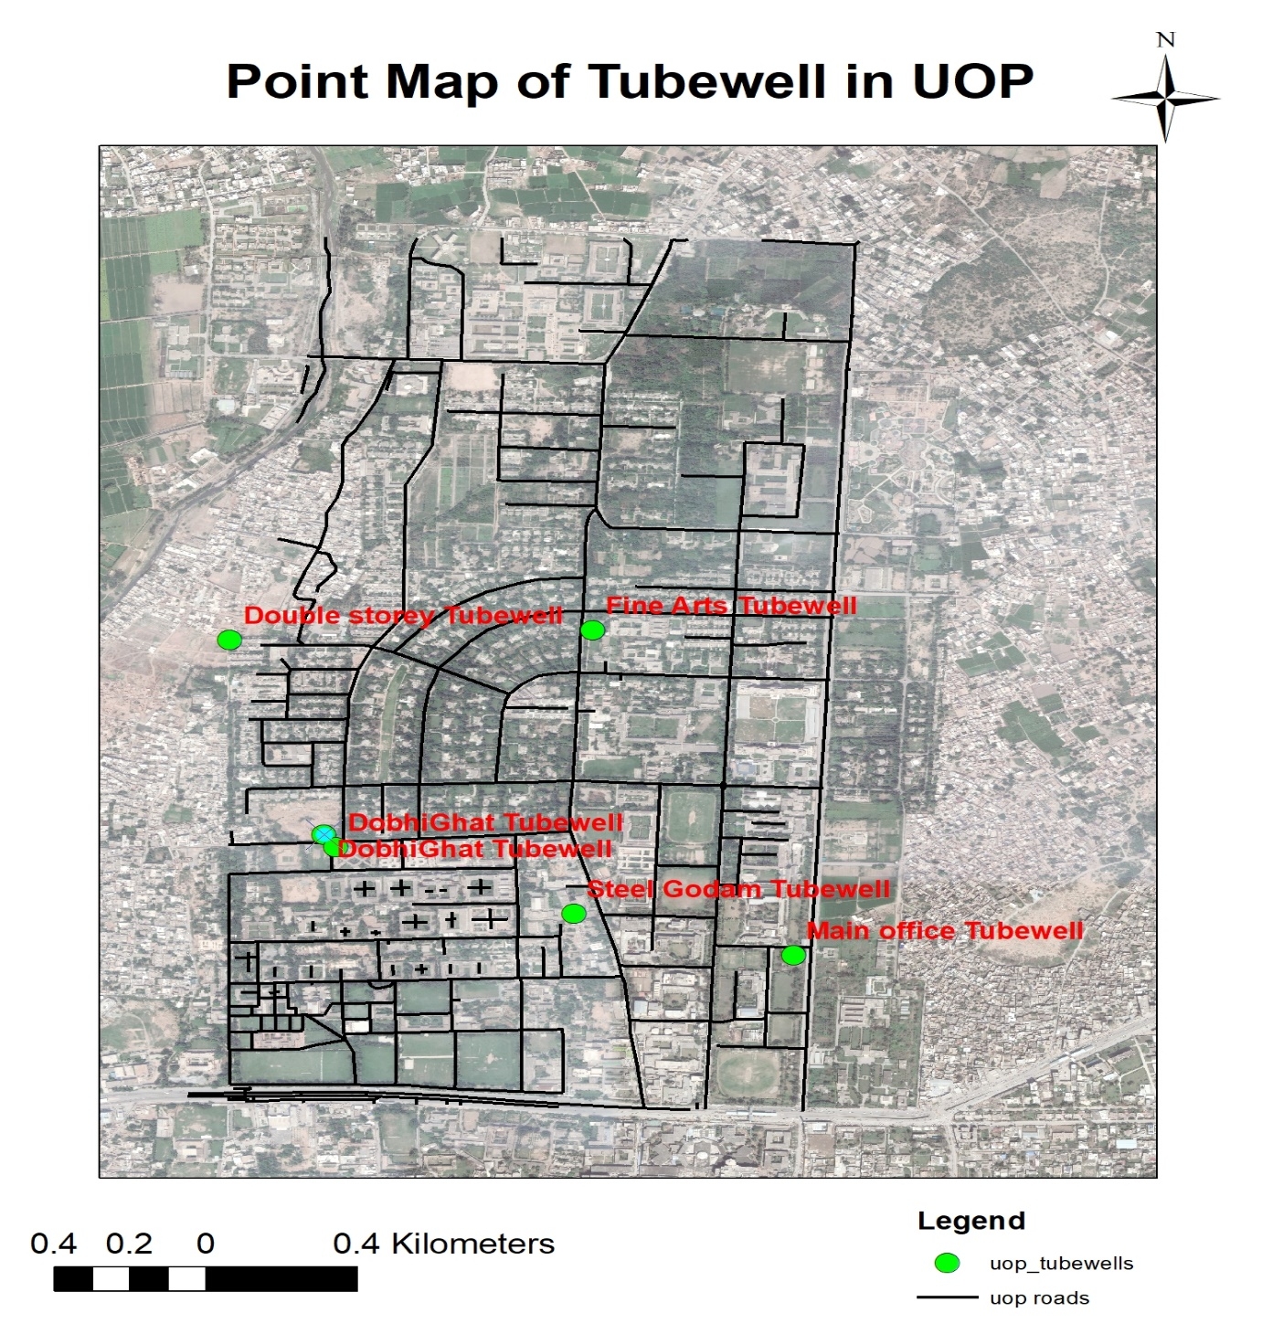

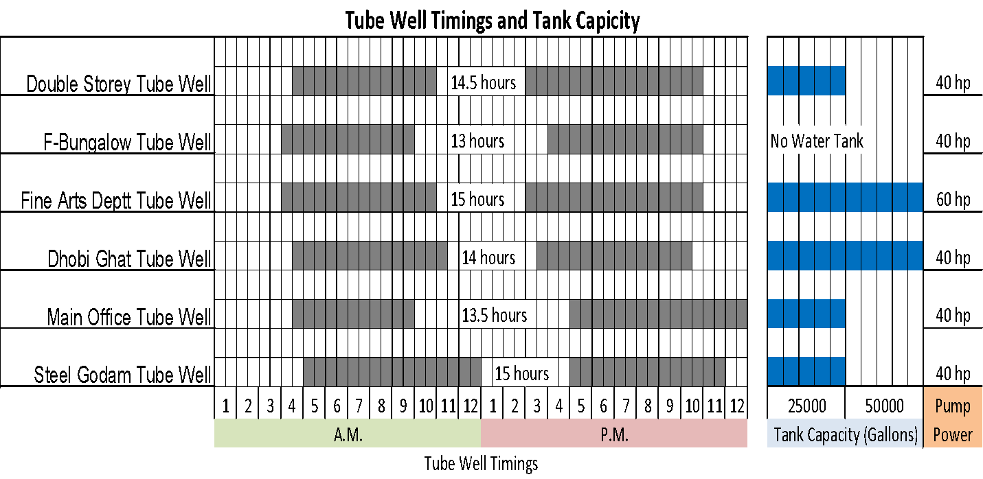
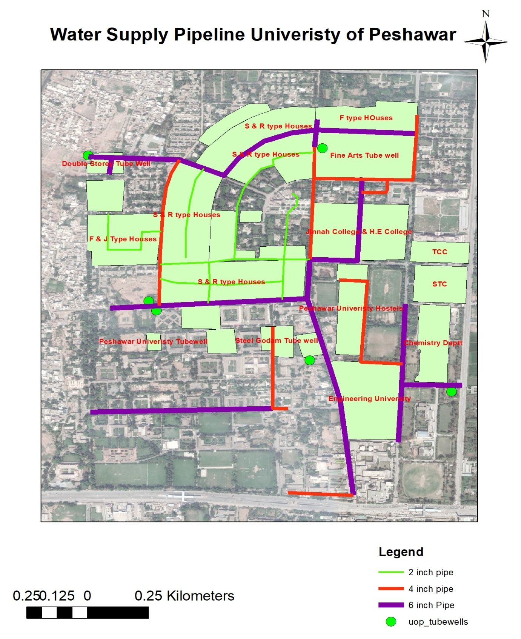

Table no 1.1: Peshawar University: Household Water Consumption by Class

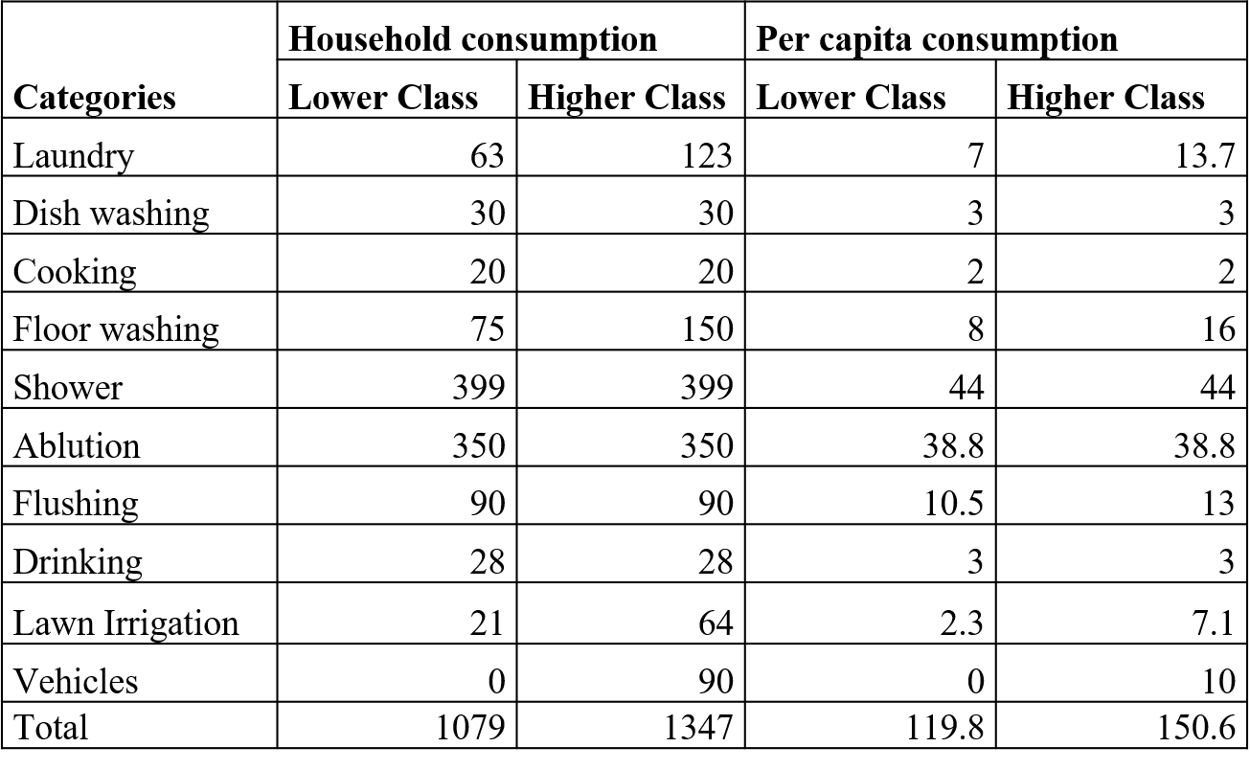
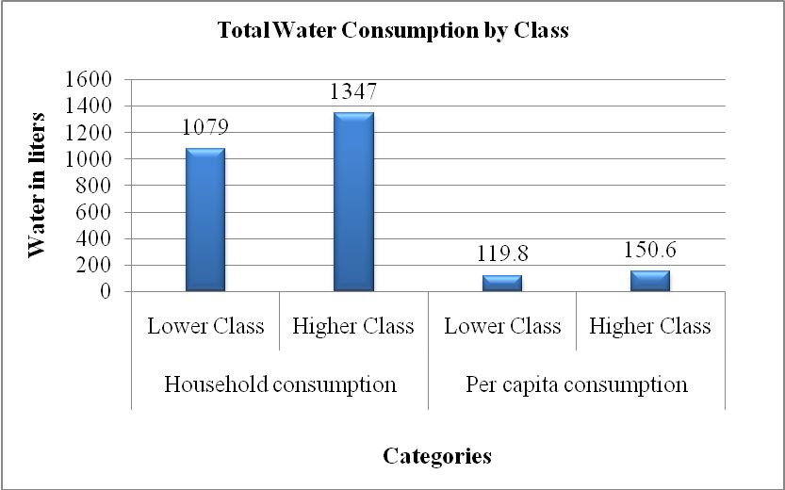

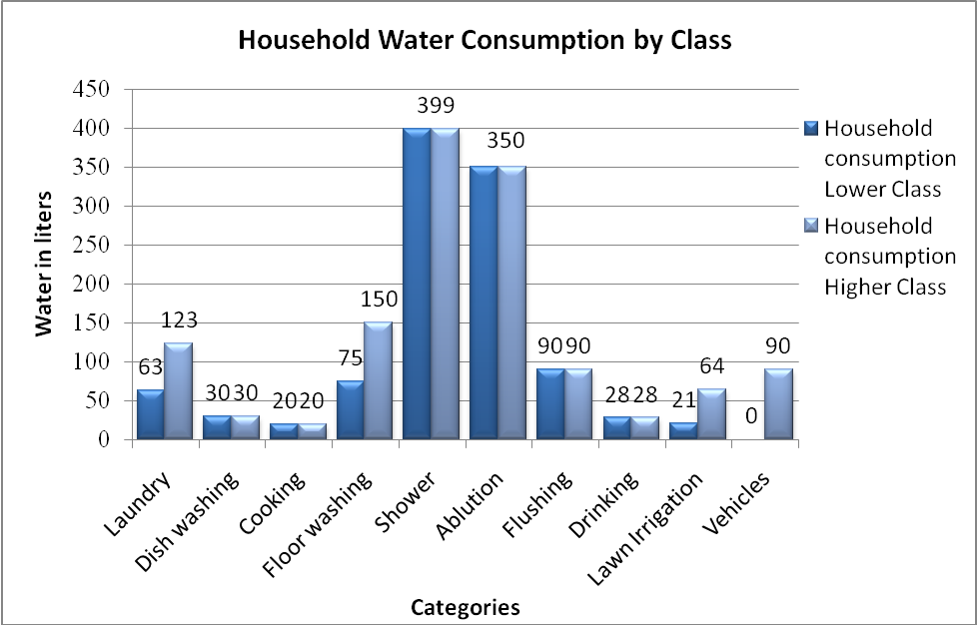

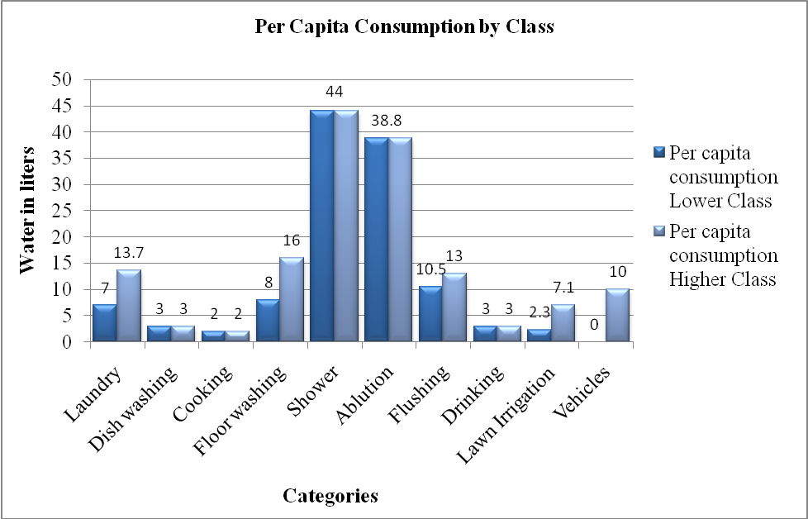

Table no. 1.2: Level of Satisfactions of the Respondents with water quality

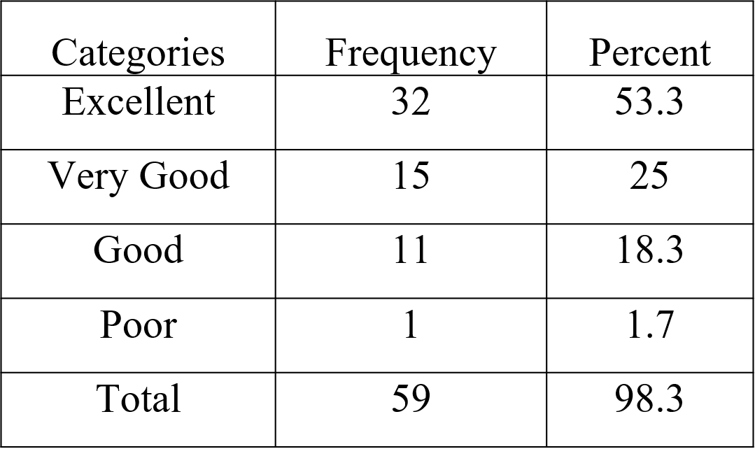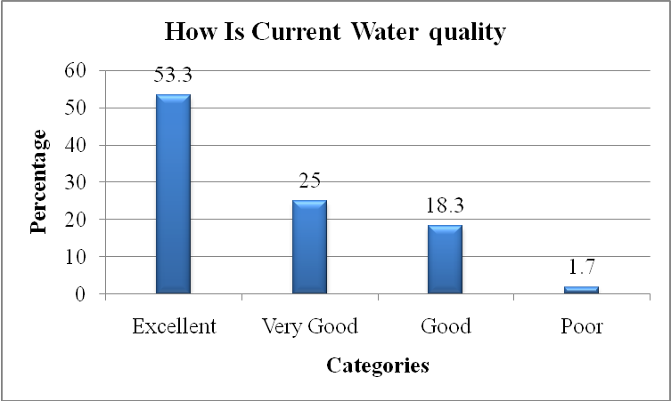

Table no. 1.3: Level of Satisfaction of the Respondents with water taste

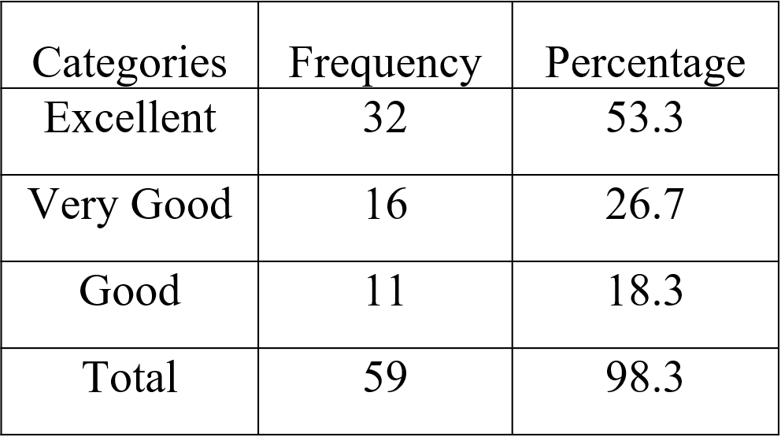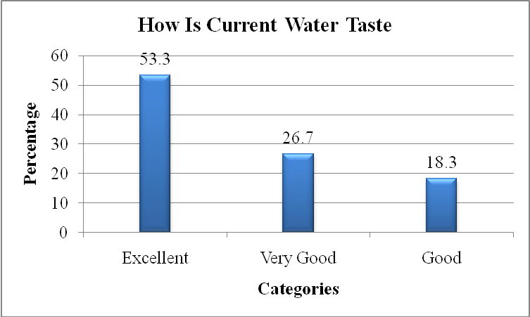

Table no. 1.4: Level of Satisfaction of the Respondents with water pressure

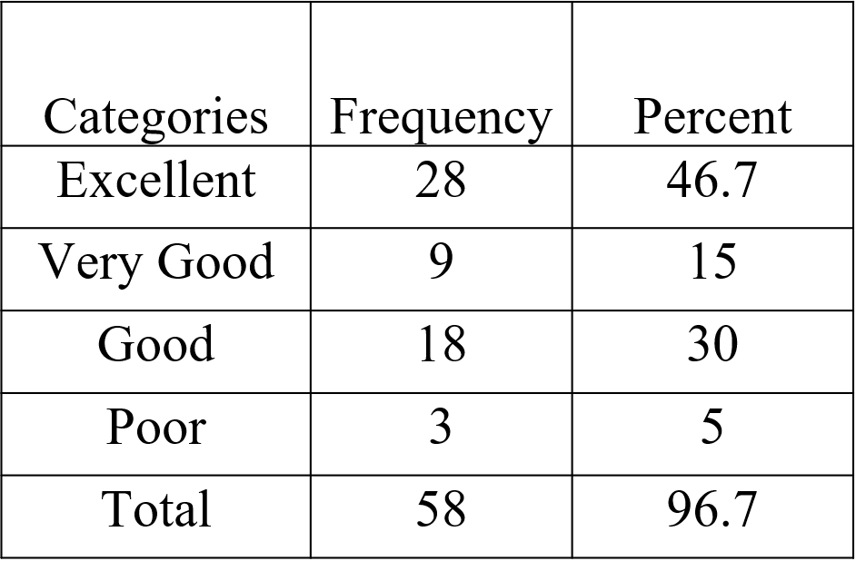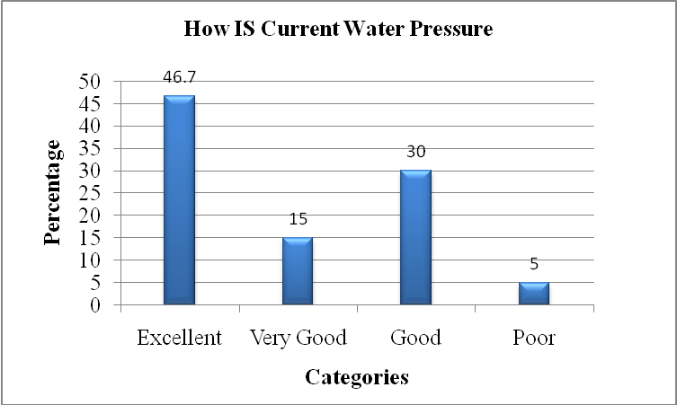

Table no. 1.5: Taps leakage
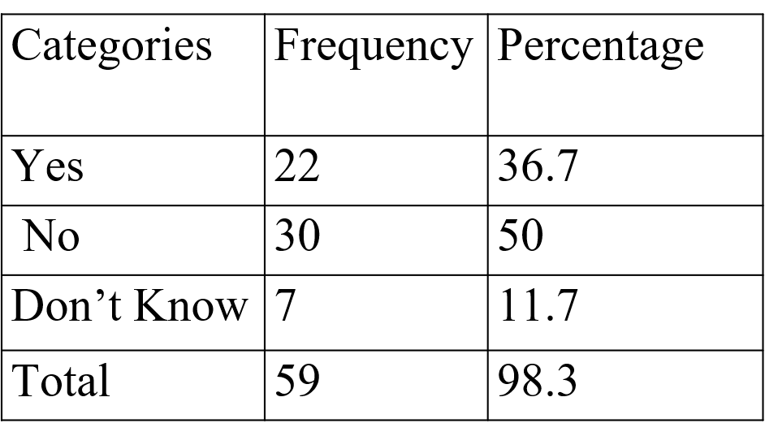

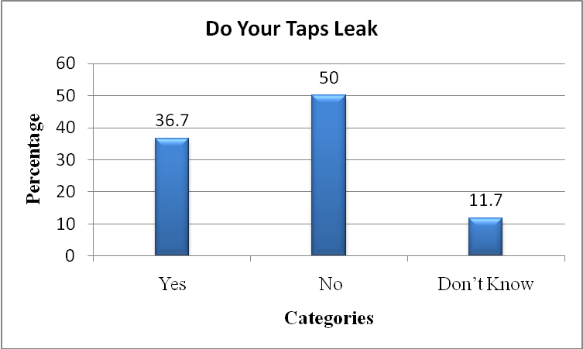

Table no. 1.6: Perception of respondents about water shortage

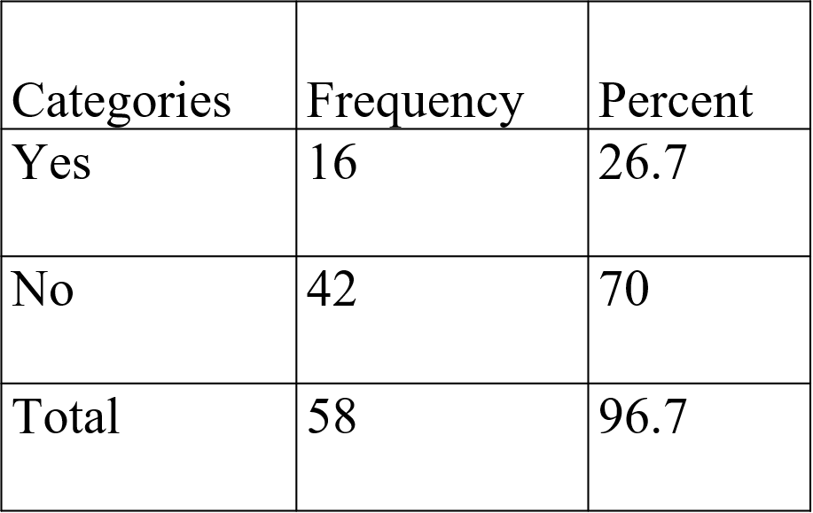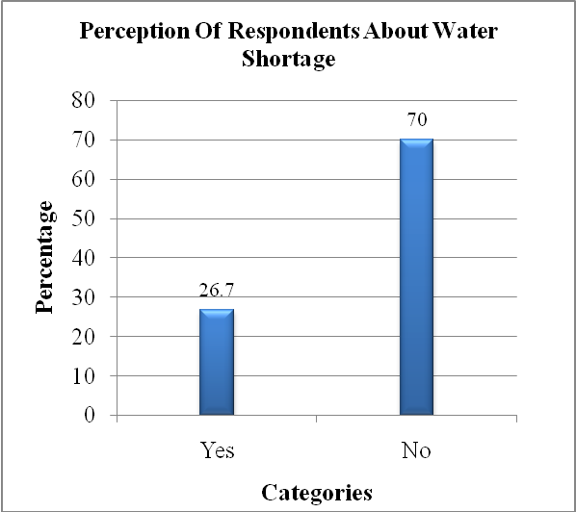

Table no. 1.7: Major water using appliances

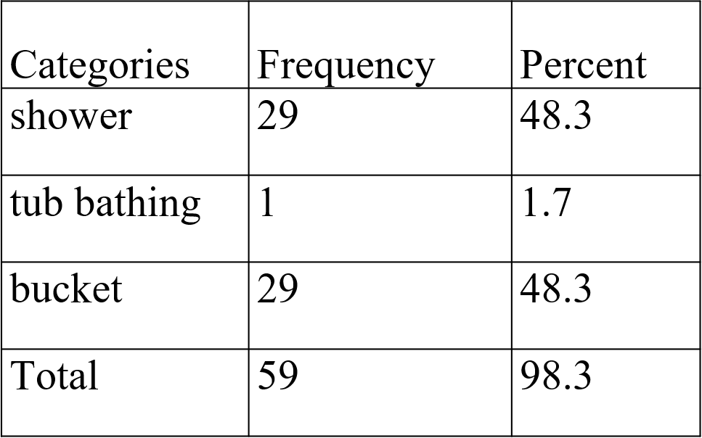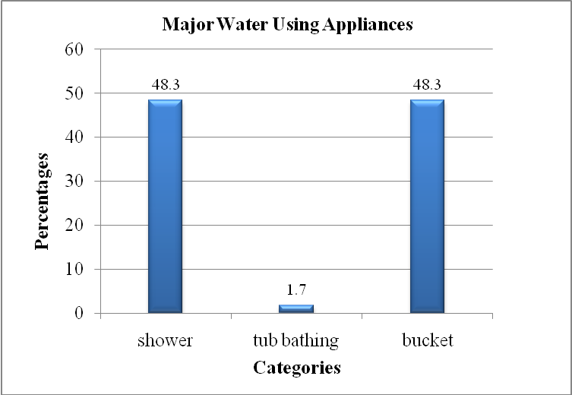

Table no. 1.8: Bathing frequency in summer

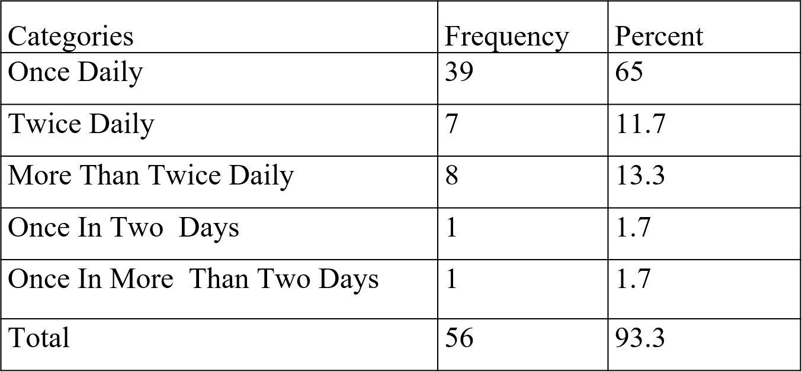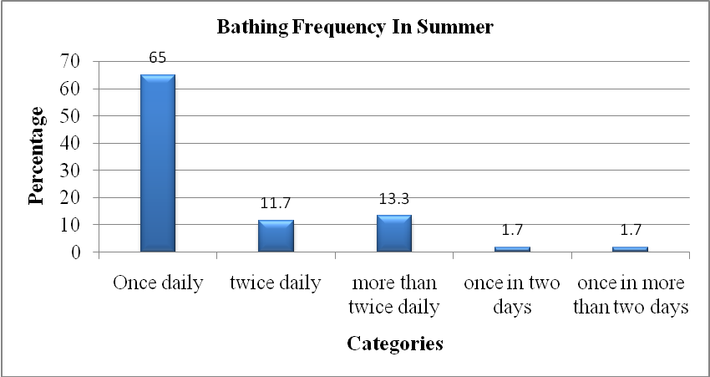

Table no. 1.9: Bathing frequency in winter

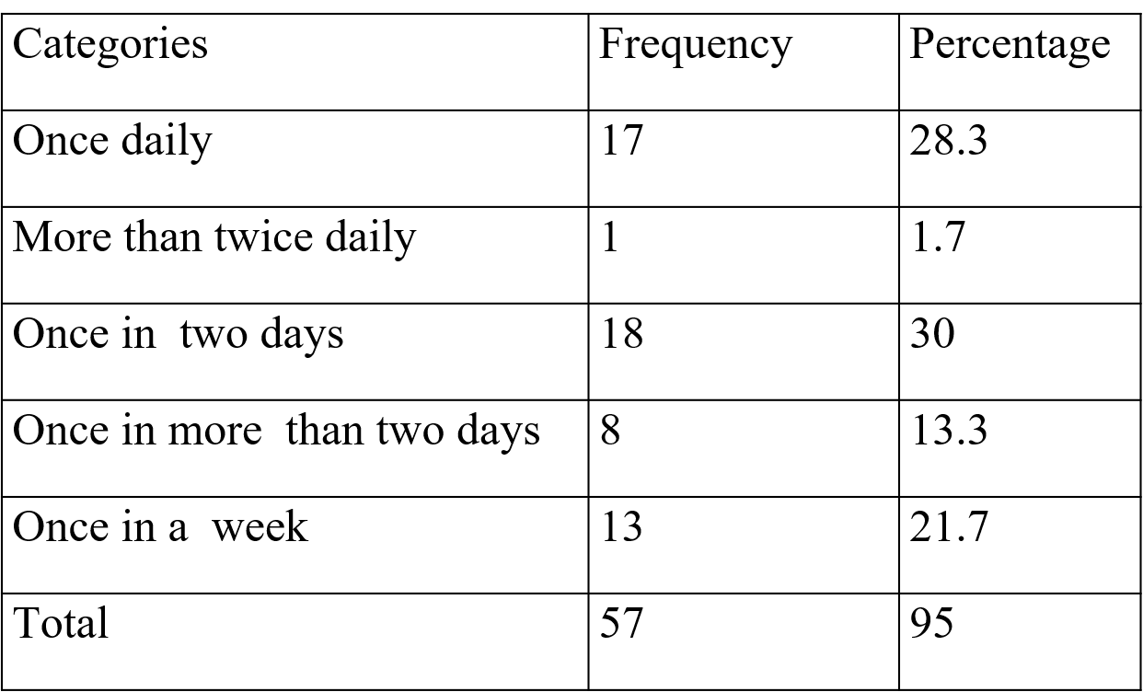

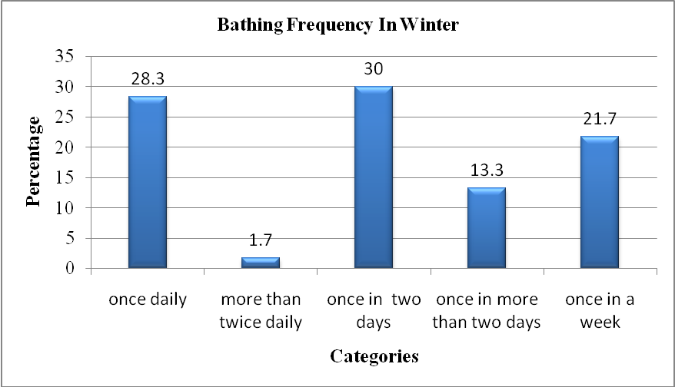

Table no. 1.10: How long does each shower last?

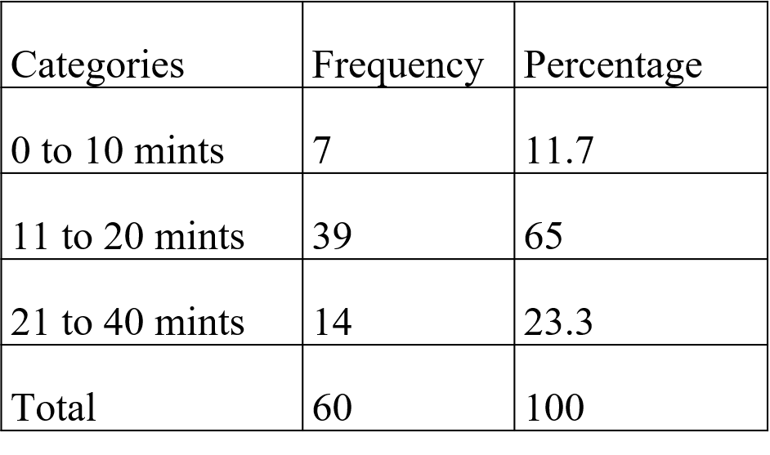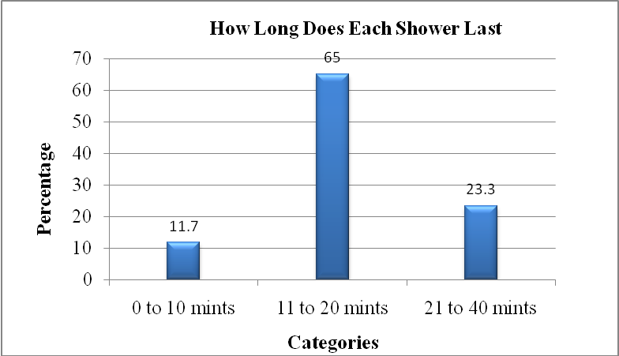

Table no. 1.11: Laundry frequency in a week

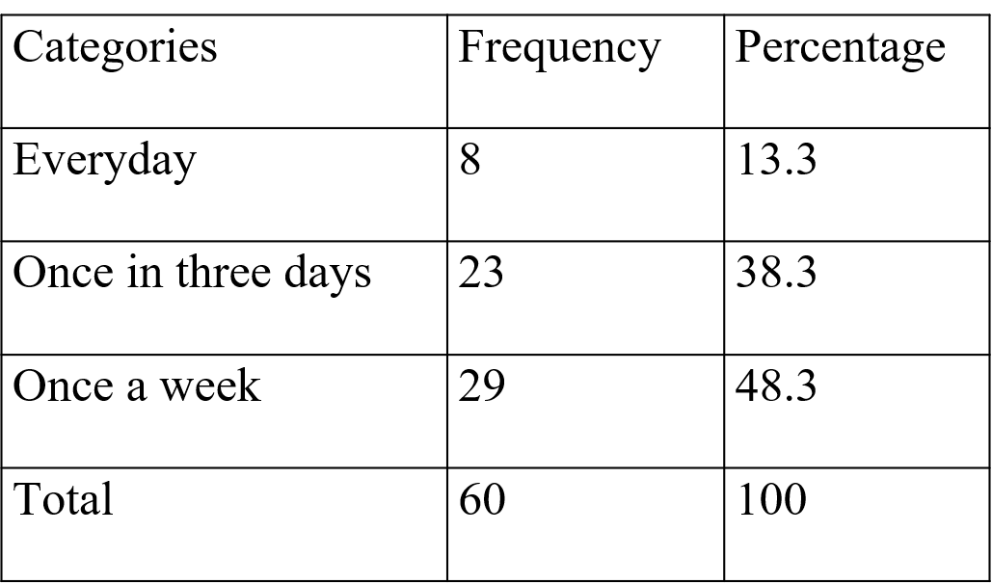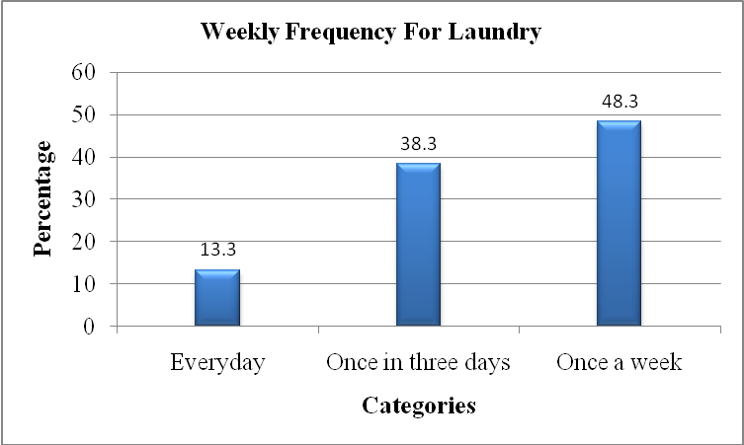

Table no. 1.12: Method of laundry

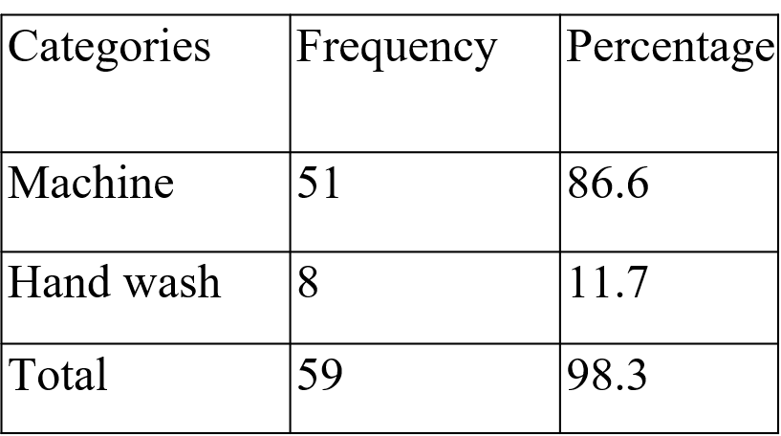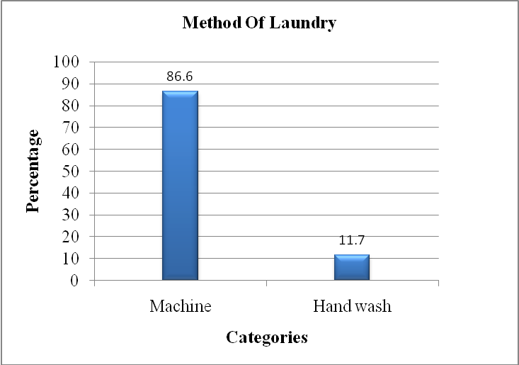

Table no. 1.13: Loads of laundry

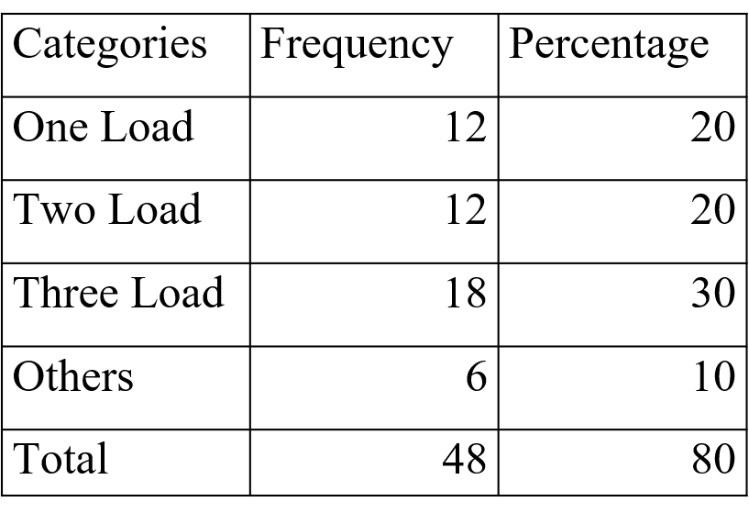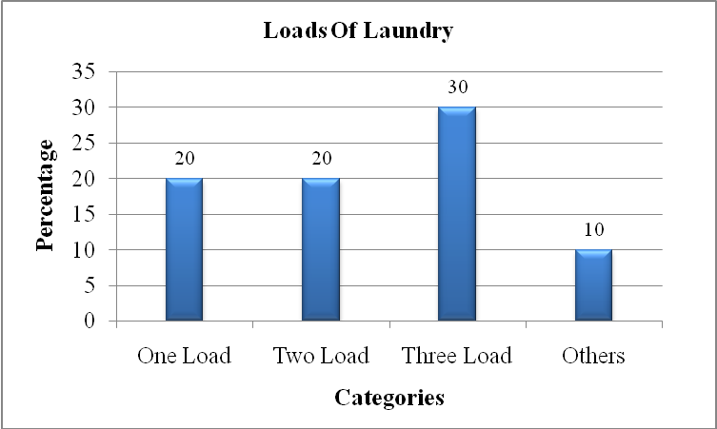

Table no. 1.14: Major source of drinking water

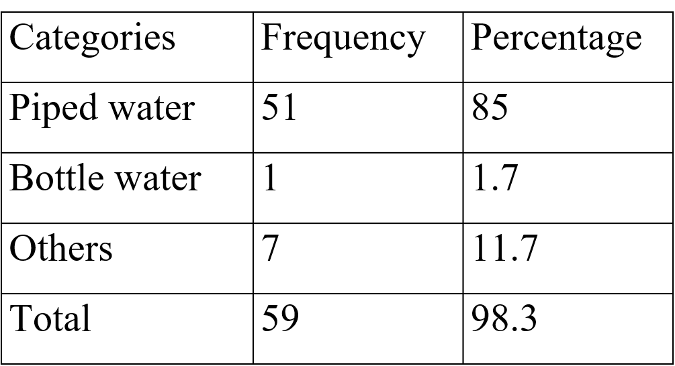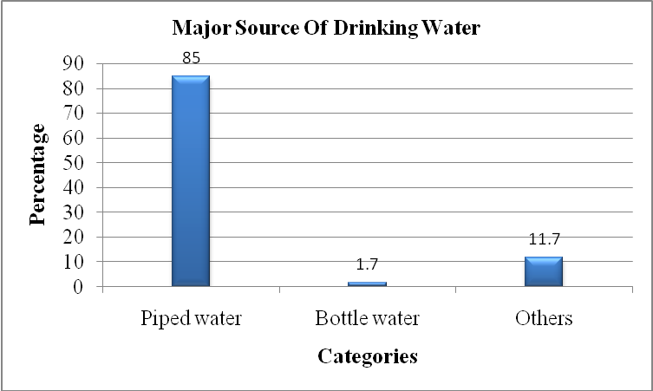

Table no. 1.15 Daily Residential Water Demand

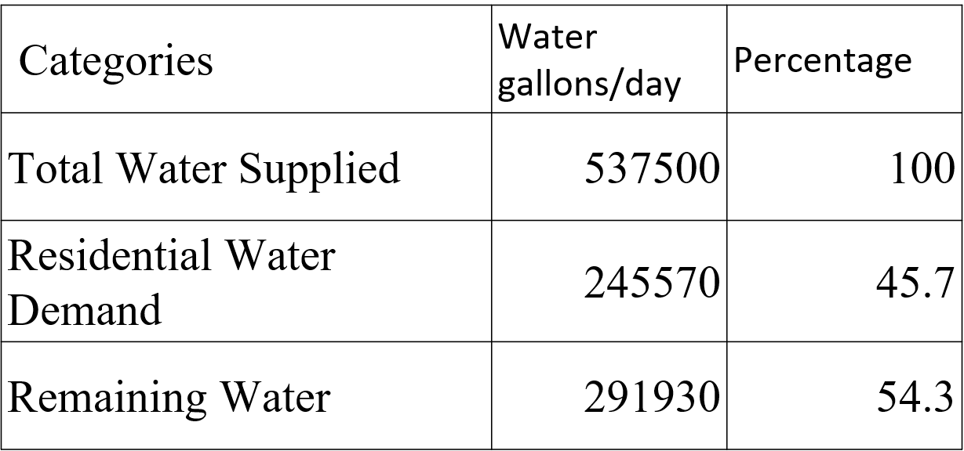

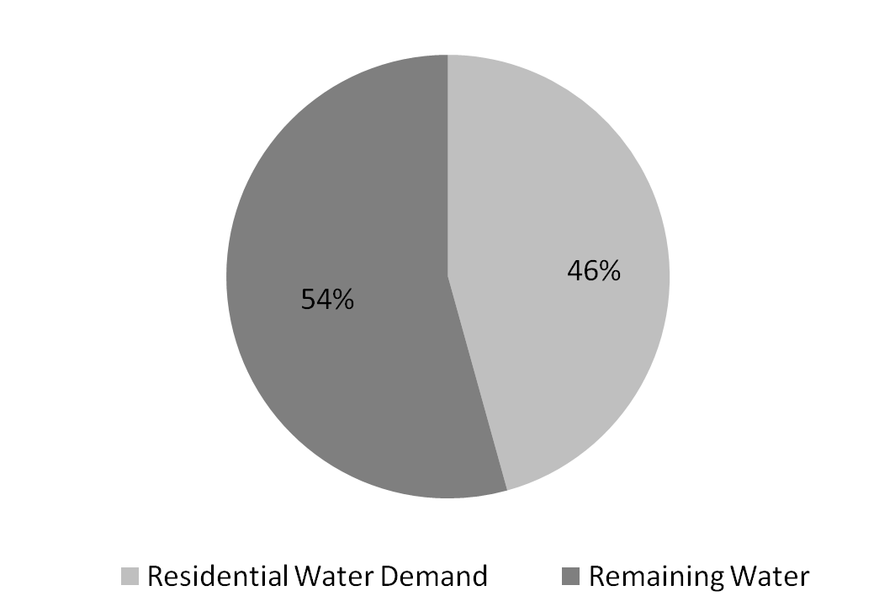
Daily Residential Water Demand

FINDINGS
- Daily per capita water use was calculated as (119.8 Liters/day) for lower class and (150.6 Liters/day) for higher class.
- Daily household consumption was calculated as (1079 Liters/day) for lower class and 1347 Liters/day) for higher class.
- Total estimated water supply by all the tube wells was 537500 (100%) gallons/day in which 245570 (46%) gallons/day was used for Residential water demand and the remaining 291930 (54%) gallons/day was used for hostels and institutional use.
- Tube wells are the major source of water supply in the study area.
- Majority of the residents of the study area are satisfied with the amount water supplied, water availability, water pressure, maintenance and repair and water quality
- The timings of two tube wells (Fine Arts and Steel GODAM) are 15 hours which are comparatively greater than the other tube wells. It means that the sphere of influence of these two tube wells is quite large. The Fine Arts tube well supplies water to a larger residential area while Steel GODAM tube well supplies water to hostels.
- 35% residents of the study area are facing taps leakage problem which means that a huge volume of water is wasted daily.
- Shower is the major water consumer head as people waste hundreds of liters water while taking bath.

SUGGESTIONS
- Though it was not possible to estimate the total water losses of water, however, it is assumed that a lot of fresh water is wasted on road watering, pipe leaks and tape leaks. It is suggested that a water loss survey may be conducted so that an accurate water loss could be estimated and minimized.
- Instead of using fresh water, the water which is discharged from houses and masjids may be recycled and used for road watering as well as lawn irrigation.
- New low flow faucets should be tested and installed which could save water.
- A large-scale study should be launched for the accurate estimation of water supply and demand for the sustainable of water use in the University Campus.

