Name: Mohammad Yar Khan Khattak
ID: 13921
Final Assignment
Project Management
Subject Instructor: Sir Zaigham Abbas

A1)

The learning outcomes of the subject project management are:

- The subject taught us about managing different aspects of the project which includes; Scope, cost, timing and quality. And keeping the project on the success path which are designed by the Stakeholders.
- Learned about synchronizing the project to the organization strategies and plans throughout the lifecycle of project.
- Helped us identifying the project goal, which has to be achieved, restrictions, deliverables, the criteria of performance, control needs and resources required(consulting with stakeholders) to make the project the successful.
- Implementation of project management knowledge, processes, the cycle of project, concepts and techniques in order to reach the success point of any project.
- Keeping the project In mind while responding to internal and external issues that arise.
- Helped us getting used to technological tools which helps us in communication, collaboration, information management and decision support.
- Implementation of business concepts, practices and tolls in to order to support project success.
- Application of Legal and ethical code of conducts and standards.
- Keeping the track with the stakeholder’s needs from the economy sector(i.e. consulting, arts, government) with the help of project management practices
- Project management knowledge and practices help to launch new programs, products, services and initiating.
- It keeps the project management roles in organization change.

The project management subject helps us to groom in terms of doing some work done professionally and bring discipline, professionalism and art of doing work with the plan. This applies to an individual and the organization. As an individual, it helps a person to manage something if it’s a project or an individual task. It molds a person into time management person, keeping the track a of his work and managing if the individual is on right track.
Coming to the organization, the subject speaks for itself. It starts with the management and ends with achieving the success. It helps an organization to start with a project. While the project goes on, it helps it with the plan, resources and mainly the time management.
Keeping all the elements of project management which mainly includes, plan, schedule, budget, human resources and quality. This subject covers all these elements and help us putting these practically as an individual and organization to achieve the success.

A3)

Project Quality:
Project quality is defined as products or service ability to perform up to the mark and efficiently, whether it is suited for the required goals. Or all the activities related to the project achieves the standard sets to complete a particular project

Purpose:
The main purpose of project quality management is to check whether the project meets or exceeds the stakeholder’s needs and wants. It helps you identify the quality and standard requirements needs to be follow and to be followed in order to achieve success. The project quality/management is vital in all aspects while carrying a certain project.

Project quality management processes:
There are 3 main parts of processes, which includes quality Planning, Quality assurance and Quality control. ( with inputs and outputs)

1) Quality planning: Identifies which quality standards are needs to be followed which are related to the project.
Input: environmental factors, assets, scope statement, PM plan
Output: quality management plan, quality metric, quality checklist, process improvement plan, quality baselines
For example; If mobile companies makes a phone and it has all features which others phone have but its screen breaks easily. Here the quality has not be ensured and it has to go through quality planning process to ensure it doesn’t break that easily.

2) Quality assurance: it’s evaluation of overall performance which is carried out during the project and ensuring that it satisfies all the quality standards
Input: Quality management plan, quality metrics, work performance information, change requests, quality control measurement, implemented change requests
Outputs: Requested changes, recommended corrective actions, organization process asset, project management plan
For example: the phone screens break easily. Now it needs quality assurance. So it go through the relevant process of assurance using the relevant tools and techniques. It must recheck the quality standards that have been set by a particular company or organization.

3) Quality Control: It’s monitoring of results to check whether the project has followed the standards that were set in terms quality.
Input: quality management plan, quality metrics, quality checklist, work performance assets/information, approved request, deliverables
Output: Quality control measurement, Validated defect repair, updates, recommended defects repair, requests changes
For example: The phone gets recheck for the quality and defects are found during the process. Now quality control comes into play. Here it should request to change the certain things and remove the defects so it could match the standards set for the particular process.

A2)

Project Budget: In simple words, project budget is total cost needs to complete one project in a given period of time.

Components and it’s sequence:
- Activity estimates
- Work Package estimates
- Control Account estimates
- Project Estimates
- Contingency Reserves
- Cost Baseline
- Management Reserves
- Cost Budget

EXAMPLE: COMMUNITY WORKSHOP

INCOME: In this project, the budget should show where the income is received. Including the funds that are already in your account, allocated towards the project. The budget should also include sources of funding from any other potential funders. If you write an application to other funders, it shall be included in the budget project

EXPENSE/COST: You also have to mention all the costs in the budget, you have paid in order to complete the project. Donations and sponsors funds should also be mentioned as an expense (IN BRACKETS) and specify how the mentioned fund is being paid for e.g Catering( sponsored)

SHORTFALL: The budget also illustrates how much more funds you require from the workshop which you are making the budget for in the application
1) Activity estimates: Estimation of all the activities which have their own costs
2) Work package estimates: Cost of all the group related task within the project
3) Control Account Estimates: The estimation point that is compared to the earned value for performance measurement
4) Project Estimates: It’s a reality check that how much resources cost is needed to complete project activity
5) Contingency reserve: The retained earning set aside to possibly needed for losses
6)Cost Baseline: Money projected to cost on the other side when the money will be spent
7) Management reserves: Amount set aside for the management purposes which are generally unknown
8) Cost Budget: Total estimate or cost to complete a certain projects

If I am making a restaurant I will need certain components to ensure and complete the project gets successful
Activity estimates for different activities like Electric purposes , paint and plumbing

Work package will be for the group of people working on different task

Project estimates for checking the resource cost to complete the restaurant

I have to keep the contingency reserve a little for if something I don’t like and needs to be change or for the possible losses

I will keep the cost baseline once the restaurant is completed. I might need it for other purposes.

I will keep something for reserve not revealing to the people

Now I will get the total cost budget towards the ends that how much cost I have to bear to complete a certain project.

A4)
Critical path.: A1-A2-A4-A5

What is the duration of critical path? = 18 weeks

What is the float of activity 3? = 5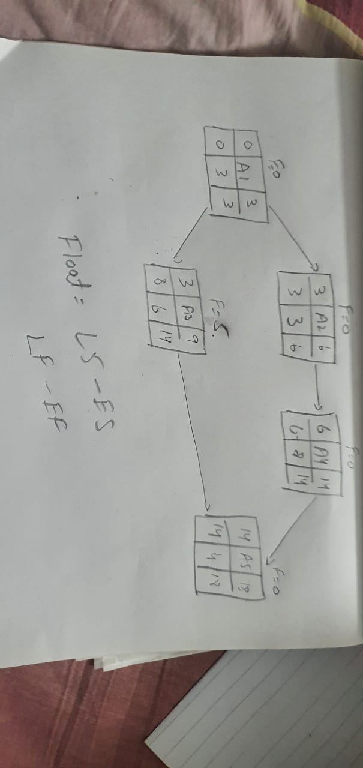

What is the float of activity 2? = 0

What is the float of the path with longest float ? = 5

