

IQRA NATIONAL UNIVERSITY

Sessional 2020 Examination

|  |  |  |  |  |
| --- | --- | --- | --- | --- |
| **Course Name** | **Max. Marks** | **Deadline** | **Date** | **Instructor** |
| Software Requirement Specification | 20 | 10th June, 2020 | 10th May, 2020 | Aasma Khan |

|  |  |
| --- | --- |
| ID | 14293 |
| Name | Shoaib Rehman |
| Semester | 5th |
| Department | Bs(SE) |

* **Attempt all questions.**
* **Marks will be given as per the DEPTH of the answer, not LENGTH.**

**Question No: 01**  **(20)**

Pair programming is an agile software development technique in which two programmers work together at one work station. One types in code while the other reviews each line of code as it is typed in. The person typing is called the driver. The person reviewing the code is called the observer. The two programmers switch roles frequently (possibly every 30 minutes or less).

Suppose that you are asked to build a system that allows Remote Pair Programming. That is, the system should allow the driver and the observer to be in remote locations, but both can view a single desktop in real-time. The driver should be able to edit code and the observer should be able to “point” to objects on the driver’s desktop. In addition, there should be a video chat facility to allow the programmers to communicate. The system should allow the programmers to easily swap roles and record rationale in the form of video chats. In addition, the driver should be able to issue the system to backup old work.

* Draw a use case diagram to show all the functionality of the system.
* Describe in detail four non-functional requirements for the system.
* Give a prioritized list of design constraints for the system and justify your list and the ordering.
* Propose a set of classes that could be used in your system and present them in a class diagram.

**Answer No:1**

**1:** Draw use case diagram to show all the functionality of the system

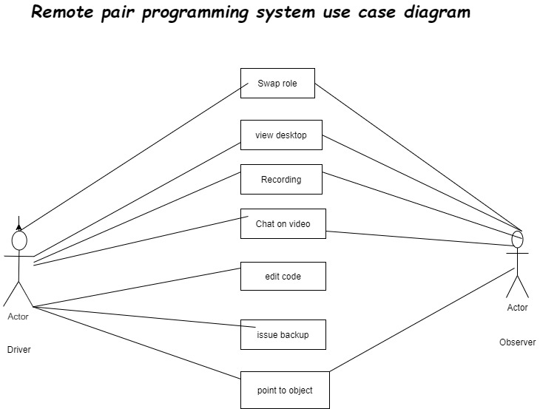

**Figure 1**

2. **Give a prioritized list of design constraints for the system and justify your list and the ordering.**

a) More output in the time available. This may seem obvious, but with two designers working, you get more ideas per hour. In addition to each designer coming up with his or her own ideas, they can also bounce ideas off each other, coming up with new concepts that would not have surfaced without the collective brainstorming.

b) Better quality output. Pair designing challenges us as designers to question our choices at times of critical decision making with someone who also understands the client’s domain. This is different than pair critique, in which another designer provides feedback while looking in on the project, and the designer has to justify his or her decisions after the fact.

c) Validation of earlier decisions This practice provides an outlet for talking through difficult decisions sooner, rather than waiting for a critique at the end. It also offers a devil’s advocate early on, which helps keep biased decisions from sneaking into a more final wireframe or prototype.

d) Increased confidence in decisions. Pair designing also gives us a chance to practice talking through our design decisions and fully rationalizing them before discussing them with the client. Also, as two designers have already worked through the design challenges

*3. Describe Four non-functional Requirements*

*Driver can view desktop*

*Driver can swap roles*

*Observer can test the code written by driver*

*Observer can verify the code typed by the driver*

4. **Propose a set of classes of the system and present them in class diagram**

Good



Good Luck ☺