Iqra National University

Department of Civil Engineering

ASSIGNMENT

Discipline: MS Civil Engineering
Course Title: Construction Financial Management
Instructor Name: Dr.Engr. Muhammad Zeeshan Ahad
SUBMITTED BY: AFZAL HUSSAIN
ID: 15429
Date: 30/06/2020

Problem 1: A construction company will replace an excavator after 5 years. A new one costs $250,000. How much is the end of year annual uniform payment the company has to put into a bank in order to save enough money in five years’ time for purchasing the equipment if the bank is offering an interest rate of 4%per annum?
Solution:

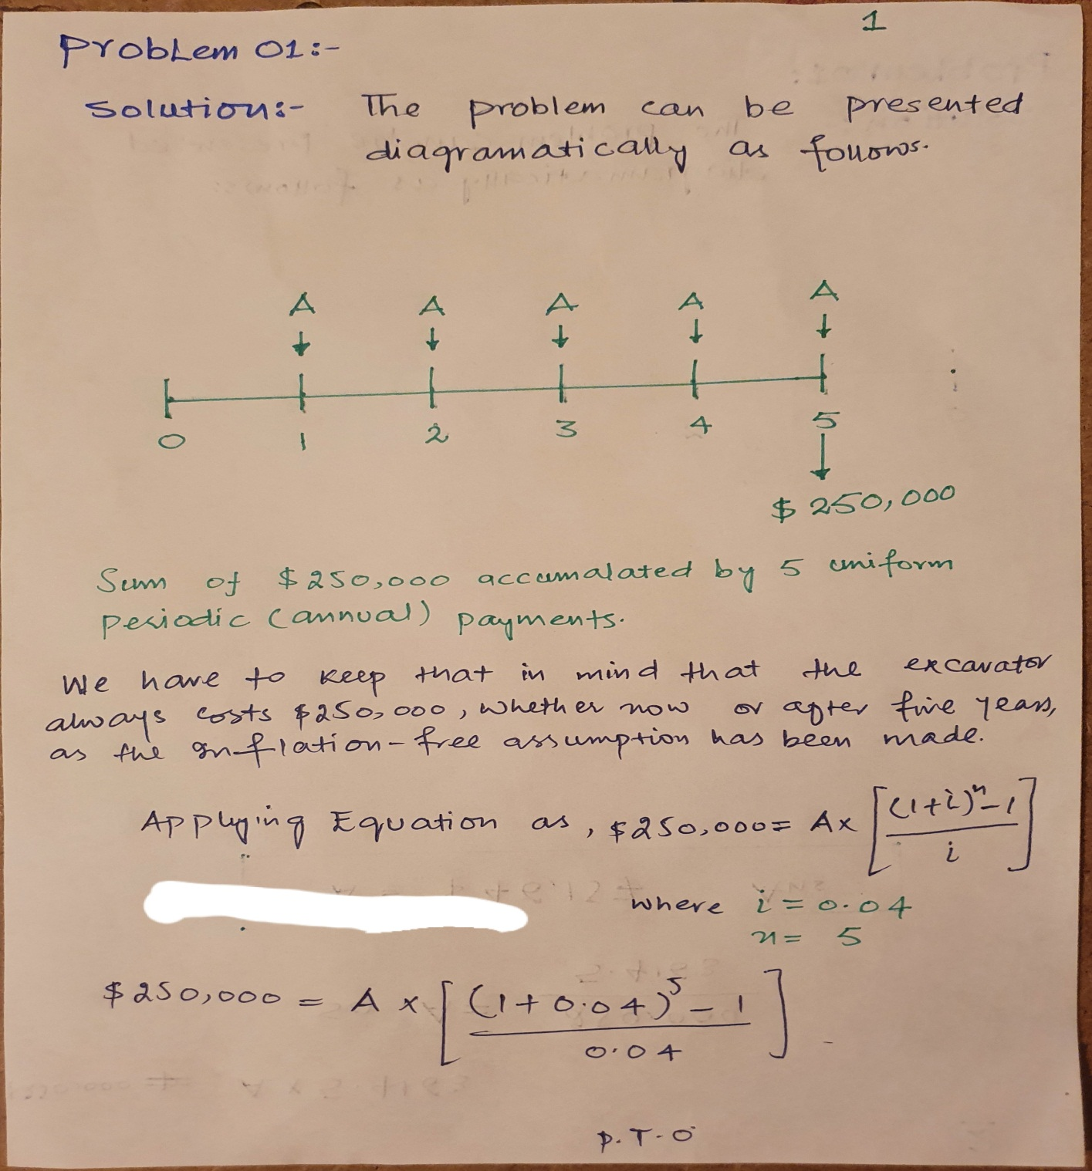
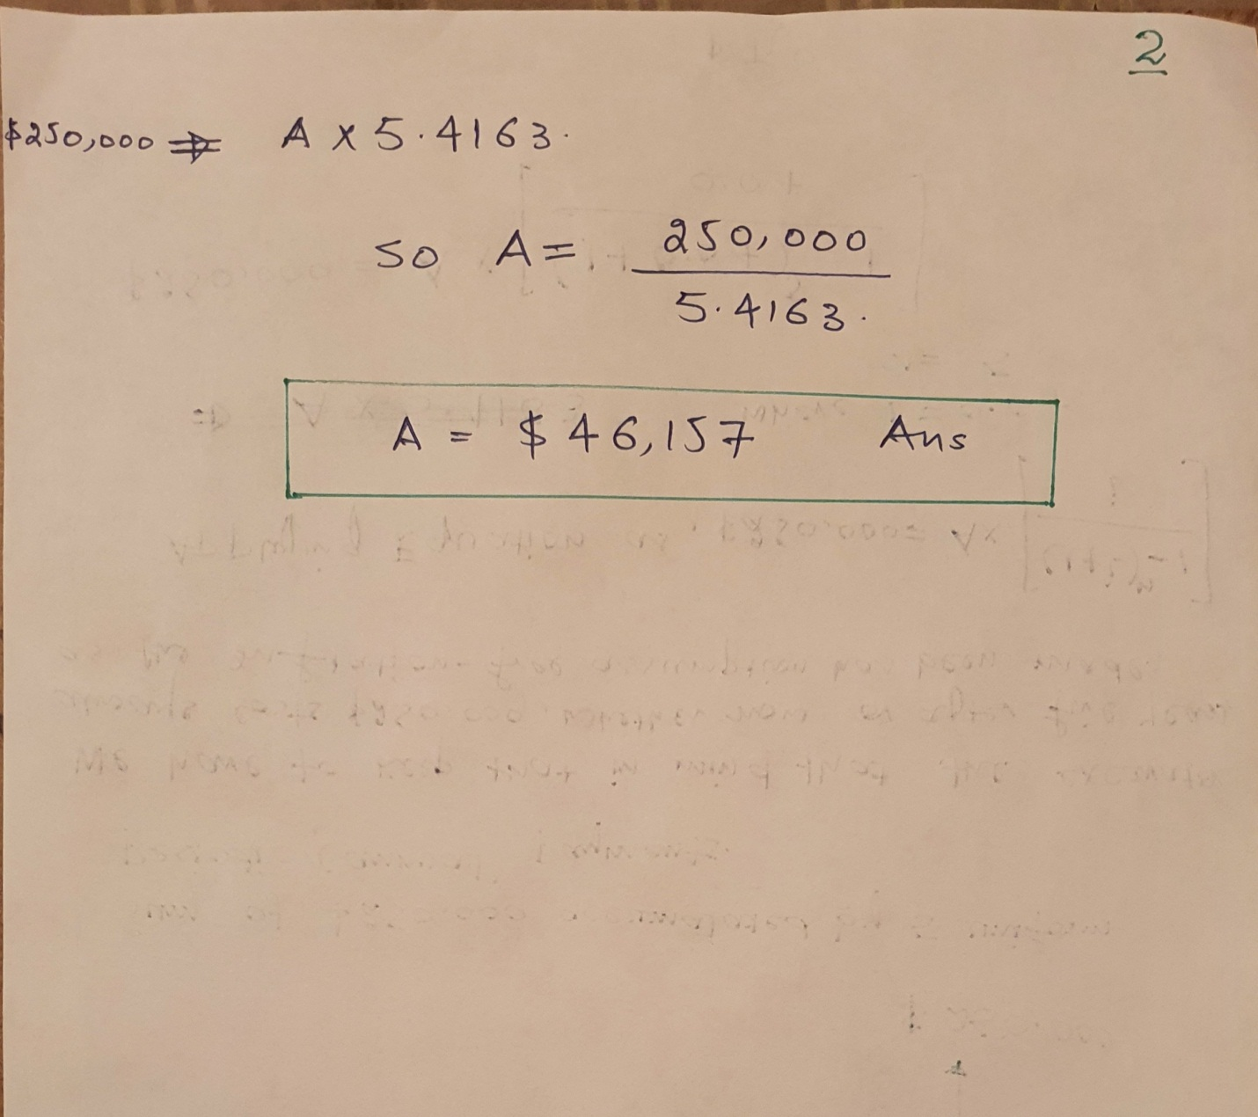

Problem 2: A construction material company makes and sells window panels. The selling price per panel is $900. The variable cost for making the window panels is $500 per unit. The fixed cost is $8,000,000. Find the BEP ( Break-even Point).
Solution:
