Final-Term Assignment/Paper (spring -020)
Human Anatomy-II
BS Radiology Sec-A 2nd Semester)
Instructor: Dr. M. Jaffar
Time: 6-hours (9am-3pm) Max Marks: 50
Student’s Name: Loqman Shah (15785)

Q1. Write anterior compartment of thigh and posterior compartment of leg muscles with origin, insertion and action. (10)
Answer:
Muscles of Anterior Compartment of Thigh
Flexes thigh at hip and extends leg at knee
- Quadriceps femoris
RECTUS FEMORIS:
Origin: anterior inferior iliac spine, margin of acetabulum.
Insertion: patella and tibial tuberosity via the patellar ligament.
Action: extends knee, flexes thigh
- Vastus lateralis
- Vastus medialis
- Vastus intermedius
Origin: femur
Insertion: patella and tibial tuberosity via the patellar
Action: extends knee
Sartorius:
Origin: anterior superior iliac spine
Insertion: medial tibia
Action: flex, abduct, late rotate thigh; weak knee flexor.
Iliopsoas:
Origin: llia, sacrum, lumbar vertebrae.
Insertion: lesser trochanter
Action: flexor of thigh
Innervations: femoral nerve
Adductors:
- Adductor longus
- Adductor brevis
- Adductor Magnus
Origin: inferior pelvis
Insertion: femur
Action: adducts and medial rotates
Innervations: obturator nerve
Pectineus:
Origin: pubis
Insertion: lesser trochanter
Action: Adducts, medial rotates
Innervations: Femoral, sometimes obturator.
Gracilis:
Origin: pubis
Insertion: medial tibia
Action: adducts Thigh, flex, medial, rotates leg
Innervations: obturator nerve.
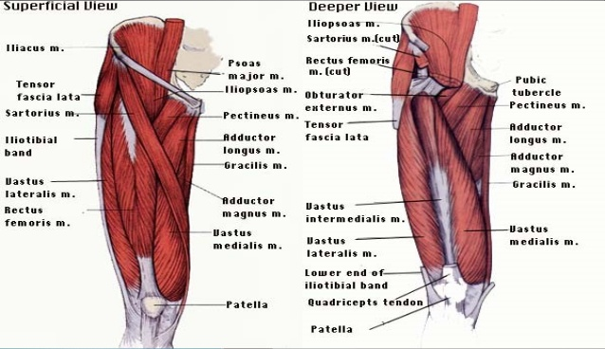
Muscles of Posterior Compartment of Leg
Plantar flex foot, flex toes
Innervation: Tibial nerve
Superficial Posterior Compartment:
Triceps surae
GASTROCNEMIUS (2 HEADS)
Origin: medial and lateral condyles of femur
Insertion: posterior calcaneus via Achilles tendon
SOLEUS:
Origin: tibia and fibula
Insertion: same as above
Action of both; plantar flex foot
PLANTARIS (variable):
Origin: posterior femur
Insertion: same as above
Action: plantar flex foot, week knee flexion
All innervated by the tibial nerve
Deep Posterior Compartment:
Popliteus:
Origin: lateral condyle femur and lateral meniscus
Insertion: proximal tibia
Action: flexes and medially rotates leg.
Flexor digitorum longus:
Origin: tibia
Insertion: distal phalanges of toe 2-5
Action: plantar flex and invert foot, flex toe
Flexor hallucis longus:
Origin: fibula
Insertion: distal phalanx of hallux
Action: plantar flex and invert foot, flex toe
Tibialis posterior:
Origin: tibia, fibula, and interosseous membrane
Insertion: tarsals and metatarsals
Action: plantar flex and invert foot.
All innervated by the tibial nerve.
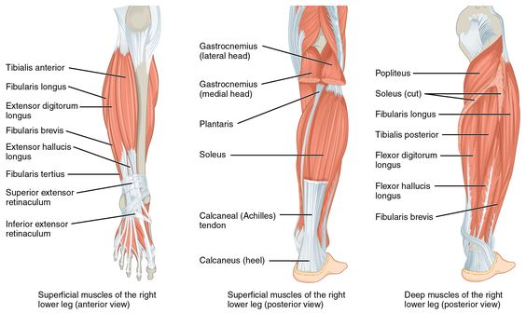
Q2. Define the following (10).
Answer:
- Endocrine gland
- Endocrine glands secrete their hormones directly into the blood rather than through a duct. E.g. pituitary gland, thyroid gland, adrenal glands
- Endocrine glands are ductless glands of the endocrine system that secrete their products, hormones, directly into the blood. The major glands of the endocrine system include the pineal gland, pituitary gland, pancreas, ovaries, testes, thyroid gland, parathyroid gland, hypothalamus and adrenal glands.
- Glands:
  - The organ that secretes hormones is known as Glands.
  - Hormones are chemical substances in the body to generate different chemical reactions in the body.
  - Endocrine System is the hormonal system of the body is called Endocrine System.
Function of Endocrine Glands:
- The endocrine system is responsible for regulating a range of bodily functions through the release of hormones.
- Hormones are secreted by the glands of the endocrine system, traveling through the bloodstream to various organs and tissues in the body. The hormones then tell these organs and tissues what to do or how to function.
- Some examples of bodily functions that are controlled by the endocrine system include:
- Metabolism
- Growth and development
- Sexual function and reproduction
- Heart rate
- Blood pressure
- appetite
- Sleeping and waking cycles
- Body temperature

- Exocrine gland
- Exocrine glands secrete their hormones into ducts. E.g. sweat glands, salivary glands, Liver.
- Exocrine glands are glands that secrete substances onto an epithelial surface by way of a duct.
- Examples of exocrine glands include sweat, salivary, mammary, ceruminous, lacrimal, sebaceous, prostate and mucous. Exocrine glands are one of two types of glands in the human body, the other being endocrine glands, which secrete their products directly into the bloodstream. The liver and pancreas are both exocrine and endocrine glands; they are exocrine glands because they secrete products, bile and pancreatic juice into the gastrointestinal tract through a series of ducts, and endocrine because they secrete other substances directly into the bloodstream.
Function of Exocrine Glands:
- Depending on the exocrine gland, they can function to regulate body temperature, lubricate, nurture newborns (lactation), aid in digestion, and aid in reproduction.

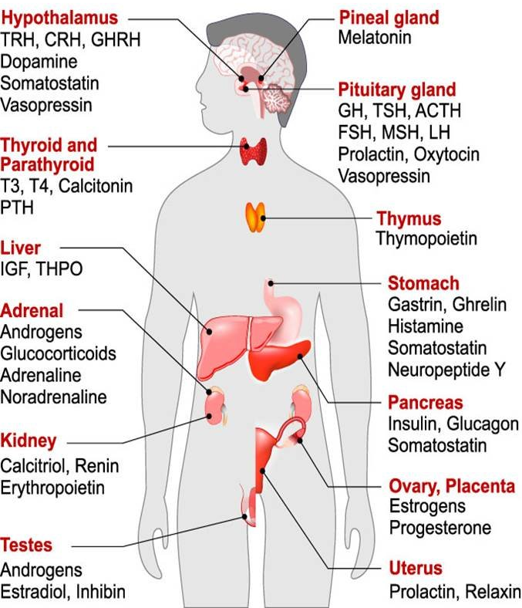
- Thalamus
- Thalamus is a part of diencephalon.
- Large mass of grey matter lies immediately lateral to third ventricle.
- The thalamus is a void nuclear mass, 4cm long, which borders the dorsal part of third ventricle.
- Two poles:
Anterior pole (or end):
- It is lies behind the interventricular foramen
Posterior pole (or end):
- Also called PULVNAR
- Lies just above and lateral to superior
- The thalamus is a mostly gray matter structure of the diencephalon that has many essential roles in human physiology. The thalamus is composed of different nuclei that each serves a unique role, ranging from relaying sensory and motor signals, as well as regulation of consciousness and alertness. Internally, the thalamus is divided into anterior, medial and lateral nuclear groups by a vertical Y-shaped sheet of white matter, the internal medullary lamina Nuclei of the anterior part.
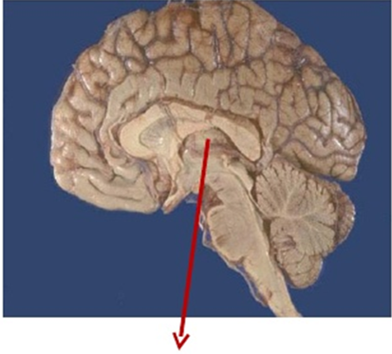
Thalamus
Functions of thalamus:
Relay center:
- Almost all impulses sensation reaches thalamic nuclei and processed in thalamus impulses carried to cerebral cortex by thalamocortical fibers
- That’s why thalamus is relay center for sensations like pain, touch, etc.
Center of relax activity
Center for integration of motor functions
Center for integration of sensory functions
Center for sexual sensation
Role in alertness reactions

- femoral triangle
- The femoral triangle is a hollow area in the anterior thigh. Many large neurovascular structures pass through this area, and can be accessed relatively easily. Thus, it is an area of both anatomical and clinical importance.
Borders:
Femoral triangle has three borders:
- Superior border – Formed by the inguinal ligament, a ligament that runs from the anterior superior iliac spine to the pubic tubercle.
- Lateral border – Formed by the medial border of the Sartorius muscle.
- Medial border – Formed by the medial border of the adductor longus muscle. The rest of this muscle forms part of the floor of the triangle.
- Some sources consider the lateral border of the adductor longus to be the medial border of the femoral triangle. However, the majority states that it is the medial border of the adductor longus – and this is definition we have gone with.
It also has a floor and a roof:
Anteriorly, the roof of the femoral triangle is formed by the fascia lata.
Posteriorly, the base of the femoral triangle is formed by the pectineus, iliopsoas and adductor longus muscles.
The inguinal ligament acts as a flexor retinaculum, supporting the contents of the femoral triangle during flexion at the hip.
Contents:
The femoral triangle contains some of the major neurovascular structures of the lower limb. Its contents (lateral to medial) are:
Femoral nerve – Innervates the anterior compartment of the thigh, and provides sensory branches for the leg and foot.
Femoral artery is Responsible for the majority of the arterial supply to the lower limb.
Femoral vein is the great saphenous vein drains into the femoral vein within the triangle.
Femoral canal is structure which contains deep lymph nodes and vessels.
The femoral artery, vein and canal are contained within a fascial compartment – known as the femoral sheath.
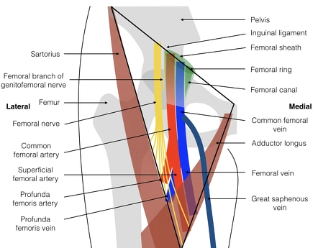

Femoral triangle
Q3. Write the Extraocular muscles. Enlist both voluntary and involuntary. (10)
Answer:
Extraocular muscles:
- The extraocular muscles are located within the orbit, but are extrinsic and separate from the eyeball itself. They act to control the movements of the eyeball and the superior eyelid.
- There are seven extraocular muscles – the Levator palpebrae superioris, superior rectus, inferior rectus, medial rectus, lateral rectus, inferior oblique and superior oblique.
- Functionally, they can be divided into two groups:
- Responsible for eye movement: Recti and oblique muscles.
- Responsible for superior eyelid movement: Levator palpebrae superioris.
Voluntary Muscle:
- LPS (Levator Palpebrae Superiors)
- Recti muscle
- Oblique muscle
Involuntary Muscle:
- Superior tarsal muscle
- Inferior tarsal muscle
- Orbitalis muscle
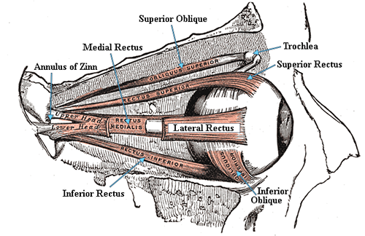
Extraocular muscles of Eye

Q4. Describe the arches of foot and functions of arches. (10)
Answer:
The Arches of the Foot:
A segmented structure can interference weight provided that it's inbuilt the shape of an arch.
The Foot has three such arches, which are present at birth.
- The medial longitudinal
- Lateral longitudinal
- Transverse arches
The Medial Longitudinal: This consists of the calcaneum, the talus, the navicular bone, the three cuneiform bones, and also the first three metatarsal bones…
Lateral Longitudinal Arch: This incorporates the calcaneum, the cuboid, and also the 4th and 5th metatarsal bones.
Transverse Arch: This consists of the bases of the metatarsal bones and also the cuboid and also the three cuneiform bones.
Maintenance of Arch Support:
- Examination of the planning of any stone bridge reveals the subsequent engineering methods used for its support
- The shape of the stones: the foremost effective way of supporting the arch is to create the stones wedge shaped with the skinny fringe of the wedge lying inferiorly, this is applicable particularly to the important stone that occupies the middle of the arch and is said because the “keystone.”
- The inferior edges of the stones are tied together: This accomplished by interlocking the stones or binding their lower edges along with metal staples. This method effectively counteracts the tendency of the lower edges of the stones to separate when the arch is weight bearing.
- The use of the tie beams: When the span of the bridge is large and also the foundations at either end are insecure, a tie connecting the ends effectively prevents separation of the pillars and consequent sagging of the arch.
- A suspension bridge: Here, the upkeep of the arch depends on multiple supports suspending the arch from a cable above the extent of the bridge.
- Using the bridge analogy, one can now examine the methods accustomed support the arches of the feet
Functions of arches:
- Spread the body weight to the weight bearing points of the sole (example, heel; balls of the toes, primarily those of first and fifth toes and lateral border of the sole).
- It is Serves as shock absorber during bound by their spring like activity.
- The concavity of the arches protects the nerves and vessels of the sole.

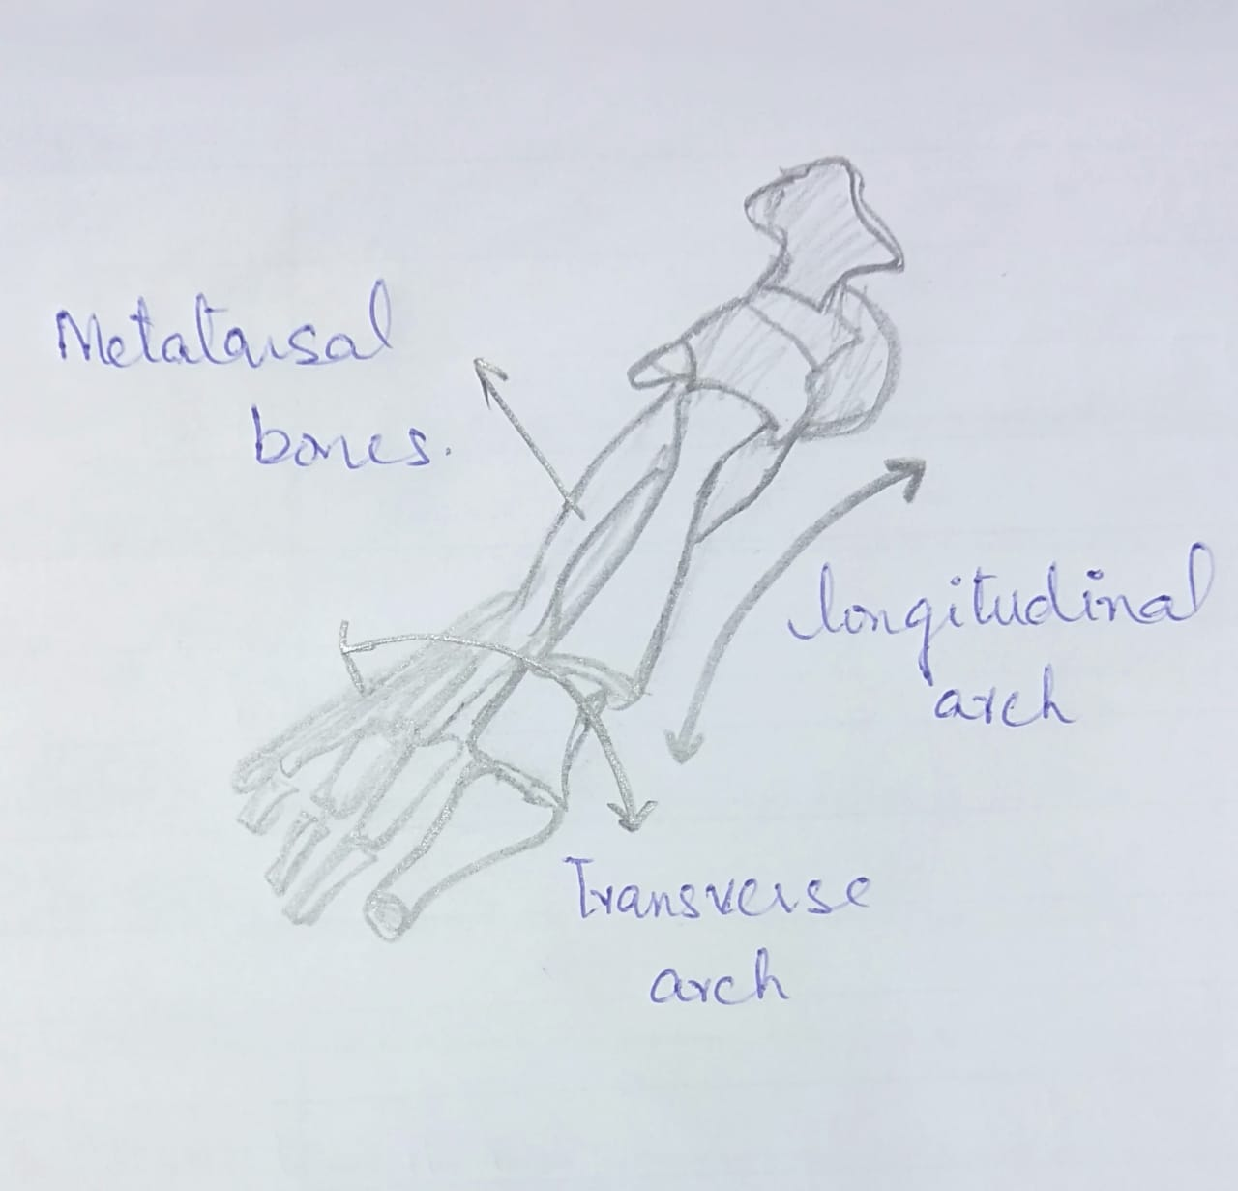
The Arches of the Foot

Q5. Write a note on cerebrum, its lobes and functions. (10)
Answer:
Cerebrum:
- The largest part of brain is consists of right and left hemisphere connected by the corpus callosum.
- Each cerebral hemisphere is composed of different lobes containing frontal lobe, temporal lobe, parietal lobe and occipital lobe.
- A deep structure is embedded in cerebrum is the basal ganglia.
- The principal and most anterior part of the brain in human being is located in the front area of the skull and consisting of two hemispheres, left and right, separated by a fissure. It is responsible for the integration of complex sensory and neural functions and the initiation and coordination of voluntary activity in the body.
Frontal Lobe of Brain:
- The frontal lobe is the largest lobe of our brain.
- Its name is indicates to present at front in the cranium/skull.
- It is also the part of the Brain’s cerebral cortex. Individually, the paired lobes are known as the left and right frontal cortex.
Functions of Frontal Lobe:
- The frontal lobe mainly affects our personality, responsible for judgement, Social behavior, abstract reasoning, social behavior, judgement, language expression (Broca’s Area) and motor movement (voluntary movements refer to those movements which are control directly/under control of brain in our body).
Temporal Lobe of Brain:
- The temporal lobe is one of the four major lobes of the cerebral cortex in the brain of mammals.
- It is located beneath the lateral fissure on the both cerebral hemispheres of the mammalian brain.
Functions of Temporal Lobe:
- This is a part of cerebrum controls the hearing, language comprehension, storage and recall of memories.
- The limbic System (it controls emotions) is deeply located in the temporal lobe is consists of three parts:
Hypothalamus: It controls pituitary glands that lie below it and attached to it. So the hypothalamus, with the help of pituitary gland, controls body metabolism, body temperature, hunger, thirst (water balance), sleep, menstrual cycle, etc.
Amygdala: it controls the sensation of pleasure, sexual responses, fear, anger, etc.
Hippocampus: it deals with the formation of long term memories, so important for learning.
Wernicke’s area: it controls the language comprehension (understanding).
Parietal Lobe of Brain:
- The parietal lobe is one of the four major lobes of the cerebral cortex in the brain of human being.
- The parietal lobe is positioned above the temporal lobe and behind the frontal lobe and central sulcus.
Functions Parietal Lobe:
- Parietal lobe is the principal center for the reception and interpretation of sensation.
- This part of brain/cerebrum interprets and integrates the sensory inputs like touch temperature and pain.
- It is also interprets size, shape distance and texture.
Occipital lobe of Bran:
- The occipital lobe is one of the four major lobes of the cerebral cortex in the brain of human-being.
- The two occipital lobes are the smallest of four paired lobes in the human brain. Located in the rearmost portion of the skull, the occipital lobes are part of the posterior cerebrum. The lobes of the brain are named from the overlying bone and the occipital bone overlies the occipital lobes.
- The occipital lobe is the smallest of the four lobes of the cerebral hemisphere.
Functions of Occipital Lobe:
- The main function of occipital lobe of brain/cerebrum is to interpret visual stimuli.
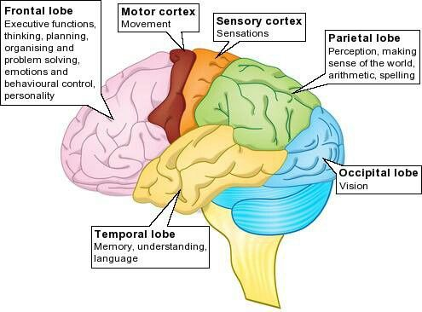
Lobes of Brain
THE END

