Name: Usama Jamal
ID: 12573
Final term Assignment
Subject: Basic electronic
Instructor: M Khalid Hamid
Date: 25/06/2020

Q1a. An unloaded zener regulator has a source voltage of 24 V, a series resistance of 470 Ω, and a zener voltage of 15 V. What is the zener current?
ANS: let Consider Zener current formula
= (Source Voltage)-(Zener Voltage)
Resistance
= 24-15
470
= 9
470
Zener Current =0.01914 ANSWER
b. If the zener diode is disconnected in the following figure, what is the load voltage?

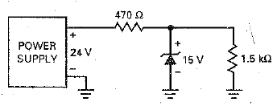

ANS: Given
V3=24v
V2=15v
Rs=470 ohm
Rl=1.5k ohm
Vl=(Rl/(Rs+Rl))Vs (Voltage Divider Formula)
Vl=[1.5 k ohm/(470 ohm+1.5k ohm)]24v
Vl=18.27v
The load voltage is 18.27v

Q2: Draw a set of collector curves for BJT Transistor. Then using these curves show where the four operating regions of a transistor are located?

ANS: 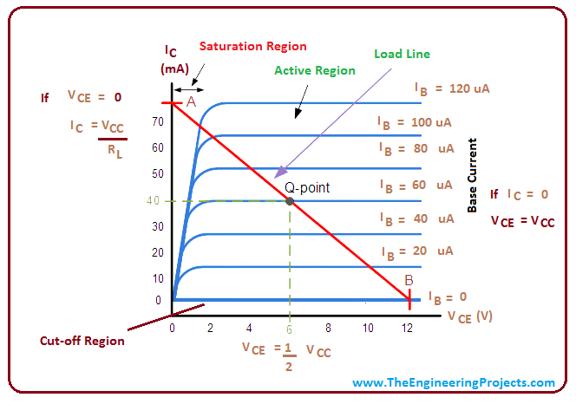
- Active region:

The curves would ideally be horizontal straight lines, indicating that the collector behaves as a constant current source independent of the collector voltage

- Saturation region:

Saturation region, which is highly nonlinear and is not usable for amplification.

Cut off region:

The cutoff region of operation occurs for base currents near zero. In the cutoff region, the collector current approaches zero in a nonlinear manner and is also avoided for amplification applications.

Q.3 Draw and explain Transistors connected in the following configurations.
- Common emitter
In electronics, a common-emitter amplifier is one of three basic single-stage bipolar-junction-transistor amplifier topologies, typically used as the voltage amplifier. In this circuit the base terminal of the transistor serves as the input, the collector is the output, and the emitter is common to both, hence its name. The analogous FET circuit is the common-source amplifier, and the analogous tube circuit is the common-cathode amplifier.
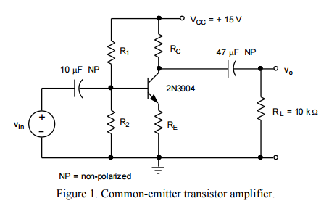

- Common collector
In electronics, a common collector amplifier is one of three basic single-stage bipolar junction transistor amplifier topologies, typically used as a voltage buffer. In this circuit the base terminal of the transistor serves as the input, the emitter is the output, and the collector is common to both, hence its name. The analogous field-effect transistor circuit is the common drain amplifier and the analogous tube circuit is the cathode follower. 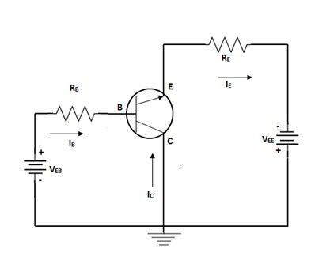

- Common base
In electronics, a common-base (also known as grounded-base) amplifier is one of three basic single-stage bipolar junction transistor (BJT) amplifier topologies, typically used as a current buffer or voltage amplifier.
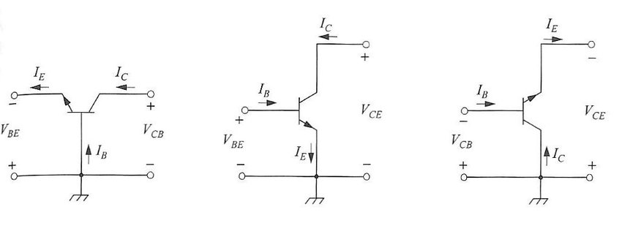

Q4: Draw an E-MOSFET showing the p and n regions, then explain the off and on action?
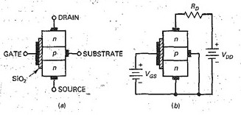

ANS: The depletion-mode MOSFET was part of the evolution toward the enhancement~ mode MOSFET, abbreviated E-MOSFET. Without the E-MOSFET, the personal computers that are now so widespread would not exist.
The Basic Idea
Figure 14-Sa shows an E-MOSFET. The p substrate now extends all the way to the silicosis dioxide. As you can see, there no lolled is an n channel between the source and the drain. How does an E-MOSFET work? Figure 14-8b shows normal biasing polarities. \When the gate voltage is zero, the current between source and drain is zero. For this reason, an E-MOSFET is normally off when the gate voltage is zero. The only way to get Current is with a positive gate voltage. When the gate is positive, it attracts free electrons into the p region. The free electrons recombine with the holes next to the Silicon dioxide. When -_the gate voltage is positive enough, all the holes. touching the silicon dioxide 'are filled and free electrons begin to flow from the source to the drain. The effect is the same as creating a thin layer of n type material next to the silicon dioxide. This thin conducting layer is

Q5:
- List and compare the advantages and disadvantages of BJT and FET amplifiers.
ANS: Advantages of BJT:
They have a better voltage gain
They have a high current density
They have a low forward voltage
It can be operated in low to high power application
BJT has a large gain bandwidth
BJT shows better performance at high frequency

Disadvantages of BJT:
BJT has a low thermal stability
BJT is most effective by radiation
BJT has more noise produced
BJT has a low switching frequency
BJT has a very complex control
The switching time is not very fast compared to a high alternating frequency of current and voltage

Advantages of FETs
They are devices controlled by voltage with a very high input impedance (107 to 1012 ohms)
FETs generate a lower noise level than the Bipolar Junction Transistor (BJT)
FETs are more stable than BJT with temperature
FETs are easier to manufacture than the BJT, because they require fewer steps to be built and they allow more integrated devices in the same IC
FETs behave like resistors controlled by voltage for small drain-source voltage values
The high input impedance of FET allows them to withhold loads long enough to allow its usage as storage elements
Power FETs can dissipate higher power and can switch very large currents

Disadvantages of FETs
FETs have a poor frequency response due to its high input capacitance
FETs have a very poor linearity, and generally they are less linear than Bipolar Junction Transistor
FETs can be damaged due to the static electricity

b. Explain what happens when drain current starts to increase through a power FET.
ANS: The EMOSFET in high power applications is called power FET. When the current increases through FET power it reaches the saturation current ld(sat)· Beyond this point, the device is biased in the holmic region. Therefore, ld cannot increase, even though Vgs increases. To ensure hard saturation, a gate voltage of Vgs(on) well above Vgs(th) is used.

