IQRA NATIONAL UNIVERSITY
Name: Nazish
ID NO: 6861
Degree: BS (SE)
Subject: Data Mining
Lecturer: Sir zain

Q1. Implement a code of Genetic Algorithm in any language and show the output.
import java.util.Random;

//Main class
public class SimpleDemoGA {

Population population = new Population();
Individual fittest;
Individual secondFittest;
int generationCount = 0;

public static void main(String[] args) {

Random rn = new Random();

SimpleDemoGA demo = new SimpleDemoGA();

//Initialize population
demo.population.initializePopulation(10);

//Calculate fitness of each individual
demo.population.calculateFitness();

System.out.println("Generation: " + demo.generationCount + " Fittest: " + demo.population.fittest);

//While population gets an individual with maximum fitness
while (demo.population.fittest < 5) {
++demo.generationCount;

//Do selection
demo.selection();

//Do crossover
demo.crossover();

//Do mutation under a random probability
if (rn.nextInt()%7 < 5) {
demo.mutation();
}

//Add fittest offspring to population
demo.addFittestOffspring();

//Calculate new fitness value
demo.population.calculateFitness();

System.out.println("Generation: " + demo.generationCount + " Fittest: " + demo.population.fittest);
}

System.out.println("\nSolution found in generation " + demo.generationCount);
System.out.println("Fitness: "+demo.population.getFittest().fitness);
System.out.print("Genes: ");
for (int i = 0; i < 5; i++) {
System.out.print(demo.population.getFittest().genes[i]);
}

System.out.println("");

}

//Selection
void selection() {

//Select the most fittest individual
fittest = population.getFittest();

//Select the second most fittest individual
secondFittest = population.getSecondFittest();
}

//Crossover
void crossover() {
Random rn = new Random();

//Select a random crossover point
int crossOverPoint = rn.nextInt(population.individuals[0].geneLength);

//Swap values among parents
for (int i = 0; i < crossOverPoint; i++) {
int temp = fittest.genes[i];
fittest.genes[i] = secondFittest.genes[i];
secondFittest.genes[i] = temp;

}

}

//Mutation
void mutation() {
Random rn = new Random();

//Select a random mutation point
int mutationPoint = rn.nextInt(population.individuals[0].geneLength);

//Flip values at the mutation point
if (fittest.genes[mutationPoint] == 0) {
fittest.genes[mutationPoint] = 1;
} else {
fittest.genes[mutationPoint] = 0;
}

mutationPoint = rn.nextInt(population.individuals[0].geneLength);

if (secondFittest.genes[mutationPoint] == 0) {
secondFittest.genes[mutationPoint] = 1;
} else {
secondFittest.genes[mutationPoint] = 0;
}
}

//Get fittest offspring
Individual getFittestOffspring() {
if (fittest.fitness > secondFittest.fitness) {
return fittest;
}
return secondFittest;
}

//Replace least fittest individual from most fittest offspring
void addFittestOffspring() {

//Update fitness values of offspring
fittest.calcFitness();
secondFittest.calcFitness();

//Get index of least fit individual
int leastFittestIndex = population.getLeastFittestIndex();

//Replace least fittest individual from most fittest offspring
population.individuals[leastFittestIndex] = getFittestOffspring();
}

}

//Individual class
class Individual {

int fitness = 0;
int[] genes = new int[5];
int geneLength = 5;

public Individual() {
Random rn = new Random();

//Set genes randomly for each individual
for (int i = 0; i < genes.length; i++) {
genes[i] = Math.abs(rn.nextInt() % 2);
}

fitness = 0;
}

//Calculate fitness
public void calcFitness() {

fitness = 0;
for (int i = 0; i < 5; i++) {
if (genes[i] == 1) {
++fitness;
}
}
}

}

//Population class
class Population {

int popSize = 10;
Individual[] individuals = new Individual[10];
int fittest = 0;

//Initialize population
public void initializePopulation(int size) {
for (int i = 0; i < individuals.length; i++) {
individuals[i] = new Individual();
}
}

//Get the fittest individual
public Individual getFittest() {
int maxFit = Integer.MIN_VALUE;
int maxFitIndex = 0;
for (int i = 0; i < individuals.length; i++) {
if (maxFit <= individuals[i].fitness) {
maxFit = individuals[i].fitness;
maxFitIndex = i;
}
}
fittest = individuals[maxFitIndex].fitness;
return individuals[maxFitIndex];
}

//Get the second most fittest individual
public Individual getSecondFittest() {
int maxFit1 = 0;
int maxFit2 = 0;
for (int i = 0; i < individuals.length; i++) {
if (individuals[i].fitness > individuals[maxFit1].fitness) {
maxFit2 = maxFit1;
maxFit1 = i;
} else if (individuals[i].fitness > individuals[maxFit2].fitness) {
maxFit2 = i;
}
}
return individuals[maxFit2];
}

//Get index of least fittest individual
public int getLeastFittestIndex() {
int minFitVal = Integer.MAX_VALUE;
int minFitIndex = 0;
for (int i = 0; i < individuals.length; i++) {
if (minFitVal >= individuals[i].fitness) {
minFitVal = individuals[i].fitness;
minFitIndex = i;
}
}
return minFitIndex;
}

//Calculate fitness of each individual
public void calculateFitness() {

for (int i = 0; i < individuals.length; i++) {
individuals[i].calcFitness();
}
getFittest();
}

}
OUTPUT 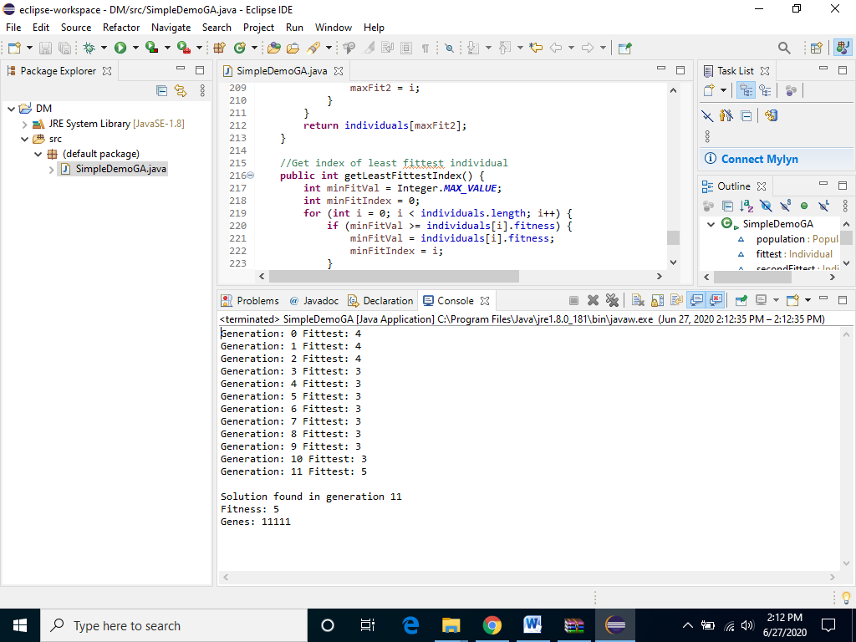

Q2. Implement a code of Fuzzy logic in any language and show the output.
To implement a fuzzy system in C, the following types of data must be accommodated:
- System inputs.
- Input membership functions.
- Antecedent values.
- Rules.
- Rule-output strengths.
- Output membership functions.
- System outputs.
Listing One includes the C-code definition of these data structures:
/*CODE is about General-purpose fuzzy inference engine supporting any number of system
inputs and outputs, membership functions, and rules. Membership functions can
be any shape defineable by 2 points and 2 slopes--trapezoids, triangles,
rectanlges, etc. Rules can have any number of antecedents and outputs, and can
vary from rule to rule. "Min" method is used to compute rule strength, "Max"
for applying rule strengths, "Center-of-Gravity" for defuzzification. This
implementation of Inverted Pendulum control problem has: System Inputs, 2
(pendulum angle and velocity); System Outputs, 1 (force supplied to base of
pendulum); Membership Functions, 7 per system input/output; Rules, 15 (each
with 2 antecedents & 1 output). If more precision is required, integers can
be changed to real numbers.*/

#include <stdio.h>
#define MAXNAME 10 /* max number of characters in names */
#define UPPER_LIMIT 255 /* max number assigned as degree of membership */

/* io_type structure builds a list of system inputs and a list of system
outputs. After initialization, these lists are fixed, except for value field
which is updated on every inference pass. */
struct io_type{
char name[MAXNAME]; /* name of system input/output */
int value; /* value of system input/output */
struct mf_type /* list of membership functions for */
*membership_functions; /* this system input/output */
struct io_type *next; /* pointer to next input/output */
};
/* Membership functions are associated with each system input and output. */
struct mf_type{
char name[MAXNAME]; /* name of membership function (fuzzy set) */
int value; /* degree of membership or output strength */
int point1; /* leftmost x-axis point of mem. function */
int point2; /* rightmost x-axis point of mem. function */
int slope1; /* slope of left side of membership function */
int slope2; /* slope of right side of membership function */
struct mf_type *next; /* pointer to next membership function */
};
/* Each rule has an if side and a then side. Elements making up if side are
pointers to antecedent values inside mf_type structure. Elements making up then
side of rule are pointers to output strength values, also inside mf_type
structure. Each rule structure contains a pointer to next rule in rule base. */
struct rule_element_type{
int *value; /* pointer to antecedent/output strength value */
struct rule_element_type *next; /* next antecedent/output element in rule */
};
struct rule_type{
struct rule_element_type *if_side; /* list of antecedents in rule */
struct rule_element_type *then_side; /* list of outputs in rule */
struct rule_type *next; /* next rule in rule base */
};
struct rule_type *Rule_Base; /* list of all rules in rule base */

Listing Two:
main()
{
initialize_system();
while(1){
get_system_inputs();
fuzzification();
rule_evaluation();
defuzzification();
put_system_outputs();
}
}

Listing Three:
/* Fuzzification--Degree of membership value is calculated for each membership
function of each system input. Values correspond to antecedents in rules. */
fuzzification()
{
struct io_type *si; /* system input pointer */
struct mf_type *mf; /* membership function pointer */
for(si=System_Inputs; si != NULL; si=si->next)
for(mf=si->membership_functions; mf != NULL; mf=mf->next)
compute_degree_of_membership(mf,si->value);
}
/* Rule Evaluation--Each rule consists of a list of pointers to antecedents
(if side), list of pointers to outputs (then side), and pointer to next rule
in rule base. When a rule is evaluated, its antecedents are ANDed together,
using a minimum function, to form strength of rule. Then strength is applied
to each of listed rule outputs. If an output has already been assigned a rule
strength, during current inference pass, a maximum function is used to
determine which strength should apply. */
rule_evaluation()
{
struct rule_type *rule;
struct rule_element_type *ip; /* pointer of antecedents (if-parts) */
struct rule_element_type *tp; /* pointer to consequences (then-parts) */
int strength; /* strength of rule currently being evaluated */
for(rule=Rule_Base; rule != NULL; rule=rule->next){
strength = UPPER_LIMIT; /* max rule strength allowed */
/* process if-side of rule to determine strength */
for(ip=rule->if_side; ip != NULL; ip=ip->next)
strength = min(strength,*(ip->value));
/* process then-side of rule to apply strength */
for(tp=rule->then_side; tp != NULL; tp=tp->next)
*(tp->value) = max(strength,*(tp->value));
}
}
/* Defuzzification */
defuzzification()
{
struct io_type *so; /* system output pointer */
struct mf_type *mf; /* output membership function pointer */
int sum_of_products; /* sum of products of area & centroid */
int sum_of_areas; /* sum of shortend trapezoid area */
int area;
int centroid;
/* compute a defuzzified value for each system output */
for(so=System_Outputs; so != NULL; so=so->next){
sum_of_products = 0;
sum_of_areas = 0;
for(mf=so->membership_functions; mf != NULL; mf=mf->next){
area = compute_area_of_trapezoid(mf);
centroid = mf->point1 + (mf->point2 - mf->point1)/2;
sum_of_products += area * centroid;
sum_of_areas += area;
}
so->value = sum_of_products/sum_of_areas; /* weighted average */
}}

Q3. Solve this using KNN.

Answer

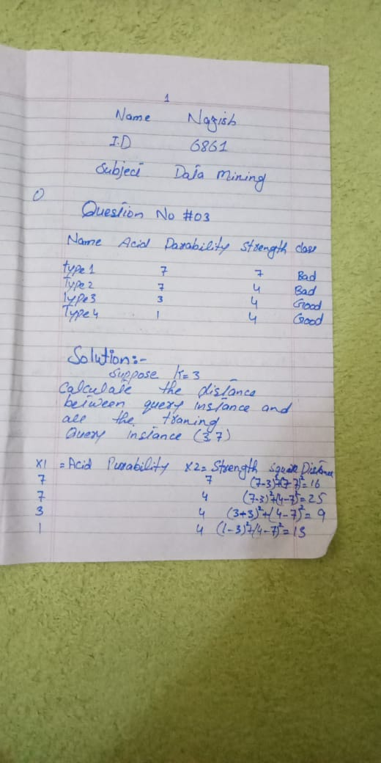
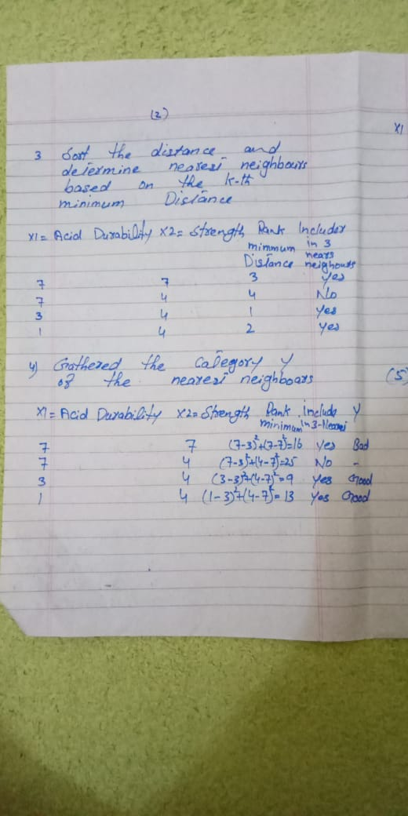

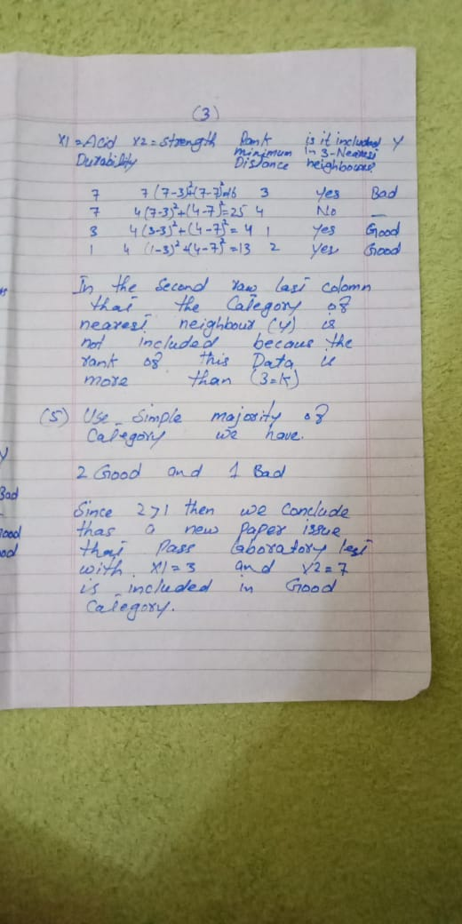
Q4. Give solved example of hierarchical Clustering. (15)
Answer
Objective : For the one dimensional data set {7,10,20,28,35}, perform hierarchical clustering and plot the dendogram to visualize it.
Solution: First, let’s visualize the data.
Observing the plot above, we can intuitively conclude that:
- The first two points (7 and 10) are close to each other and should be in the same cluster
- Also, the last two points (28 and 35) are close to each other and should be in the same cluster
- Cluster of the center point (20) is not easy to conclude
Let’s solve the problem by hand using both the types of agglomerative hierarchical clustering :
- Single Linkage : In single link hierarchical clustering, we merge in each step the two clusters, whose two closest members have the smallest distance.
Using single linkage two clusters are formed :
Cluster 1 : (7,10)
Cluster 2 : (20,28,35)
- Complete Linkage : In complete link hierarchical clustering, we merge in the members of the clusters in each step, which provide the smallest maximum pairwise distance.
Using complete linkage two clusters are formed :
Cluster 1 : (7,10,20)
Cluster 2 : (28,35)
Conclusion : Hierarchical clustering is mostly used when the application requires a hierarchy, e.g creation of a taxonomy. However, they are expensive in terms of their computational and storage requirements

