Assignment No:1
ID: 13579
Name: Taimoor Khan
Subject: Differential Equation

Question 1: Use any of the Methods for solving the Ordinary Differential Equations as given below.
Questions:
12: x²y"- 4xy'+ 6y = 0, y(1) = 0.4, y'(1) = 0
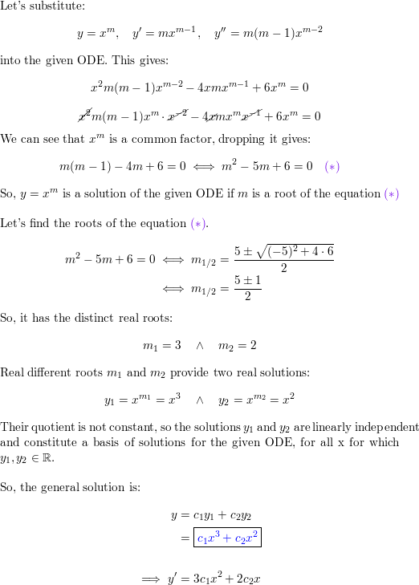
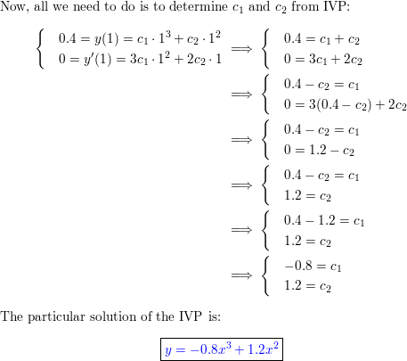

13:
SOLVE:
3(x+6)2y′′+25(x+6)y′−16y=03(x+6)2y″+25(x+6)y′−16y=0
Solution
So, we get the roots from the identical quadratic in this case.
3r(r−1)+25r−16=03r2+22r−16=0(3r−2)(r+8)=0⇒r1=23,r2=−83r(r−1)+25r−16=03r2+22r−16=0(3r−2)(r+8)=0⇒r1=23,r2=−8
The general solution is then,
y(x)=c1|x+6|23+c2|x+6|−8

14:
SOLVE:
We start at the initial value \displaystyle{\left({0},{4}\right)}(0,4) and calculate the value of the derivative at this point. We have:
\displaystyle\frac{{\left.{d}{y}\right.}}{{\left.{d}{x}\right.}}= \sin{{\left({x}+{y}\right)}}-{e}^{x}dxdy​=sin(x+y)−ex
\displaystyle= \sin{{\left({0}+{4}\right)}}-{e}^{0}=sin(0+4)−e0
\displaystyle=-{1.75680249531}=−1.75680249531
We substitute our starting point and the derivative we just found to obtain the next point along.
\displaystyle{y}{\left({x}+{h}\right)}\approx{y}{\left({x}\right)}+{h} f{{\left({x},{y}\right)}}y(x+h)≈y(x)+hf(x,y)
\displaystyle{y}{\left({0.1}\right)}\approx{4}+{0.1}{\left(-{1.75680249531}\right)}y(0.1)≈4+0.1(−1.75680249531)
\displaystyle\approx{3.82431975047}≈3.82431975047

Step 2
Now we need to calculate the value of the derivative at this new point \displaystyle{\left({0.1},{3.82431975047}\right)}(0.1,3.82431975047). We have:
\displaystyle\frac{{\left.{d}{y}\right.}}{{\left.{d}{x}\right.}}= \sin{{\left({x}+{y}\right)}}-{e}^{x}dxdy​=sin(x+y)−ex
\displaystyle= \sin{{\left({0.1}+{3.82431975047}\right)}}=sin(0.1+3.82431975047) \displaystyle-{e}^{0.1}−e0.1
\displaystyle=-{1.8103864498}=−1.8103864498
Once again, we substitute our current point and the derivative we just found to obtain the next point along.

18: (9x²D² + 3xD + I)y = 0, y(1)=1, y'(1) = 0
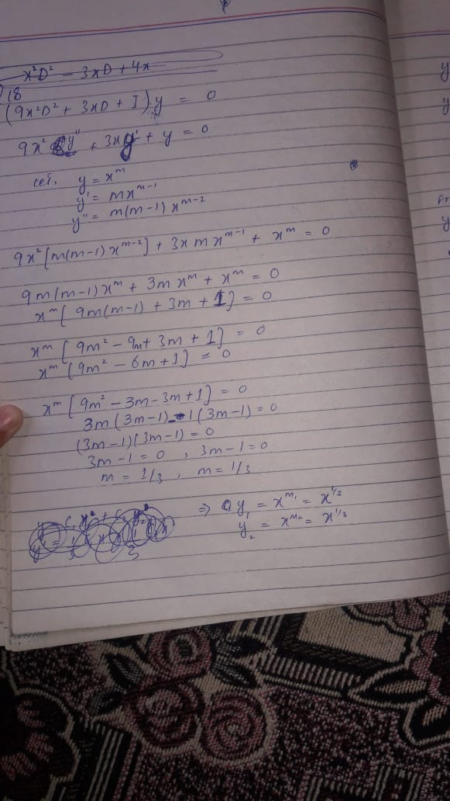
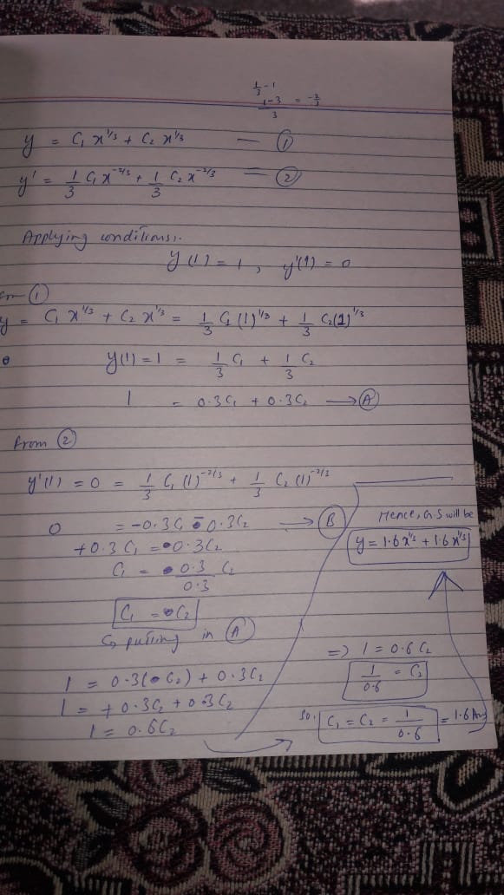

19: (x²D² - xD- 15I)y = 0, y(1) = 0.1, 