Name :Muhammad .Wali
  - I’d : 15881
DEPARTMENT : MEDICAL LAB TECHNOLOGY
SAMESTER : 2nd
SECTION : B
PAPER : ISLAMYAT
DATE : MONDAY , JUNE , 22, 2020
FATHER NAME : Said WALI
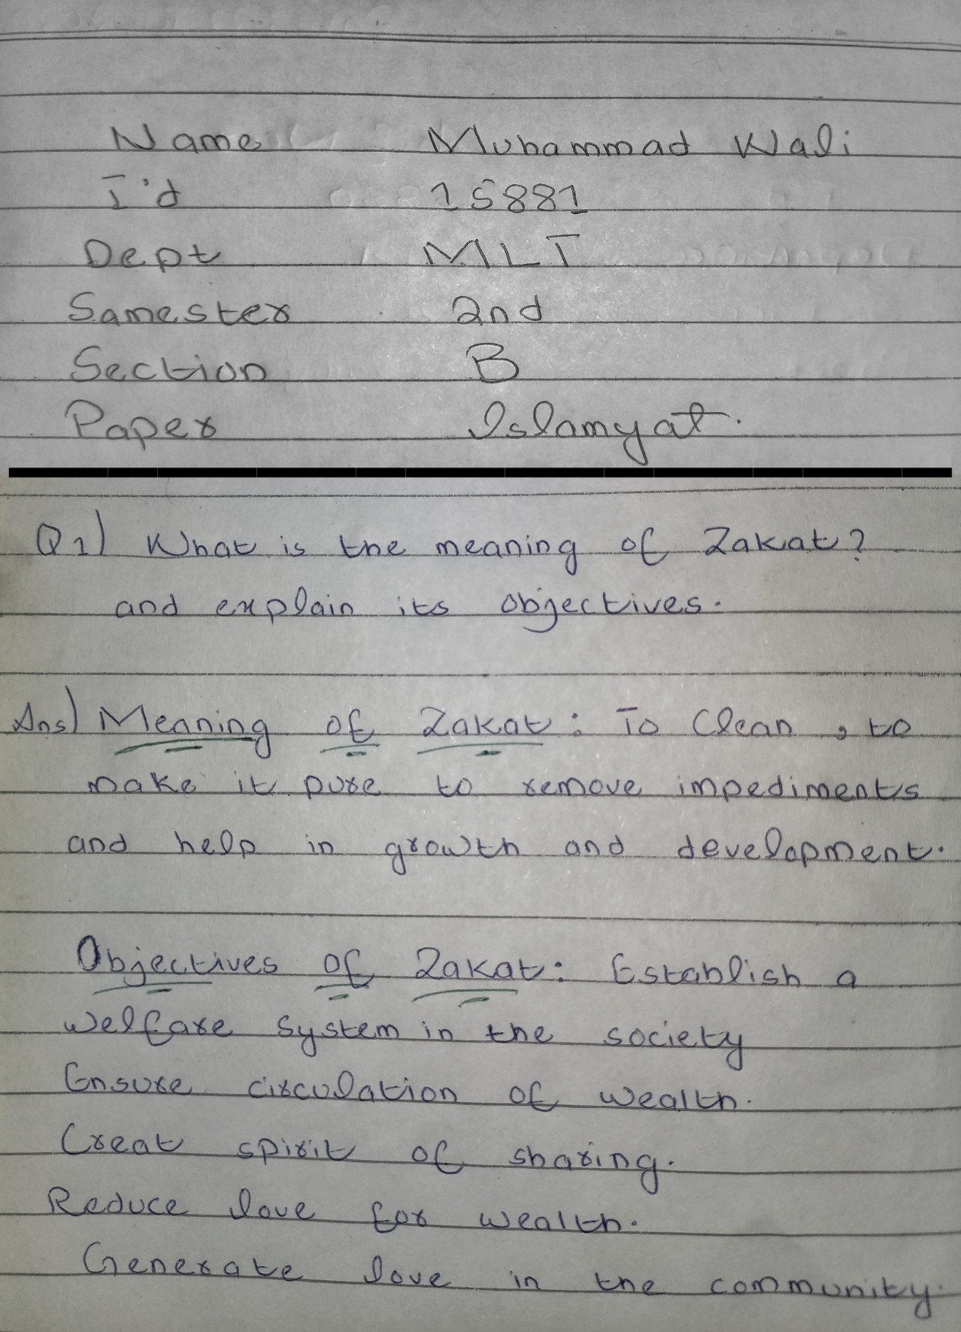
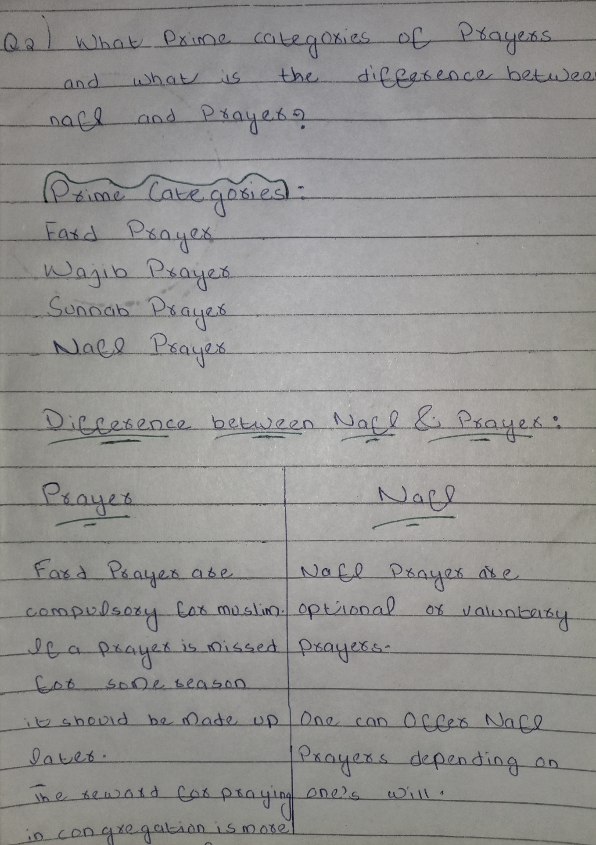
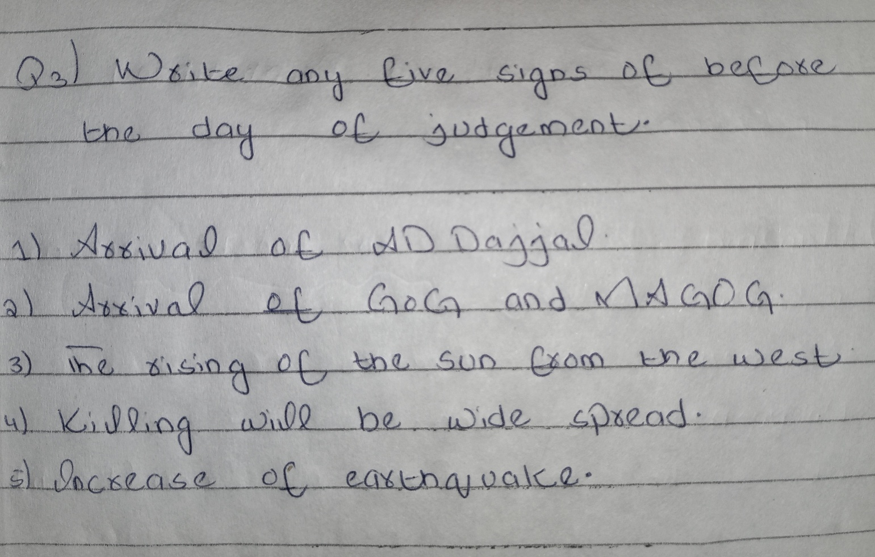

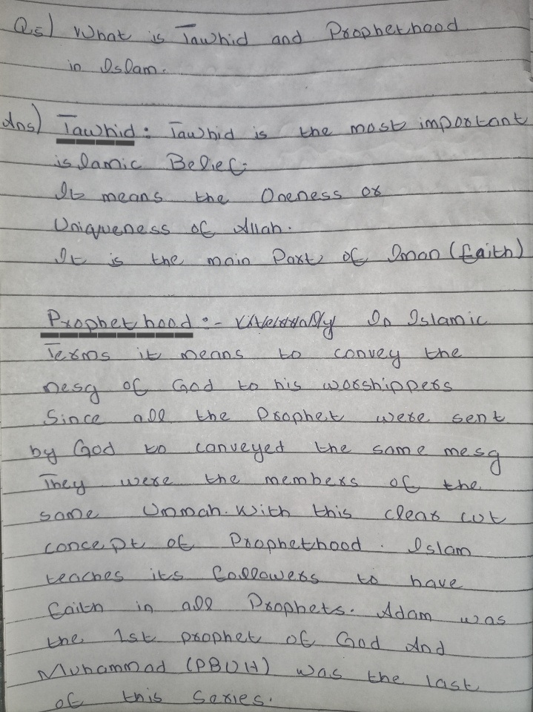
t

