I’D: 16777
NAME:Arshad khan
Pepar: surveying
Submitted to: mam humaira
Q(4):
Ans:
- classification of leveling.
• Differential leveling
It is the operation of leveling to determine the elevation of points some
distance apart or to establish B.M. the process is same as that in
continuous or compound leveling.
• Check leveling
It is the operation of running levels for the purpose of checking a series of
levels, which have been previously fixed.
• Profile Leveling
It is the operation in which the object is to determine the elevation of
points at known distance apart along a given line ,also called longitudinal
leveling or Sectioning.
• Cross-sectioning
It is the method of leveling to determine the surface undulations or the
outline of the ground transverse to the given line and on either side of it.
• Reciprocal Leveling
It is the method of leveling in which the difference in elevation
between two points is accurately determined by two sets of
observation, when I is not possible to set up the level midway
between the two points.
• Barometric Leveling
it is the method of leveling in which the altitudes of points are
determined by means of a barometer, which measures the
atmospheric pressure.
• Hypsometric Leveling
It is the method of leveling in which the height of mountains are
found by overseeing the temperature at which water boils.
- 0bjective of hydrographic surveying.
a) Measurement of tides for sea coasts i.e. construction of the sea
defense work, harbors etc
b) Determination of the bed depth by sounding
• For navigation
• Location of rock, sand bar, buoys, navigation lights etc.
• For location of the under water works , volume of the under water
excavation etc.
• In connection with irrigation & land drainage scheme.
c) Determination of direction of current in connection with
• Location of sewer out fall
• Determination of the area subjected to silt & scour
• For navigation purposes
d) Measurement of quantity of water & flow of water in connection
with water scheme, power scheme etc.
- equipment for making sounding.
1)sounding boat.
• A power boat (steam or motor launch) is most suitable when
wind is blowing & water converts are strong.
• It should be sufficiently roomy & stable . A flat bottom boat is
suitable in quiet water while round bottom boat is convenient
in rough water.
2) Sounding Rods
• Sounding rod are convenient in shallow & smooth water up to
depth of about 4 to 6m (15 to 20 feet) .
• They are made of well season tough timber & are circular in
cross section of 5cm diameter ( 2inch) & usually 3 to 7.5m long
( 12 to 25ft long) , graduated in meter or feet with a metal
shoe at the bottom.
• Direct depth measurements are taken by lowering it vertically
into the water until it hits the bottom & reading the graduation
at the surface.
3) Lead Line
• Lead lines are also called sounding lines are used for depth
over about 6m (20ft). It consists of suitable length of stretchresistance cord or other material to which a heavy lead
weight 5 to 10 lb is attached.
• The cord is marked with feet or meter graduation & there
should be checked frequently against a steel tape, for their
accuracy.
• In use the weight is lowered into the water being careful to
keep the cord vertical. The graduation at the surface is read
when the weight hits bottom.
4) Sounding chain
• For regular sounding a brass chain is most satisfactory since its
length is practically constant.
• The links are welded . the brass tags are attached at 0.2m
interval but leather or cloth tags are preferred as the brass
tags can injure the hands of the lead man .
5) Signals
• Shore signals are required to mark the ranges i.e, lines along
which sounding are to taken and the reference points to which
angular observations are to be taken from the boat.
• They should be clearly visible for considerable distances. If the
water is shallow, ordinary pole signal may be used but if water
deep buoys are used as signals.
6) Ranges
• The lines on which sounding are taken are called ranges or range
lines.
• They are laid on the shore parallel to each other and at right
angles to the shore line or radiating form a prom nay natural
object when the shore line is very irregular.
• Each range line should be marked by means of signals erected at
2 points it, at considerable distance apart.
• The spacing of range lines vary form 6m 30m (20 to 100ft)
depending upon the object of survey and the nature of the
bottom.
7) Fathometer
• For ocean sounding an instrument known as fathometer is
used.
• It is electric device and measure the time required for the
sound (impulses) travel to the bottom of water and back.
• The travel time is converted into depth displayed in either
digital or graphic for fathometer is also called echo sounder.
8) Sextant
• The theodolite and other instrument used in land surveys are
not used in a boat where the support is unstable. The sextant is
well suited to hydro graphic work and has the added
advantage of measuring angles in any plane.
• It is the most precise hand instrument yet device for measuring
angles.
10) Sounding Machine
• It is very useful when much sounding is to be done.
• The type commonly used in hand driven & consists of a paino
wire carrying a 7 kg load & wound around a drum .
• Two dials , the outer one indicated the depth in m or ft & an
inner one is tenth of a meter.
10) Sounding Lead
• The weight attached to the lead line conical in shape & varies
from 2.5 kg to 12.5 kg depending upon the depth of water &
the strength of the water currents.
• The shallow still water weight equal to 2.5 kg (5 lb)
• Moderate depth upto 10m (40 ft ) weight is equal to 5kg
(10lb).
Q (1): ANS: 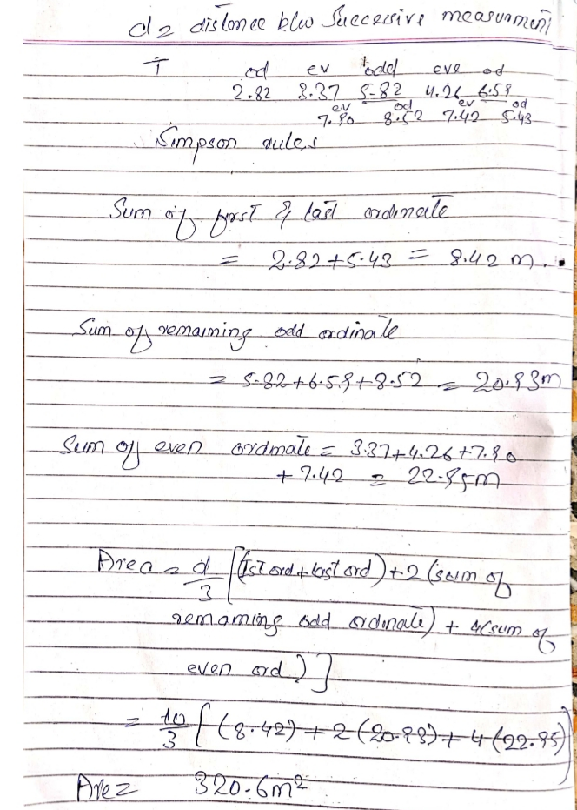
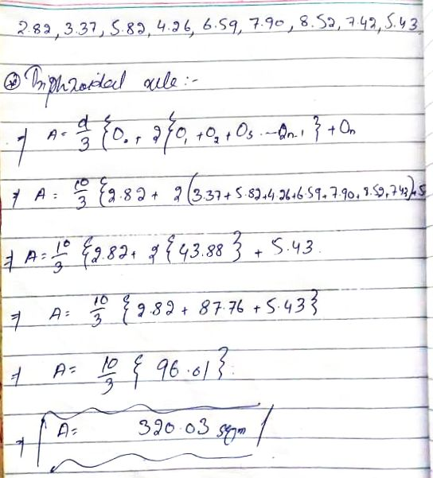

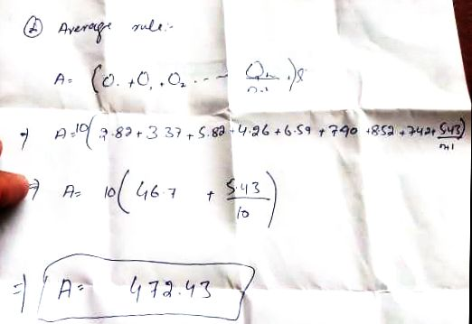

Q (3):
ANS:
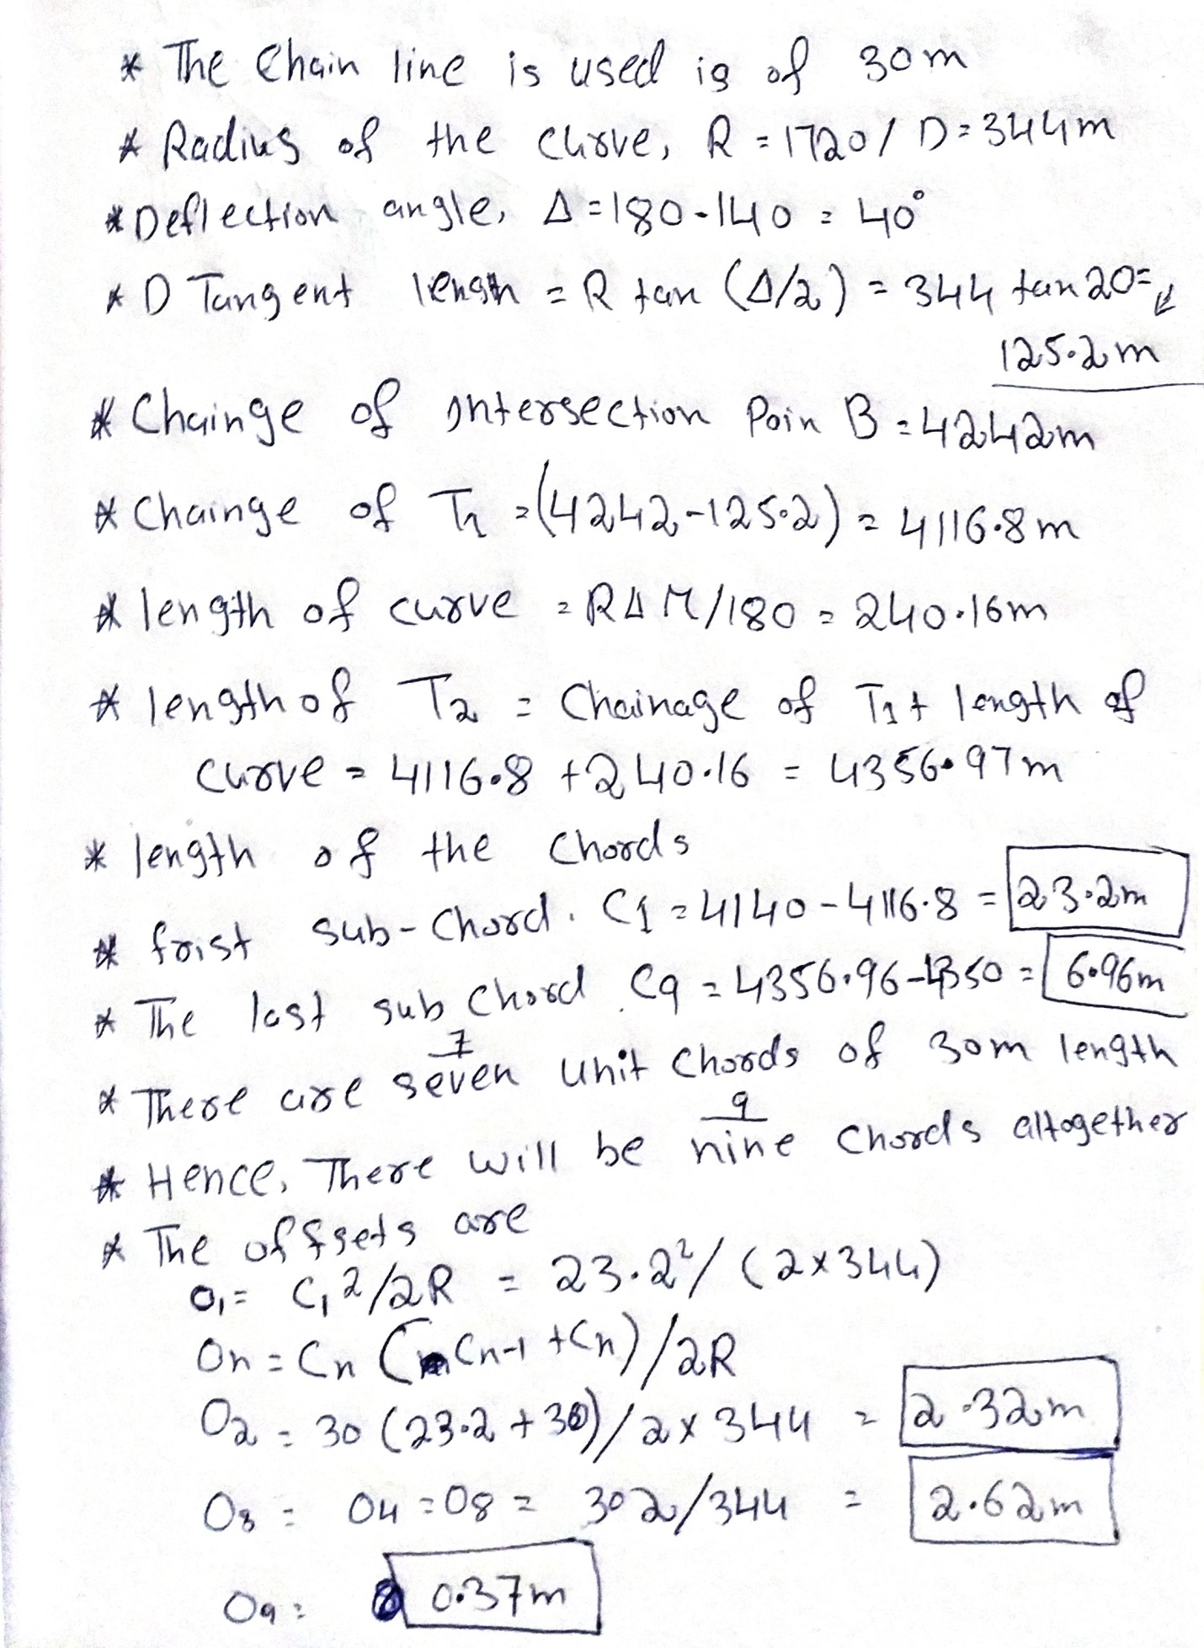
Q (2): ANS….
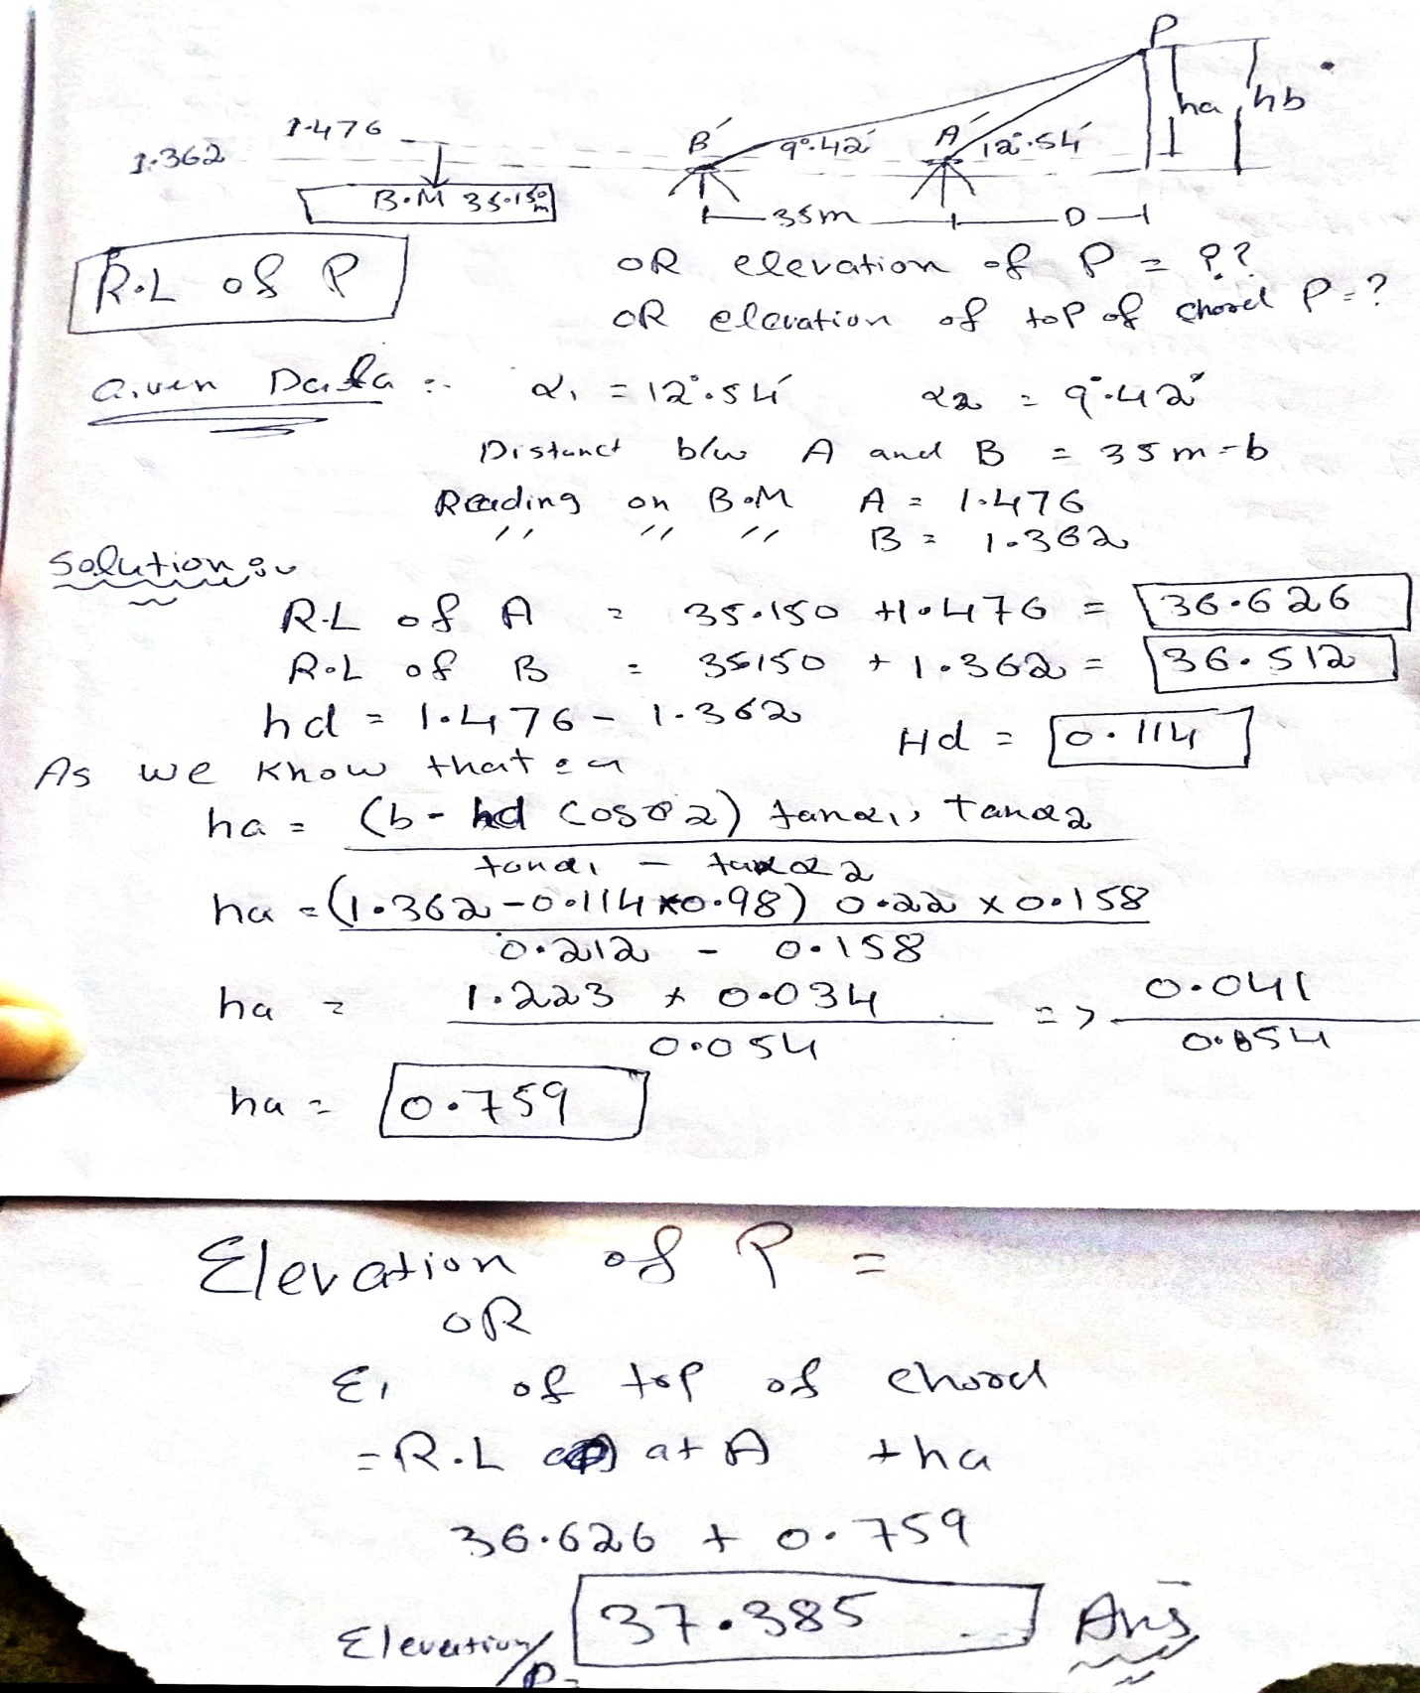
THE END

