IQRA NATIONAL UNIVERSITY
DEPARTMENT OF ALLIED HEALTH SCIENCES
Final-Term Examination
DPT 8th semester
Course Title: Surgery II Instructor: Dr Sara Naeem
Name Hassan jan DPT 8th semester ID # 13385

Q1. Differentiate between communicating and non- communicating hydrocephalus. Give prognosis of hydrocephalus.
Ans Differences between communicating and non-communicating hydrocephalus:
Communicating hydrocephalus:
, also known as nonconstructive hydrocephalus, is caused by impaired CSF reabsorption in the absence of any obstruction of CSF flow between the ventricles and subarachnoid space.
Non communicating hydrocephalus:
No communicating hydrocephalus occurs when CSF flow is obstructed within the ventricular system or in its outlets to the arachnoid space, resulting in impairment of the CSF from the ventricular to the subarachnoid space.
Prognosis:
The prognosis for hydrocephalus depends on the cause, the extent of symptoms and the timeliness of diagnosis and treatment. Some patients show a dramatic improvement with treatment, while others do not. In some instances of normal pressure hydrocephalus, dementia can be reversed by shunt placement.
Q2. Identify population at risk of developing nephrolithiasis. Give surgical management of kidney stones.
Ans: Nephrolithiasis (kidney stones): is a disease affecting the urinary tract. Kidney stones are small deposits that build up in the kidneys, made of calcium, phosphate and other components of foods. They are a common cause of blood in urine
Risk population of nephrolithiasis:
Factors that increase risk of developing kidney stones include:
- Family or personal history. ...
- Dehydration. ...
- Certain diets. ...
- Obesity. ...
- Digestive diseases and surgery.
Signs and symptoms of kidney stones can include

Surgical management of kidney stone
Surgical approach :
urologist can remove the kidney stone or break it into small pieces with the following treatments:
Shock wave lithotripsy. The doctor can use shock wave lithotripsy NIH external link to blast the kidney stone into small pieces. The smaller pieces of the kidney stone then pass through your urinary tract. A doctor can give you anesthesia NIH external link during this outpatient procedure.
Cystoscopy
ureteroscopy.
During cystoscopy, the doctor uses a cystoscopy to look inside the urethra and bladder to find a stone in your urethra or bladder. During ureteroscopy, the doctor uses a ureter scope, which is longer and thinner than a cystoscope, to see detailed images of the lining of the ureters and kidneys. The doctor inserts the cystoscope or ureteroscope through the urethra to see the rest of the urinary tract. Once the stone is found, the doctor can remove it or break it into smaller pieces. The doctor performs these procedures in the hospital with anesthesia. You can typically go home the same day.
Percutaneous nephrolithotomy. The doctor uses a thin viewing tool, called a nephroscope, to locate and remove the kidney stone. The doctor inserts the tool directly into your kidney through a small cut made in your back. For larger kidney stones, the doctor also may use a laser to break the kidney stones into smaller pieces. The doctor performs percutaneous nephrolithotomy NIH external link in a hospital with anesthesia. You may have to stay in the hospital for several days after the procedure
Q3. Give lab and radiological investigations for intestinal obstruction. what can be possible surgical management of intestinal obstruction.
Ans: Lab investigation :
Complete blood cell (CBC) count: The white blood cell (WBC) count may be elevated with a left shift in simple or strangulated obstructions; increased hematocrit is an indicator of volume state (ie, dehydration) Serum lactate levels: Increased levels are suggestive of dehydration or tissue under perfusion.

Radiological investigation for intestinal obstruction.
Plain X-ray in intestinal obstruction- Plain X-ray remains the primary step in evaluation of bowel obstruction.
Radiographic finding report:
The intussuscepted may form a large, convex, soft-tissue mass in the region of the ascending or transverse colon,.
Surgical management
All obstructions will be treated with IV fluids and electrolyte correction. Occasionally, a nasogastric tube is placed to remove fluid and gas backing up in the upper digestive tract. Medications are used to help with nausea and severe pain. A complete obstruction may require surgery or stenting.
Surgery Approach:
surgery for a Bowel Obstruction. There are several types of surgical procedures used to relieve a bowel obstruction, which is a partial or complete blockage of the intestines. A bowel obstruction can be treated with a surgical resection, stenting, colostomy, removal of adhesions, or revascularization.
Q4. What are the clinical manifestations of subarachnoid hemorrhage. Explain GCS .
Ans: clinical manifistication :
The headache may be accompanied by nausea and/or vomiting from increased ICP and meningeal irritation. Symptoms of meningeal irritation, including nuchal rigidity and pain, back pain, and bilateral leg pain, occur in as many as 80% of patients with SAH but may take several hours to manifest.
Gcs scale
The Glasgow coma scale is used to assess patients in a coma. The initial score correlates with the severity of brain injury and prognosis. The Glasgow Coma Scale provides a score in the range 3-15; patients with scores of 3-8 are usually said to be in a coma
Gcs score:
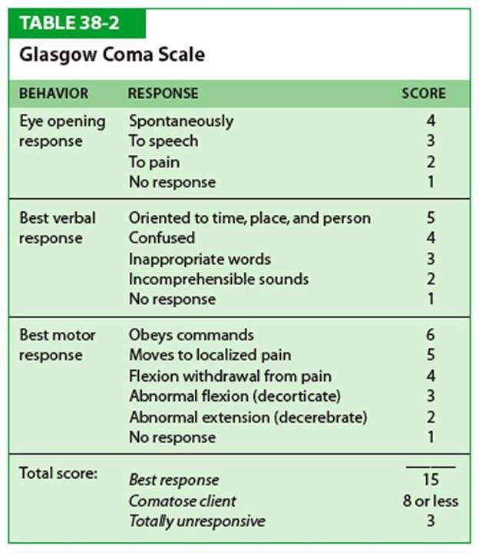

Q5. Enumerate vital clinical signs for confirmation of appendicitis. How can you manage a
patient with acute appendicitis.
Ans :Vital clinical sign of appendicitis
vital signs: BP, 110/70;
- pulse, 106 and regular,
- Respiration 20; and temperature,
- 100° F (37.8° C).
Your physical assessment reveals diminished breath sounds bilaterally and significant tenderness of the right lower abdominal quadrant with rigidity and rebound tenderness.

ManageMENT
- IV FLUID
- ELECTROLYTE BALANCE
- PAIN KILLRER
- ULTRASOUND
- CT SCAN
- APPENDISECTOMY ARE RECOMMENDED IF THE SYMPTOMS ARE NOT REMOVED.

Thank you maam

