RADIOLOGY SEC B PHYSIOLOGY, 2ND SEMESTER
MAM KOUSAR SHAH JEHAN
STUDENT NAME : ZAKAULLAH ID.No. : 16464
Discipline: BS Radiology(Sec B)
Attempt all questions. Every question carry 10 marks.
Q1. Write the functions and composition of blood?
Answer:
Functions Of Blood:
The major functions of blood are;
Transport:
The main function of blood is transport.
Respiration:
Blood transport Oxygen and carbondioxide.
Trophic:
It delivered nutrients materials to the tissues.
Excretion:
It deliveres metabolites from tissues to excretory organs.
Regulation:
It transports biologically active substances and harmones.
Homeostasis:
It maintain water content and acid-base balance.
Protection:
Immunity and non specific resistance.
Blood coagulation.
Maintenance of Body temperature:
Blood plays an important role in maintaining body temperature.
Composition Of Blood:
Blood is composed of:
1.Plasma:
- Liquid part of blood
- Pale yellow made up of;
- 92% water
- mineral ions
- hormones
- CO2
- Glucose
- protiens etc.
2.Formed Elements:
RBCs:
- Biconcave in shape
- 4.2- 6.2 million
- Life span is 100-120 days
WBCs:
- 5000- 9000 million
- Life span is 13-20 days
Platelets:
- 300000 per microlitre of blood.
- Life span is 10 days.

Q2. What is erythrocyte, erythropoiesis, erythrocytosis and erythropenia?
Answer:
Erythrocytes:
2nd Name:
Red blood cells
Development:
Develop in the bone marrow.
Abundance:
Abundant type of blood cells.
Production:
Approximately 2.4 million are produced per second.
More Occurance:
Approximately a quarter of the cells are red blood cells.
Structure:
Mature red blood cells are oval biconcave disks and flexible.
Life span:
Its life span is 100-120 days
Cycle:
Takes 20 seconds to complete one cycle of circulation.
Main Function:
The transport of haemoglobin, which in turn carries oxygen from lungs to the tissues.
Erythropoiesis:
Definition:
It is the process by which red blood cells are produced.
Stimulation:
It is stimulated by decreased O2 in circulation , which is detected by the kidneys, which then secrete the hormone erythropoietin.
Process:
The whole process lasts about 7days.
Rate of Production:
Erythrocytes are produced in the bone marrow at a rate of about 2 million per second in a healthy adult.
Erythrocytosis:
2nd Name:
Also called polychythemia.
Definition:
If the erythrocytes count is more than normal, such state is called erythrocytosis.
It can be;
Physiological:
Due to
- High altitude
- Exercises
Pathological:
Due to
- Bone marrow disorder
- Any cardiovascular or respiratory disease.
Erythropenia:
Definition:
A decrease in the number of erythrocytes.
Physiological:
Due to
- Deficiency of production
- Pregnancy
Pathological:
Due to
- Bone marrow disorder
- Any kidney disease

Q3. What is platelets and write about clotting mechanism and its all steps?
Answer:
Platelets:
2nd Name:
Thrombocytes
Definition:
A component of blood whose function is to react to bleeding from blood vessel injury by clumping, thereby initiating blood clott.
No cell nucleus
Fragments of cytoplasm
Life Span:
10 days
Functions:
- Stop bleeding
- Maintain homeostasis
Clotting mechanism
Clotting Mechanism and Its Steps:
Initiation:
Instantly after an injury to the blood vessel which has damaged the endothilium lining of the vessel.
Mechanism involves;
Adhesion:
- Blood comes into the space under endothelium
- Underlying collagen exposed to circulating platelets.
- Platelets bind with surface receptors of collagen and adhere tightly.
Activation:
- Platelets change shape
- Turn on receptors and secrete chemical messengers to activate and invite additional platelets.
- Activated platelets adhere tightly at injury site.
Aggregation:
- Platelets connect to each other through receptor bridges.
- Platelet plug formed at injury site unless the interruption is physically too large.
Fibrin Deposition:
- Formation of platelet plug will ensure primary hemostasis.
- Now fibrin deposition start and thus started seconday hemostasis.
- Thus fibrin clott formed .
Coagulation:
Definition:
The formation of blood clott.
Stages:
Stage 1:
Platelets attack to the endothelium.
Stage 2:
Platelets start to release fibrin and begin to seal the endothelium.
Stage 3:
The fibrin network traps the RBCs and completely seal the endothelium.
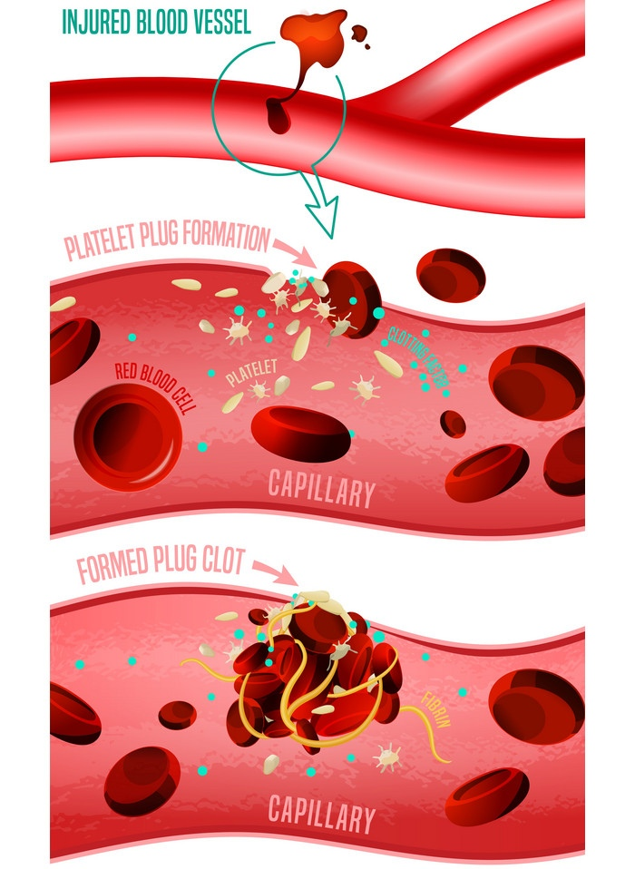
Q4. Write a detail note on ABO system?
Answer:
ABO System:
Average Worlwide:
- O 47%
- A 41%
- B 9%
- AB 3%
Invention:
Invented by Karl Landsteiner
Inherit:
Inherited from parents
Base on A and B antigens- agglutinogens
May have;
- Neither of them
- One of them
- Both of them
Agglutinogens:
On the surface of RBCs
Agglutinins:
In blood plasma
Can cause blood transfusion reactions.
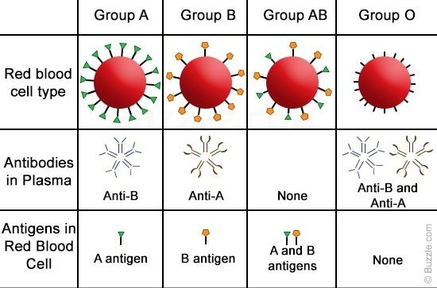
Role Of Blood Groups In Blood Transfusion:
- Blood typing is compulsory in blood transfusion.
- If the blood is not matched the hemolysis occur.
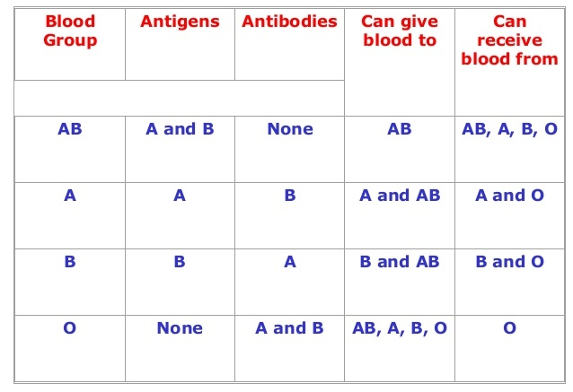
Complications Of Blood transfusion with reference to ABO Incompatibility:
If mismatched blood has transfused then following complications can occur;
- Acute hemolysis
- Jaundice
- Kidney shutdown etc.
Q5.(i) A person fell down from a tree and become unconscious, with bleeding from head, what will you do as a first aid?
Answer:
Opinion:
- If a person fell down from a tree and become unconcious, with bleeding from head so i will take the following steps as a first aid;
- First i will correct his position by laying in safe place e.g bed because of unconciousness his position will not correct.
- As a medical student i have already first aid kit, so for bleeding i will use bandages to stop it blood flowing.
- The i will check his pulse rate and blood pressure.As the patient are in the state of unconciousness so, it could not realize its pain, so then i will took it for more diagnosis to the hospital where its x.ray etc will be done and followed the better medications.
(ii) you have to meet with your friend and you came to know he is covid positive, what precautionary measures will you take?
Answer:
Opinion:
- When i became know that my friend's corona test is positive.So, first of all i will isolate myself in a room and will told the family members not to meet with me till i will do my test and confirmed to be negative.
- Then i will do my test and till the test result i will never go out from my isolation room and will use the mask, specific medications, gloves , separate utensils (disposible) for eating meals.
- Use of dettol while bathing and having keep a sanitizer.
- If the test result became negative then its better and will leave the isolation room and if the test became positive so i will be in my isolation room for at least 14 days and will follow the above precausionary measures as in the daily routine.

The End

