Subject: Human Anatomy II. Zabih Ullah 15834
Class: Radiology, 2nd semester
Section: B
Instructor: Dr. Arooba.
MidTerm Assignment, spring 2020. Marks 30.

Select the best option.

1. A metatarsal bone has the following basic parts:
A. Head, shaft, and tail
B. Head, shaft, and base
C. Head, neck, tubercle, and base
D. Head, neck, tubercle, and tail
2. Sustentaculum tali is located on______ of calcaneum.
A. Medial surface
B. Lateral surface
C. Anterior surface
D. Superior surface
3. Circumduction is the combination of?
A. Flexion, extension, medial rotation, and lateral rotation
B. Flexion, extension, abduction, and adduction
C. Abduction, adduction, medial rotation, and lateral rotation
D. Extension, adduction, medial rotation, and lateral rotation

4. It looks like inverted Y shaped:
A. Iliofemoral ligament
B. Pubofemoral ligament
C. Ischiofemoral ligament
D. Plantar aponeurosis
5. The increase in neck angle with the shaft of the femur is called:
A. Coxa valga
B. Coxa vara
C. Coxa benda
D. Coxa increase
6. The floor of the acetabulum is non-articular called:
A. Acetabular fossa
B. Acetabular margin
C. Acetabular notch
D. Capsule
7. The tubercle separating the tendons of peroneus longus and peroneus brevis is:
A. Anterior tubercle
B. Posterior tubercle
C. Medial tubercle
D. Peroneal tubercle
8. The symphysis pubis is:
A. Primary cartilaginous joint
B. Secondary cartilaginous joint
C. Synovial joint
D. Fibrous joint
9. Which bone does not part in the formation of the knee joint?
A. Femur
B. Tibia
C. Fibula
D. Patella
10. Regarding tibia:
A. Anterior border is subcutaneous
B. Lateral border is subcutaneous
C. Medial border is subcutaneous
D. Medial surface is subcutaneous

Give brief answers to the following questions. Add diagrams/ pictures where needed.
Each question carries 5 marks.

1. Describe the arches of foot. Name the factors responsible for the maintenance of these arches.
Ans:Arches of foot: the foot has three arches. Two longitudinal (medial and lateral)arches and one anterior transverse arche. These arches are formed by the tarasal and metatarsal bones and are supported by the ligaments and tendons and the foot.
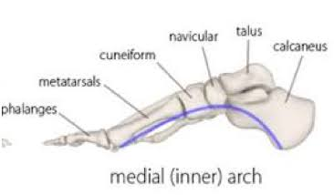
Medial arche:the medial arche is the higher of the two longitudinal arches. It is made of by the calcaneus, the talus, the navicular, the three c uniforms, and the first, second, and third metatarsal.

Lateral arche:the lateral arche is the flatter of the two longitudinal arches, and lies on the ground and the standing position. It is composed of the calcaneous, the cuboid, and the forth and fifth metatarsals.
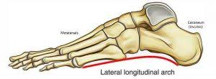

Transverse arches: in addition to longitudinal arches the foot presents a series of transverse arches. The transverse arches is located in the coronal plan of the foot.
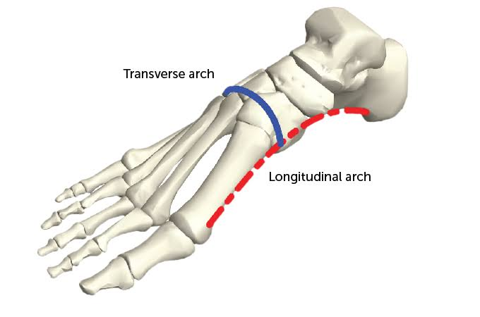

Factor that maintain foot arches: the curvature of the arche is mainly maintained by the fibularis longus, tendons, assisted by the tibialis posterior tendon, which both cross under sole of the foot. The deep taransverse ligaments, the transverse head of the adductor longus and fibularis longus tendon, also help to stabilise this arche.
2. Mention the attachments, nerve supply and actions of the muscle largely responsible for the prominence of buttocks. Which site is safe for the intramuscular injection in this region?
Ans:Attachments :originates from the gluteal, (posterior) surface of ilium, sacrum and coccyx, it slopes across the buttock at a 45 degree angle, then inserts into the iliotibial track and the gluteal tuberosity of the femur.
Action :it is the main extensor of the thigh, and assists with lateral rotation. However, it is only used when force is required, such is running and climbing.
Nerve supply :the superior gluteal nerve(L4, L5, S1) passes through sciatic notch above the piriformis muscle. It supplies the gluteus medius and minimus and tensor fasciae latae muscle. The inferior gluteal nerve(L5, S1, S2) supplies the gluteus maximus.
The dorsogluteal muscle of buttocks was the site most commonly selected by health care provides for many years. However, due to the potential for injury to the sciatic nerve, the ventrogluteal is most often used now.
3. How greater and lesser sciatic foramina formed and enlist the structures passing through them
Ans:the greater sciatic foramen is an opening (foramen) and the posterior human pelvis. It is formed by the scrotuberous and sacrospinous ligaments. The piriformis muscle passes throgh the foramin and occupies most of its volume.
The lesser sciatic foramen is an opening (foramen) between the pelvis and the back of the thigh. The foramen is formed by the scrotuberous ligament which runs between the scrum and the ischial tuberosity and the sacrospinous ligament which runs between the sacrum and ischial spine.
Structure that passing through greater sciatic foramen
- Superior gluteal nerve
- Superior gluteal vessels
- Inferior gluteal nerve
- Inferior gluteal vessels
- Sciatic nerve
Structures that passing through lesser sciatic foramen
- Tendon of obturator internus
- Nerve of obturator internus
- Internal pudendal vessels
- Pudendal nerve
4. What are hamstring muscles? Give their origin, insertion, nerve supply and action.
Ans: the hamstring are a group of muscles and their tendons at the rear of the upper leg they include the biceps femoris, semitendinosus, and semimembranosus. The hamstring flex the knee joint and extended the thigh to the back side of the body.
- Origin: tuberosity of the ischium, linea aspera
- Insertion :tibia, fibula
- Nerve supply :sciatic nerve(tibial nerve and common fibular nerve)
- Action:the main action is flexion it the knee. It also extends the tigh at the hip, and laterally rotatas at the hip and knee.
