Name Muhammad shoaib
ID numb 16820
In structure Dr Arooba
Assignment for Viva
Question: write a complete note on hip joint.

HIP joint

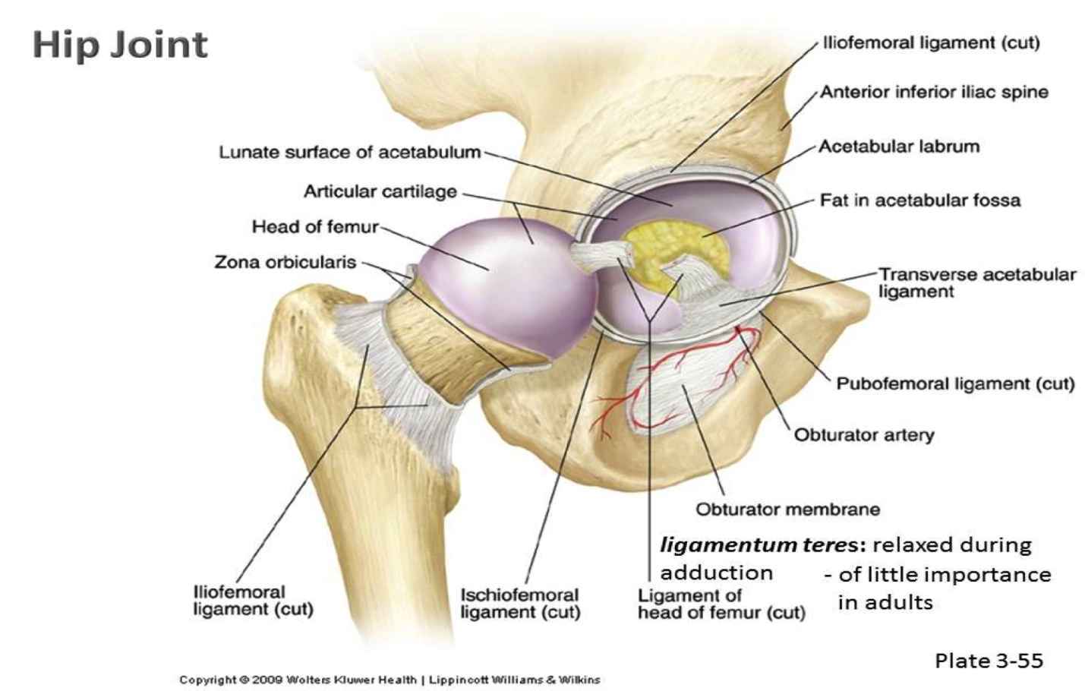
Articulation
It’s the articulation between
  - Hemispherical head of the femur
  - Cup shaped acetabulum of the hip bone
Articular surfaces:
Covered with hyaline cartilage
Articular surface of acetabulum is horseshoe shaped
Deficient inferiorly at acetabular notch
Cavity of acetabulum:
Ddeepened by the presence of fibrocartilaginous rim called acetabular labrum
The labrum bridges across the acetabular notch (transverse acetabular ligament)
Type of joint
- Synovial, ball-and-socket joint
Capsule:
- Encloses the joint
- Attached to acetabular labrum medially
- Laterally attached to intertrochanteric line of femur in front
- Half way along the posterior aspect of neck of the bone behind
Ligaments of Hip joint
- Iliofemoral ligament
- Pubofemoral ligament
- Ischiofemoral ligament
- Ligament of the head of the femur
- Transverse acetabular ligament
Iliofemoral ligament
- Strong, inverted Y shaped ligament
- Base is attached to the anterior inferior iliac spine above
- Below the 2 limbs of Y are attached to upper and lower parts of intertrochanteric line of the femur
- Prevents over extension during standing
Pubofemoral ligament
- Triangular shaped ligament
- Base is attached to superior ramus of pubis
- Apex attached to lower part of intertrochanteric line
- Limits extension and abduction
Ischiofemoral ligament
- Spiral shaped ligament
- Attached to body of ischium near acetabular margin
- Fibers pass upward and laterally and are attached to the greater trochanter
- Function: limits extension
Transverse acetabular ligament
- Formed by acetabula labrum
- It bridges acetabular notch
- Converts the notch into a tunnel through which blood vessels and nerves enter the joint
Synovial membrane of the hip joint
- Lines the capsule
- Attached to the margins of the articular surfaces
- Covers the portion of the neck of the femur that lies within the joint capsule
- Ensheathes ligament of the head of the femur
- Covers the pad of fat contained in the acetabular fossa
- Pouch of the membrane that protudes through a gap in the anterior wall of the capsule between pubofemoral and iliofemoral ligaments forms psoas bursa beneath psoas tendon
Movements of hip joint
- Wide range of movements
- Flexion and extension occur around transverse axis
- Medial and lateral rotation occur around vertical axis
- Abduction and adduction occur around horizontal axis
Flexion:
- Bending of the trunk on extended lower limbs or bending of extended lower limbs on fixed trunk
- Perfomed by iliopsoas, rectus femoris,sartorius and adductor muscles
Extension:
- Backward movement of the flexed thigh
- Perfomed by gluteus maximum and hamstring muscles
Adduction:
- Movement towards the other thigh
- Perfomed by adductor longus, brevis and adductor fibers of adductor magnus
Abduction:
- Movement away from the other thigh
- Perfomed by gluteus medius and minimus, assisted by sartorius, piriformis and tensor fasciae latae
- Lateral rotation:
- Twisting the thigh laterally
- Perfomed by piriformis, obturator internus, externus, superior and inferior gemelli and quadratus femoris
- Medial rotation:
- Twisting the thigh medially
- Perfomed by anterior fibers of gluteus medius, gluteus minimus and tensor fasciae latae
- Circumduction
- Combination of the previous movements

THAnk you

