IQRA NATIONAL UNIVERSITY
DEPARTMENT OF ALLIED HEALTH SCIENCES
Final-Term Examination (summer)
DPT 2nd semester
Course Title: Biomechanics and Ergonomics Theory Instructor: Mam kousar Shah Jehan
Time: 4hrs Max Marks:50
Submitted By: Saqlain khan
I-D Number: 15309
Instructor: Mam Kouar Shah Jehan
Q1. write a note on biomechanics of shoulder joint?
Q2.what do you know about carpel tunnel syndrome?explain in detail along with diagram.
Q3. Differenciate between tendinitis and tendonopathy ?
Q4. Differenciate between ligament and tendon ?also write injuries of ligament and tendons?
Q5 write a note on medial and ulnar nerve injury along with diagram?

Question No 1:
Answer:
Biomechanics of shoulder joint:
Introduction:
The shoulder is composed of 3 Synovial Joints
- Glenohumeral joint (GH)
- Acromioclavicular joint (AC)
- Sternoclavicular joint ( SC)
- The scapulothoracic joint also functions as joints in the shoulder complex.SC joint connects the components of shoulder joint to the axial skeleton. This puts greater demands on the muscles for securing the shoulder girdle on thorax during static and dynamic conditions (dynamic stabilization).
Components of shoulder complex:
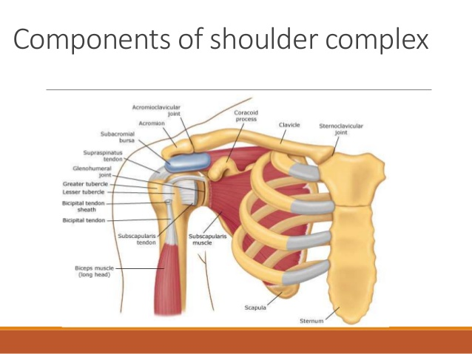
STERNOCLAVICULAR JOINT
- SC joint is a plane synovial joint.
- Movement of the clavicle at the SC joint inevitably produces movement of the scapula under conditions of normal function, because the scapula is attached to the lateral end of the clavicle.
- The SC articulation consists of two saddle-shaped surfaces, one at the sternal or medial end of the clavicle and one at the notch formed by the manubrium of the sternum and first costal cartilage.
Sternoclavicular disc:
- It is a fibro cartilaginous disc to increase the congruency b/w incongruent articular surfaces. The disc diagonally transects the SC joint space and divides the joint into 2 separate cavities.
- The disc is considered part of the manubrium in elevation/depression and thus the upper attachment of the disc serves as pivot point and the disc acts as the part of the clavicle in protraction/ retraction with lower attachment serving as pivot point.
Sternoclavicular joint capsule and ligaments:
SC joint is supported by fibrous capsule 3 ligaments.
- Sternoclavicular ligament ANTERIOR and POSTERIOR
- Costoclavicular ligament ANTERIOR LAMINA POSTERIOR LAMINA
- Interclavicular ligaments
Sternoclavicular motions:
3 rotatory degrees of freedom
- Elevation/depression
- Protraction/retraction
- Anterior/posterior rotation of clavicle
3 degrees of translatory motion at the SC joint (very small in magnitude):
- Anterior/posterior
- Medial/lateral
- Superior/inferior
Elevation/depression of clavicle
- Clavicular elevation = up to 48 degrees
- Clavicular depression= less than 15 degrees
Protraction/retraction of clavicle
- protraction= 15-20 degrees
- Retraction= 20-30 degrees
Anterior and Posterior Rotation of the Clavicle
- Posterior rotation= 50 degrees
- Anterior rotation= less than 10 degrees
Acromioclavicular Joint:
- Plane synovial joint 3 rotational and 3 translational degrees of freedom .The primary function of the AC joint is to allow the scapula additional range of rotation on the thorax and allow for adjustments of the scapula outside the initial plane of the scapula in order to follow the changing shape of the thorax as arm movement occurs.
- In addition, the joint allows transmission of forces from the upper extremity to the clavicle.
AC articulating surface
AC joint Capsule and ligaments
- Superior acromioclavicular ligament
- Inferior acromioclavicular ligament
- Coracoclavicular ligament TRAPEZOID (LATERAL) CONOID (MEDIAL)
AC motions:
3 rotatory motions
- Internal/external rotation.
- Anterior and posterior tipping
- Upward and downward rotation
3 translatory motions
- Anterior/posterior
- Medial/lateral
- Superior/inferior
GLENO-HUMERAL JOINT:
GH ARTICULATING SURFACE
Scapula:
- Glenoid fossa is facing upwards and 6-7 degrees retroverted. The radius of curvature of the fossa is increased by articular cartilage that is thinner in the middle and thicker on the periphery, which improves congruence with the much larger radius of curvature of the humeral head.
Humerus:
- The head faces medially, superiorly, and posteriorly with regard to the shaft of the humerus. ANGLES: 1. Angle of inclination=130-150 degrees 2. Angle of torsion=30 degrees posteriorly
GLENOID LABRUM
- Enhance the depth or curvature of the fossa by 50%. It is a redundant fold of dense fibrous connective tissue with little fibrocartilage.
- It is attached to glenohumeral ligament.
GH ligaments
- Superior GH ligament
- Middle GH ligament
- Inferior GH ligament
- Coracohumeral ligament
Function of GH ligament:
- Limits ant and inf translation in arm at 0 degrees of abduction Superior GH Ligament
- Limits anterior translation at arm 45 degrees abduction Middle GH Ligament
- Limits ant translation beyond 45 degrees abduction + external rotation Anterior band of IGHLC
- Limits posterior translation with arm 45 degrees abd+ internal rotation Posterior band of IGHLC
Glenohumeral motions:
- MOTIONS ROM available Flexion 120 Extension 50 Abduction 90-120 Adduction External rotation 60 degrees of combined motions (arm at side) 120 degrees of combined motions ( arm at 90 degrees abducted).
Muscles noted previously can be divided into functional groups
Flexion:
- Pectoralis major
- Biceps brachii
- Anterior deltoid
Extension:
- Posterior deltoid
- Teres major
- Latissimus dorsi
Abductors:
- Deltoid
- Supraspinatus
- Trapezius,
- Serratus anterior.
Adduction
- Subscapularis
- Infraspinatus
- Teres minor
- Pectoralis
- Latissimus dorsi
- Teres major
Internal rotation:
- Subscapularis
- latissimus dorsi
- Anterior fiber of the deltoid
- Pectoralis major
- Teres major.
External rotators
- Infraspinatus
- Teres minor
- Posterior fibers of the deltoid
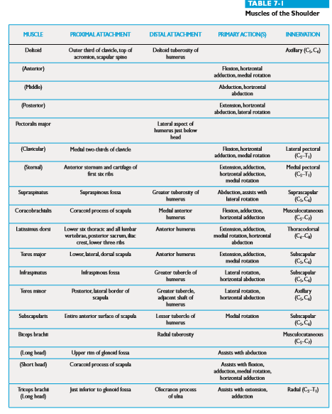
Question No2: what do you know about carpel tunnel syndrome?explain in detail along with diagram.
Answer
Carpal tunnel syndrome:
- Also called median nerve compression, is a condition that causes numbness, tingling, or weakness in your hand.
- It happens because of pressure on your median nerve, which runs the length of your arm, goes through a passage in your wrist called the carpal tunnel, and ends in your hand.
- The median controls the movement and feeling of your thumb and the movement of all your fingers except your pinky.
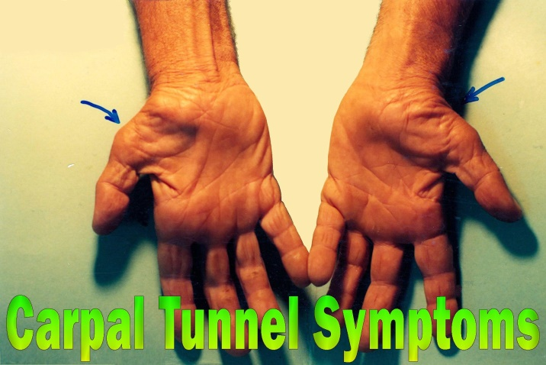
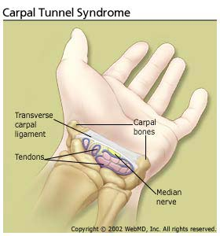

Carpal Tunnel Syndrome Symptoms
Symptoms of carpal tunnel include:
- Burning, tingling, or itching numbness in your palm and thumb or your index and middle fingers
- Weakness in your hand and trouble holding things
- Shock-like feelings that move into your fingers
- Tingling that moves up into your arm.
- In the morning, you may wake up with numbness and tingling in your hands that may run all the way to your shoulder. During the day, your symptoms might flare up while you’re holding something with your wrist bent, like when you’re driving or reading a book.
- Early on in the condition, shaking out your hands might help you feel better. But after some time, it may not make the numbness go away. As carpal tunnel syndrome gets worse, you may have less grip strength because the muscles in your hand shrink. You’ll also have more pain and muscle cramping.
- Median nerve can’t work the way it should because of the irritation or pressure around it. This leads to:
- Slower nerve impulses
- Less feeling in your fingers
- Less strength and coordination, especially the ability to use your thumb to pinch

Carpal Tunnel Syndrome Causes:
- Often, people don't know what brought on their carpal tunnel syndrome. It can be due to:
- Repetitive motions, like typing, or any wrist movements that you do over and over. This is especially true of things you do when your hands are lower than your wrists.
- Conditions like hypothyroidism, obesity, rheumatoid arthritis, and diabetes
- Pregnancy

Carpal Tunnel Syndrome Diagnosis and Tests:
Doctor may tap the palm side of your wrist, a test called Tinel sign, or fully flex your wrist with your arms extended. They might also do tests including:
- Imaging tests. X-rays, ultrasounds, or MRI exams can doctor look at your bones and tissues.
- Electromyogram doctor puts a thin electrode into a muscle to measure its electrical activity.
- Nerve conduction studies. Doctor tapes electrodes to your skin to measure the signals in the nerves of your hand and arm.
Prevention:
- Keep your wrist straight
- Use a splint or brace that helps keep your wrist in a natural position.
- Avoid flexing and extending your wrist over and over again.
- Keep your hands warm
- Take Break whenever you can.
- Put your hands and wrist in the right position while you work.

Carpal Tunnel Syndrome Treatment:
Your treatment will depend on your symptoms and how far your condition has progressed. You might need:
- Lifestyle changes. If repetitive motion is causing your symptoms, take breaks more often or do a bit less of the activity that’s causing you pain.
- Exercises. Stretching
- Immobilization. Doctor may tell you to wear a splint to keep your wrist from moving and to lessen pressure on your nerves..
- Medication. Doctor may give you anti-inflammatory drugs or steroid shots to curb swelling.
- Surgery. If none of those treatments works, you might have an operation called carpal tunnel release that increases the size of the tunnel and eases the pressure on your nerve.
Question No 3: Differenciate between tendinitis and tendonopathy ?
Answer:
Differentiate between tendinitis and tendonopathy:
Tendonitis:
- Once used to describe almost any tendon pain, medical professionals now only use the term tendonitis to describe acute inflammation of the tendon due to small (micro) tears (the suffix it is indicates inflammation). Common symptoms include localized pain, swelling, and warmth.
- Tendonitis may develop as a result of a sudden, acute injury or repeated micro-traumas to a tendon or group of tendons. Recommended treatments to reduce inflammation may include resting the affected joint and taking over-the-counter non-steroidal anti-inflammatory drugs (NSAIDs), such as ibuprofen (e.g. Motrin, Advil), or naproxen (e.g. Aleve, Naprosyn). Patients with tendonitis typically recover within several weeks.
Research suggests tendon inflammation is uncommon, and what is often diagnosed as tendonitis, may actually be tendinosis chronic tendonitis may lead to tendinosis.
- Tendonitis is inflammation of the tendon. Achilles tendonitis tends to be an acute (or quick-onset) condition lasting 6 weeks or less. Some practitioners view this diagnosis as the first in a continuum of tendon injuries that subsequently increase in severity.
Tendinopathy:
- Tendinopathy is inflammation, and later, degeneration of the tendon fibers that insert on the back of the heel bone (calcaneus).
Or
- Tendinopathy is typically used to describe any problem involving a tendon. The suffix “pathy” is derived from Greek and indicates a disease or disorder. Therefore, tendinopathy literally means a disease or disorder of a tendon.
- While most experts define tendinopathy as an umbrella term to describe all tendon conditions, others may use it to describe a chronic tendon condition that fails to heal. For example; a runner who has suffered a repetitive hamstring tendon strain that does not heal properly may be diagnosed with tendinopathy.
- To avoid confusion, patients who are diagnosed with tendinopathy should ask their doctors to specify the details of their tendon injuries.
Question No 4. Differenciate between ligament and tendon ? Also write injuries of ligament and tendons
Answer:
Differentiate between ligament and tendon
Tendons
Connects skeletal muscles to bones
  - Tough and elastic
  - Connects the end of the muscles to bones
  - Each muscle contains only one tendon.
  - Proteoglycan content is low
  - White in color
  - Blood supply is poor
  - Fibroblasts lie in a continuous row
  - The fibers are compact and present in parallel bundles
  - No such classification
Ligaments:
Connects bones to bones
  - Elastic
  - Connects the end of the bones at joints
  - Each joint contains many ligaments
  - Proteoglycan content is comparatively more
  - Yellow in color
  - Blood supply is just as poor
  - Fibroblasts are scattered
  - They are not arranged in parallel bundles but are compactly packed
  - They are classified into three types, namely: Articular ligaments, Remnant ligaments and peritoneal ligaments.
Tendon injuries:
Tendons are the soft tissues that connect muscles to bone and allow joints to move. Overuse activities can cause inflammation of the tendon and this is called tendonitis. Tendons in the upper extremity can also be cut in deep lacerations.
Symptoms of a tendon injury include:
  - A snap or pop you hear or feel.
  - Severe pain.
  - Rapid or immediate bruising.
  - Marked weakness.
  - Inability to use the affected arm or leg.
  - Inability to move the area involved.
  - Inability to bear weight.
  - Deformity of the area.

Ligament injuries:
A sprain is an injury to the ligaments which are soft tissue structures that stabilize a joint. Ligaments are strong, flexible fibers that hold bones together. When a ligament is stretched too far or tears, the joint will become painful and swell. Sprains are caused when a joint is forced to move into an unnatural position. For example, "twisting" one's ankle causes a sprain to the ligaments around the ankle.

Symptoms of ligament injuries:
  - Pain, often sudden and severe.
  - A loud pop or snap during the injury.
  - Swelling within the first 24 hours after the injury.
  - A feeling of looseness in the joint.
  - Inability to put weight on the joint without pain, or any weight at all.

Question No 5: write a note on medial and ulnar nerve injury along with diagram?
Answer:
Ulnar nerve injury:

- Most common postoperative peripheral neuropathy
- Anatomy of the ulnar nerve makes it vulnerable to injury (there is little tissue or fat around the elbow to protect the nerve from external compression)
- Evidence has shown that most perioperative ulnar injuries are not the result of faulty patient positioning.

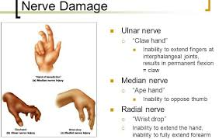

REDUCING THE RISK OF ULNAR NERVE INJURIES:
- Avoid obvious compression by using padded arm boards
- Avoid compressive restraints that exert downward pressure on the elbow
- Assure that surgical personnel do not compress patient’s arm
- Place blood pressure cuff proximally so that it does not impose on ulnar groove or cubital tunnel.
- Avoid prolonged flexion of the elbow.

MEDIAN NERVE INJURIES:
- Lies in close proximity to the medial cubital and basilic veins and may be harmed by venous catheters or extravasation of intravenous drugs.
- Positioning is an unlikely cause of median nerve injuries

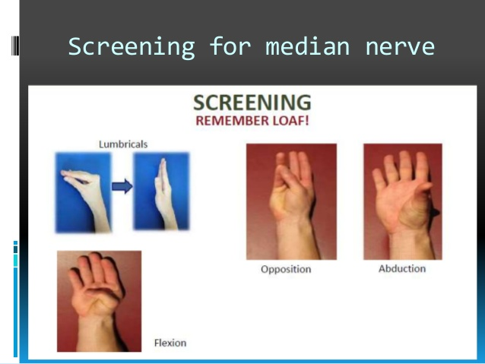

MEDIAN NERVE INJURIES MANIFESTATIONS:
  - Unopposed thumb
  - Inability to oppose the 1st and 5th digits
  - Decreased sensation on the palmer surface of the lateral three and one half fingers

Thank you MAm

