Subject: Human Anatomy II
Instructor: Dr. Arooba.
Class: Dental Technology, 2nd semester
Section: B
MidTerm Assignment, Spring 2020. Total marks: 30.

Select the best option.

1. A muscle known for tailor master:
A. Iliacus
B. Psoas major
C. Sartorius
D. Pectineus

2. Which of the quadricep femoris muscles performs extension as well as flexion?
A. Vastus lateralis
B. Vastus medialis
C. Vastus intermedias
D. Rectus femoris

3. Which of the following muscles crosses two joints?
A. Vastus lateralis
B. Vastus medialis
C. Vastus intermedius
D. Rectus femoris
4. It is the largest and longest bone of the body:
A. Hip bone
B. Femur
C. Vertebra
D. Tibia

5. It is the union of three bones:
A. Sternum
B. Femur
C. Hip bone
D. Tibia
6. The true foot drop occurs because of:
A. Sciatic nerve
B. Common peroneal nerve
C. Tibial nerve
D. Posterior cutaneous nerve
7. Peripheral hearts are located in:
A. Thorax
B. Abdomen
C. Thigh
D. Leg
8. Which of the following structure does not take part in the formation of the knee joint?
A. Condyle of tibia
B. Head of fibula
C. Medial femoral condyle
D. Lateral femoral condyle
9. It is inserted to the quadrate tubercle:
A. Quadriceps femoris
B. Quadratus plantae
C. Quadratus femoris
D. Rectus femoris
10. How many tarsal bones are there?
A. 12
B. 14
C. 16
D. 18

Give brief answers to the following questions. Add diagrams/ picture where needed.
Each question carries 5 marks.

1. GIVE REASONS:
a) Why hip joint is more stable than shoulder joint?
b) Why flexor compartment of lower limb is directed posteriorly?
c) Why varicose veins are more common in prolonged standing working persons?

2. What do you know about the ligaments of hip joint?

3. Write a note on the movements and stability of talocrural joint.
4. Write a note on the transverse arch of the foot.

Q1 :PART NO:(A)
ANSWER: This is because the socket is deeper and the ligaments and muscles much bigger and
Stronger.
As a result we can’t get the same range of movement from our hips as from our
Shoulders but in return the hip is more stable and much less likely to dislocate than the
Shoulders.
The hip is much more constrained or inherently stable than the shoulder.
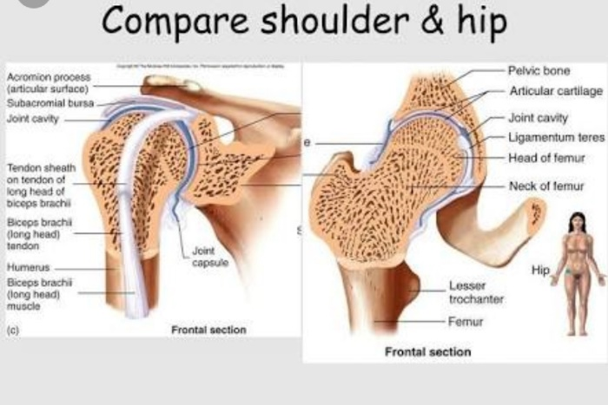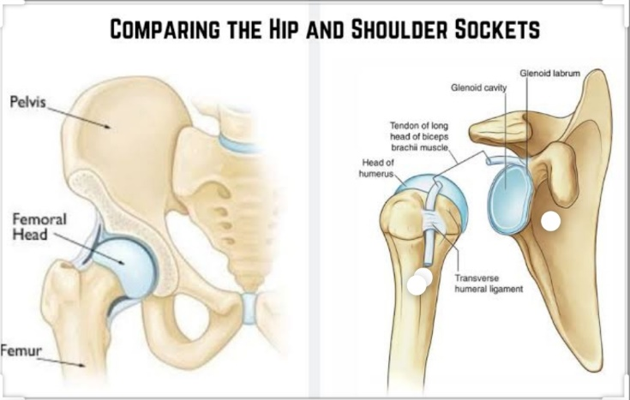
Q1:PART C
ANSWER: Prolonged standing can cause veins to overwork and blood may pool in the leg veins
Increasing pressure in those veins causing the valves to become weak and inefficient
Leading to varicose veins prolonged sitting also causes blood to pool in the legs which
Increases vein pressure and may lead to varicose veins. 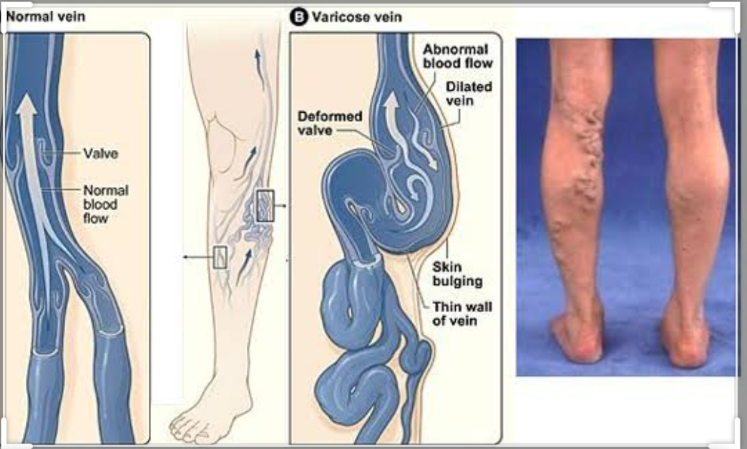
Q1:PART(B)
ANSWER : the flexors compartments of lower limb are both superficial and deep. Deep compartments v are like popliteus, flexor digitorum longus , tabialis posterior, flexor hallius longus. etc while superficial are gastroenemius, plantaris, soleus etc. so these flexors have their specific function like movement and flexion . so they are directed posteriorly to perform their specific
action like planter flexion and dorsi flexion and also do flexion of leg and thigh
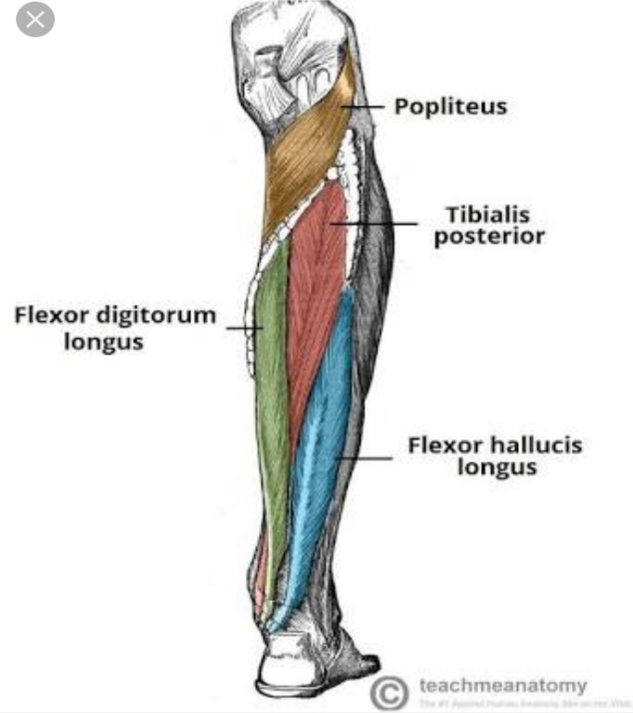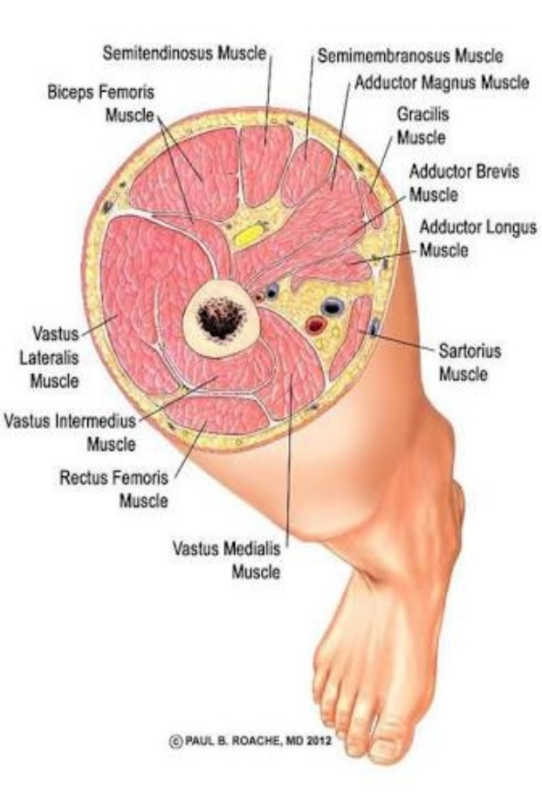
Q2:
ANSWER : The most notable ligaments in the hip joint are .
ILLIOFEMORAL LIGAMENT: which connects the pelvis to the femur at the front of the joint.
It keeps the hip form hyper-extension .
- This is strong inverted Y shaped ligament.
- Prevents over extension during standing.
PUBOFEMORAL LIGAMENT : which attaches the most forword part of the pelvis know as the pubis to the femur.
The
- Triangular shaped ligament
- Base is attached to superior ramus of pubis
- Apex attached to lower part of intertrochanteric line
- Limits extension and abduction
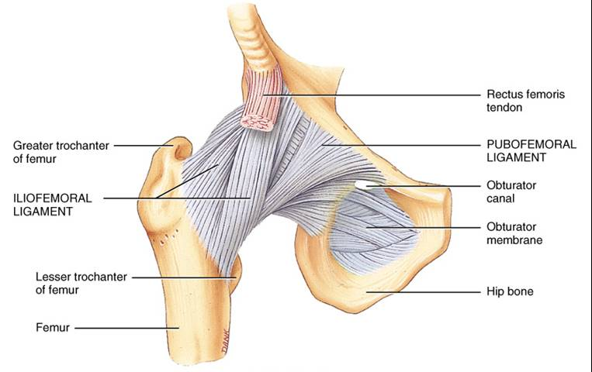

Ischiofemoral ligament
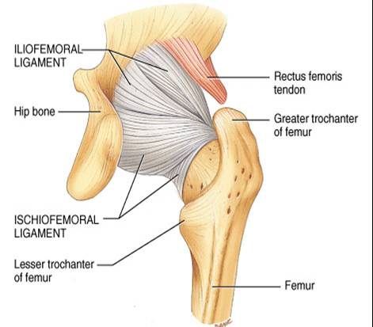
- Spiral shaped ligament
- Attached to body of ischium near
acetabular margin
- Fibers pass upward and laterally and
are attached to the greater trochanter
- Function: limits extension
Transverse acetabular ligament

- Formed by acetebular labrum
- It bridges acetabular notch
- Converts the notch into a tunnel through which blood vessels and
nerves enter the joint
Ligament of the Head of the femur
- FLat and triangular in shape
- Apex is attached to the pit on the head of the femur (fovea capitis)
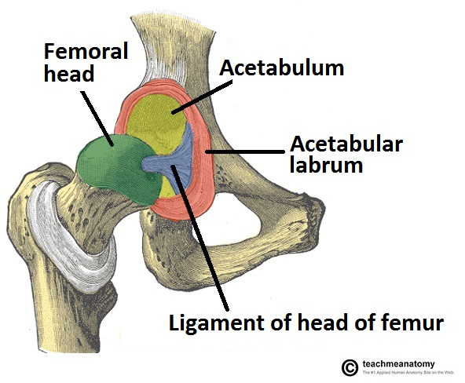
- Base is attached to the transverse ligament and the margins of the
acetabular notch
- Lies within the joint
- covered by synovial membrane

Q3:
ANSWER: stability of talucrural joint: The ankle joint is hinge joint which have great
stability. The deep mortise formed the lower end of tibia and medial and lateral malleoli of tibia also hold the talus bone more fixed in its position . Alos the geometry of talucrural joint with its oblique rotation of talus causes that when the talus is moved in V large anterior position, the joint was more unstable in planter flexion.
- Movement of talucrural joint: The movements of talucrural joint included are the dorsiflexion and planter flexion of the foot.
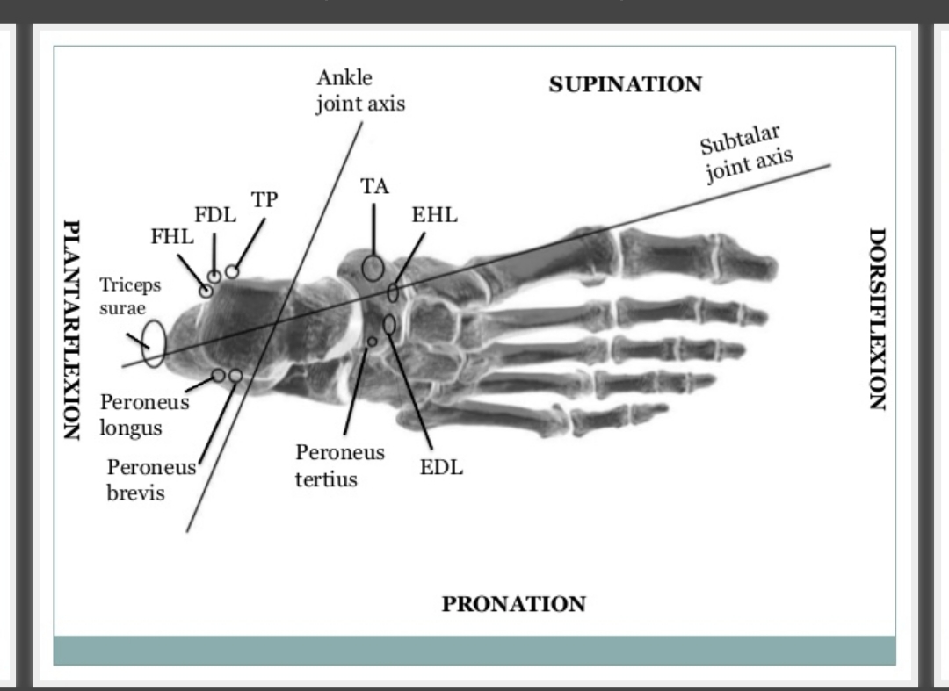
Q4:
ANSWER: The transverse arch is located in the coronal plan of the foot it is
Formed by the metatarsal bases the cuboid and the three cuneiform
Bones it has.
- Muscular support : fibularis longus and tibialis posterior.
- Ligamentous support : plantar ligaments(in particular the long plantar, short plantar and plantar calcaneonavicular ligaments) and deep transverse metatarsal ligaments.
- Other support : plantar aponeurosis.
- Bony support : the wedged shaped of the bones of the arch.
FUNCTION :
The arches of the foot, formed by the tarsal and metatarsal bones, strengthened by ligaments and tendons, allow the foot to support the weight of the body in the erectposture with the least weight.
The are categorized as longitudinal and transverse arches.

