DPT IV
Biochemistry
Final term
Name: Aftab ahmad
ID: 15096
Marks 50
Attempt the following questions each carries equal marks
- Write brief note on steroid hormone?

A1. Steroid:
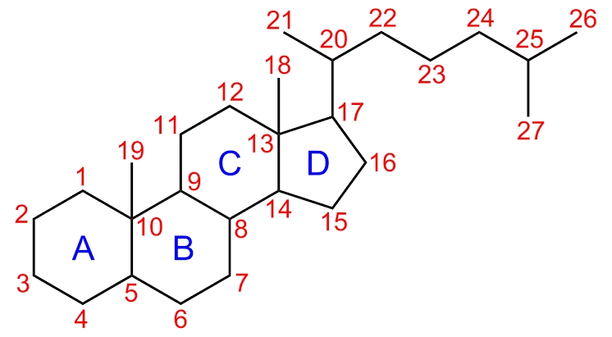
A steroid is an organic compound with four rings arranged in a specific molecular configuration.

Steroid hormones:
A steroid that act as a hormone is known as steroid hormone.

Classes of steroid hormones:
Steroid hormones can be grouped into two classes;
- Corticosteroids (typically made in the adrenal cortex, hence cortico-)
- Sex steroids ( typically made in the gonads or placenta )
Types of steroid hormones:
Within those two classes are five types according to the receptors to which they bind:
- Glucocorticoids
Such as cortisol control or influence many metabolic processes, including the liver. Glucocorticoids also help to maintain normal blood pressure, and their anti-inflammatory actions.
- Mineralocorticoids (corticosteroids)
Such as aldosterone help to maintain the balance between water and salts in the body, predominantly exerting their effects within the kidney.
- Androgens
- Estrogens
- Progesterone (sex steroids)

Functions of steroid hormones:
Steroid hormones help control:
- Metabolism
- Inflammation
- Immune function
- Salt and water balance
- Development of sexual characteristics
- The ability to withstand illness and injury.
Synthesis of steroid hormones:
The natural steroid hormones are generally synthesized from cholesterol in the gonads and adrenal glands.
These forms of hormones are lipids. They can pass through the cell membrane as they are fat-soluble and then bind to steroid hormone receptors to bring about changes within the cell.
Steroid hormones are generally carried in blood, bound to specific carrier proteins such as sex hormone-binding globulin or corticosteroid-binding globulin.
Further conversions and catabolism occur in the liver, in other “peripheral” tissues, and in the target tissues.
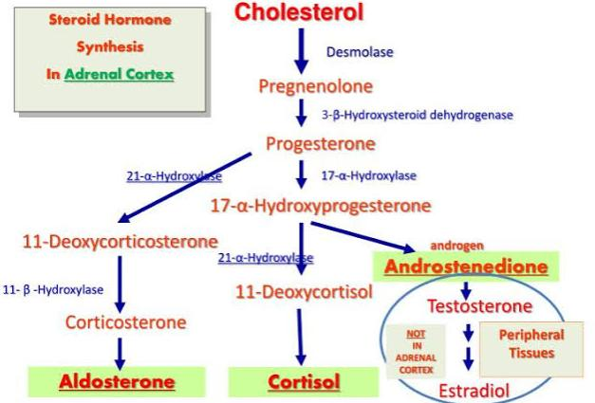

Transport:
Steroid hormones are transported through the blood by being bound to carrier proteins-serum proteins that bind them and increase the hormones solubility in water. Some examples are sex hormone-binding globulin SHBG, corticosteroid-binding globulin and albumin.
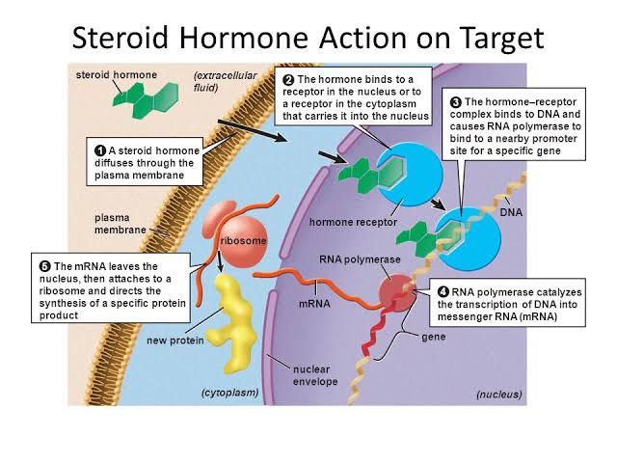
- What is deamination and transamination?
Transamination:
The transfer of an amino group from an amino acid to a keto acid is know as transamination.
The process involves the interconversion of amino acids and a pair of keto acids, catalyzed by a group of enzymes called transaminase.
It is a reversible reaction.
Transamination takes place in cytoplasm of all the cells
Most amino acids (not lys, Thr, Pro, His, Trp, Arg, Met)

Role of transamination:
The amino group of amino acid is utilized for the formation of urea which is an excretory end product of proteins.
The carbon skeleton of amino acid is converted into keto acids.
These keto acids undergo following functions:
- Utilized to generate
- Used for the synthesis of pyrimidines
- Diverted for the formation of fat or keto bodies
- Involved for the formation of unwanted amino acids.
Mechanism of transamination:
Step 1:
Transfer of amino group from AA₁ to the coenzyme PLP to form pyridoxamine phosphate.
Amino acid₁ is converted to keto acid₂
Step 2:
Amino group of pyridoxamine phosphate is then transferred to a keto acid₁ to produce a new AA₂ and enzyme with PLP is generated.
Clinical significance:
- Enzymes, present within cell, released in cellular damage into blood.
- ↑ AST- myocardial infarction (MI)
- ↑ AST, ALT- hepatitis, alcohol cirrhosis.
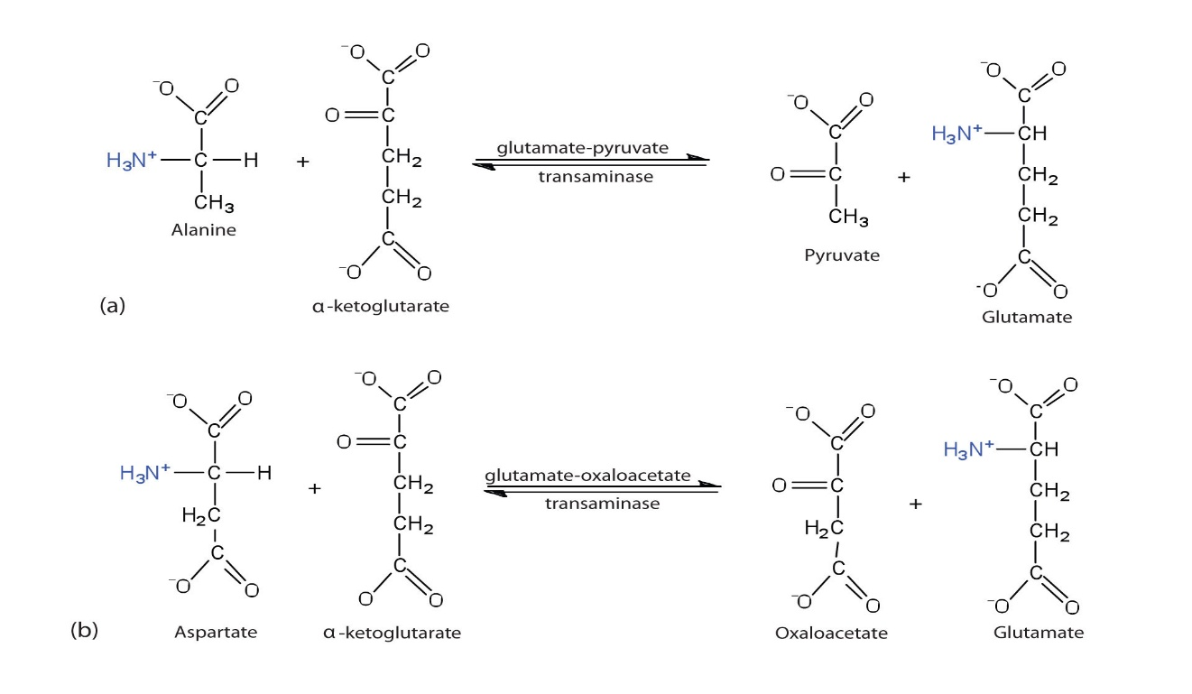
- Muscular dystrophy

Deamination:
Deamination is the removal of an amine group from a molecule.
Enzymes which catalyzes this reaction are called deaminases.
In the human body, deamination take place in liver, however Glutamate is also deaminated in the kidneys.
It is the process by which amino acid are broken down if there is an excess of protein intake.

Types of deamination:
There are four types of deamination:
- Oxidative deamination
An amino acid is converted into the corresponding keto acid by removal of the amine functional group as ammonia
It occurs primarily on higher animals
It occurs mostly on glutamic acid
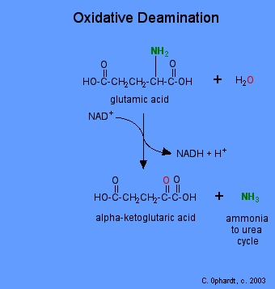
Glutamate dehydrogenase is the enzyme used.

- Reduction deamination
- Hydrolytic deamination
- Intermolecular deamination.
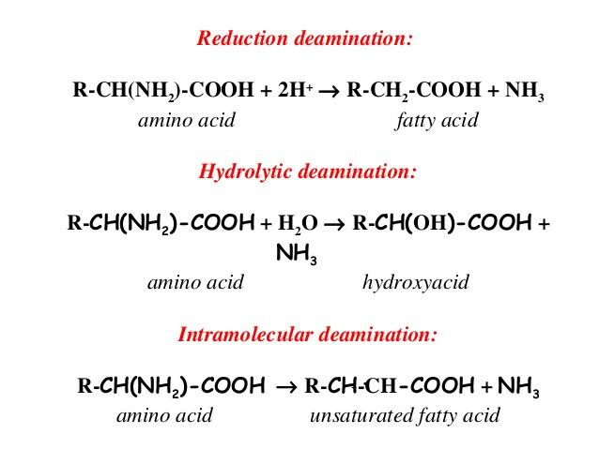

- Write down the metabolism of protein?
Protein:
Greek word meaning, primarily or holding first place.
Proteins are the main structural component of the body.
They are nitrogenous macromolecules composed of many amino acids an addition to C, H and O protein also contain N.

Metabolism of protein:
- Protein metabolism is the biochemical processes is the responsible for the synthesis of protein and amino acids (anabolism) and the breakdown of proteins by catabolism. This process is also known as proteometabolism.
- The amino acid is joined by the peptide bonds make a polypeptide chain. Polypeptide chains to form a fully functional protein.
- Dietary proteins are first start break down to individual amino acid by various enzymes.
- Hydrochloric acid present in gastrointestinal tract.
- These amino acids are further broken down to a- keto acids and which can be recycled in the body for generation of energy, production of glucose, fats or amino acid.
- Absorbed from the intestine.
Digestion of proteins:
- Dietry proteins digested to small simple molecules (amino acids), they are easily absorbed from the intestine. Protein digestion in the stomach by gastric juices.
- Digestion of protein in stomach by hormone pepsin is secreted by the stomach.
- In small intestine by proetolytic enzymes present in pancreatic and intestinal juices.
- Trypsin is secreted by the pancreas in the form of trypsinogen, which is activated in the duodenum by entrokinase to form trypsin.
- Dipeptidase enzymes are present in intestinal juice. The end products of protein digestion in the small intestine are amino acid.

Monogastric Protein Digestion :
Initiated in stomach :
- Hcl from parietal cell
- Stomach PH 1.6 to 3.2
- Denature 4⁰ , 3⁰ and 2⁰ structures
- Pepsinogen from Chief cells

Hcl
Pepsinogen ─ Pepsin
Cleaves at Phenylalanine ,tryptophan .
{Aromatic amino acids }

Protein leaves stomach as a mixture of insoluble protein ,soluble protein ,peptide and amino acids .

Hcl which is being secreated by parietal cells decrease the PH of stomach and this decrease in PH results in the break down of quaternary , secoundary,
And tertiary structures in to primary proteins structures .

While the pepsinogen in the presence of HCL convert an inactive enzymes into its active form .

Protein Digestion in small Intestine :
From pancrease pancreatic enzymes are secreted in an inactive form .
These enzymes are as follows :

- These enzymes are collectively called zymogens .
- Each of these enzyme perform its specific function by acting on sfecific sites .
- Zymogens must be converted into its active form .
Enteropeptidase / trypsin
- Trypsinogen __________ Trypsin
Endopeptidase :
Cleaves on carboxyl side of Lysine and arginine
Trypsin
- Chymotrypsinogen ______________ Chymotrypsin
Endopeptidase :
Cleaves Carboxyl terminal of phenyl , tyrosin , Tryptophan .
Trypsin
- Procarboxylpeptidase _________________ Carboxylpeptidase
Exopeptidase :
Remove carboxyl terminal residue .

Trypsin Inhibitors :
These are small peptides which block active site of pepsin and in turns stop protein digestion
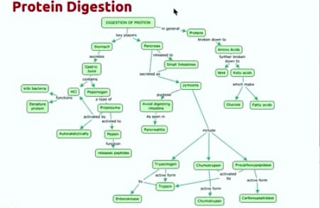
Protein Absorption in small intestine :
By the action of Hcl zymogens protein are broken down into primary aminoacids and keto groups further the keto group are broken down into glocuse molecules which are absorbed though micro villi of small intestine and become part of blood . Protein Absorption
- It is an active process that needs energy.
- It occurs in small intestine.
- Absorption of amino acids is rapid in the duodenum and jejunum, but slow in the ileum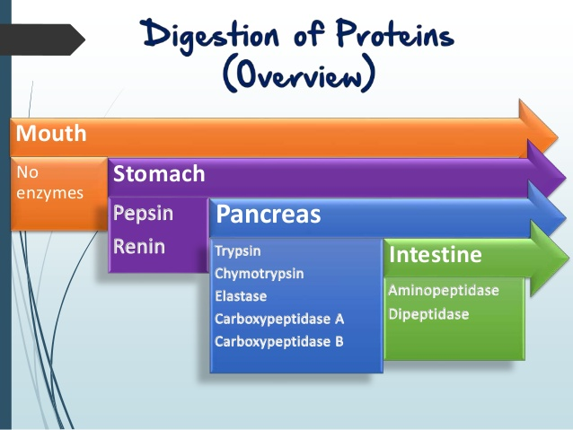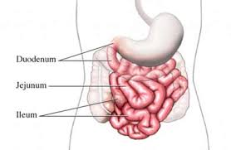.
Protein absorption:
- Protein is absorbed as tripeptides, dipeptides or amino acids and this process occurs in duodenum or proximal jejnum of the small intestine. The peptide or amino acids pass through the interstitial by facilitate diffusion or active transport.

Amino acid:
Amino acid is the smallest unit of protein and is an organic molecule made up of amine and carboxylic acid functional group.
Am amino acid is composed of nitrogen, Carbon, oxygen and hydrogen molecules.
About twenty amino acids have been named 8 out of these are described as Essential, while the remailing are non-essential.

Essential amino acids | Non-essential amino acids
- Histidine | 9. Alanine
- Isoleucine | 10.Arginine
- Leucine | 11. Asparagine
- Lysine | 12. Aspartic acid
- Methionine | 13. Cysteine
- Phenylalanine | 14. Glutamic acid
- Threonine | 15. Glutamine
- Tryptophan | 16. Glycine
 | 17. Proline
 | 18. Serine
 | 19. Tyrosine

General metabolism of amino acids:
- Catabolic reaction
- Anabolic reaction
Catabolic reaction:
Dietary proteins re body proteins are broken down to amino acids, this is called catabolic reactions.
Anabolic reaction:
Amino acids are used for synthesis of body proteins; this is anabolic reaction.
- Explain briefly translation of DNA in eukaryotes?

Translation:
Translation is basically a synonym process of protein synthesis.
It is the process in which the protein is synthesized from the information contained in a molecule of messenger RNA (mRNA)

Definition:
It can be defined as “the process by which the sequence of neuclotides in a messenger RNA molecule directs the incorporation of amino acid into protein”

Translational machinery:
The machinery required for translating the language of messenger RNAs into the language of protein is composed of four primary components.

mRNAs: messenger RNA (mRNA) provides an intermediate that carries the copy of a DNA sequence that represents protein.

tRNAs: tRNA act as an adaptor between the codons and the amino acid they specify.

Enzymes: required for the attachment of amino acids to the correct tRNA molecules.
- Aminoacyl-tRNA synthetase.
- Peptidyl transferase.
Ribosome: it is the macromolecular complex that directs the synthesis of protein.

Steps:
Translation involves there major steps:
- Initiation
- Elongation
- Termination
Initiation:
Initiation is divided into 4 steps:
- Ribosomal dissociation.
- Formation of 43S preinitiation complex.
- Formation of 48S initiation complex.
- Formation of 80S initiation complex.
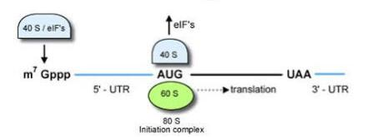
Translation initiation is a complex process in which initiator tRNA, 40S, and 60S ribosomal subunits are assembled by eukaryotic initiation factors (eIFs) into an 80S ribosome at the ini
Elongation:
Elongation depends on eukaryotic elongation factors. At the end of the initiation step, the mRNA is positioned so that the next codon can be translated during the elongation stage of protein synthesis. The initiator tRNA occupies the P site in the ribosome, and the A site is ready to receive an aminoacyl-tRNA. During chain elongation, each additional amino acid is added to the nascent polypeptide chain in a three-step microcycle.
The steps in this microcycle are:
- positioning the correct aminoacyl-tRNA in the A site of the ribosome.
- forming the peptide bond.
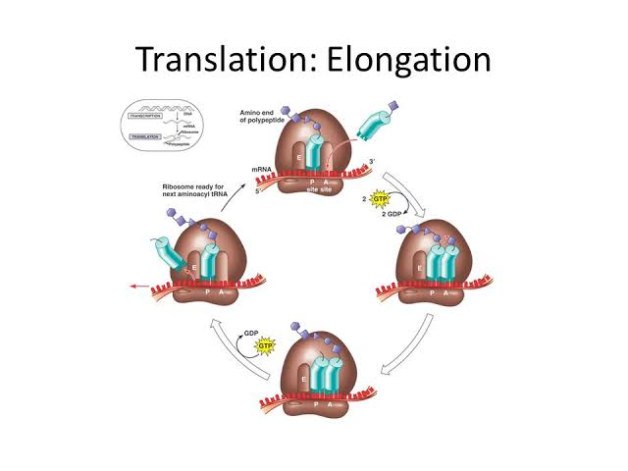
- shifting the mRNA by one codon relative to the ribosome.

Termination:
Translation ends in a process called termination. Termination happens when a stop codon in a mRNA (UAA, UAG, UGA) enters A site.
Stop codons are recognized by proteins called release factor, which fit neatly into the P site.

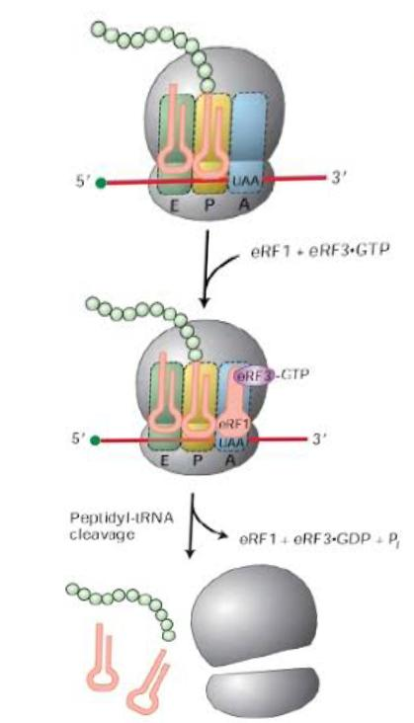

Write down clinical significance of cholesterol?
Cholesterol:
Cholesterol is a waxy, fat-like substance made by the liver that’s found in all the cells in your body.
Your body needs some cholesterol to make hormones, vitamins D, and substances that help you digest foods.
Cholesterol is exclusively found in animals.
It is widely distributed in all cells and is a major component of cell membrane and lipoprotein.
Cholesterol (Greek: chole-bile) was first isolated from bile
Cholesterol literally means “solid alcohol from bile.
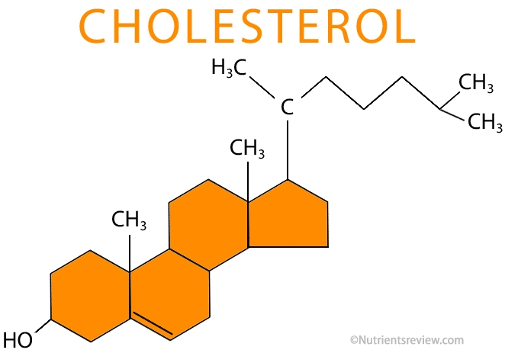
High blood cholesterol causes:
- Being overweight
- Not exercising regularly
- Overuse of alcohol
- Family history; high blood cholesterol can be an inherited condition.
- Age, sex; as you age, your LDL (bad cholesterol) level rises. After age 55, women have higher LDL levels than men.
CLINICAL SIGNIFICANCE OF THE CHOLESTEROL:

1. Hypercholesteriolemia:
Hypercholesterolemia is also called high cholesterol, is the presence of the high level of the cholesterol in the blood. Its form hyperlipidemia, high blood lipids, any hyperlipoproteinemia (elevated levels of lipoproteins in the blood).

Causes:
- It is a genetic disorder. And it is caused by a defect on chromosomes 19.
- Cholesterol from the blood this result in a high level of Low Density Lipid in the blood and this make your arteries narrowing.

2. Hyperthyroidism:
- Hyperthyroidism the condition of the thyroid. It produces tetraiodothyronin T4 and triiodothyronine .Thyroid gland regulates your metabolism through the release of
these hormones.
Causes:
Mostly common cause of hyperthyroidism.
- Excess iodine, a key of the ingredient in T3 AND T4.
- This causes T4 andT3 to leak out of the gland.

- Hyperlipidemia:
- Hyperlipidemia, high cholesterol, refers to the elevated the levels of the fats in the blood.
- Hyperlipidemias having increased the risk of the developing heart diseases and increase the stroke and may be death.

- Atherosclerosis:
- It is the high levels can lead to blocked arteries that come from a process known as atherosclerosis or plaque of the arteries and this can restrict blood flow.
- The plaque can burst, triggering a blood clot. Nephrotic syndrome (is a kidney disorder that causes your body to pass too much protein in your urine).

- Nephrotic syndrome:
- Is a kidney disorder that causes your body to pass too much protein in your urine.
- That causes your body pass too much protein in your urine.
- Nephrotic syndrome is caused by damage to the cluster of small blood vessels in your kidneys that filter waste and excess amount of the water from your blood.

Functions of cholesterol:
- Cholesterol is the also used to make sex hormones testosterone, progesterone and estrogen.
- The liver also uses cholesterol to make bile, a fluid that the plays a vital role in the processing and digestion of lipids.
- It is present in abundance in nervous tissue.
- It appears that cholesterol functions as an insulating cover for the transmission of electrical impulses in the nervous tissue.

