Final-Term-Assignment
Name : Shahid Ali
Id : 13942
Degree : BS (SE)
Module : Summer Semester
Subject : ICT
Submitted To : Dr. Atif Ishtiaq
Date : 25/09/2020

Q.1: Write a note on Multimedia and its type with common media for storage access and transmission in details.
Ans: Multimedia: Multimedia is a form of communication that combines different content forms such as text, audio, images, animations, or video into a single presentation, in contrast to traditional mass media, such as printed material or audio recordings. Popular examples of multimedia include video podcasts, audio slideshows, animated shows, and movies.
Multimedia can be recorded for playback on computers, laptops, smart phones, and other electronic devices, either on demand or in real time (streaming). In the early years of multimedia, the term "rich media" was synonymous with interactive multimedia. Over time, hypermedia extensions brought multimedia to the World Wide Web.
Types: The types of multimedia applications include the interaction of different media types like animation, video, text and sound. All modern devices are able to use these different types. From a user’s perspective, a device is considered more modern if it can load multimedia components and has multimedia capability.
The types of multimedia have become a part of our lives as soon as we entered the digital age. But even before that, modern technology has provided the tools for us to appreciate some of the types of multimedia such as videos on television. Right now, everyone has the capacity to load videos on their computer.
Media for storage access: To provide a more enriched user experience, many apps allow users to contribute and access media that's available on an external storage volume. The framework provides an optimized index into media collections, called the media store, that allows for retrieving and updating these media files more easily. Even after your app is uninstalled, these files remain on the user's device.
Transmission: Transmission media is a pathway that carries the information from sender to receiver. We use different types of cables or waves to transmit data. Data is transmitted normally through electrical or electromagnetic signals.
An electrical signal is in the form of current. An electromagnetic signal is series of electromagnetic energy pulses at various frequencies. These signals can be transmitted through copper wires, optical fibers, atmosphere, water and vacuum Different Medias have different properties like bandwidth, delay, cost and ease of installation and maintenance. Transmission media is also called Communication channel.

Q.2: What are the relation between hardware and software. And types of software with Logical system architecture.
Ans: Relationship between Hardware and Software:
- Both hardware and software are necessary for a computer to do useful job. They are complementary to each other.
- Same hardware can be loaded with different software to make a computer system perform different types of jobs.
- Except for upgrades, hardware is normally a one-time expense, whereas software is a continuing expense.
- Upgrades refer to renewing or changing components like increasing the main memory, or hard disk capacities, or adding speakers, modems, etc.
Types of Software: two types of software.
- System Software: system software are designed to control the operation and extend the processing capability of a computer system.
- Make the operation of a computer system more effective and efficient.
- Help hardware components work together and provide support for the development and execution of application software.
- Programs included in a program system software package are called system programs and programmers who prepare them are called system programmers.
- Examples of system software are operating system, programming language translators, utility programs, and communications software.
- Application Software: Application software are designed to solve a specific problem or to do a specific task.
- Programs included in an application software package are called applications programs and programmers who prepare them are called applications programmers.
- Examples of applications software are word processing, inventory management, preparation of tax returns, banking etc.

Logical System Architecture:
HARDWARE
(Physical devices/components of the computer system

System Software
(Software that constitute the operating and programming environment of the computer)

Applications Software
(Software that do a specific task or solve a specific problem)

Users
(Normally interact with the system via the user interface provided by the application software)

Relationship among hardware, system software, applications software, and users of a computer system.

Q.3: Write a note on each of the following in details. ANS:
a) Modulation Techniques:
Amplitude Modulation (AM): Two binary values (0 and 1) of digital data are represented by two different amplitudes of the carries signal, keeping frequency and phase constant.
Frequency Modulations (FM): Two binary values of digitals data are represented by two different frequencies, while amplitude and phase are kept constant.
Phase Modulation (PM): Two binary values of digital data are represented by shift in phase of carries signal.

(b) Multiplexing & DeMultiplexing:
Multiplexing:
Method of dividing physical channel into many logical channels so that a number of independent signals may be simultaneously transmitted
An electronic device that performs multiplexing is known as a multiplex.
Multiplexing enables a single transmission medium to concurrently transmit data between several transmitters and receivers.

DeMultiplexing: Demultiplex (DEMUX) is the reverse of the multiplex (MUX) process – combining multiple unrelated analog or digital signal streams into one signal over a single shared medium, such as a single conductor of copper wire or fiber optic cable. Thus, demultiplex is reconverting a signal containing multiple analog or digital signal streams back into the original separate and unrelated signals

(c) Switching Techniques: Data is often transmitted from source to destination through a network of intermediate nodes.
Switching techniques deal the methods of establishing communication links between the sender and receivers in a communication network.
Three commonly used switching techniques are:
Circuit Switching: dedicated physical path is established between sending and receiving stations through nodes of the network for the duration of communications.
Message switching: Sender appends receivers destination address to the message and it is transmitted from source to destination either by sore-and-forward method or broadcast method.
Packet switching: Message is split up into fixed size packets and each packets is transmitted independently from source to destinations node. Either store-and forward or broadcast method is used for transmitting the packets. All the packet of a message are re-assembled into original message at the destination node.

(d) Optical Fiber Communication System. Fiber optical communication has revolutionized the telecommunications industry. It has also made its presence widely felt within the data networking community as well. Using fibre optic cable, optical communications have enabled telecommunications links to be made over much greater distances and with much lower levels of loss in the transmission medium and possibly most important of all, fiber optical communications has enabled much higher data rates to be accommodated.
As a result of these advantages, fibre optic communications systems are widely employed for applications ranging from major telecommunications backbone infrastructure to Ethernet systems, broadband distribution, and general data networking.
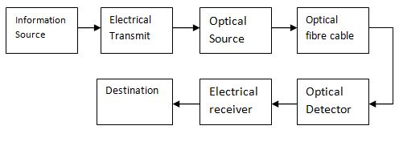

Q.5: What is OSI reference model explain each layer of OSI model in details.
Ans: The Open Systems Interconnection model (OSI model) is a conceptual model that characterizes and standardizes the communication functions of a telecommunication or computing system without regard to its underlying internal structure and technology. Its goal is the interoperability of diverse communication systems with standard communication protocols. The model partitions a communication system into abstraction layers.
A layer serves the layer above it and is served by the layer below it. For example, a layer that provides error-free communications across a network provides the path needed by applications above it, while it calls the next lower layer to send and receive packets that constitute the contents of that path.
The model is a product of the Open Systems Interconnection project at the International Organization for Standardization (ISO).

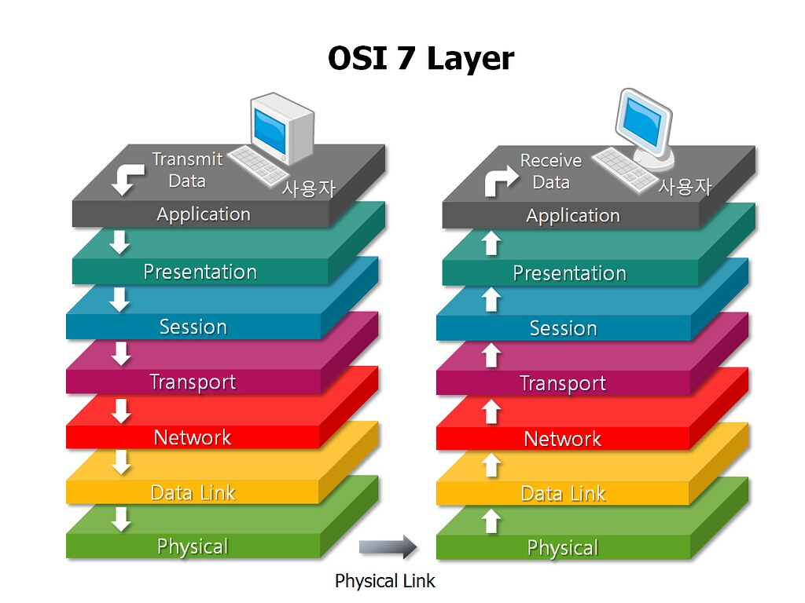

Layer 7 - Application
To further our bean dip analogy, the Application Layer is the one at the top - it’s what most users see. In the OSI model, this is the layer that is the “closest to the end user”. Applications that work at Layer 7 are the ones that users interact with directly. A web browser (Google Chrome, Firefox, Safari, etc.) or other app - Skype, Outlook, Office - are examples of Layer 7 applications.

Layer 6 - Presentation
The Presentation Layer represents the area that is independent of data representation at the application layer. In general, it represents the preparation or translation of application format to network format, or from network formatting to application format. In other words, the layer “presents” data for the application or the network. A good example of this is encryption and decryption of data for secure transmission - this happens at Layer 6.

Layer 5 - Session
When two devices, computers or servers need to “speak” with one another, a session needs to be created, and this is done at the Session Layer. Functions at this layer involve setup, coordination (how long should a system wait for a response, for example) and termination between the applications at each end of the session.

Layer 4 – Transport
The Transport Layer deals with the coordination of the data transfer between end systems and hosts. How much data to send, at what rate, where it goes, etc. The best known example of the Transport Layer is the Transmission Control Protocol (TCP), which is built on top of the Internet Protocol (IP), commonly known as TCP/IP. TCP and UDP port numbers work at Layer 4, while IP addresses work at Layer 3, the Network Layer.

Layer 3 - Network
Here at the Network Layer is where you’ll find most of the router functionality that most networking professionals care about and love. In its most basic sense, this layer is responsible for packet forwarding, including routing through different routers. You might know that your Boston computer wants to connect to a server in California, but there are millions of different paths to take. Routers at this layer help do this efficiently.

Layer 2 – Data Link
The Data Link Layer provides node-to-node data transfer (between two directly connected nodes), and also handles error correction from the physical layer. Two sublayers exist here as well - the Media Access Control (MAC) layer and the Logical Link Control (LLC) layer. In the networking world, most switches operate at Layer 2.

Layer 1 - Physical
At the bottom of our OSI bean dip we have the Physical Layer, which represents the electrical and physical representation of the system. This can include everything from the cable type, radio frequency link (as in an 802.11 wireless systems), as well as the layout of pins, voltages and other physical requirements. When a networking problem occurs, many networking pros go right to the physical layer to check that all of the cables are properly connected and that the power plug hasn’t been pulled from the router, switch or computer, for example.

