Department of Computer Science
Spring Semester 2020
Online Final – Term Examination

Name ______ Mohammad Basir
ID ______ 13142
INSTRUCTOR Name _____ Mr. Shahab Ul Islam
Semester _____ 8th
Course Title: ______ HUMAN COMPUTER INTERACTION

Question 1: Consider the chair given below. Your Employees want to use it as a computer chair. Your task is to write any As HCI Specialist, your job is point out any Five issues in the design of this chair.

Answer :
Human Computer Interactions: Issues and Challenges focuses on the multidisciplinary subject of HCI which impacts areas such as information technology, computer science, psychology, library science, education, business and management.
The chair presents an interesting design challenge, because it is an object that disappears when in use. The person replaces the chair. So chairs need to look fantastic when empty, and remain invisible (and comfortable) while in use.

Again and again, new chair designs rise to this challenge, and more are coming out all the time. Some have argued that there are too many chair designs in this world, including one of the greatest headlines from Onion: "Report Confirms No Need To Make New Chairs For The Time Being."

Question 2: What is Paradigm, and what do you mean by paradigm shift?

Answer :
Paradigms are generally defined as a framework that has unwritten rules and that directs actions. A paradigm shift occurs when one paradigm loses its influence and another takes over. The concept defines paradigm and paradigm shift and explains how it can relate to company strategies and industry cycles ,
A system of beliefs, ideas, values, and habits that is a way of thinking about the real world. At the time, this way of thinking was the dominant paradigm for social scientists. A paradigm is an example, model or pattern, especially the most basic or central one. ... (Grammar) A paradigm is the set of all word forms
: an important change that happens when the usual way of thinking about or doing something is replaced by a new and different wayThis discovery will bring about a paradigm shift in our understanding of evolution.

A paradigm shift occurs when our usual way of thinking about or doing something is replaced by a new and different way thinking or acting. Paradigm shifts often occur around what we call “AHA moments” when we suddenly understand something in a new or different way.
4 steps to creating a paradigm shift by choice…
- STEP 1: Decide what you want.
- STEP 2: Identify the belief that supports your new reality.
- STEP 3: Gather supporting evidence for your new belief.
- STEP 4: Take action that requires faith in your new belie

Question3 :
Explain Design Rationale. Write and explain the types of design rational

Answer :

There are many definitions of Design Rationale:

"Design rationale expresses elements of the reasoning which has been invested behind the design of an artifact

"Design rationale is the reasoning and argument that leads to the final decision of how the design intent is achieved." "Design intent is the `expected’ effect or behavior that the designer intended the design object should achieve to fulfil the required function."

"Design rationale means statements of reasoning underlying the design process that explain, derive, and justify design decisions"

Design rationale means "information that explains why an artifact is structured the way that it is and has the behavior that it has"

"Design rationales include not only the reasons behind a design decision but also the justification for it, the other alternatives considered, the tradeoffs evaluated, and the argumentation that led to the decision"

While all these definitions have their merits, Lee’s [1997] definition most clearly states the content and purpose of design rationale.

Types of Rationale

Rationale can be classified into several types. These types are not mutually exclusive and some systems may support multiple types of rationales. The following types of rationale are discussed in this document:

• Argumentation based - the design rationale is primarily used to represent the arguments that define a design [Garcia, 1993]. These arguments consist of issues raised, alternative responses to these issues, and arguments for and against each alternative.

• History-based - the rationale consists of the design history – the sequence of events that occurred while performing the design [Garcia, 1993]. This information can be stored in many forms. It could be in the form of entries in a design notebook, an archive of e-mail messages, or other types of documents that capture actions taken over time.

• Device-based - a model of the device itself is used to both obtain and present rationale [Gruber, 1990]. The explanations of the design would be produced by using the model to simulate the behavior of the device. It would be possible for the user to view the model and ask questions about its design and behavior.

• Process-based -- the DR capture is integrated into the design process itself which guides the format of the rationale. In Ganeshan, et. al. [1994], the design description is modified only by changes to and refinements of the design objectives, thus capturing the rationale as part of the design process.

• Active document-based - the DR is pre-generated and stored in the system. In these systems, the designer creates the design and the DR system generates the rationale for it based on the system's stored knowledge. For each decision made, the system compares the decision made by the user with the decision that it would have made based in its knowledge. If the actions of the user conflict with the system recommendations, they are given the option of changing their decision or modifying some of the criteria.

Question 4: Find the web pages that illustrate the principle of consistency.
You must provide on good and one bad example of consistency. You must provide the screen shot of web pages along with URL and the written explanation justifying your good and bad example in your answer. To provide the relevant examples browse the internet .

ANSWER :
Design consistency is the act of keeping all of the repeating elements of your website the same throughout the entire site. This encompasses everything from the placement of buttons and icons to the colors and fonts you use

Two Key Reasons for Consistency and Standards in User Interface Design
As you design the user interface, it is important to keep in mind the interactions that take place between the human cognition and the screen you’re designing for. Making things easier for your users means not forcing them to learn new representations or toolsets for each task. Reducing the length of the thinking process by eliminating confusion is also a sure bet when it comes to improving user experience
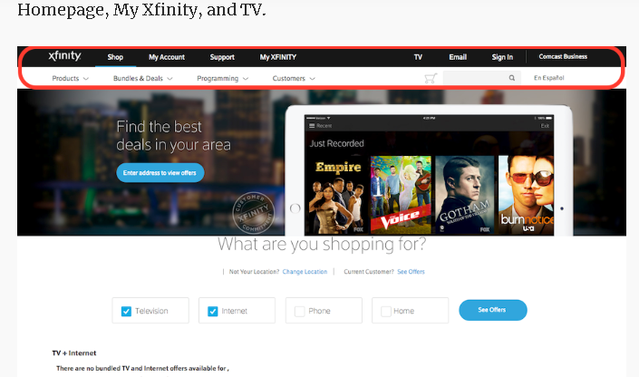

This is the homepage of the Xfinity website. Notice how the annotated area highlighting both the primary and secondary menu bars will differ as the user clicks into other pages.

This is the TV page of the Xfinity website. What makes it confusing for the user is how the colors, layout, and font-styles look different from the home page.

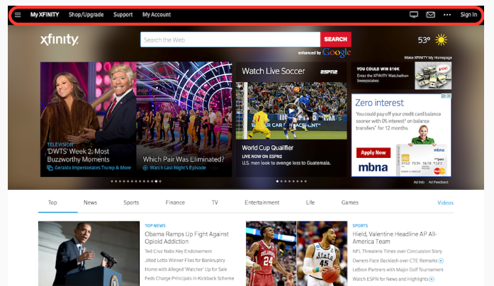
This is the My Xfinity page of the Xfinity website. All three pages examined above have very different colors, layout, and font-styles in their navigation menu. These differences make it confusing and disorienting for the user as it no longer feels like one website, as if they are three different companies.
…………………….
An example of consistency is a sauce that is easy to pour from a pitcher. An example of consistency is when all tests that students take are graded using the same grading scale. An example of consistency is when paint is applied uniformly so that the wall looks the same from one side to the other.

Examples of Bad Design in the Real World
- Pant Labels. Why do pant size labels never indicate which number is waist and which is length? ...
- Bathroom doors that don't clearly indicate gender. ...
- Parking Signs. ...
- Social Media Icons on Print Ads. ...
- Pedestrian Countdowns. ...
- ATM's that spit out your card after the cash. ...
- Classes with exclusively right-handed desks. ...
- Microwaves.

Question 5: Write the Shneiderman’s 8 Golden Rules.

Answer :
Shneiderman's "Eight Golden Rules of Interface Design"
These rules were obtained from the text Designing the User Interface by Ben Shneiderman. Shneiderman proposed this collection of principles that are derived heuristically from experience and applicable in most interactive systems after being properly refined, extended, and interpreted [9].
To improve the usability of an application it is important to have a well designed interface. Shneiderman's "Eight Golden Rules of Interface Design" are a guide to good interaction design.
1 Strive for consistency.
Consistent sequences of actions should be required in similar situations; identical terminology should be used in prompts, menus, and help screens; and consistent commands should be employed throughout.
2 Enable frequent users to use shortcuts.
As the frequency of use increases, so do the user's desires to reduce the number of interactions and to increase the pace of interaction. Abbreviations, function keys, hidden commands, and macro facilities are very helpful to an expert user.
3 Offer informative feedback.
For every operator action, there should be some system feedback. For frequent and minor actions, the response can be modest, while for infrequent and major actions, the response should be more substantial.
4 Design dialog to yield closure.
Sequences of actions should be organized into groups with a beginning, middle, and end. The informative feedback at the completion of a group of actions gives the operators the satisfaction of accomplishment, a sense of relief, the signal to drop contingency plans and options from their minds, and an indication that the way is clear to prepare for the next group of actions.
5 Offer simple error handling.
As much as possible, design the system so the user cannot make a serious error. If an error is made, the system should be able to detect the error and offer simple, comprehensible mechanisms for handling the error.
6 Permit easy reversal of actions.
This feature relieves anxiety, since the user knows that errors can be undone; it thus encourages exploration of unfamiliar options. The units of reversibility may be a single action, a data entry, or a complete group of actions.
7 Support internal locus of control.
Experienced operators strongly desire the sense that they are in charge of the system and that the system responds to their actions. Design the system to make users the initiators of actions rather than the responders.
8 Reduce short-term memory load.
The limitation of human information processing in short-term memory requires that displays be kept simple, multiple page displays be consolidated, window-motion frequency be reduced, and sufficient training time be allotted for codes, mnemonics, and sequences of actions

Question 6: You are familiar with internet explorer. Explain any five usability goals in terms of internet explorer. Justify each goal with example

Answer :

Availability and Accessibility :
Let’s start with a basic, yet central aspect of usability: the availability and accessibility of intrnet explorer If people try to access your it and it doesn’t work — for whatever reason –it becomes worthless.
Here are a few of the basics of availability and accessibility,
- Server uptime – It’s important to ensure your visitors don’t get an error trying to load it
Invest in good hosting. Invest in good hosting. We never cut corners here, get a good web host that you can depend on.
- Broken links – Double check that there are no dead links on your site. SEO tools like Ahrefs and Screaming Frog will crawl your site for you and find all the broken links.
- Mobile responsiveness – Make sure your site can handle different screen sizes and slow connections. Google has also moved to a “mobile-first” index which means they index the mobile versions of sites. So a great mobile site will help you get better search results.

The Daily Egg
Conversion Rate Optimization Made Easy
- Overview
- Pricing
- Free 30-Day Trial

5 Key Principles Of Good Website Usability
Home
- User Experience
Last Updated on July 10, 2019
It’s true, usability has become a commodity.
Over the past few years, we have gotten used to certain standards in web design. In order to make a lasting impression on your visitors, you need to build experiences that go beyond those of a plain, usable website. This does not mean usability has become any less important. It just takes on a different role in web design, now forming the basis for a great user experience.
Usability means user-centered design. Both the design and development process are focussed around the prospective user — to make sure their goals, mental models, and requirements are met — to build products that are efficient and easy to use.
Here are 5 key principles of good website usability. Make sure to consider these in your next project.

1. Availability and Accessibility
Let’s start with a basic, yet central aspect of usability: the availability and accessibility of your site. If people try to access your website and it doesn’t work — for whatever reason –your website becomes worthless.
Not only will users become frustrated, but you’ll also lose out on new customers and revenue every time your site is unavailable.
Here are a few of the basics of availability and accessibility,
- Server uptime – It’s important to ensure your visitors don’t get an error trying to load your site. Invest in good hosting. Invest in good hosting. We never cut corners here, get a good web host that you can depend on.
- Broken links – Double check that there are no dead links on your site. SEO tools like Ahrefs and Screaming Frog will crawl your site for you and find all the broken links.
- Mobile responsiveness – Make sure your site can handle different screen sizes and slow connections. Google has also moved to a “mobile-first” index which means they index the mobile versions of sites. So a great mobile site will help you get better search results.

Amazon.com
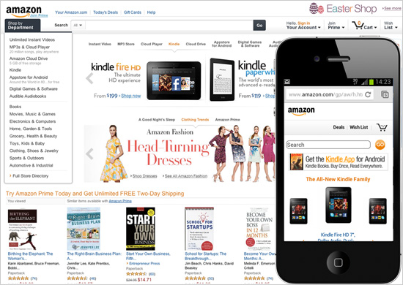
Amazon.com is a perfect example of an accessible website for several reasons.
First, the desktop version of the site is optimized for both tablets and desktop screens. The layout is flexible and adjusts automatically as the screen size is reduced. For mobile, there is an explicit version of the site with a clean interface, less clutter, and a clear hierarchy of the content. This stripped down mobile version works like a charm — even with a slow mobile internet connection.
Second, Amazon.com has almost no downtime. Obviously, this is what you expect from a company that size. Still, the history of constant availability makes Amazon a reliable and trustworthy service platform.
Last but not least, Amazon is actively concerned with it’s accessibility. On their website, they state: “We’re always looking for ways to improve usability of the site for our customers, including those with disabilities.” For screen readers, they specifically recommend their mobile site with a cleaner presentation of the content.

2. Clarity
You could say the core of usability is clarity.
If you distract or confuse your visitors, they will either need more time to find what they came for, or they might forget their initial goal all together. Either way, they will not experience your website as user-friendly and chances are that they leave dissatisfied and with no intention of coming back.
Note :
((A clear and usable design can be achieved through:
- Simplicity – Focus on what’s important. If you don’t distract your vistors they will be more likely to do what you want them to do.
- Familiarity – Stick to what people already know. There is nothing wrong with looking at other sites for inspiration.
- Consistency – Don’t get cute. Create a consistent experience across your entire website to keep your visitors mind at ease.
- Guidance – Take your visitors by the hand. Don’t expect your visitors to explore your site all on their own. Instead, guide them through your site and show them what you have to offer.
- Direct feedback – Feedback is essential to any interaction. The moment people interact with your site, make sure to offer an indication of success or failure of their actions.
- Good information architecture – Understand your visitors’ mental models and how they would expect you to structure the content on your site. ))

3. Learnability
Learnability is another important aspect of usability.
It should be your goal to design intuitive interfaces — interfaces that don’t require instructions, or even a long process of trial and error to figure them out. Key to intuitive design is to make use of what people already know, or create something new that is easy to learn.
By now, people are familiar with a lot of design concepts used on the web. By using these concepts consistently, you meet your visitors’ expectations. This way, you help them reach their goals more quickly. As human beings, we like patterns and recognition, which is why we are better at handling familiar situations rather than unfamiliar ones.

4. Credibility
Credibility is a crucial aspect of any website.
Even if people find the content they are looking for, if they don’t trust you, that content is worthless. Your website could cause site visitors to be skeptical about your business in any number of ways including whether or not you really exist, your reputation, or the quality of your content.
It is important that people know you are a real company with real people. Offer a clear “About Us” page together with your contact details and if possible a physical address.

5. Relevancy
Last but not least, relevancy contributes to good website usability.
It is not enough that your website is clear, your content must also be relevant. Again, it is essential that you know your users and why they visit your site.
Start with defining who your users are. Second, talk to them to find out what their goals are when visiting your site. Third, define user scenarios that demonstrate in which situation people visit your site to find what kind of content. Any design decision that you make should result in a more user-friendly website for your users.

Usability means test, test, and test again
Good usability is not attained overnight.
It requires thorough user research and an iterative approach of constant testing and refining.
Good usability depends on whether your website is available, clear, credible, learnable, and relevant to the people who actually use it

