NAME: REHAN ULLAH
ID NO: 15929
DEGREE: RADIOLOGY 2nd section(B)
PAPER: ANATOMY
SUBMITTED TO: Dr. Arooba

Q:No:1
Ans:
The floor of the cranial cavity is didided into three distinct depressions. They are know as the anterior cranial fossa. Each fossa accommodates a different part of the brain.

The anterior cranial fossa is the most shallow and superior cranial of the three cranial fossae. It lies superiorly over the nasal and orbital cavities. The fossa accommodates the anteroinferior potions of the frontal lobes of the brain.
In this article, we shall look at the borders, contents and clinical correlations of the anterior cranial fossa.

Borders:
The anterior cranial fossa consists of three bones;
The frontal bone, ethmoid bone and sphenoid bone.

It is bounded as follows:
- Anteriorly and laterally; it is bounded by the inner surface of the frontal bone.
- Poteriorly and medially; it is bounded by the limbus of the sphenoid bone. The limbus is a bony ridge that anterior border of the prechiasmatic sulcus (a groove running between the right and left optic canals).
- Posteriorly and laterally; it is bounded by the lesser wings of the sphenoid bone (these are two triangular projection of bone that arise from the central sphenoid body).
- The floor; consists of the frontal bone, ethmoid bone and the anterior aspects of the body and lesser wings of the sphenoid bone.

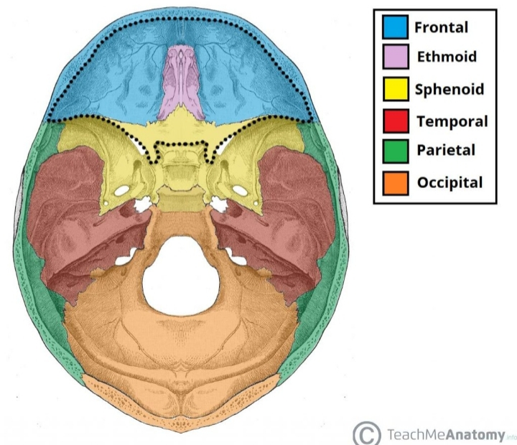

Contents:
There are several bony landmarks present in the anterior cranial fossa.
The frontal bone is marked in the midline by a body ridge, known as the frontal crest. It pojects upwards, and acts as a site of attachment for falx cerebri (a sheet of dura mater that divides the two cerebral hemispheres).
In the midline of the ethmoid bone, the crista galli (latin for cock’s comb) is situated. This is an upwards projection of bone, which acts as another point of attachment for the lalx cerebri.
On either side of the crista is the cribriform plate which supports the olfactory bulb and has numerous foramina that transmit vessels and nerves.
The anterior aspect of the sphenoid bone lies within the anterior cranial fossa. From the central bony, the lesser wings arise. The rounded ends of the lesser wings are know as the anterior clinoid precesses. They serve as a place of attachment for the tentorium. They serve as a place of attachment for the tentorium cerebelli (a sheet of dura mater that divides the cerebrum from the cerebellum). The lesser wings of the sphenoid bone also separate the anterior and middle cranial fossae.
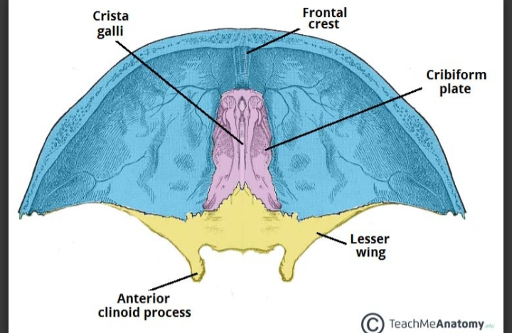

Foramina:
The ethmoid bone in particular contains the main foramina (opening that transmit vessels and nerves) of the anterior cranial fossa. The cribriform plate is a sheet of bone seen either side of the crista galli which contains numerous small foramina these transmit olfactory nerve fibres ( CNL) into the nasal cavity. It also contains two larger foramen:
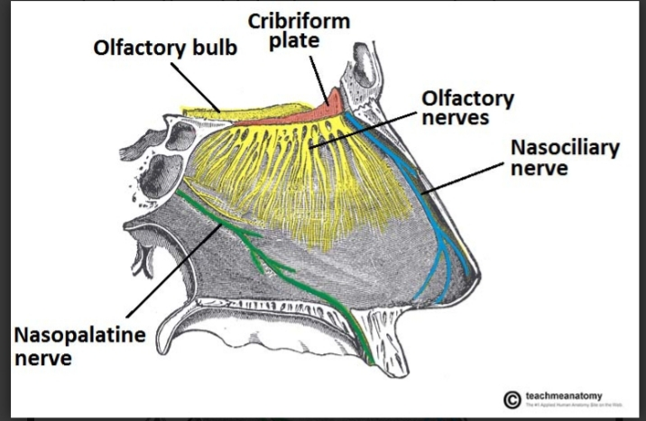

Fracture of the cribriform plate:
The cribriform plate of the ethmoid is the thinnest part of the anterior cranial fossa, and therefore most likely to cribriform plate fracture;
- Anosmia; the olfactory nerve fibres run through the cribriform plate, and can be sheared resulting in loss of sense of smell.
- CSF rhinorrhoea; the tragments of bone can tear the meningeal coverings of the brain, causing the leakage of cerebrospinal fluid into the nasal cavity. This is visible as a clear fluid.

Q: NO: 2
Ans:
Cranial Nerves:
The cranial nerves are a set of twelve nerves that originate in the brain. Each has a different function for sense or movement.
The function of the cranial nerves are sensory, motor or both;
- Sensory cranial nerves help a person to see, smell and hear.
- Motor cranial nerves help in the head and neck.
This article will explore the function of the cranial and provide a diagram.

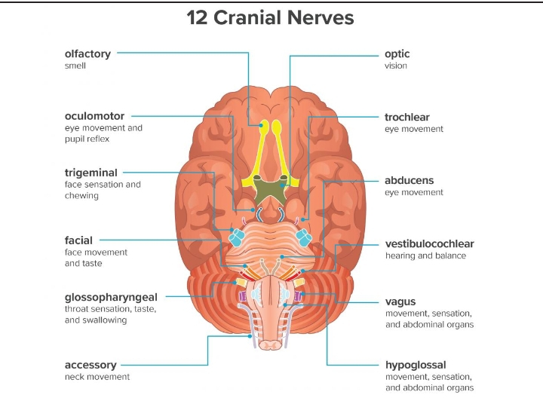

- Olfactory nerve:
The olfactory nerve transmits information to the brain regarding a person’s sense of smell.
When a person inhales fragrant molecules, olfactory receptors within the nasal passage send the impulses to the cranial cavity, which then travel to the olfactory bulb.
2. Optic nerve:
The optic nerve transmits information to the brain regarding a person’s vision.
When light enters the eye, it hits the retina, which contains rods and cones.
These are photoreceptors that translate signals from light into visual information for the brain.
Cones are located in the central retina and are involved with color vision.
3. Oculomotor nerve:
The oculomotor nerve helps control muscle movements of the eyes.
The oculomotor nerve provides movement to most of the muscles that move the eyeball and upper eyeball, known as extra ocular muscles.
The oculomotor nerve also helps with involuntary function of the eye.

4. Trochlear nerve:
The trochlear nerve is also involved in eye movement.
The trochlear nerve, like the oculomotor nerve, originates in the midbrain. It powers the contra lateral superior oblique muscle that allows the eye to point downward and inward.
5. Trigeminal nerve:
The trigeminal nerve is the largest cranial nerve and has both motor and sensory function.
It motor functions help a person to chew and clench in the tympanic membrane of the ear.
Trigeminal neuralgia: trigeminal neuralgia is a common disorder of the trigeminal nerve that can cause intense pain and facial tics.
6. Abducens nerve:
The abducens nerve also helps control eye movement.
It helps the lateral rectus muscles, which is one of the extra ocular muscles, to turn the gaze outward.
7. Facial nerve:
The facial nerve also has both motor and sensory function.
The facial nerve is made up of four nuclei that serve different function.
- Movement of muscles that produce facial expression.
- Movement of the lacrimal, submaxillary and submandibular glands.
- The sensation of the external ear.
- The sensation of taste.
8. Vestibulocochlear nerve:
The vestibulocochlear nerve is involved with a person’s hearing and balance.
The vestibulocochlear nerve contains two components:
- The vestibular nerve helps the body sense changes in the position of the head with regard to gravity. The body uses this information to maintain balance.
- The cochlear nerve helps with hearing. Specialized inner hair cells and the basilar membrane vibrate in response to sounds and determine the frequency and magnitude of the sound.
These fibers combine in the pons and exit the skull via the internal acoustic meatus in the temporal bone.
9. Gloss pharyngeal nerve:
The gloss pharyngeal nerve possesses both motor and sensory function.
- The sensory function receives information from the throat, tonsils, middle ear and back of the tongue. It is also involved with the sensation of taste for the back ofthetongue.
- The motor division provides movement to the stylopharyngeus, which is a muscle that allows the throat to shorten and widen.
10. Vagus nerve:
the vagus nerve has a range of function, providing motor, sensory and parasympathetic function.
- The sensory part provides sensation to the outer part of the ear, the throat, the heart, abdominal organs. It also plays a role in taste sensation.
- The motor part provides movement to the throat and soft palate.
- The parasympathetic function regulates heart rhythm and innervates the smooth muscles in the airway, lungs, and gastrointestinal tract
The vagus nerve is the longest cranial nerve as it start in the medulla and extends to the abdomen.
11. Accessory nerve:
The accessory nerve provides motor function to some muscles in the neck.
It controls the sternocleidomastoid and trapezius muscles that allow a person to rotate, extend and flex the neck and shoulders.
The accessory nerve separates into spinal and cranial parts.
12. Hypoglossal nerve:
The hypoglossal nerve is a motor nerve that supplies the tongue muscles.
The hypoglossal nerve originates in the medulla.
Disorders of the hypoglossal nerve can cause paralysis of the tongue, most often occurring on one side.

Q No: 3
Ans:
Norma Frontalis:
When viewed from the front the skull exhibits a somewhat oval outline, limited above by the frontal bone, below by the zygomatic bones and the mandibular rami. The upper part, formed by the lower part, made up of the bones of the face, is irregular; it is excavated laterally by the orbital cavities, and present in the middle line the anterior nasal aperture leading to the nasal cavities, and below this the transverse slit between the upper and lower dental arcades. Above, the frontal eminences stand out more or less prominently, and beneath these are the superciliary arches, joined to one above the glabella a trace of thr frontal suture sometimes persists; beneath it is the frontonasal suture, the mid point of which is termed the nasion. Behind and below the frontonasal suture the frontal articulates with the frontal process of the maxilla and with the lacrimal. Arching transersely below the superciliary arches is the upper part of the margin of the orbit, thin and prominent in its lateral two thirds, rounded in its medial third, and presenting, at the junction of these two portions, the supraorbital notch or foramen for the supraorbital nerve and vessels. The supraorbital margin ends laterally in the zygomatic process which articulates with the zygomaticbone, and from it the temporal line extends upward and backward. Below the frontonasal suture is the bridge of the nose, convex from downward, and formed by the two nasal bones supported in the ethmoid, and laterally by the frontal processes of the maxillae which are prolonged upward between the nasal and lacrimal bones and from the lower and medial part of the circumferenceof each orbit.
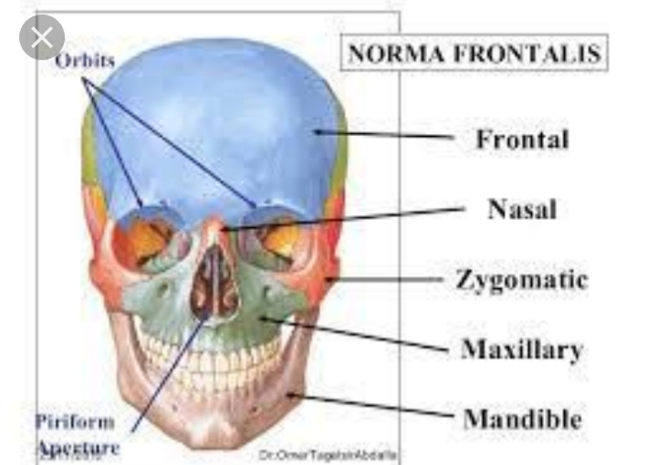

Narma Occipitakis:
When viewed from behaind the cranium presents a more or less circular outline. In the middle line is the posterior part of the sagittal connecting the parietal bones; extending downward and lateralward from the hinder end of the sagittal suture is the deeply serrated lambdoidal suture joining the parietals to the occipiral and continuous below with the parietomastoid and occipitomastoid sutures; it frequently contains one or more sutural bones. Near the middle of the occipital squama is the external occipital protuberance or inion, and extending lateraward from it on either side is the superioe nuchal line, and above this the faintly marked highest nuchal line. The part of the squama above the inion and highest lines is named the planum occipitale, and is covered by the occipitalis muscle; the part below is termed the planum nuchale and is divided by the median nuchal line which runs downward and forward from the inion to the foramen magnum; this ridge gives attachment to the ligamentum nuchae. The muscles attached to the planum nuchale are enumerated attached to the plantum nuchale are enumerated on p. 130. Below and in front are the mastoid processes, convex laterally and grooved medially by the mastoid notches. In or near mastoid foramen for the passage of the mastoid emissary vein.

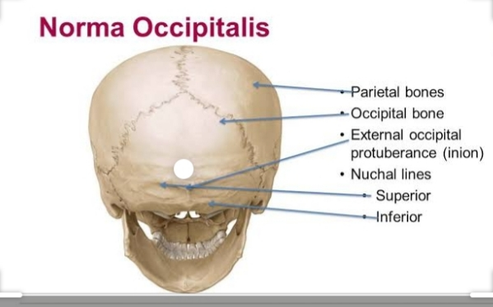

Q No: 4
Ans:
Muscles ot the Hip:
The hiip joint is one of the most flexible joints in the entire human body. The many muscles of the hip provide movement, strength and stability to the hip joint and the bones of the hip and thigh. These muscles can be grouped based their location and funtion. The four groups are the anterior group, the postior proup, adductor group and finally group.
The anterior muscle group features muscles that flex (bend) the thigh at the hip.
HIP MUSCLES ARE DIVIDED INTO THREE COMPARTEMENT:-
- ANTERIOR COMPARTEMENT
- MEDIAL COMPARTEMENT
- POSTERIOR COMPARTEMENT
- ANTERIOR COMPARTEMENT:-
There are nine muscles in this campartement
- Iliopsoas
- Iliacus
- Quadriceps femoris
- Vastus lateralis
- Vastus medialis
- Vastus intermedius
- Sartorius
- Pectineus
- Rectus femoris
MEDIAL COMPARTEMENT:-
There are five muscles in this compartement
- Gracilis
- Obturator externus
- Adductor brevis
- Adductor longus
- Adductor magnus
POSTERIOR COMPARTEMENT:-
There are three muscles in this compartement
- Semi membranosus
- Semitendinosus
- Biceps femoris
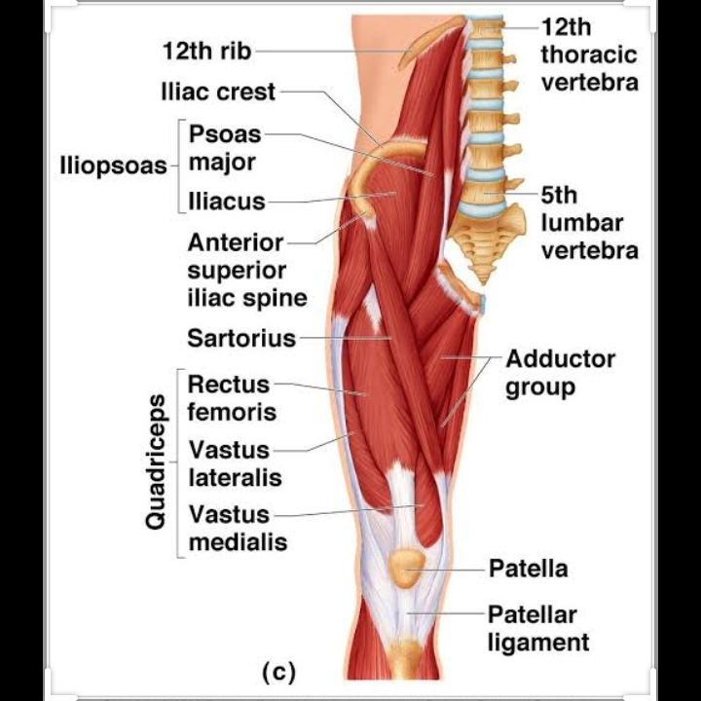

MUSCLES OF THE KNEE:-
The muscle of the knee include the quadriceps, hamstring and the muscles of the calf. These muscles work in group to flex, extend and stabilized the knee joint.
These motion of the knee allow the body to perform such important movement as walking, running, kiking, and jumping.
Extending along the anterior surface of the thigh are the four muscles of the quadriceps femoris group (vastus lateralis, vastus medialis, vastus intermedias and rectus femoris) these large muscles originate in the ilium and femur and insurt on the tibia.
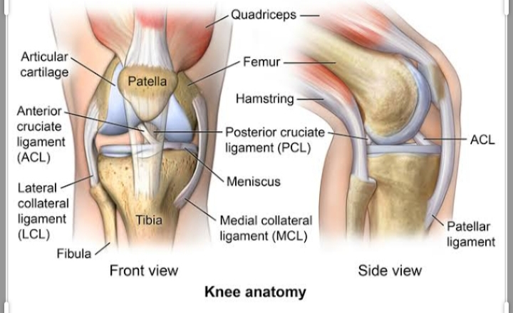

QNO5. WRITE A COMPREHENSIVE NOTE ON THE FEMORAL TRIANGLE?
ANS:- FEMORAL TRIANGLE:-
- POSITION:- It is located in the upper one third of the anteromedial region of the thigh.
- BORDER:- It is bounded by the follwing border.
- Superior border: it is formed by the inguinal ligament
- Lateral border: it is formed by the medial border of the sartorius.
- Lateral border: it is formed by the medial border of the sartorius.
- Medial border: it is formed by the medial border of the adductor longus.
- Anterior border: it is formed by the skin, the superfacial fascia and the fascia lata.
- Posterior border: it is formed by the adductor longus, pectinous and iliopsoas from medial to the lateral side.

iii content:-
it contains the femoral nerve, femoral sheath with its contents, femoral lymphatic nodes and fatty tissue.
- The femoral nerve: it gives off following branches
- Articular branches
- Cutaneous branches
- Anterior cutaneous branches
FORMATION:- The femoral sheath is formed by the continous part of transverse fascia and iliac fascia which enclose the upper part of femoral vessels.
SHAPE OF FEMORAL SHEATH:-It is a funnel shaped fascia tube 3 to 5 cm in length.
Parts of femoral sheath: it is divided into three parts by two longitudnal fibrous septa. They are as follow:
1 lateral part
2 intermediate part
3 medial part
CONTENT OF FEMORAL SHEATH:-
It contain following structures.
- Femoral artery: it gives off the following branches
- Superfacial artery
- Superfacial iliac circumflex artery
- External pudandal artery
- Deep femoral artery
- Perforating artery
- Femoral vein:it is corresponding tributaris accompanying with the branches of femoral artery.
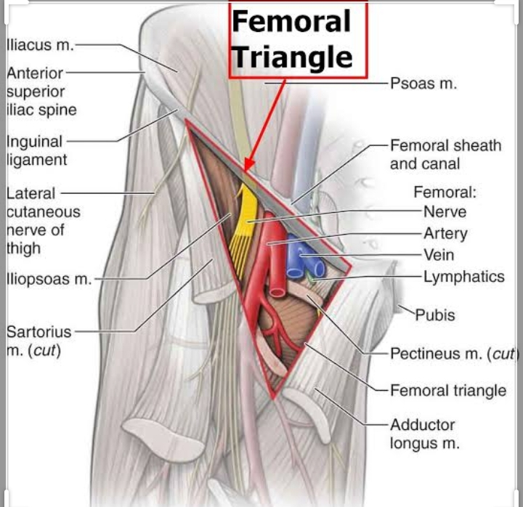

THE END

THANK YOU MAM

