INU Peshawar Date 20th April 2020
Department | (AHS) DT,RAD & DPT
Subject | English-II
Marks | 30
Semester | -II
Mid Term Assignment | Spring 2020
Instructor | Hajra Iqbal
Fill below blocks.
Student Full Name | aleeza
Student Father Name | Arif khan
University ID Card Number | 16673
Instructions: Your time starts once you log in. You have only 48 hours to complete and submit your paper on the portal. After 48 hours your time would be automatically expired. Download this paper and save it with your full name and subject. Attempt all the answers on the same page and keep in your mind to click the SAVE after every 10 minutes. When you are done with paper, go through it and submit your final copy with your name and id on SIC portal.
Note: i. Attempt all three questions. All questions carry equal marks. Be careful about spellings, sentence structure and punctuation marks.
- Make a report on Sports Week Closing Ceremony at your University. (300-350 words)

Good evening

Before we close this ceremony I’d like to take this last opportunity to, say on behalf of the faculty staff, students, admininstartion INU congratulations, both the graducates and the family and friends who have helped us arrive at this moment.
Your outsatndning achievement and its well deserved pride, through thats not merely the end of awarding of certificates and diplomas and medals and be followed by hanging in your wall just for many people to admire with.
So exactly that tonight means is not the highlight of great applause for such token recived but, rather accentuating the individuality on how far you set your limits.
Just think about all trough us here, all trails and misfortunes, too great to recall, all the nights of study, all the grades, all the classrooms experances, all the stress, all the relations, its all comes tonights togather in this ceremony.sure you will face predicaments. But despite of that don’t forget to hold on character that is very cruvicle that will be your reflection for tomarrow on how you will build a strong foundation in your family, peers, community and even yourself.
as the end accadmic year 2019-2020 once again congratulations.

- Write a letter to the Health Department regarding the present outbreak of COVID-19, briefing about the present condition of your area, the response of the people and the preventive facilities at hand. ( 300 words)
Iqra national university
Phase 2
Hayatabad Peshawar

20 april 2020
Dr. Arif Khan
HOD of Health Dept.

Dear sir,
Most respectfully I want to say that the present situation in our area due to COVID 19 is very harshfull for the poor. Those hard workers who were just able to earn enough money for their food are now unable to even earn that. They are now getting out of their homes for work which is a bad decision to take. If they are infected then this situation will be out of control.
So now I request you to take a step for them and make availability of food and ration for them. There should be availability of food for them or the situation will get out of hands.
I will be waiting for your response.

Aleeza khan

3. Describe a picture in your own words and suggest a title. (300 words)

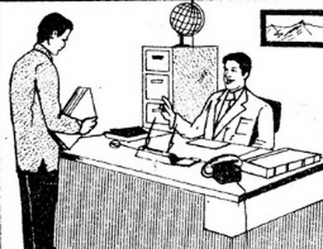

Conversation between boss and employ

This is a picture of office in which the boss is talking to his employ. In this picture we can see that an employ is getting some instructions from his boss about some files. The files are clearly seen in his hands. This is not an interview because if it was an interview the employ will be siting there. The boss is happy about his work because he is passing a smile to the employ. The boss is a lover of nature because there is a painting of mountains at the back of the his chair. This picture is very old as we can see the old model telephone. The employ is also a very sincere employ because he is looking down which is a sign of sincerity and not looking to the eyes of his boss. We can see a cupboard at the back of the boss and a globe of earth is kept on the top of it. Two pens are kept on the table of the boss. There are two books kept on the both sides of the table. The boss is wearing vast and coat that means he is a classic man.

