Name Khubaib Anwar

Id 12886

Subject logical & critical thinking

Q1. What is Aristotelian logic? Discuss the four kinds of categorical propositions with at least five examples of each.
Answer:
Aristotelian logic;
The traditional system of logic expounded by Aristotle and developed in the Middle Ages, concerned chiefly with deductive reasoning as expressed in syllogisms.
Kinds of categorical propositions;
There are four and only four kinds of standard-form categorical propositions.
Here are examples of each of the four kinds:
1. All politicians are liars.
2. No politicians are liars.
3. Some politicians are liars.
4. Some politicians are not liars.
We will examine each of these kinds in turn.
1. Universal affirmative propositions. In these we assert that the whole of one class is included or contained in another class. “All politicians are liars” is an example; it asserts that every member of one class, the class of politicians, is a member of another class, the class of liars. Any universal affirmative proposition can be written schematically as
All S is P.
where the letters S and P represent the subject and predicate terms, respectively. Such a proposition affirms that the relation of class inclusion holds between the two classes and says that the inclusion is complete, or universal. All members of S are said to be also members of P. Propositions in this standard form are called universal affirmative propositions. They are also called A propositions.

2. Universal negative propositions. The second example above, “No
politicians are liars,” is a proposition in which it is denied, universally,
that any member of the class of politicians is a member of the class of liars. It asserts that the subject class, S, is wholly excluded from the predicate class, P. Schematically, categorical propositions of this kind can be written as
No S is P.
where again S and P represent the subject and predicate terms. This kind of proposition denies the relation of inclusion between the two terms, and denies it universally. It tells us that no members of S are members of P.
Propositions in this standard form are called universal negative propositions. They are also called E propositions.

3. Particular affirmative propositions. The third example above, “Some politicians are liars,” affirms that some members of the class of all politicians are members of the class of all liars. But it does not affirm this of politicians universally. Only some particular politician or politicians are said to be liars. This proposition does not affirm or deny any-thing about the class of all politicians; it makes no pronouncements about that entire class. Nor does it say that some politicians are not liars, although in some contexts it may be taken to suggest that. The literal and exact interpretation of this proposition is the assertion that the class of politicians and the class of liars have some member or members in common. That is what we understand this standard form proposition to mean.
“Some” is an indefinite term. Does it mean “at least one,” or “at
least two,” or “at least several”? Or how many? Context might affect
our understanding of the term as it is used in everyday speech, but
logicians, for the sake of definiteness, interpret “some” to mean “at
least one.” A particular affirmative proposition may be written schematically as
Some S is P.
which says that at least one member of the class designated by the subject term S is also a member of the class designated by the predicate term P.
The proposition affirms that the relation of class inclusion holds, but does not affirm it of the first class universally but only partially, that is, it is affirmed of some particular member, or members, of the first class.
Propositions in this standard form are called particular affirmative propositions. They are also called I propositions.

4. Particular negative propositions. The fourth example above, “Some politicians are not liars,” like the third, does not refer to politicians universally, but only to some member or members of that class; it is particular. Unlike the third example, however, it does not affirm the inclusion of some member or members of the first class in the second class;
this is precisely what is denied. It is written schematically as
Some S is not P.
which says that at least one member of the class designated by the subject term S is excluded from the whole of the class designated by the predicate term P. The denial is not universal. Propositions in this standard form are called particular negative propositions. They are also called O propositions.
Examples;
1.“Every man is mortal” is an example A-proposition.
2.“All Politicians are lairs” is an example A-proposition.
3.“All tables are wooden” is an example A-proposition.
4.“All Dogs bark” is an example A-proposition.
5.“No man is mortal” is an example E-proposition.
6.“No Politicians are lairs” is an example E-proposition.
7.“No tables are wooden” is an example E-proposition.
8.“No Dogs bark” is an example E-proposition.
9.“Some man is mortal” is an example I-proposition.
10.“Some Politicians are lairs” is an example I-proposition.
11.“Some tables are wooden” is an example I-proposition.
12.“Some Dogs Bark” is an example I-proposition.
13.“Some man is not mortal” is an example O-proposition.
14.“Some Politicians are not lairs” is an example O-proposition.
15.“Some Tables are not wooden” is an example O-proposition.
16.“Some Dogs not bark” is an example O-proposition.
Q2. Discuss the Venn Diagram technique for testing syllogism with the help of examples.
Answer:
A. A syllogism is a two premiss argument having three terms, each of which is used twice in the argument.
B. Each term ( major, minor, and middle terms) can be represented by a circle.
C. Since a syllogism is valid if and only if the premisses entail the conclusion, diagramming the premisses will reveal the logical geography of the conclusion in a valid syllogism. If the syllogism is invalid, then diagramming the premisses is insufficient to show the conclusion must follow.
D. Since we have three classes, we expect to have three overlapping circles.
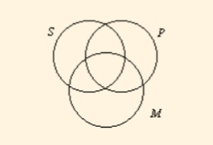

1. The area in the denoted circle represents where members of the class would be, and the area outside the circle represents all other individuals (the complementary class). The various area of the diagram are noted above.
2. Shading represents the knowledge that no individual exists in that area. Empty space represents the fact that no information is known about that area.
3. An "X" represents "at least one (individual)" and so corresponds with the word "some."
II. Some typical examples of syllogisms are shown here by their mood and figure.
A. EAE-1
1. The syllogism has an E statement for its major premiss, an A statement for its minor premiss, and an E statement for its conclusion. By convention the conclusion is labeled with S (the minor term) being the subject and P (the major term) being the predicate.

2. The form written out is
No M is P.

All S is M

No S is P.

3. Note, in the diagram below, how the area in common between S and P has been completely shaded out indicating that "No S is P." The conclusion has been reached from diagramming only the two premisses. All syllogisms of the form EAE-1 are valid.
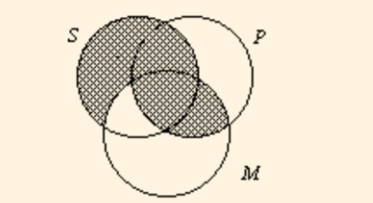
B. AAA-1
1. This syllogism is composed entirely of "A" statements with the M-terms arranged in the "left-hand wing" as well.
2. Its form is written out as
All M is P.

All S is M.

All S is P.

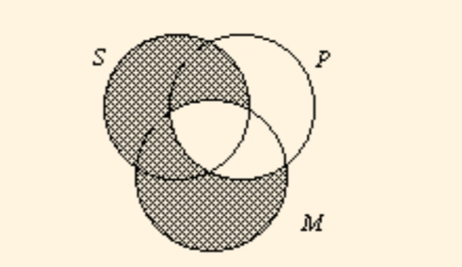
3. Note, in the diagram below, how the only unshaded area of S is in all three classes. The important thing to notice is that this area of S is entirely within the P class. Hence, the AAA-1 syllogism is always valid. In ordinary language the AAA-1 and the EAE-1 syllogisms are by far the most frequently used.

C. AII-3
1. The AII-3 syllogism has the M-terms arranged in the subject position--the right side of the brick.
2. This syllogism sets up as
All M is P.

Some M is S.

Some S is P.

3. When diagramming the syllogism, notice how you are "forced" to put the "X" from the minor premiss in the area of the diagram shared by all three classes. The "X" cannot go on the P-line because the shading indicates this part of the SM area is empty. This "logical" forcing enables you to read-off the conclusion, "Some S is P."
4. This syllogism is a good example why the universal premiss should be diagrammed before diagramming a particular premiss. If we were to diagram the particular premiss first, the "X" would go on the line. Then, we would have to move it when we diagram the universal premiss because the universal premiss empties an area where the "X" could have been.

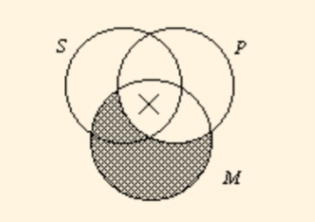
D. AII-2
1. The AII-2 has the M terms in the predicate of both premisses.
2. The syllogism is written out as
All P is M.

Some S is M.

Some S is P.

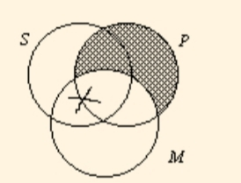
3. The diagram below shows that the "X" could be in the SMP area or in the SPM area. Since we do not know exactly which area it is in, we put the "X" on the line, as shown. When an "X" is on a line, we do not know with certainty exactly where it is. So, when we go to read the conclusion, we do not know where it is. Since the conclusion cannot be read with certainty, the AII-2 syllogism is invalid.

E. The final syllogism described here, the EAO-4 raises some interesting problems.
1. Notice that in this syllogism there are universal premisses with a particular conclusion.
2. Its form is written out as
No P is M.

All M is S.

Some S is not P.

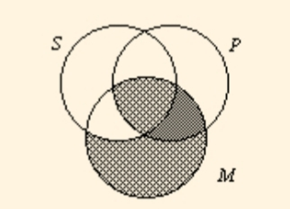
3. And its diagram is rather easily drawn as

4. When we try to read the conclusion, we see that there is no "X" in the SMP class. We must conclude that the syllogism is invalid because we cannot read-off "Some S is not P."
5. However, if we know that M exists, all the members of M have to be in the SMP class. These M's are S's as well. Hence, we know that some S's are not P's! In other words, the EOA-4 syllogism is valid if we know ahead of time the additional premiss "M exists."
6. Most contemporary logicians have concluded that we should not assume any class exists unless we have evidence.
a. We want to talk about theoretical entities without assuming their existence.
b. For example, in science and mathematics, our logic will apply when talking about circles, points, frictionless planes, and freely falling bodies even though these entities do not physically exist.
c. This diagram illustrates the contemporary topic called the problem of existential import. When can we reasonably conclude something exists? How does this conclusion affect our theory of logical validity?

Q3. Discuss symbolic logic in terms of negation, conjunction and disjunction supplemented by examples. Also state the different symbols used in symbolic logic.
Answer:
1.Negation
The negation of a statement p is not p .

The symbol ∼ or ¬ is used to denote negation.

If p is true, then ∼p is false, and vice versa.
Original Statement Negation of Statement
Today is Monday. Today is not Monday.
That was fun. That was not fun.
2.Conjunction
In logic, a conjunction is a compound sentence formed by the word and to join two simple sentences.

The symbol for this is Λ. (whenever you see Λ , just read 'and') When two simple sentences, p and q, are joined in a conjunction statement, the conjunction is expressed symbolically as p Λ q.
Simple Sentences p : Ahmed eats fries. q : Maria drinks soda.

Compound Sentence: Conjunction
p Λ q : Ahmed eats fries, and Maria drinks soda.

3.Disjunction
A disjunction is a compound statement formed by combining two statements using the word and . In symbolic logic, the disjunction of p and q is written p∨q .

A disjunction is true if either one or both of the statements in it is true. The following truth table gives the truth value of p∨q depending on the truth values of p and q .

p q p∨q
T T T
T F T
F T T
F F F

Simple Sentences Compound Sentence: Disjunction
p: The clock is slow.
q: The time is correct. p ν q: The clock is slow, or the time is correct.

■Symbols
p, q, r,… statements

v "or"

Λ "and"

~ "it is not the case that"

=> "implies" or "If..., then..."

↔ "implies and is implied by" or "....if and only if..."

Q4. What are truth value, truth table and validity? Discuss and draw truth tables for negation, conjunction and disjunction.
Answer:
Truth value;
Truth values have been put to quite different uses in philosophy and logic, being characterized, for example, as:
• primitive abstract objects denoted by sentences in natural and formal languages,
• abstract entities hypostatized as the equivalence classes of sentences,
• what is aimed at in judgements,
• values indicating the degree of truth of sentences,
• entities that can be used to explain the vagueness of concepts,
• values that are preserved in valid inferences,
• values that convey information concerning a given proposition.

Truth Tables
The fact that someone says something doesn't make it true.
Statements can be false as well as true. In logic, they must be one or the other, but not both and not neither. They must have a "truth value," true or false, abbreviated T or F.

P | q | ~p | pΛq
T | T | F | T
T | F | F | F
F | T | T | F
F | F | T | F

Whether a conjunction is true depends on the statements which make it up. If both of them are true, then the conjunction is true. If either one or both of them are false, the conjunction is false. For example, the familiar expression 3 < x < 7, which means "x > 3 and x < 7" is true only when both conditions are satisfied simultaneously, that is for numbers between 3 and 7.

Validity
The concept of validity was formulated by Kelly (1927, p. 14) who stated that a test is valid if it measures what it claims to measure. For example a test of intelligence should measure intelligence and not something else (such as memory). A distinction can be made between internal and external validity. These types of validity are relevant to evaluating the validity of a research study / procedure.
Internal validity refers to whether the effects observed in a study are due to the manipulation of the independent variable and not some other factor. In-other-words there is a causal relationship between the independent and dependent variable. Internal validity can be improved by controlling extraneous variables, using standardized instructions, counter balancing, and eliminating demand characteristics and investigator effects. External validity refers to the extent to which the results of a study can be generalized to other settings (ecological validity), other people (population validity) and over time (historical validity).

TRUTH TABLE FOR NEGATION
Truth Tables
• Negation (not): Opposite truth
value from the statement. Negation
Truth Tables
• Negation (not): Opposite truth
value from the statement. Negation
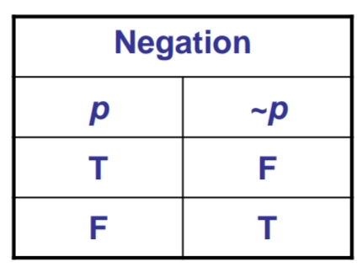
TRUTH TABLE FOR CONJUNCTION
Conjunction (and): Only true
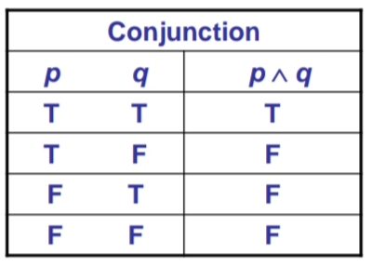
when both statements are true.
TRUTH TABLE FOR DISJUNCTION

• Disjunction (or): Only false when
both statements are false.

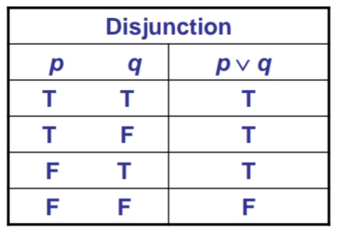

Q5. Discussion argument by analogy, casual connection and cause and effect with the help of examples.
Answer:
An analogy is a comparison between two objects, or systems of objects, that highlights respects in which they are thought to be similar. Analogical reasoning is any type of thinking that relies upon an analogy.

Causal relationships may be understood as a transfer of force. If A causes B, then A must transmit a force (or causal power) to B which results in the effect. Causal relationships suggest change over time; cause and effect are temporally related, and the cause precedes the outcome.

Cause and effect is a logical system that organizes evidence to show how something happened. Examples: We received seven inches of rain in four hours. - The underpass was flooded.

