Name: Aimal Khan
ID No: 16079
Paper: Introduction of Architecture and town planning
Department: BE (civil)
Section: A

Q1: Take any building from internet, put its picture in Microsoft Word and explain its positive and negative points according to the principles of design. What could be done to make the building more attractive? Answer must be at least 200 words. (CLO1-PLO7)
Ans.
Positive Points
One of the most powerful examples of golden ratio. If you see the focal point which seems to be in center but it is not the center of the building but it is in the ratio of 1.6 which is known as golden ratio.
Let me explain in simple words how it is golden ratio. If you have look at the windows of the building you can see that 3 windows separated by a minor margin. And you can see that the one side of the focus has the 6 windows and the other side has the 4 windows if you divide the 6 by 2 you have got the answer is 1.5. Which is approximately the golden ratio.
Negative Points
One thing that I never like in this building is that if we see to the bottom of the building shown that there is another focus point which is a little bit disturb the beauty of the building. Also the appearance of the bottom side is not a good. It looks like a backside of the building but create a little bit confusion and make the viewers to think about it.

Q2: Design and sketch an ideal single story house on the site shown below. The design should be free hand and can be drawn on graph paper. If a graph paper is not available then make a grid of 5’x5’ on a separate white A4 size paper. The house should be naturally ventilated and have natural lighting. Also, it should be free of noise. The site is located in Peshawar. Label or explain the Plan neatly. (CLO1-PLO7)
Ans.

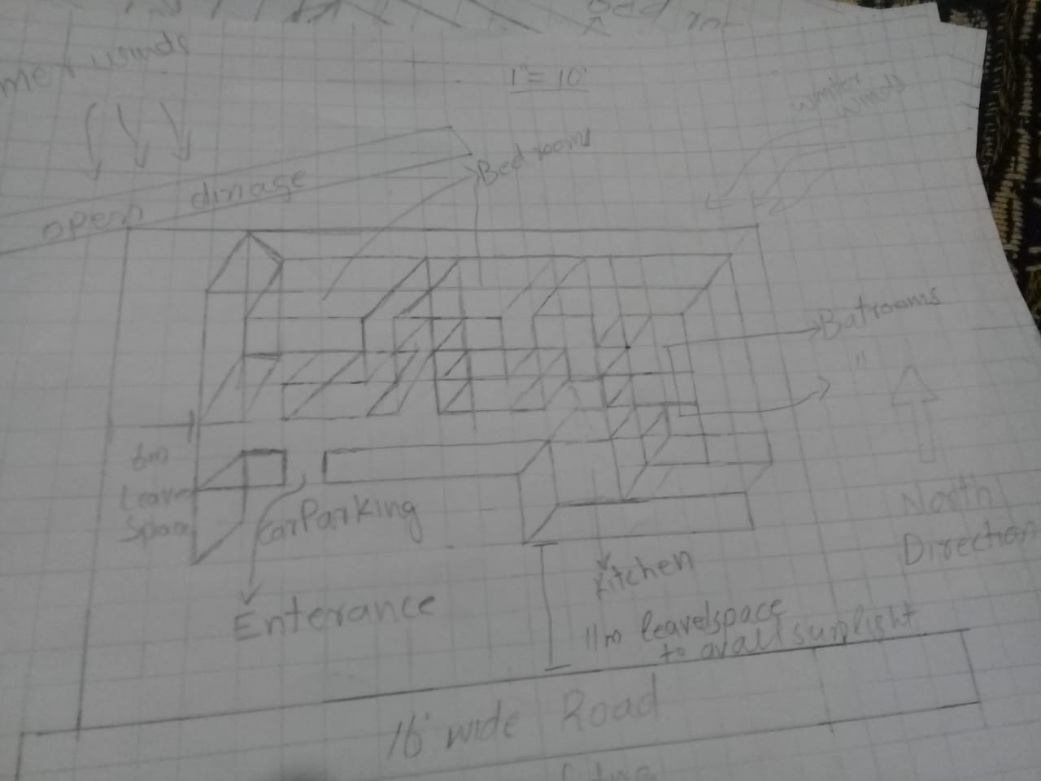
Q3: Select a site at the place where you live. Do Micro site analysis of Site and make its sketch on another A4 paper and write about it in detail. You can take your own lawn as a site for analysis or any other site in the neighborhood. Additionally, make a solar path diagram for your area on a separate piece of paper to find the exact sun angles for both winter and summer. Watch videos on YouTube to understand and make Solar Path diagram. Use these sun angles to make a rough sketch of a room. Show window height, type of fixed sun shade used, angle and height of shade as well as its depth and width by keeping sun angles in mind. The purpose for the sketch is to show how winter sun is allowed and summer sun is blocked. (CLO1-PLO7)
Ans.
