Name : Aliya Aziz
I’d : 16501
Semester: 2nd
Department: BsMLT
Submitted to sir Adnan
Assignment:
Question 1
Answer :
- Leukopenia:
Leukopenia is a condition that develops when you do not have enough white blood cells in your immune system.
Types of white blood cells :
- Basophilis
- Esoinophils
- Lymphocytes
- Monocytes
- Neutrophils
Symptoms of leukopenia:
- Fever higher than 100.5
- Chills
- Sweating
Causes of leukopenia:
- Blood cell or bone marrow conditions, like a plastic anemia and myelofibrosis.
- Cancer and cancer treatment
- Congenital problems , like kostmann syndrome and myelokarthexis
- Infectious disease, like HIV and tubercul
- Autoimmune diseases, like lupus and rheumatoid arthritis
- Vitamin and mineral deficiencies
Treatment:
Treatment is a mixture of lifestyle changes, like diet, and medication. Doctors may prescribe medications to stimulate your body to create more blood cells, as well as antifungal or antibiotics. Patients should be on a low bacterial diet to prevent infection.
2) Lymphocytosis :
Lymphocytosis is a higher – than normal amount of lymphocytes, a subtype of white blood cells , in the body . Lymphocytes are part of your immune system and work to fight off infection .
Causes:
- Lymphocytosis result form increased numbers of lymphocytes in your blood .
- Lymphocytes are a type of white blood cell .
- They play an important role in your immune system, helping your body fight of infection .
- Many underlying medical conditions can cause lymphocytosis.
- High lymphocyte blood levels indicate your body is dealing with an infection or other inflammatory condition.
- Sometimes, lymphocyte levels are elevated because of a serious condition, like leukemia.
Symptoms :
Lymphocytosis itself does not cause symptoms. However , you may experience symptoms from the underlying cause of lymphocytosis. Depending on the cause, symptoms may range from no symptoms to severe.
Treatment:
Doctor treat lymphocytosis by working to resolve its underlying cause. For most people , lymphocytosis goes away as the underlying condition improves.
3) LYMPHOPENIA :
Lymphopenia which is also known as by the terms of lymphocytopenia is a pathological condition that arises as are result of abnormally low lymphocyte count in the blood .
Causes:
- Infections :
- Severe septicemias
- Influenza , occasionally other virus infections
- Colorado tick fever
- Miliary tuberculosis
Other miscellaneous condition:
- Collagen vascular diseases , especially SLE
- Malignant disease
- Other conditions with lymhocytotoxins
- Radiotherapy
- Graft- versus – host disease .
Symptoms:
- Fever
- Cough
- Runny nose
- Enlarged lymph node
- Painful joints
- Skin rash
- Weight loss
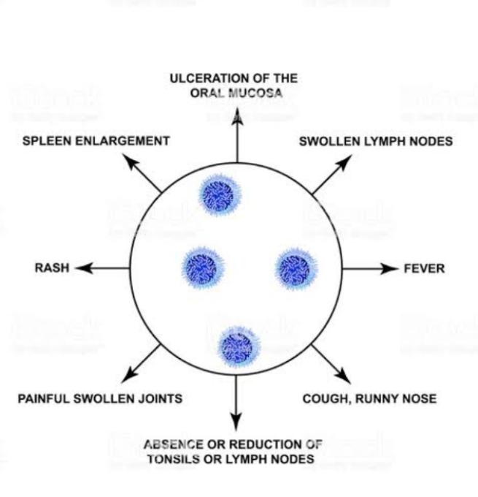
Treatment:
Type of treatment you get depend on what’s causing your disorder . if you have only mild case, it may go away on its own without treatment. Treatment option include:
- Stopping the medication that’s causing it
- Getting treatment for the infection that’s causing it, such as AIDS or a bacterial , viral or fungal infection
- Stem cell transplant for inherited causes
- Treatment with antibodies to help prevent infection if you’re low in B cells and need extra antibodies.
4) Basophilia :
It is a condition where there is an abnormal increase in the number of by basophils in the blood.
Causes :
Patient will commonly have other white cell abnormality along with basophilia . Some of the possible causes or conditions which will lead To basophilia are:
Lymphoma :
The basophils can be normally increased in various lymphomas, such as Hodgkin’s lymphoma. This is atype of cancer ,which involve the lymphatic system where the lymph nodes are palpable and become enlarged .

Cancer :
Cancers which affect the epithelial layer of the blood vessels and internal organs may also elevate the basophils in the blood .
Infection :
Certain viral and bacterial infection , such as tuberculosis, chickenpox and influenza can cause basopbilia .
Allergy :
Basophilia also occur in allergic condition such as urticaria and rhinitis because of interaction of basophils with histamines.
Inflammatory condition:
Basophilia can be seen in inflammatory conditions, such as chronic eczema and rheumatoid arthritis.
iron deficiency anemia: Individuals with iron deficiency anemia can also have basophilia.
Symptoms:
Symptoms depend on the cause of basophilia. Some of the symptoms of basophilia are:
- If a patient has basophilia due to allergy, then he/she experiences symptoms of pruritus (itching) due to the release of histamine.
- Basophilia patient with myeloproliferative neoplasms will have spleen enlargement with symptoms, such as abdominal discomfort and feeling of fullness.
- Patients with anemia as cause of basophilia will experience persistent fatigue, weakness and headache.
- Patient with thyroid problems as the cause of basophilia will have muscle aches, constipation, unintentional weight gain and joint stiffness.
Treatment :
Treatment of basophilia consists of treating the underlying condition which has caused the excessive production of basophils in the bone marrow. Basophilia related to infections, allergy or thyroid condition is usually not a cause for concern as the basophilia gets resolved with treatment/medication. However, if basophilia occurs as a result of bone marrow cancer, then it is a serious matter and requires immediate treatment.
- Bone marrow transplant can be done in severe cases, such as leukemia.
- Anti-allergic medications are prescribed for basophilia developing from allergic conditions, which lead to respiratory illnesses.
- In case of hypothyroidism related basophilia, taking the right medication brings the level of basophils back to normal.
5) Neutrophilia :
- Neutrophilia is a medical condition that involves the increase of neutrophil in the blood or serum .
- This is considered as the most common form of leukocytosis
- The neutrophils are responsible in killing or assistance of fighting off the foreign materials found in the body such as ( bacteria and fungi )
- Its precursors >7,000/cmm
Cause:
- Acute infection
- Inflammation
- Hemorrphage
- Sepsis
- Stress
- Drugs
- Malignancy
- Cigarette smoking
- Labor
Symptoms:
- Bleeding leading to hypotension, tachycardia and most probably sepsis.
- Hypothermia or decreased body temperature .
- Rashes
- Wound that doesn’t heal quickly
- Abscesses
Diagnosis:
- Low LAP score
- Philadelphia chromosome
6) Thrombocytosis:
Thrombocytosis is defined as a platelet count exceeding the upper limit of the reference range.

Causes:
- Essential ( primary )
Essential thrombocytosis (a form of myeloproliferative disease )

Reactive (secondary)
- Inflammation
- Surgery (which leads to an inflammation state)
- Hemorrhage and / or iron deficiency
Symptoms:
- Essential thrombocytosis
- Headache
- Bruising
- Blood in the urine
7) Thrombocytopenia :
Thrombcytopenia Is a medical disorder in which a person Suffer from a low blood platelets . platelets are colorless blood cell
That help blood to clot and stop bleeding by clumping and forming plugs in the wound of the blood vessels.
Causes:
- Viral infection ( chickenpox , hepsitic C )
- Systemic lupus erythematous
- Heart bypass surgery
Symptoms:
- Easy and excessive bruising
- Blood in urine and stool
- Bleeding from your gums and nose
- Fatigue
Treatment:
- Any precpitating cause should be treated approximately
- All possible mediation should be discontinued including heparin , quinine and other Drugs known as associated with thrombocytopenia
8) Polycythemia :
- Abnormal increase in in blood cells
- White blood cell, red blood cell and platelets.
- Classified as a cancer
Causes:
Transfusion :
- Twin to twin transfusion
- Material to Baby transfusion
Hypoxia in urtor:
- Material smoking
- PIH
Symptoms
- Headache
- Weakness
- Sweating
- Loss of weight
- Pain and swelling in joints
Treatment
- To decrease PVC
- Venesection
- Chemo therapy
9) Anemia:
- Anaemia is a lack of red blood cell
- Red blood cell carry oxygen around the body
- Red blood cell are made in bone marrow
Causes:
- Internal bleeding
- Hemorrhoids
- Insufficient iron
Symptoms:
- Frequent headaches
- Dizziness
- Shortness of breath
- Fatigue
- Decreased body temperature
- Chest pain
- Pale skin
- Brittle nails
- Splenomegaly
- Having frequent infections.
Treatment:
Anemia treatment depends on the cause.
- Iron deficiency anemia. Treatment for this form of anemia usually involves taking iron supplements and changing your diet.
If the cause of iron deficiency is loss of blood — other than from menstruation — the source of the bleeding must be located and the bleeding stopped. This might involve surgery.
- Vitamin deficiency anemias. Treatment for folic acid and vitamin C deficiency involves dietary supplements and increasing these nutrients in your diet.
If your digestive system has trouble absorbing vitamin B-12 from the food youeat, you might need vitamin B-12 shots. At first, you might have the shots every other day. Eventually, you'll need shots just once a month, possibly for life, depending on your situation.
10) Leukemia:
Leukemia is a blood cancer caused by a rise in the number of white blood cells in your body.
Causes :
- Smoke
- Are exposed to a lot of radiation or certain chemicals
- Had radiation therapy or chemotherapy to treat cancer
- Have a family history of leukemia
- Have a genetic disorder like Down syndrome

Symptoms:
- Weakness or fatigue
- Bruising or bleeding easily
- Fever or chills
- Infections that are severe or keep coming back
- Pain in your bones or joints
- Headaches
- Vomiting
- Seizures
- Weight loss
- Night sweats
- Shortness of breath
Treatment :
- Chemotherapy
- Radiation
- Biologic therapy
- Targeted therapy
- Stem cell transplant
- Surgery
11 ) Reticulocytes:
Reticulocytes is a condition where there is an increase in reticulocytes, immature red blood cells.
Cause:
- Hemorrhage
- Leukemia
- Pregnancy
Symptoms:
- Fatigue
- Pale skin
- Weakness

The end

