Iqra National University Peshawar Pakistan
Department of Computer Science
SpringSemester,Assignment,May-June2020

Name : Afaq

ID : 16884

Subject: | Programming Fundamentals | Issue Date: | 15/May/2020
Program: | BS (CS & SE) | Submission Date: | 10/June/2020
Teacher Name: | Dr. Fazal-e-Malik | Marks : | 20

Q1: Using a do-while loop, write a program that will do banking transactions as per the figures below:
Solution:
#include<iostream>
#include<stdlib.h>
int main(){

int TotalBalance=1000, WithdrawAmount;
int loop=0;
int userinput;

do{

cout << “ Welcome to AWESOME BANK ”<<endl <<endl;
cout << “ What do you want to do? ” <<endl;
cout << “ +------------------------------+” <<endl;
cout << “ | 1 - Withdraw |”<<endl;
cout << “ | 2 - Balance Inquiry |” <<endl;
cout << “ | 3 - Exit |” <<endl;
cout << “ +------------------------------+” <<endl<<endl;

cout << “ Please enter your choice = ” ;
cin >> userinput;

switch(userinput){

case 1:
cout<<” Please enter the amount in PKR ” ;
cin >> WithdrawAmount;

if (WithdrawAmount > TotalBalance){
cout<<” You have insufficient funds do so.”<<endl;
cout<<”Thank You!”;
}

else {
TotalBalance= TotalBalance-WithdrawAmount;
cout<<”Thank You for the Transaction”;
cout<<”Your Remaining Balance = ”<<TotalBalance;

char userin;
cout<<”Do you want to exit transaction? (Y/N)”;
cin>> userin;

if(userin = ‘Y’ || userin = ‘y’){
loop = 1;
}
}

system(“CLS”);
break;

case 2:
cout<<”Your remaining Balance = ”<<TotalBalance;

char userin;
cout<<”Do you want to exit transaction? (Y/N)”;
cin>> userin;

if(userin = ‘Y’ || userin = ‘y’){
loop = 1;
}

system(“CLS”);
break;

case 3:
loop = 1;

char userinp;
cout<<”Are you sure you want to Exit? (Y/N)”;
cin>>userinp;

if(userinp = ‘N’ || userinp = ‘n’){
loop = 0;
}

system(“CLS”);
break;

}

}while(loop < 1);

cout<<”Thank You!”;

return 0;
getch();
}

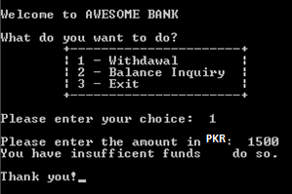
Figure 1
Based on Figure 1, the program shows the options available at the ATM machine. If the user withdraws amount more than the available balance, an error message will be displayed and the program is terminated. Assume that the account has PKR 1000.00 starting balance.

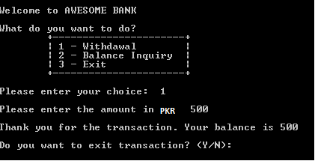
Figure 2

Figure 2 show that the user is withdrawing some amount from the account. The program will display the balance left in the account. It will then ask the user whether he or she wants to proceed with another transaction.

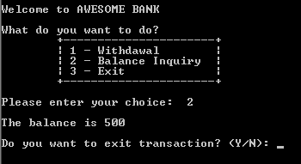
Figure 3
Figure 3 show the balance inquiry option, which allows the user to check their balance in the account.
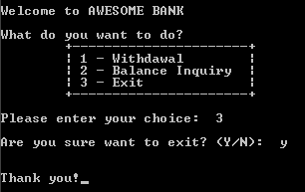
Figure 4
Figure 4 show when the user decides to exit the program. Note that to clear screen, you need to use system(“cls”); and include a header file stdlib.h
************************

