ANATOMY
Name: Laiba Israr
ID: 15168
DPT 4Th Semester
Mid Term
Instructor: Mam Arooba

Q1: Select the best possible answer?
1. Sub arachnoid hemorrhage is caused by the rupture of which vessel?
ANS: Cerebral artery
2. The superior sagittal sinus is located between the?
ANS: endosteal (parietial) and the meningeal (visceral) layers of the Dura
3. How many poles does a cerebrum has?
ANS: 3 poles
4. What type of cells is present in the fifth layer of cerebral cortex?
ANS: Both b and c
5. A fetal posterior communicating artery arises from the?
ANS: basilar artery
6. Regarding sympathetic and parasympathetic nervous system, which of the following is true?
ANS: long preganglionic fibers and short postganglionic fibers in PSNS.
7. Sensory information enters the CVS via the dorsal portion, motor commands exit the CNS via the ventral portion?
ANS: True
8. Which of the following regarding taste area is true?
ANS: both a and b
9. Given in the figure below, area labeled as 5 is?
ANS: Primary sensory (ganglion) cell body.
10. Given in the figure, area labeled as 6 is?
ANS: postganglionic autonomic neuron.
11. In the figure 1 shown, label the following numbers?
ANS:

2. Neuron cell body
3. Glial cell
4. Schwan cell
7. Node of Ranvier
8. Neuromuscular junction
--------------------------------------------------------------------------------------------------
Q1. What are the differences between spinal nerves and cranial nerves?
Answer:
Differences between spinal and cranial nerves:

Spinal Nerves:  - Spinal nerves are the chain of paired nerves that are create from the nerve roots of the spinal cord on both sides.  - Spinal nerves composed of both sensory and motor neurons.  - They are involved in movement and sweat secretion.  - They do not form dorsal and ventral roots.  - Spinal nerves are distributed in the skin, sweat glands, blood vessels, and joints.  - In mammals, there are 12 pairs of cranial nerves. | Cranial Nerves:  - Cranial nerves are the nerves that arise directly from the brain and pass through separate apertures in the skull.  - Cranial nerves may contain sensory/motor/mixed neurons.  - They are involved in vision, hearing, and sense of taste.  - They form dorsal and ventral roots.  - Cranial nerves are distributed in the head, neck and facial regions.  - There are 31 pairs of spinal nerves.  - Cranial nerves are selected by serial numbers and names.
--------------------------------------------------------------------------------------------------

Q2: what do you know about reticular formation of spinal cord?
Answer:
Reticular formation of spinal cord:

Reticular formation is a network of neurons and nerve fibers, present in the brain. Reticular formation is considered to play a very important role in different activities of the brain and nervous system.
The reticular formation is located in the brain stem. It extends throughout the length of brainstem.it occupies the anterior portions of medulla, pons, midbrain, and thalamus.
The reticular formation is made up of nerves fibers and nerve cells.it is deeply placed diffuse network of fibers and nuclei.it is divided into three column; median column, medial column, and lateral column. The median column inhabits the median plane. The lateral column is located to median column. The medial column is located medial to median .The blood supply of reticular formation is derived from the branches of vertebral arteries and basilar artery. AS the main function of reticular formation is to control the level of wakefulness. The reticular formation plays an important role in regulating the activity of skeletal muscles.it also control the respiratory muscles. Reticular formation also play role in controlling the muscles of facial expression related to emotion. For example when you cry or smile.

Diagram: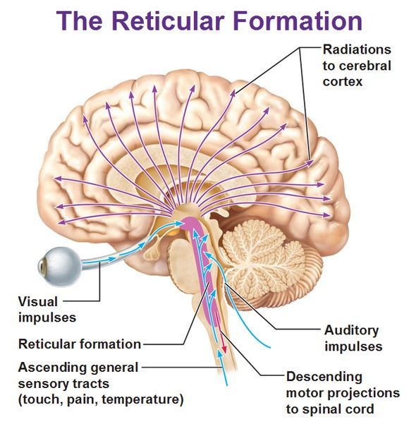

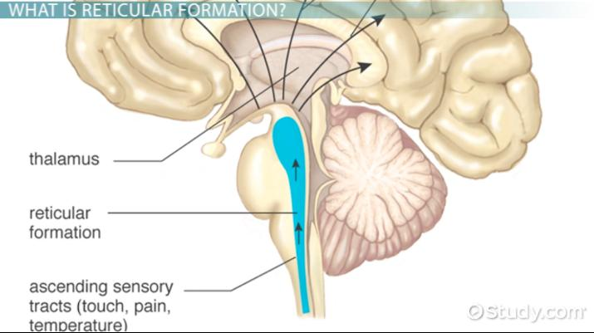

-------------------------------------------------------------------------------------------------------------------

Q3.Osman, a 23 years old boy suffered a traumatic brain injury on the right sided orbital lobe. Which side and which half of the retinal fields sensory input would be lost? Reason why?
Answer:
When injury is held on the right side so the left side of retinal fields will be damaged and left side of both eyes will lost it visual ability. It is because of decussation of fibers. The right half of the brain has visual pathways for the left hemi field of both eyes, and the left half of the brain has visual pathway for the right hemi field of both eyes. So when one of these pathways is damaged , the corresponding visual field is lost .So in this case lesion was on right side so left half of the both visual field was lost.

--------------------------------------------------------------------------------------------------------------------

