COURSE TITLE:PROSTODONTICS
INSTRUCTOR:MS. SALMA ISHAQ
NAME:GULSHAD
ID:13766
SEMESTER:6th BS. D.T

Q. 1Label the below diagram and describe the component of RPD?
Ans.
Diagram
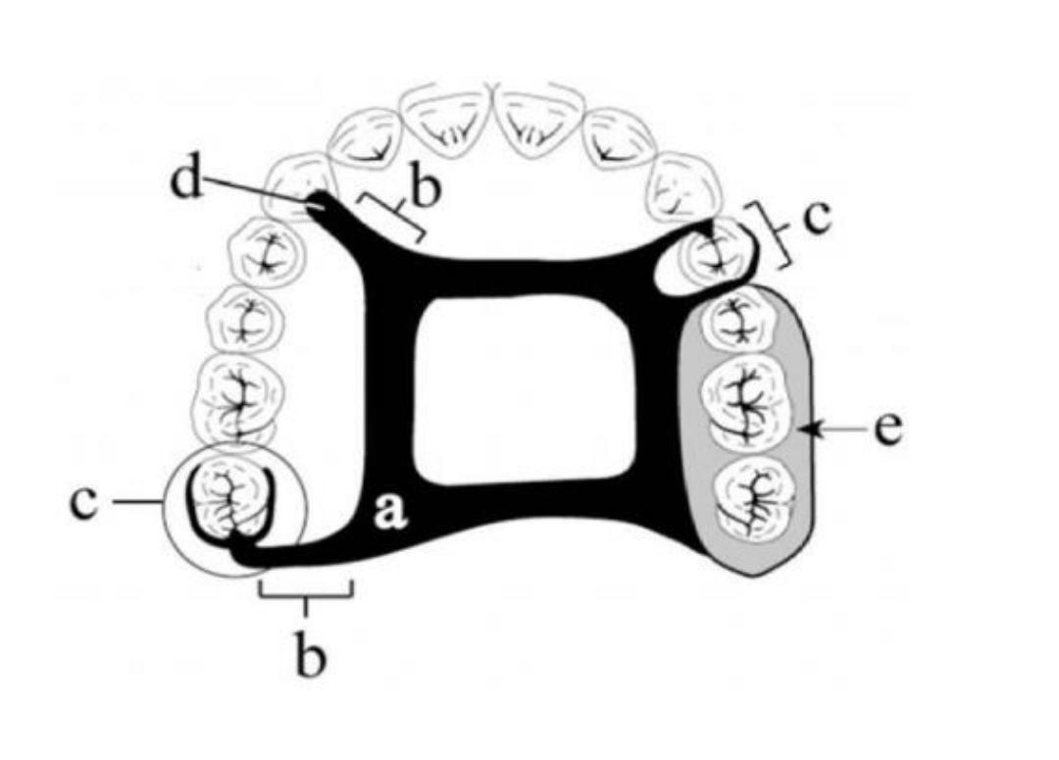

A. Major connector.
B. Miner connector.
C. Direct retainer.
D. Indirect retainer.
E. Denture base.
Component of RPD:
Rather than lying entirely on the edentulous ridge like complete dentures, removable partial
dentures possess clasps of cobalt-chrome or titanium metal or plastic that "clip" onto the
remaining teeth, making the RPD more stable and retentive.
Major connector (The thick metal "U" in the RPD image above is a lingual bar, a type of major
connector)
• Anterior-posterior palatal strap
• Single palatal strap
• U-shaped palatal connector (Horseshoe)
• Lingual bar
• Lingual plate
Minor connector
(See the small struts protruding from the lingual bar at roughly 90 degree angles.)
Direct retainer
(Examples are in the upper left of upper photo and lower right of lower photo; the clasp arms act to
hug the teeth and keep the RPD in place. The metal clasp and rest immediately adjacent to the
denture teeth is also a direct retainer.)
Indirect retainer
(An example is the little metal piece coming off the "U" at a 90 degree angle near the top of the
upper photo, which is a cingulum rest on a canine.)
Physical retainer
(This is a mesh of metal that allows the pink base material to connect to the metal framework of
the RPD. Some consider physical retainers their own component (making a total of seven), while
others consider them within the indirect retainer category (thus making a total of six components.)
Denture Base
(the pink material, mimicking gingiva)
Prosthetic Teeth
(plastic or porcelain formed in the shape of teeth)
Q. 2:Why denture should be of low density? Give reasons.
Ans. For full or partial denture wearers, even the best fitting dentures will begin to loosen and not fit
properly over time. When natural teeth are extracted, the gum tissue shrinks and continues to get
smaller and will cause your dentures to fit loosely. Unfortunately lower dentures never fit securely
due to the shape of the lower bridge in your mouth and the tongue muscles continually dislodging
the denture each time you eat or speak.
Fitting denture can:
• Cause discomfort or pain.
• Cause oral sores.
• Limit what you can eat and your chewing ability.
• Affect how you speak and articulate words.
• Result in loss of bone and gum tissue density due to the constant compression of the
dentures.
• Lead to lowered self-esteem and diminished quality of life.
• If your dentures are loose, your dentist may recommend a solution called relining. There
are two ways to reline your dentures: a temporary reline that involves adding material
under the denture that hardens and fills the space between your oral tissue and denture.
This is done during a regular visit to the dentist and will help to stabilize the denture for a
short amount of time. The second option is a permanent reline that involves the same
material being added to the denture; however a permanent denture plastic is added by a
dental lab that is more resilient and lasts longer.
• A more effective and permanent solution to relining and dentures is dental implants or
implanted dentures. Dental implants feel and look more natural, provide stability and most
of all comfort while eating, speaking and chewing. With permanent implants, you will have
lots to smile about and loose and ill-fitting dentures will be a thing of the past
Q3:Briefly explain the types of major connector?
Ans. Upper connectors
There are many options for major connectors for removable upper partial dentures. The type of
connector used will vary depending on the specific circumstances and the results of a
comprehensive examination and discussion with the patient. Commonly used major connectors are
outlined in the table below along with details of factors affecting the choice of using them.
Plate:
Advantages of plates are that they are useful when several teeth are missing or there are multiple
saddle. They also provide more retention, stability and support due to larger palatal coverage.
Plates are useful when there are long distal extensions. Disadvantages of plates are that they overs
a lot of patients mouth so sometimes not well tolerated and also may affect phonetics. Plates can be
problematic if there is a torus palatines.
Palatal bar (Strap/ Anterior-Posterior)
Advantages of these are their rigidity and minimal soft tissue coverage yet still having good
resistance to deformation. A-P strap useful for Kennedy class I and II or if there is a torus. A-P strap
gives greater distribution of stresses. Disadvantages of these are that there is not much support due
to less palatal coverage and also that is it bulky and so disliked by some patients.

U-shaped palatal bar (horseshoe connector)
Advantages of these are that they are useful in cases where we do not want to cover much of the
palate e.g. if patient has a strong gag reflex, a large palatal torus or Kennedy class III.Disadvantages
of these are that they are flexible due to distal extensions which can have adverse effects on force
transmission to abutment teeth. They can traumatic to the residual ridge.
Spoon denture
Advantages of these are that they are useful in small anterior saddles and are cheap to make.
Disadvantages of these are that they have large palatal coverage for a small saddle.
Palatal Strap/Bar (Single/ Anterior, mid or Posterior)
Advantages of these are that single strap is useful for Kennedy class III and IV cases. Disadvantage
of these are that single strap requires careful placement if there is a torus palatines. They are
generally inappropriate for Kennedy Class 1 or 2.

