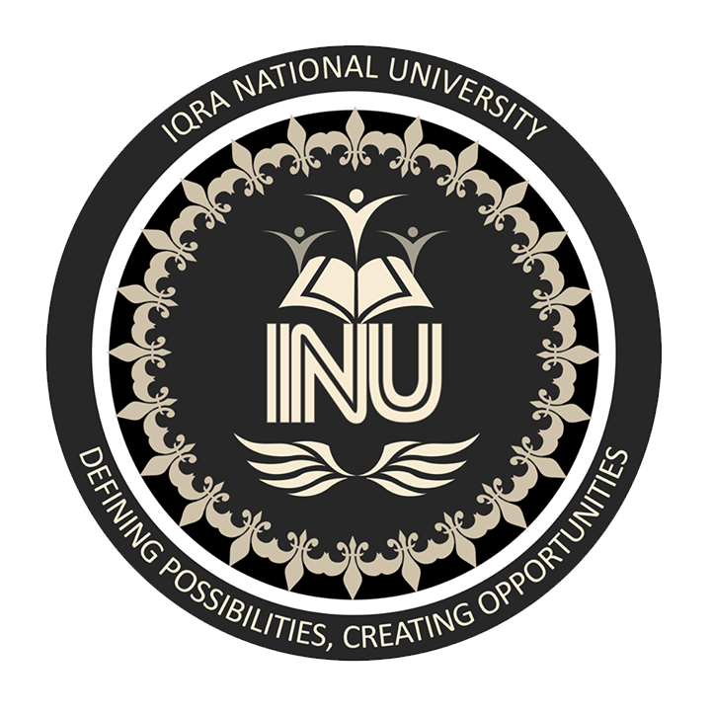

Name: Kamgar khan
ID 12808
Submitted to: Dr Adil Adnan
Major Assignment on International Marketing
Date: 26 June 2020

Dear Students please take any topic or issue related to the areas of the international marketing & discuss it thoroughly & critically in your own words.
International Marketing:
Norms and Ethics:
As we enter to new international market, we have to know their cultural norms ethics and features.
Ethics refers to moral principles, standards, and norms of conduct governing individual and firm’s behavior. They are deeply reflected in formal laws and regulations. In different parts of the world, different codes of conduct are specified that every international business player has to observe. However, globalization process has emphasized some common ethics worldwide. Corruption is another issue relating to business ethics.

