DENTAL SEC B PHYSIOLOGY, 2ND SEMESTER
MAM KOUSAR SHAH JEHAN
STUDENT NAME__Tahir ullah_, ID__16144__
Attempt all questions. Every question carry 10 marks.
Name Tahir ullah
ID 16144
Subject physiology
Samester 2nd
Bs Dental
Q1. Write the functions and composition of blood?
Answer:. Blood :.
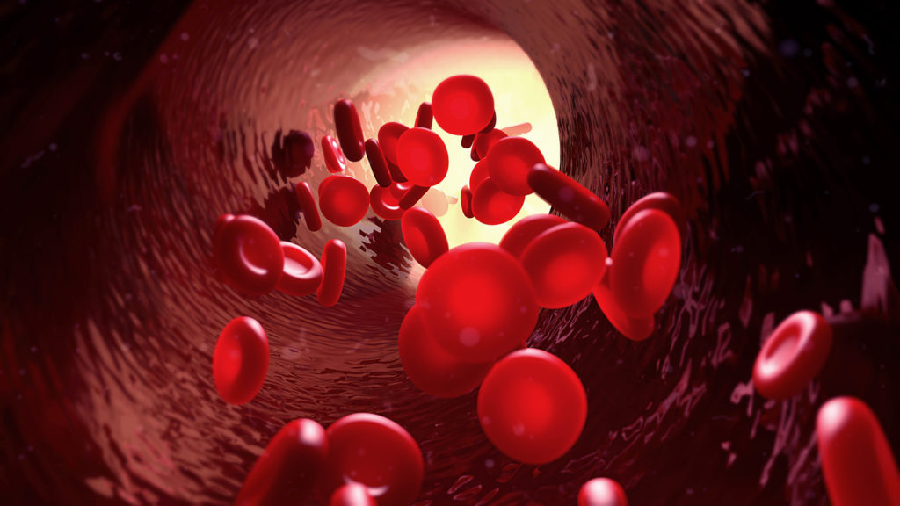
A specialized types of connectiv tissue that consist of liquid protion ( plasma ) and formed element. ( RBC, WBC, and plateletes ect
) That these elements are having dipite shape :
* Transport oxygen and nutrients to the lung and tissues.
* Froming blood clots to prevent excess blood loss.
* Carrying cell and antibodes that fight information.
1) Plasma:.

The liquid component of blood is called plasma , a mixture of water , sugar , fat , protein , and salts. The main job of the plasma is to transport blood cell throughout your body along with nutrients, waste products, proteins that the help maintain the body’s fluid balance.
2) Red Blood Cell:.
* Biconcave in shap.
* Diameter=7.8 micrometer.
* 52, 00, 000/cubic millimeter of blood in males .
* 47, 00, 000 in females.
3) White Blood Cell:.
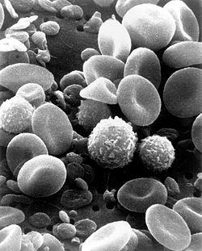
*7000 per microliter of blood .
* 6 types of WBC
= Polymorphonuclear neutrophills 62%
= polymorphonuclear eosinopills 2.3%
= polumorphonuclear basopills 0.4 %
= Monocytes 5.3%
= Lymphocytes 30%
4) Platelets:.
= 300, 000, per microliter of blood
Function of Blood::.
Blood has three main function :
Transport , Protection , and Regulation .
1) Transport:.
Blood transport the following substances:
* Gases namely oxygen (O2), and carbon dioxide ( CO2), between the lung and rest of the body .
2) Protection :.
Blood has several roles in inflammation:
* Antibodes and other proteins destoroy pathgnic substance.
* Platelet factors intiate blood clotting and help minimise loss.
3)Regulation:.
Blood help regulate:
* PH bybinteracting with acids and bases
* Water balance by transfering wayer to and from tissues.

Q2. What is erythrocyte, erythropoiesis, erythrocytosis and erythropenia?
Answer:.
1) Erythrocytes:.
* Since RBCs have a elastic membrane , they are able to change their shap when they pass through the capillaries.
* The cell develop in the bone marrow and circulate for about 100_120 days in the body before their compnents are recycled.
* Human red blood cell take on averange 20 second to complete one cycel of circulation.
2) Erythropoiesis:.
Erthropoiesis is the process which produce red blood cell which is the development from erythropoitic stem cell to mature red blood cell.It is stimulated by decreased O2 in circulation , which is detected by secrete the hormone erythropoietin.
3) Erythrocytosis:.
Erythorcytosos is defined as an increase in red blood cell (RBC) mass usallly aboluteb, and is also associated with an increased hematration (HCT) and hemoglobin concentration . Although some use the trem polycythemoa in terhange ably with erythrocytosis the two are not synonymous.
4) Erythropenia:.
Erythropenoa a decrease in the number of erythrocytes , assocoated with anemia. Primary erythrocytosis can be passed down through familes .Its caused by a mutation in genes that control how many RBCs your bone marrow makes .RBC even when your body auesnt need them.
Q3. What is platelets and write about clotting mechanism and its all steps?
Answer:
Platelets:.
Platelets , also called thrombocytes are a coponent of blood whose function is to teact to bleeding from blood vessels injury by clumping , threr by initating a blood clot .
Sturcture:..
* platelets have no cell nucleus , the are fragments of cytoplasm that are derived from the megakaryocytes of the bone , marrow which then enter the circulation.
* Circulation unactivated platelets are biconex discoied ( lens_shaped ) sturcture 2_3 um in diameter.
Life span:.
10 days.
Function :.
*Stop bleeding
* Maintain hemosyasis
* Clotting mechanism.
What is clotting mechanism:.
* Coagulation / clotting means _ blood changes from liquid to gel .
Mechanism involves:.
1) Adhesion:.
** Injury to blood vessels.
*** Endothelium lining the vessels damage.
*** Blood comes into space under endothelium.
*** This is adhesion.
2) Activation:..
** Platelets change shape .
*** Urn on receptors and secret cjemical messenger to activated and invite additionall platelets.
*** Actived platelets adhere tightly at injury site.
3) Aggregation:..
**** Platelets connect to each other through receptor bridges.
**** Platelets plug formed at injury site unless the interruption is physically too large.
3) Deposition:..
*** Formation of platelets plug will ensure primary hemostasis .
*** Now clot retraction and platelets inhibition.
*** Thus fibir clot formed .
Q4. Write a note on ABO system?
Answer:::.
ABO system ★
Land stener (1901)
discored ABO_ BG system.
=• Blood group of individul depend on prensence /Absence of specific / Antibody on RBC.
=• ABO blood group system only 2_antigen detemine the blood group .
=• Person having antigen( A) on RBC , will repressent blood group( A and B antibodies )
=• Antigen B on RBC surface _ will have antibodies A will have blood group B.
=• The person having O antigen on RBC have Antibodies both A and B .
=• O blood group is a universal donor.
Blood Antigen Antibodies Trans
A A B B

B B A B
AB AB No Aceeft universal

O No antigen AB Universal done.

Q5.(i) A person fell down from a tree and become unconscious, with bleeding from head, what will you do as a first aid?
Answer:Part 1 Frist aid :.
When a person fall down from tree and become unconsions the frist step i would take is to lay him at the shelter of a tree.
Then i will stop his bleeding.Then i will bandage the wounded place with handkerchief. At last , I will gawe him a cup of cold glass of water.
Finally , I will go with hime and take hime to the hospital.

(ii) you have to meet with your friend and you came to know he is covid positive, what precautionary measures will you take?
Answer part 2 ::.
If i have to meet my friend who has covid 19 possitive ,
The frist precavtion i would take is not shake a hand with him.
The second step is i would maintain a 2 meter distance i will wear amask and gloves.
After coming back to home I will not touch my body parts and also try not to meet others at a way coming back to home .At home, I will we sanitizer.
THANKS

