GIS Mini project Report

Submitted By :
Mushtaq Ahmad
ID:-7722
Section – C
Submitted To :
Engr Hamza Mustafa
Instructor GIS LAB

Department Of Civil Engineering
Iqra National University Of Peshawar

Table of Contents
Practical No. 1 How to Install ArcGis 3
PRACTICAL No.2 Introduction To ArcGis Desktop 4
Practical No. 3 How to Add Data in ArcGis 5
Practical No.4 How to change the color a layer 11
PRACTICAL No. 5 How to Add Point Data in ArcGis 13
PRACTICAL No.6 How to Add Polyline Data in Arc Gis 28
How to add Polygon in Arc Gis 34
Practical No.7 GEORFERECING 37

Practical No. 1
How to Install ArcGis
- Download ArcGis and open the folder
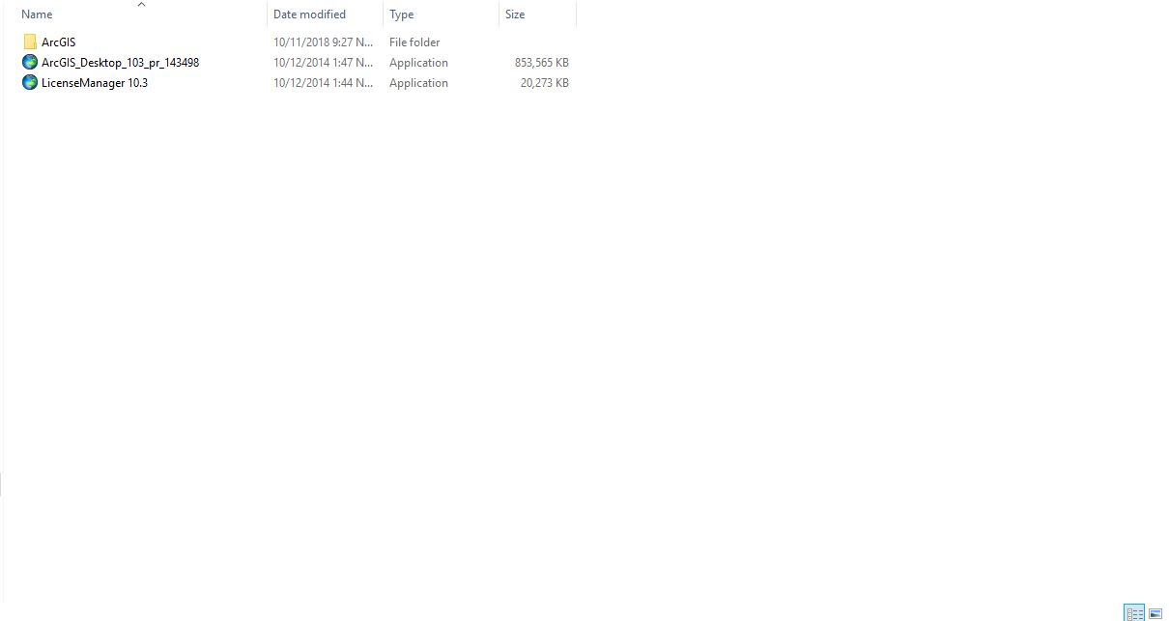
- Right Click and Select Run As Administrator
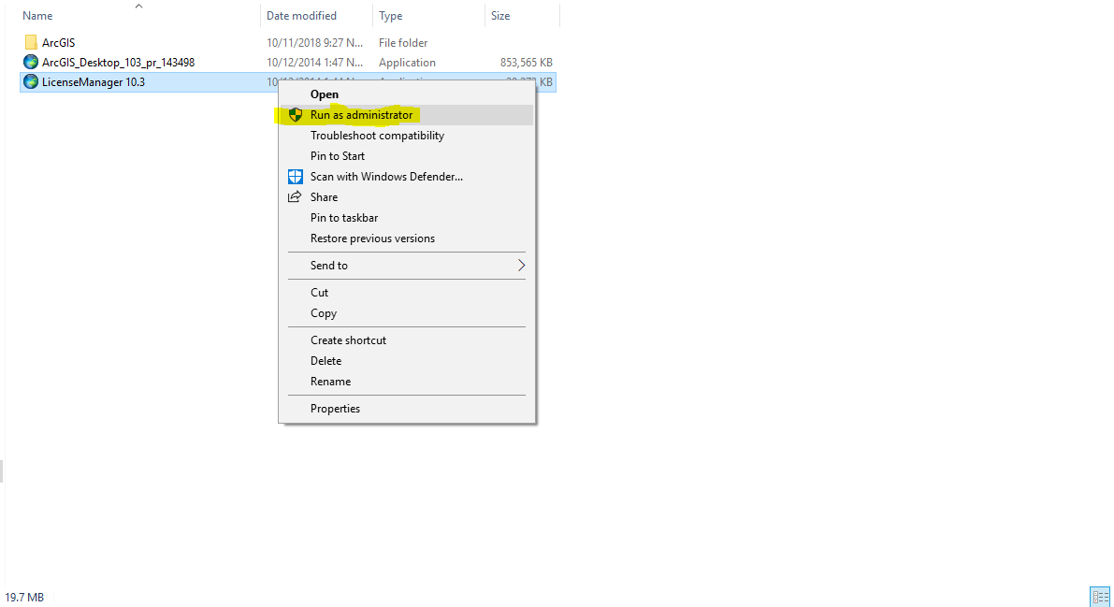
- It will Run
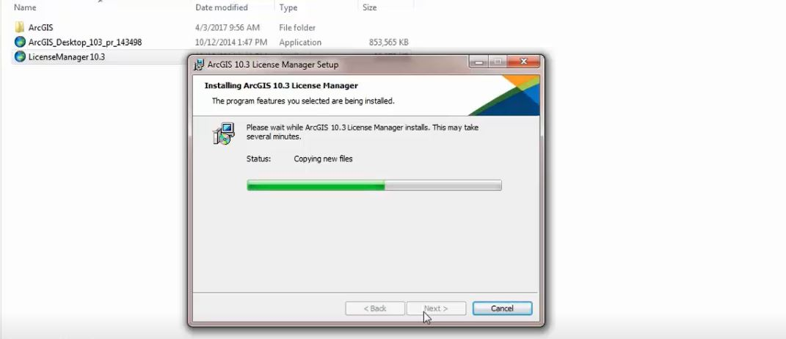
- Copy Computer Name here

- 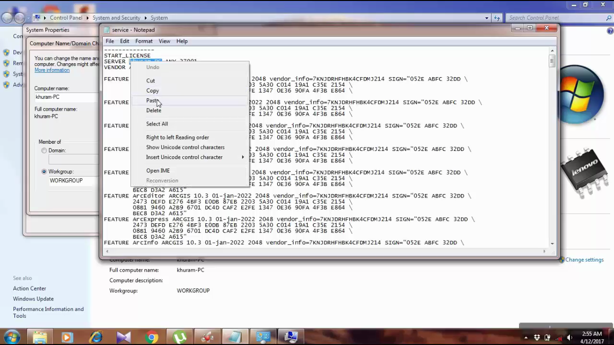

PRACTICAL No.2
Introduction To ArcGis Desktop
- Title bar , Menu Bar and Tool Bar
- Table of Content
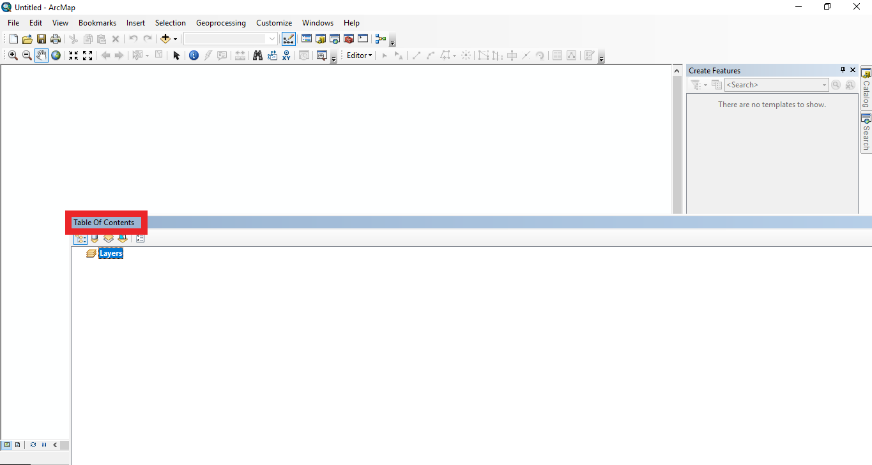

Practical No. 3
How to Add Data in ArcGis

- Click on File on top left most corner. And select on Add Data
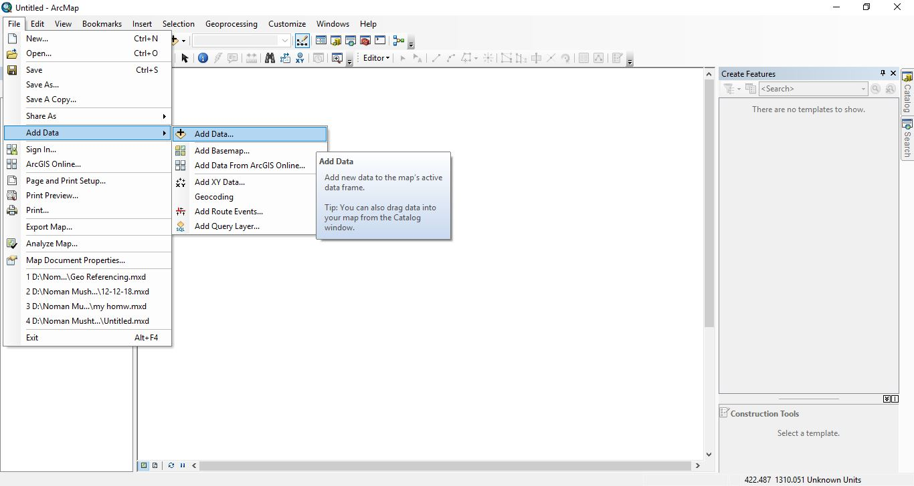
- Connect the GIS to specified Folder
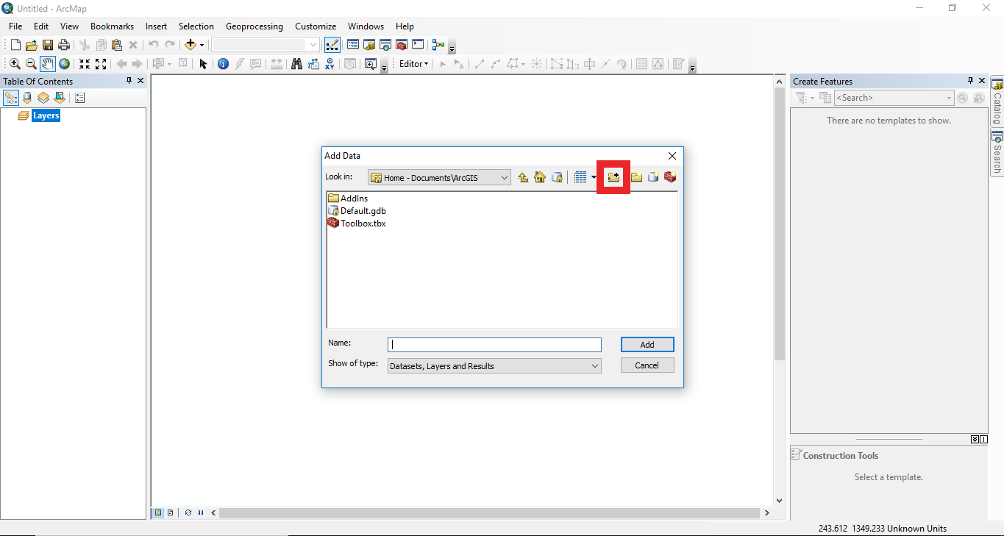
- Then
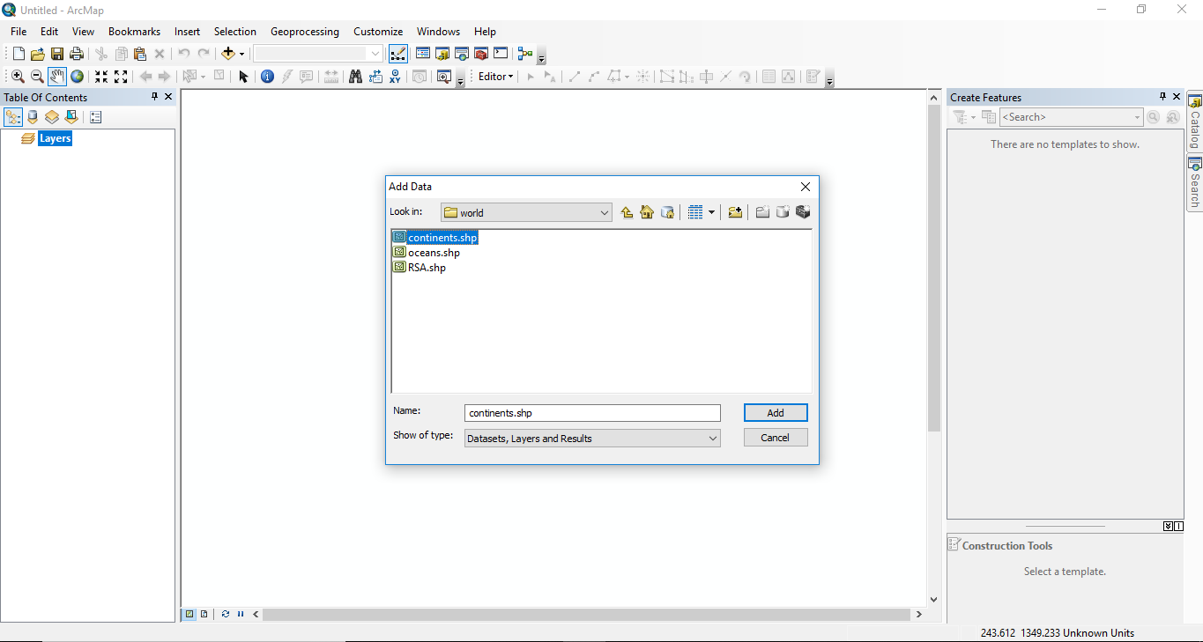
- The data will be imported and will displayed as
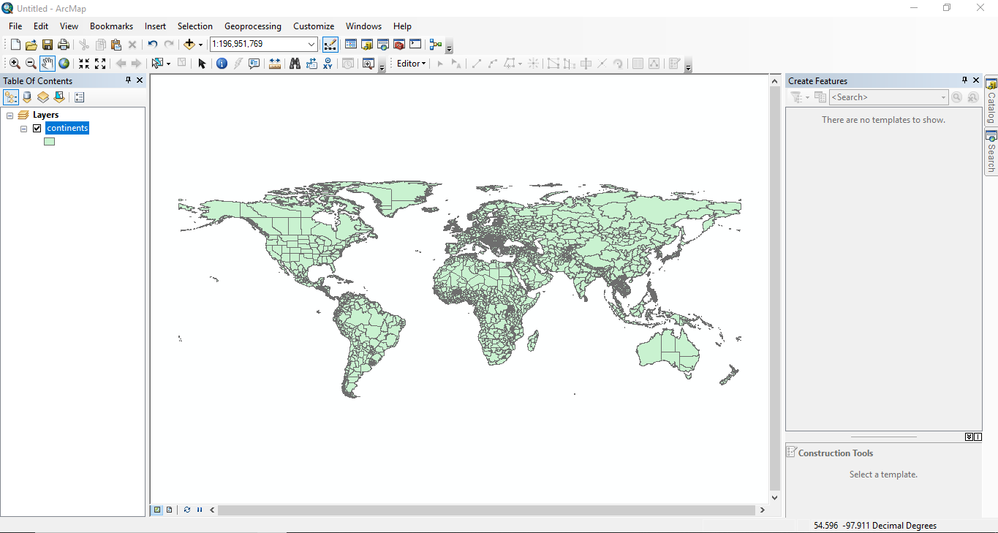
- How to Zoom to full screen
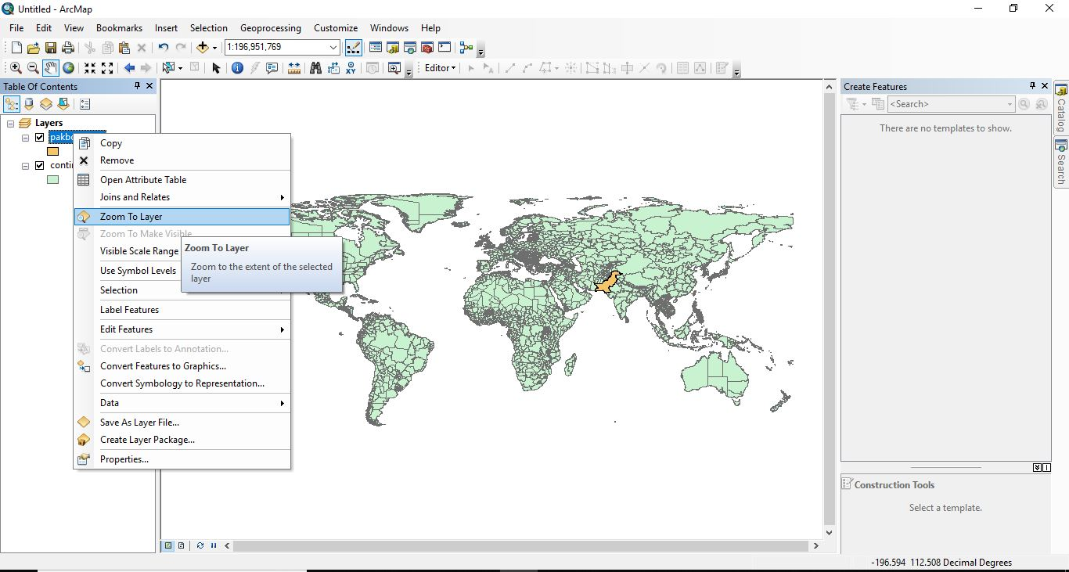

- It will be Zoomed as :
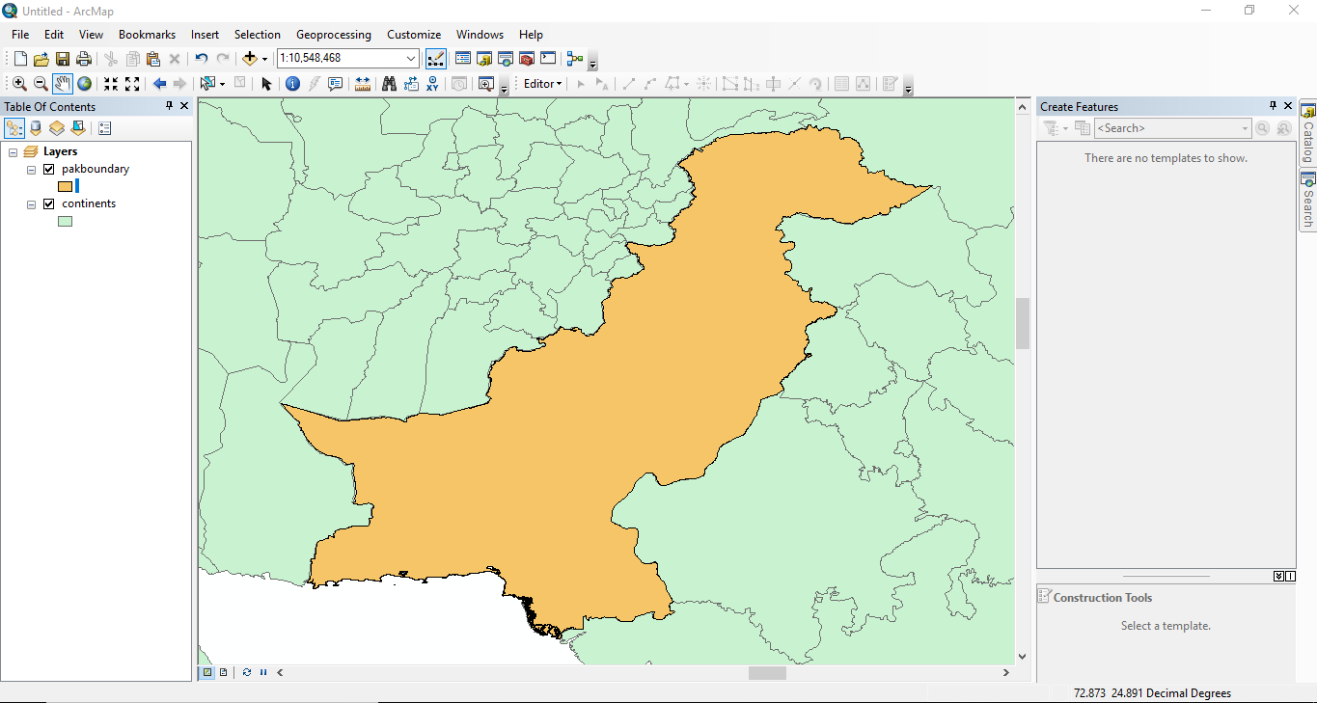
- Identify icon
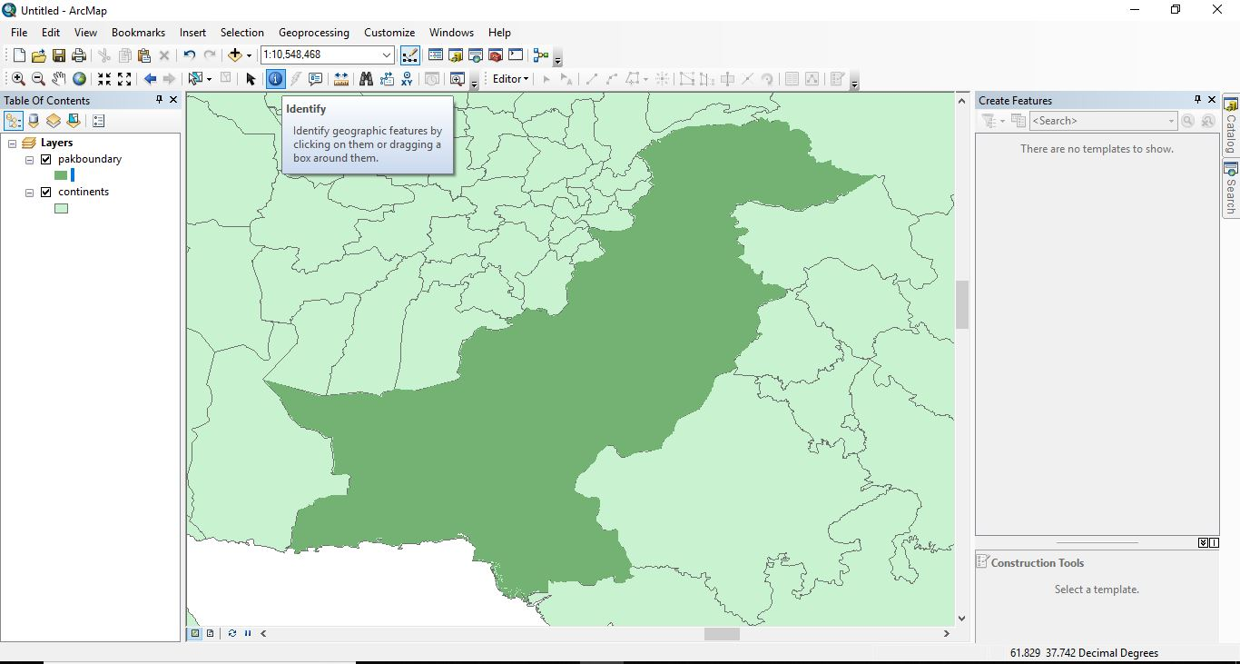
- Result of this identify system
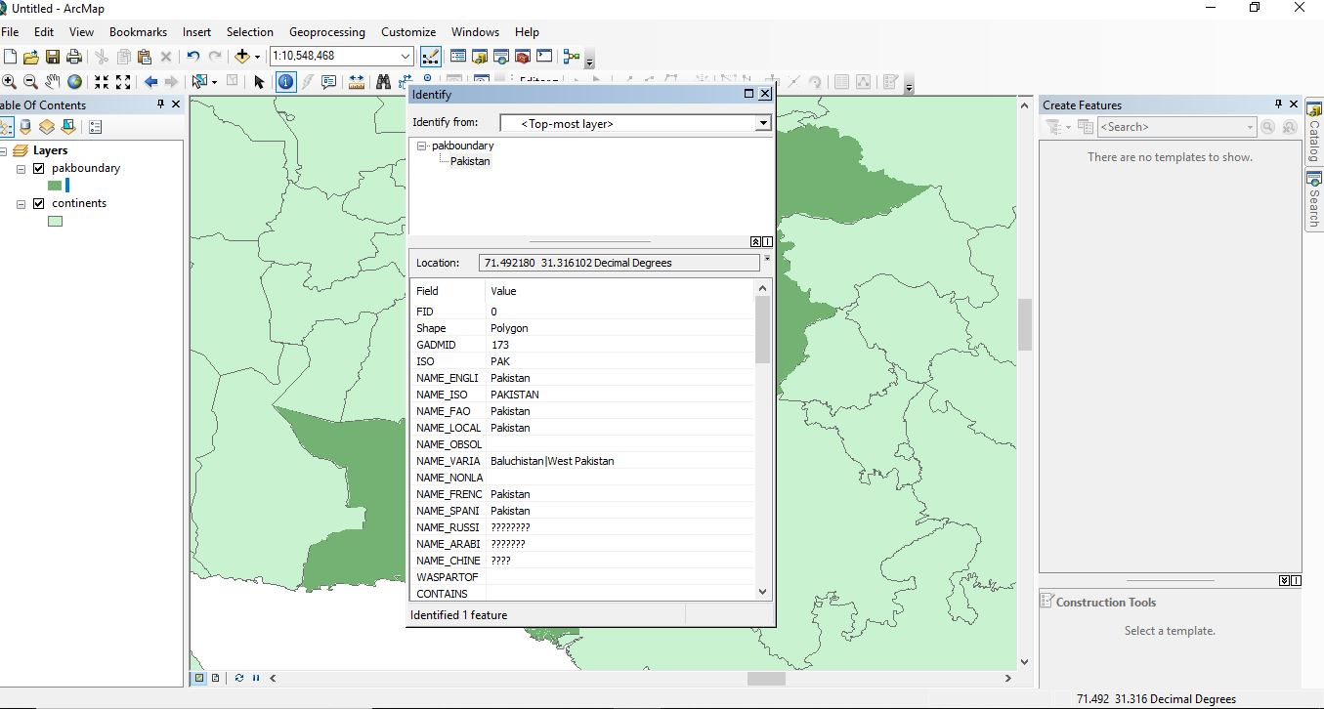
- Tools for Zoom in and Zoom Out
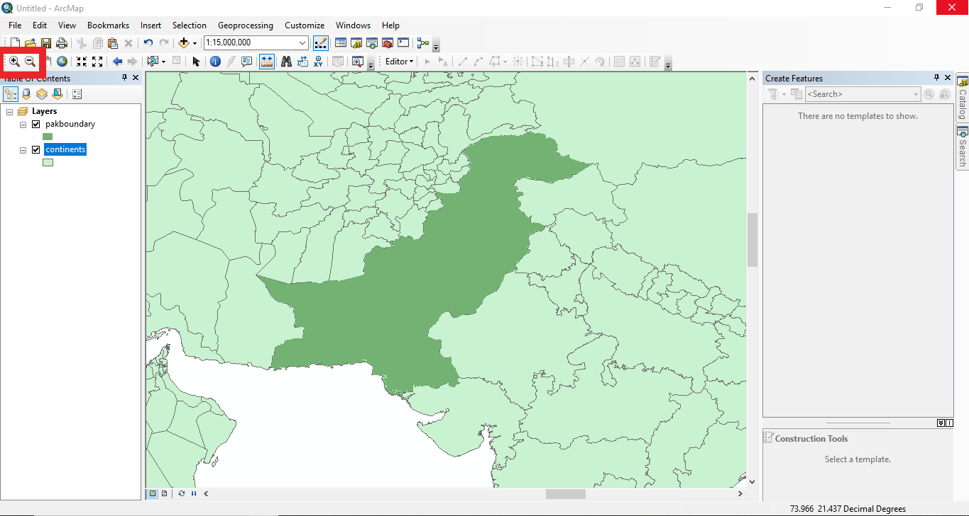
- Tool for Drag
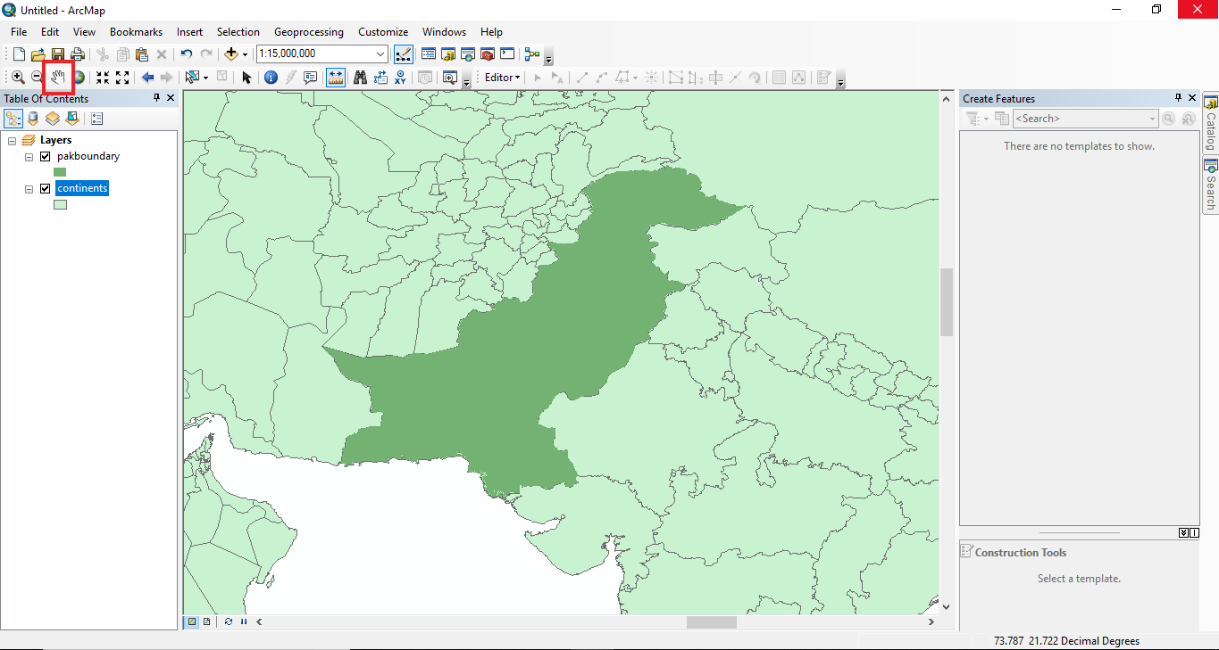
- The Attribute Table
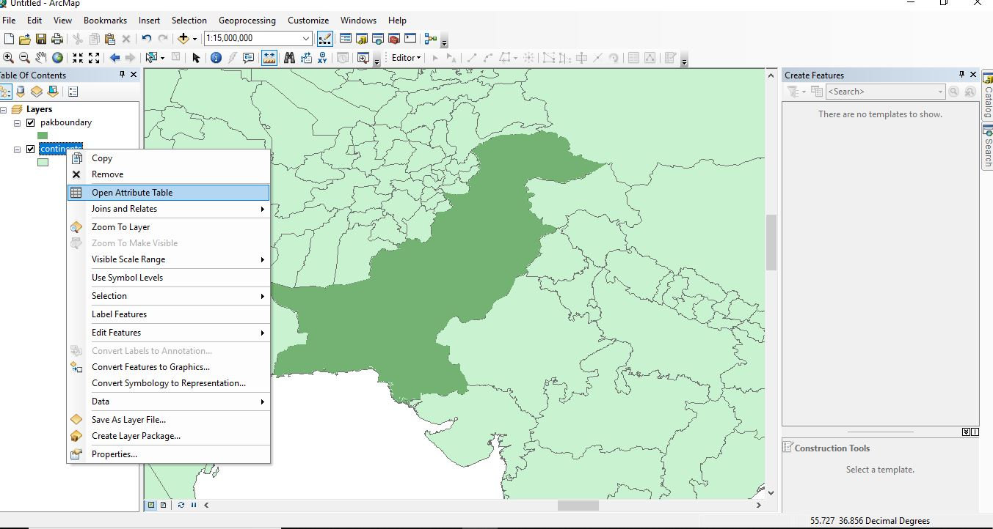
- Result of Attribute Table
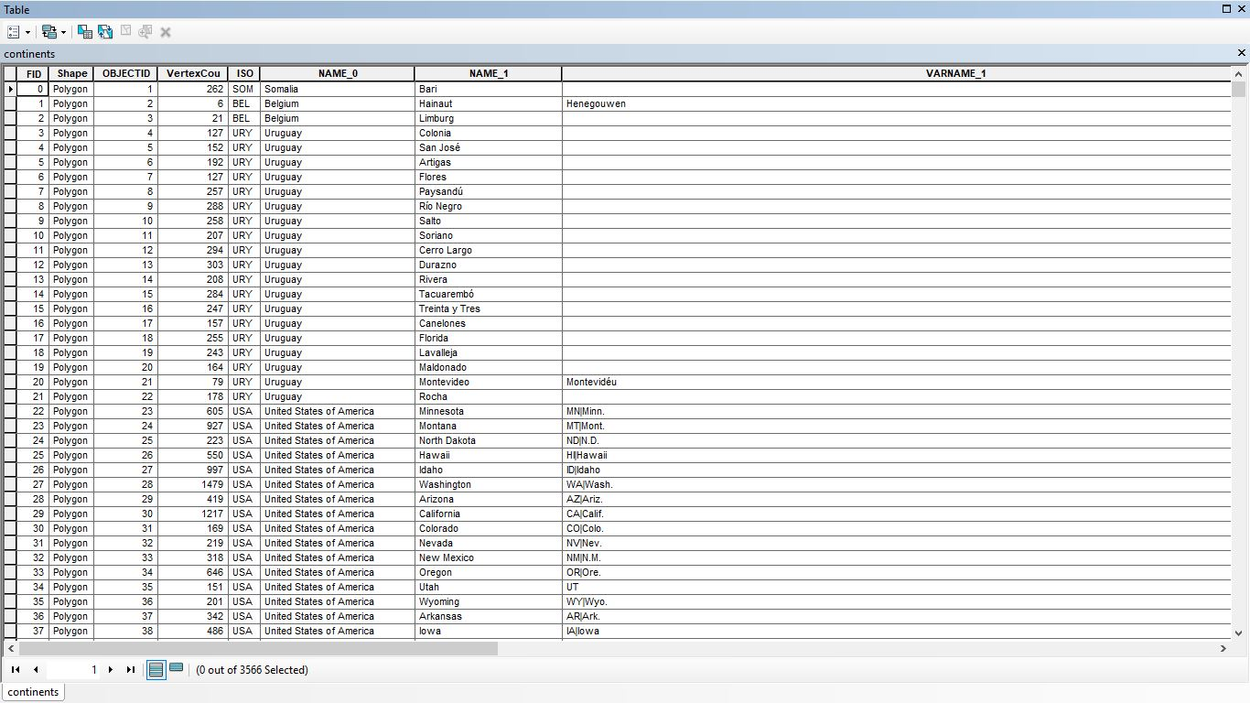

Practical No.4
How to change the color a layer
- Right click and select properties
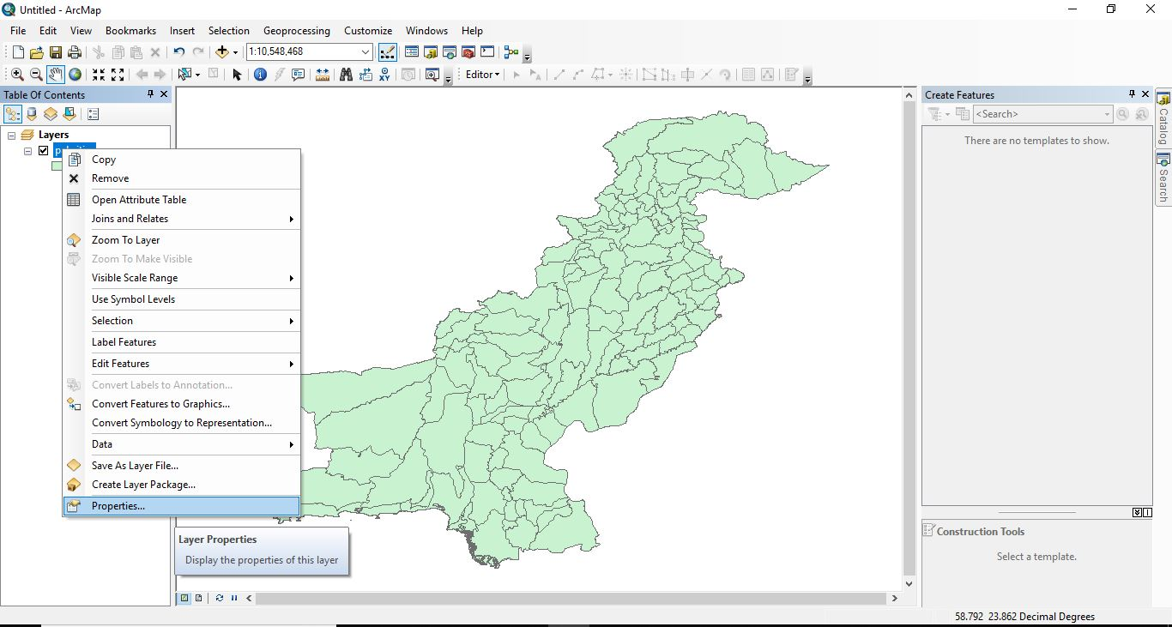
- Go to symbology and click on categories
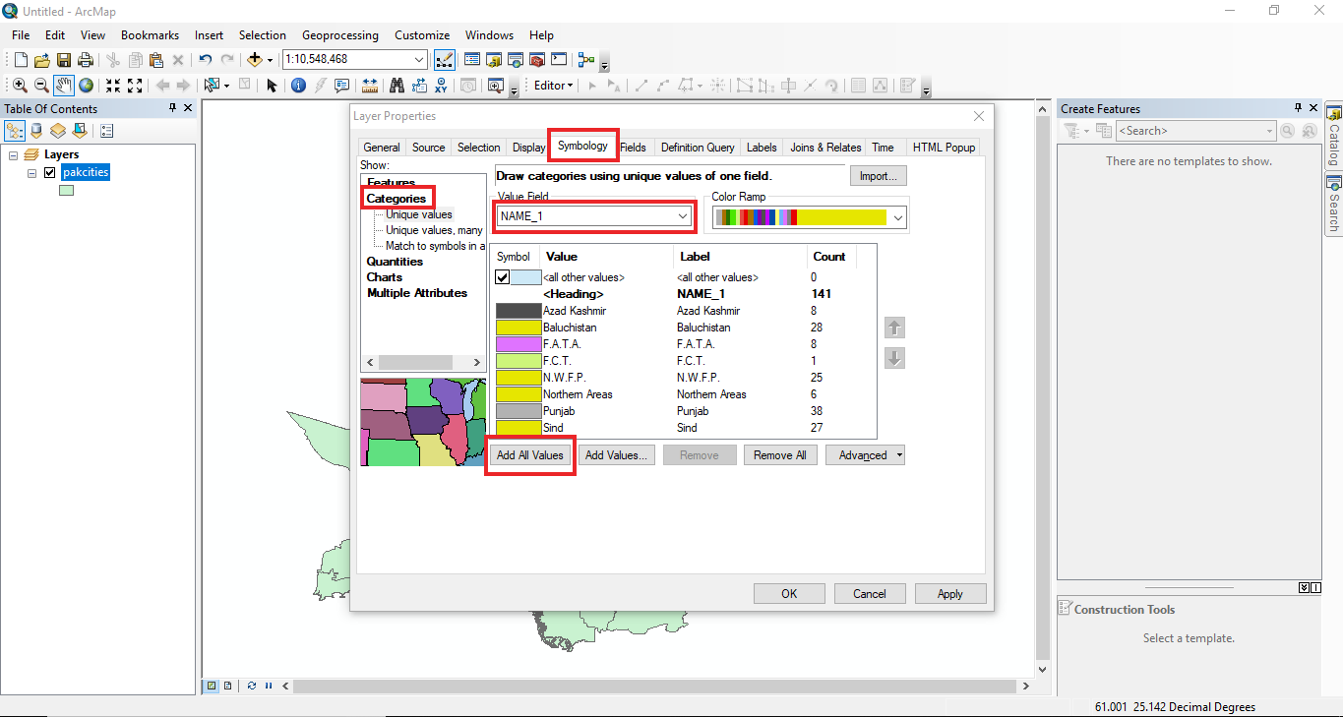
- The color of layer will be changed
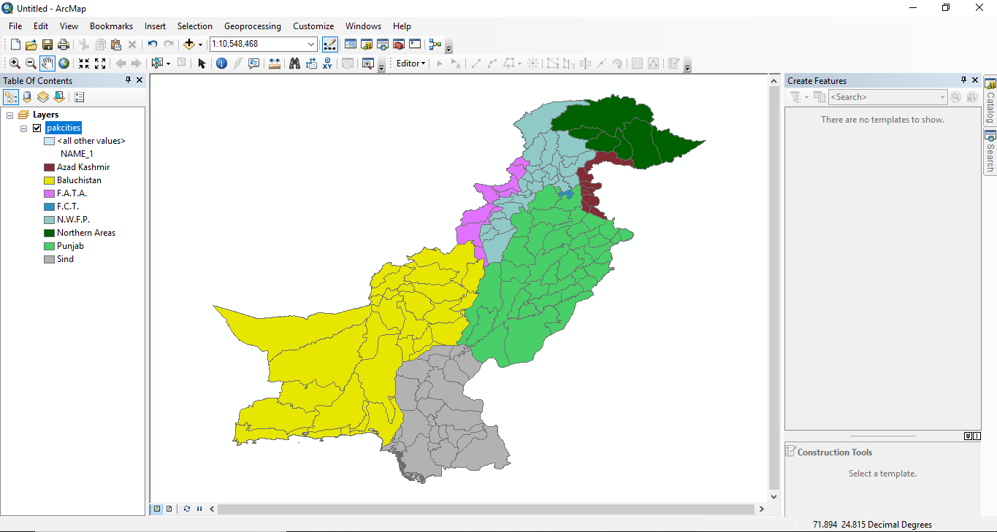

PRACTICAL No. 5
How to Add Point Data in ArcGis
- Open ArcGis
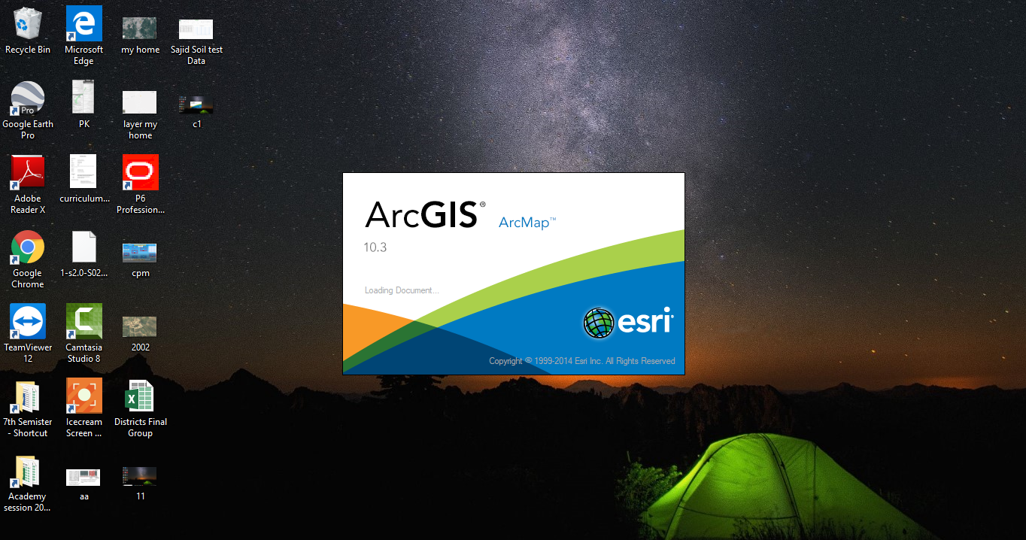

- Add Layer of Peshawar Roads
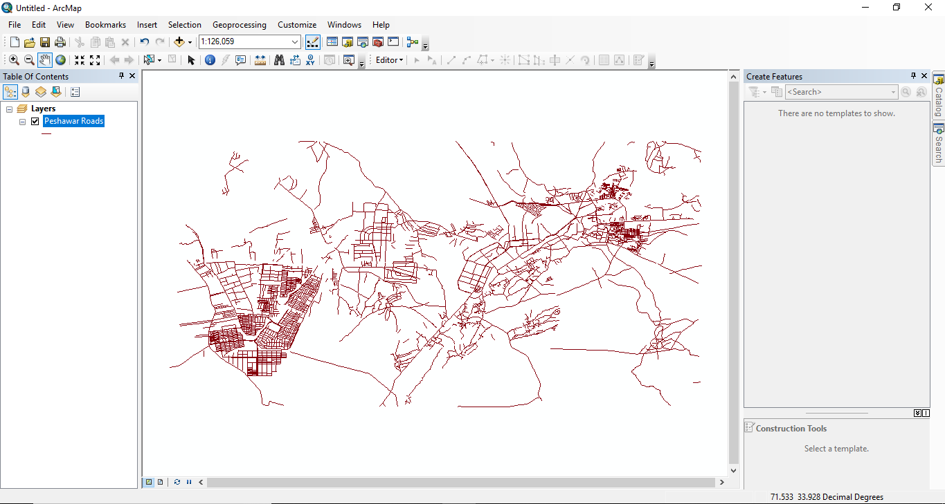
- Now Add Layer of UOP Peshawar High
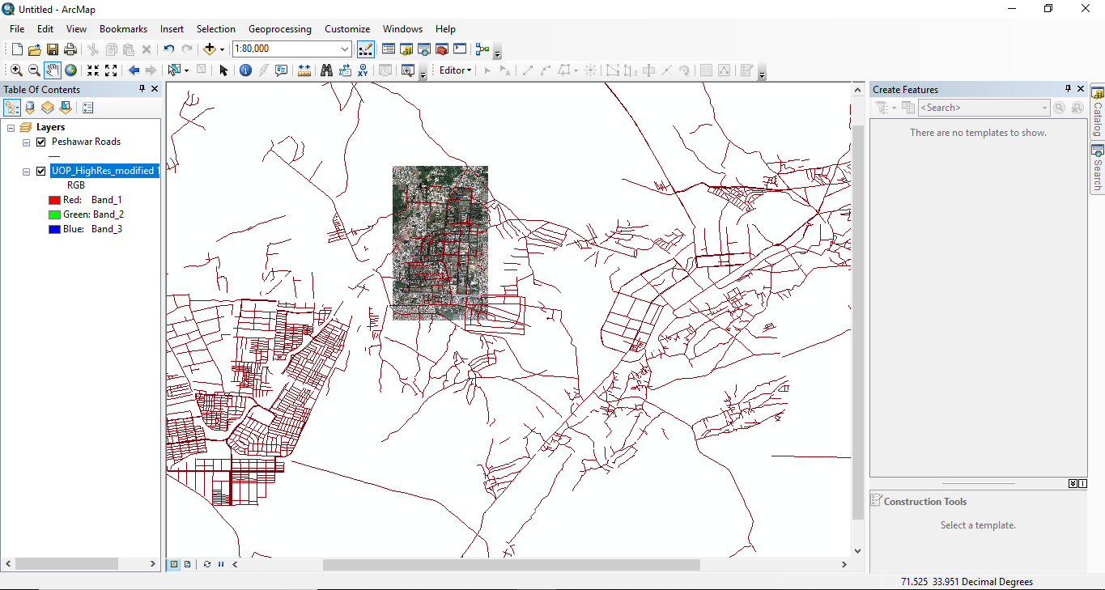
- Add Pak Cities
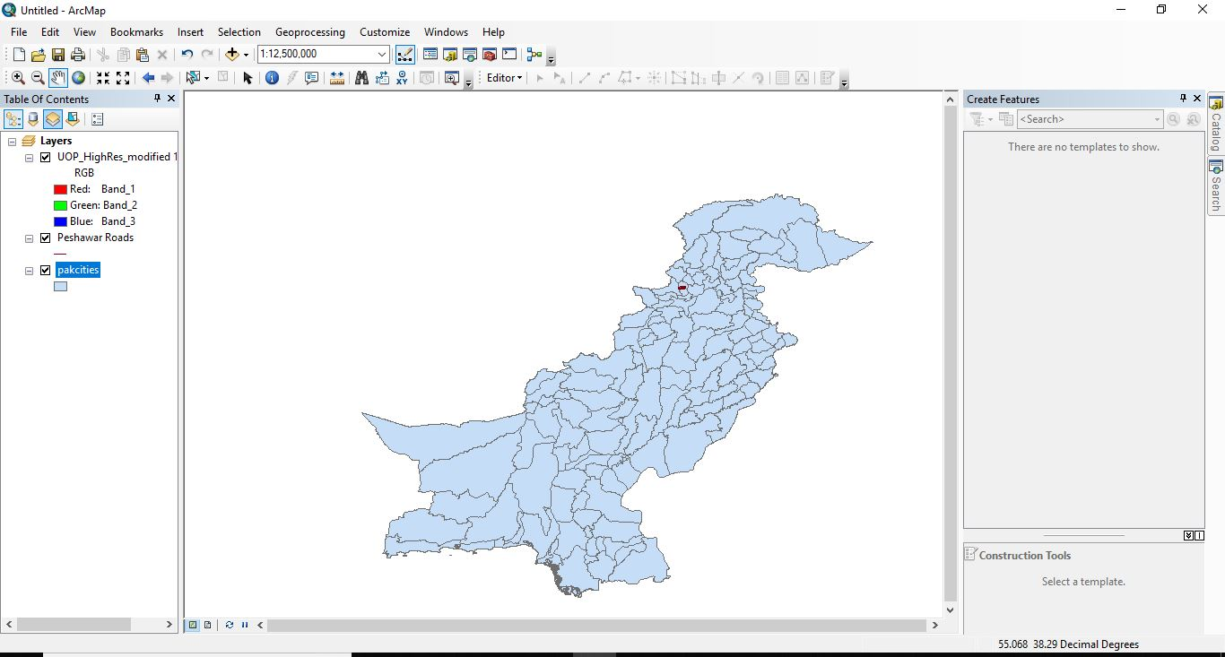
- Right Click on Peshawar Roads and Open Attribute Table.
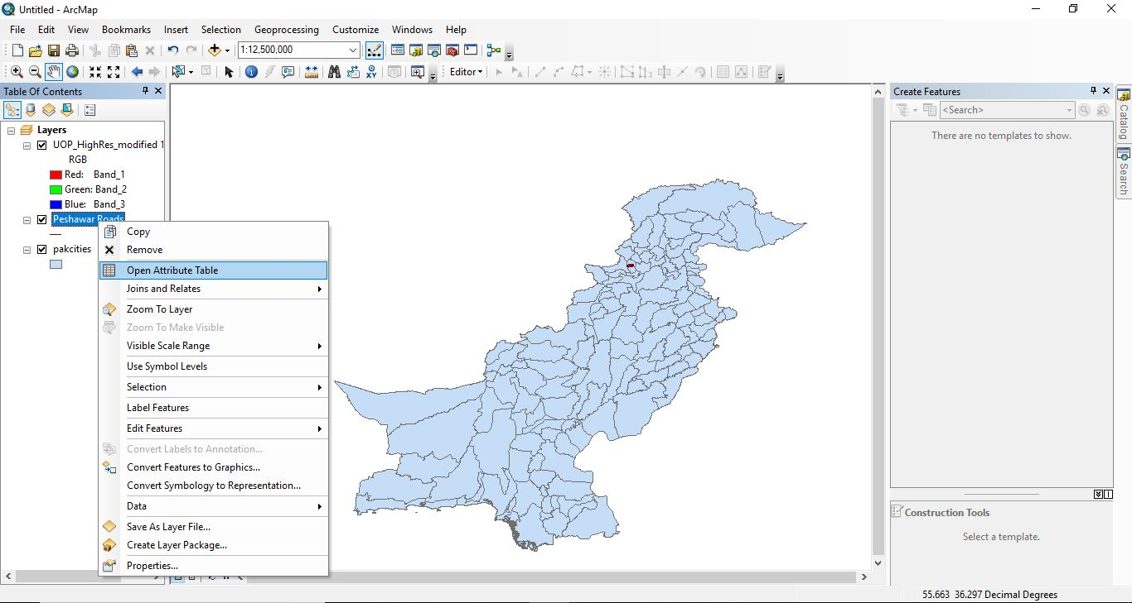
- Attribute Table will be Displayed
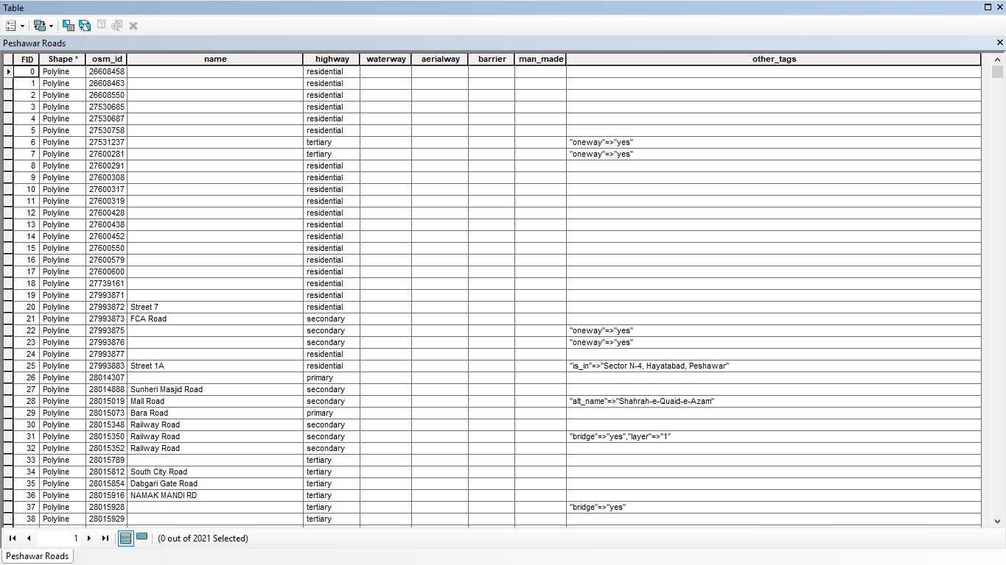
- Click on Catalog on Right Most of Screen
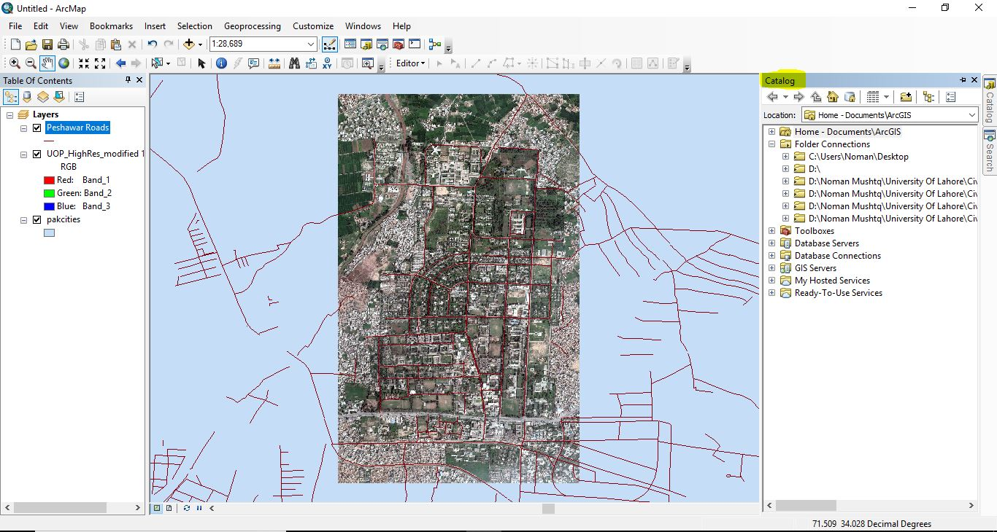

- Make Here a new Folder
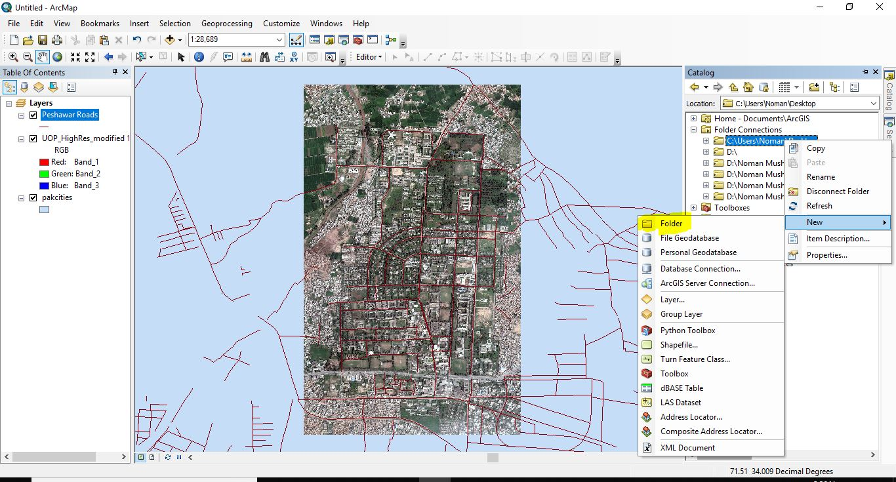
- Name It.
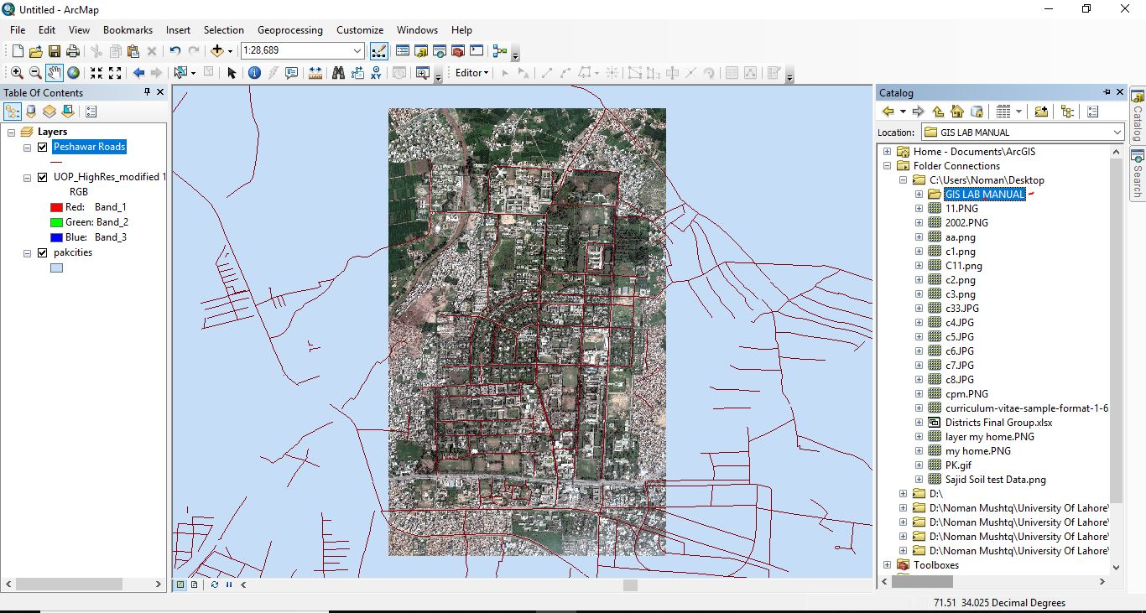
- Right Click and Select Shapefile.
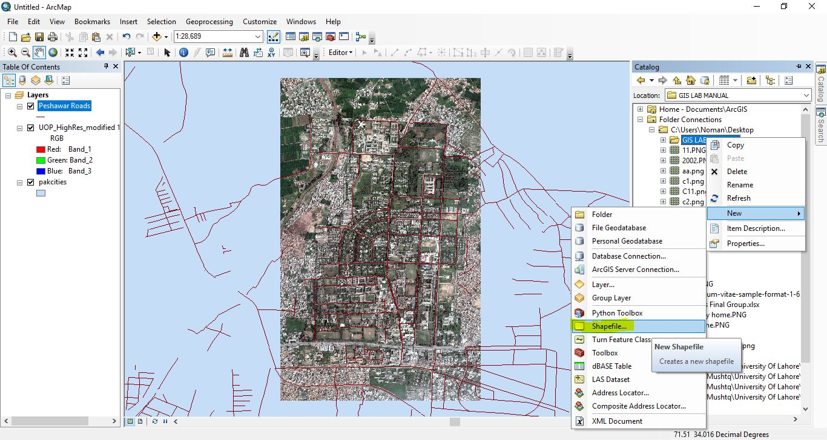
- Following Window will be displayed.
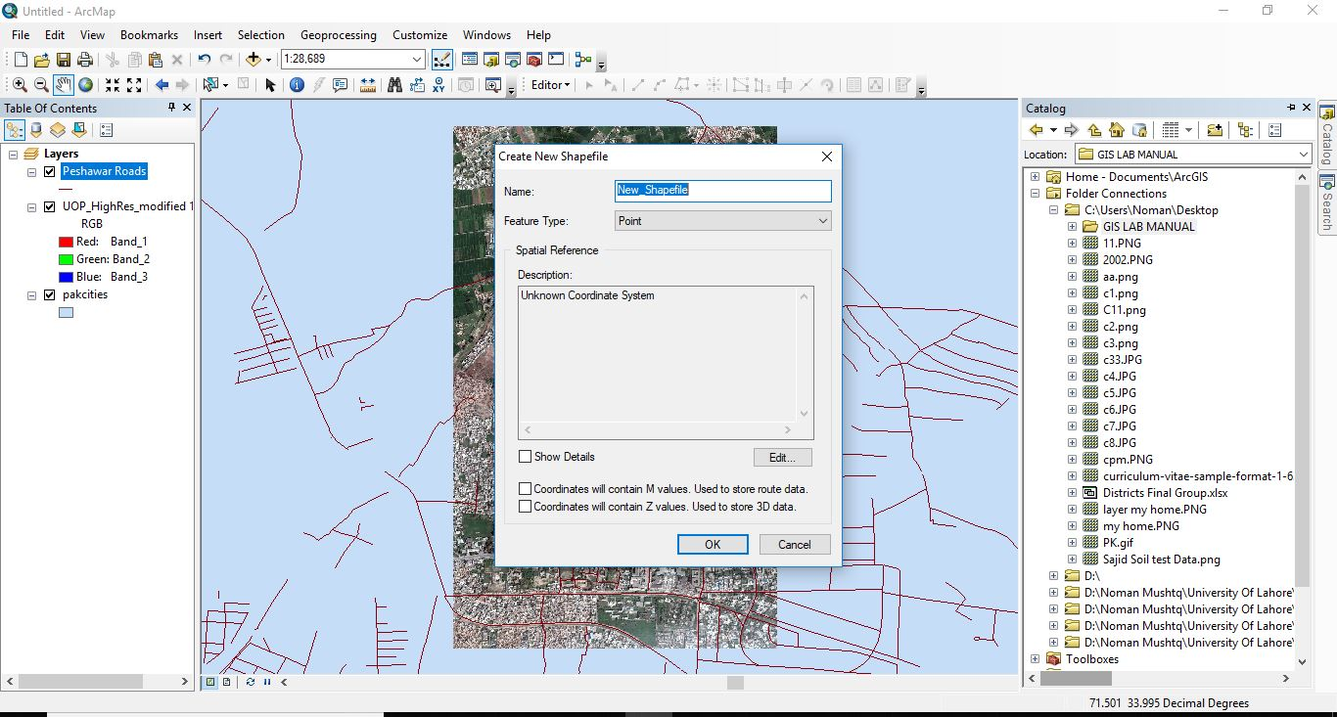
- Give it Name and Select Type of data
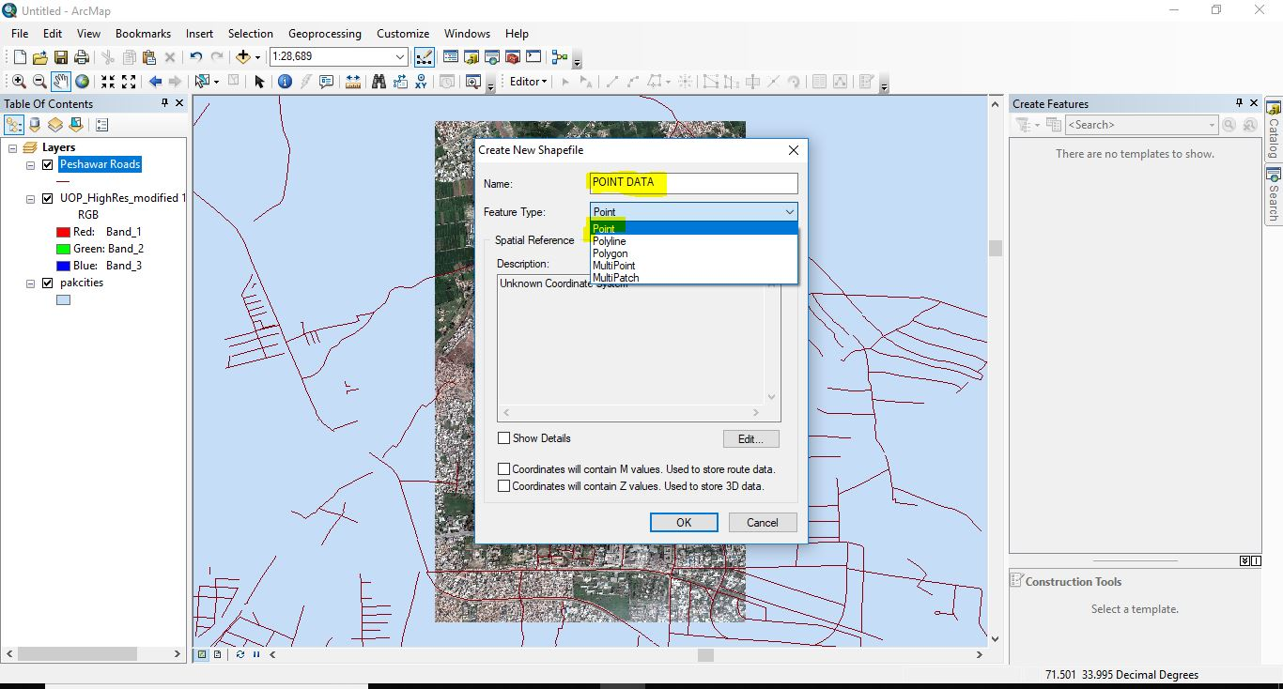
- Now Click on edit
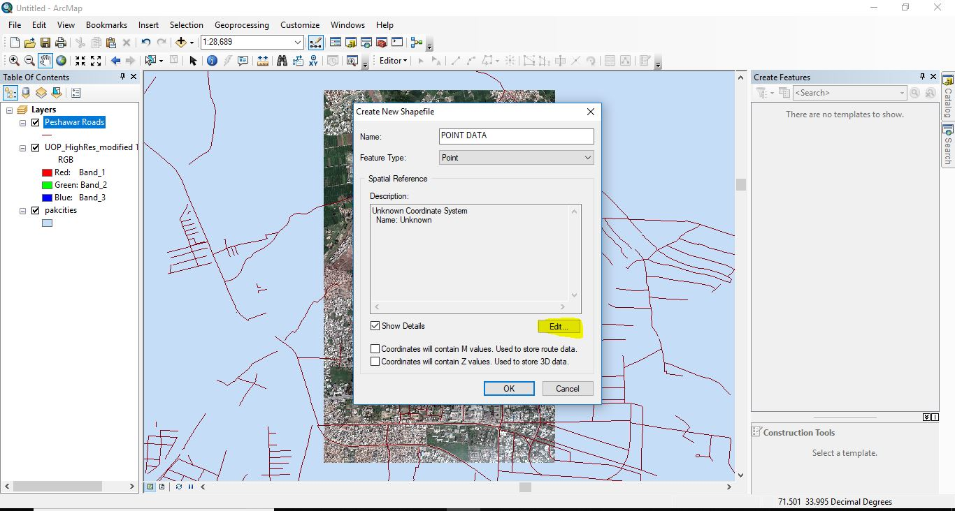
- Following Window will appear
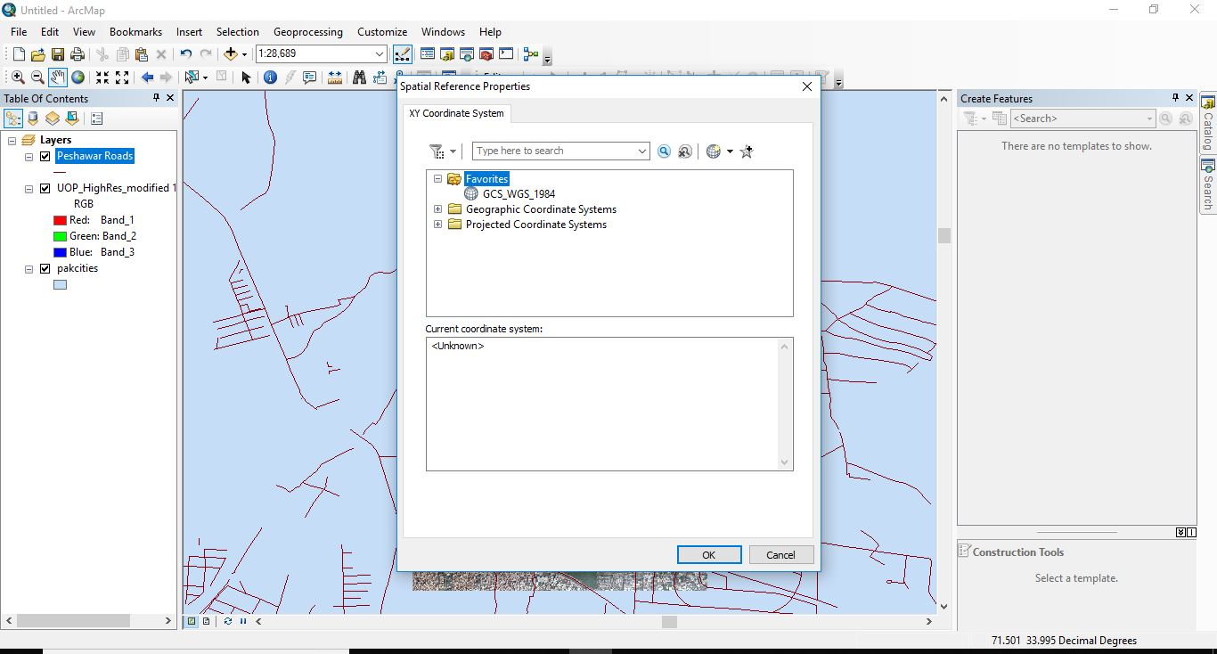
- Now Right Click on icon and select import
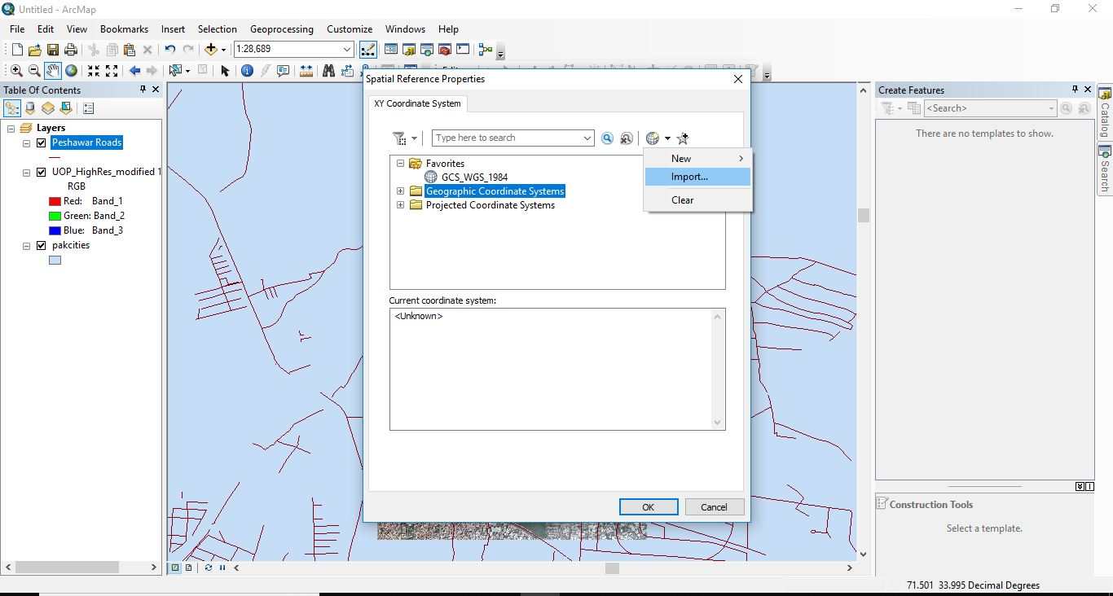
- Import Desired File.
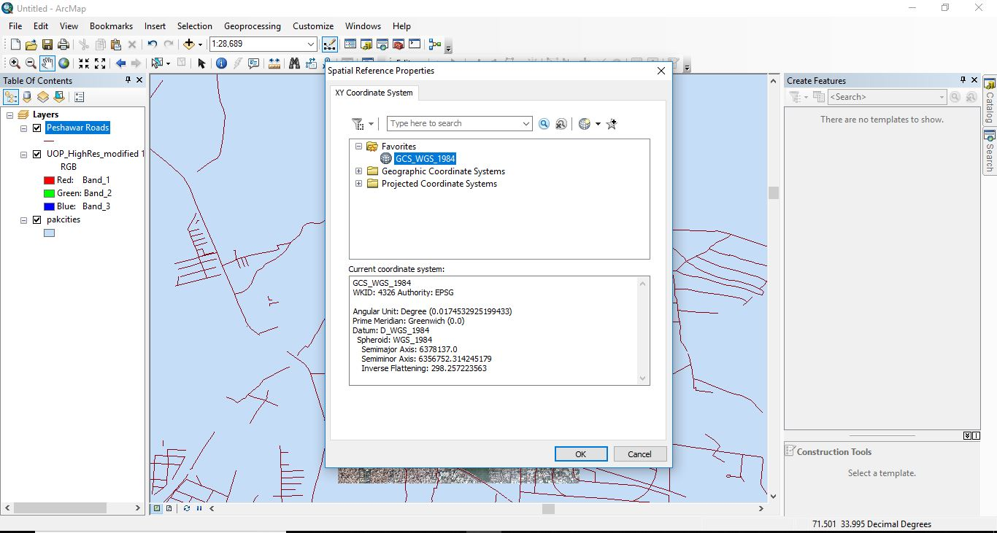
- Following Window will be displayed
- Now Click on OK
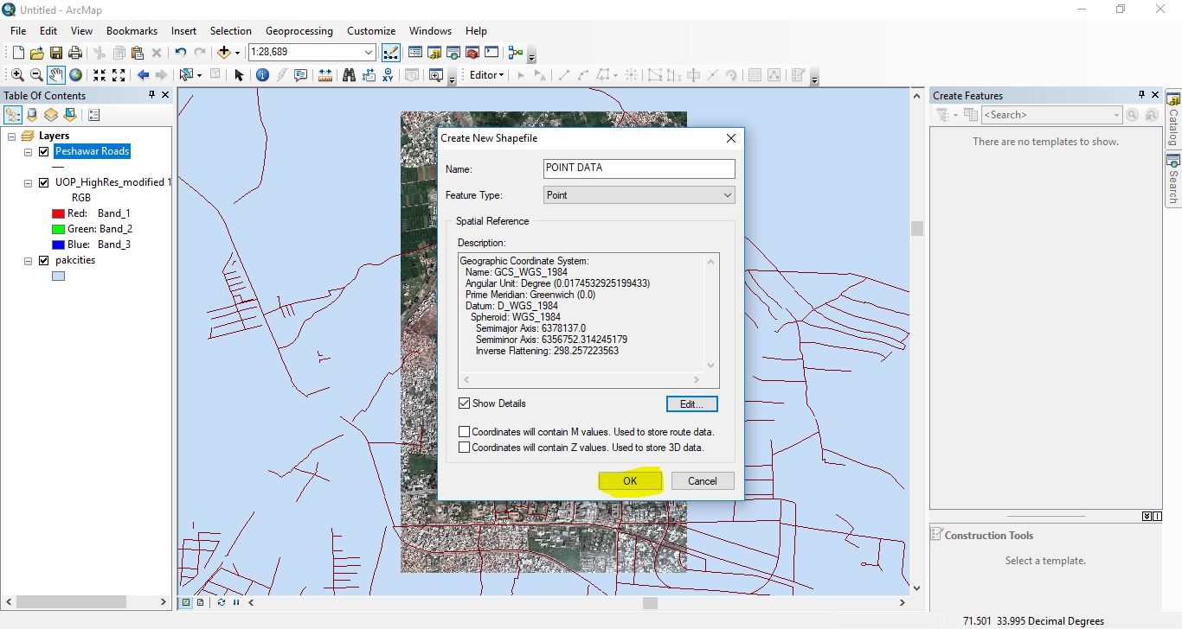
- Now Right Click on Menu Bar and Select Editor
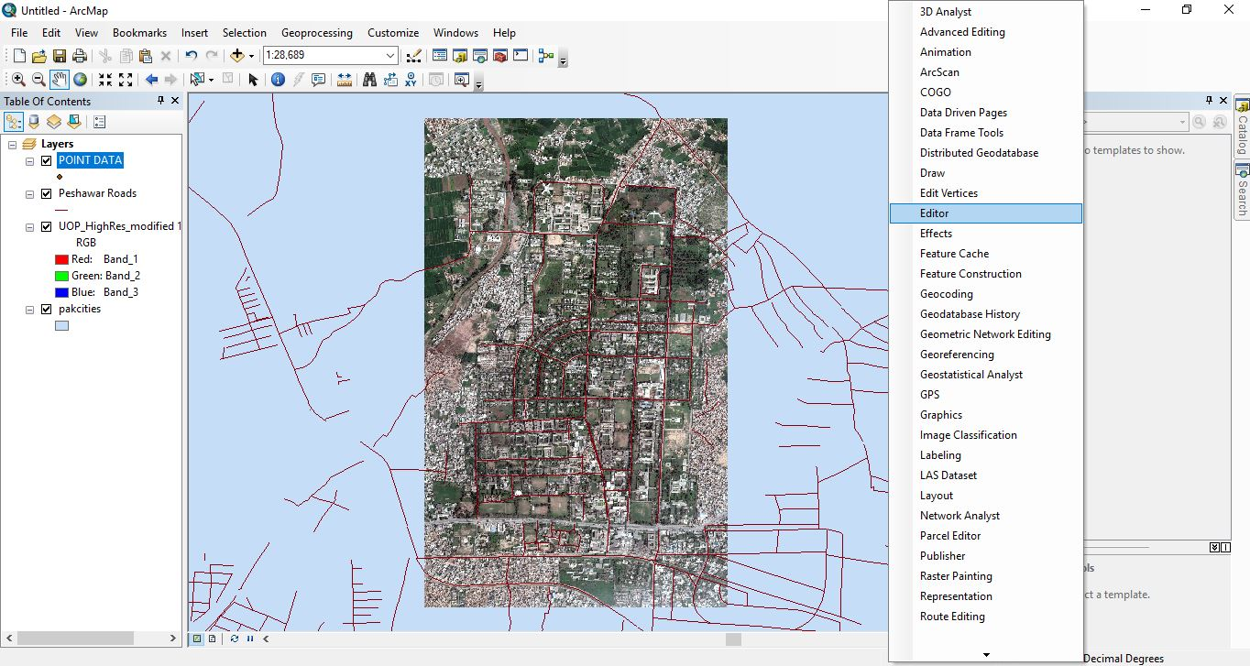
- Click on Start Editing
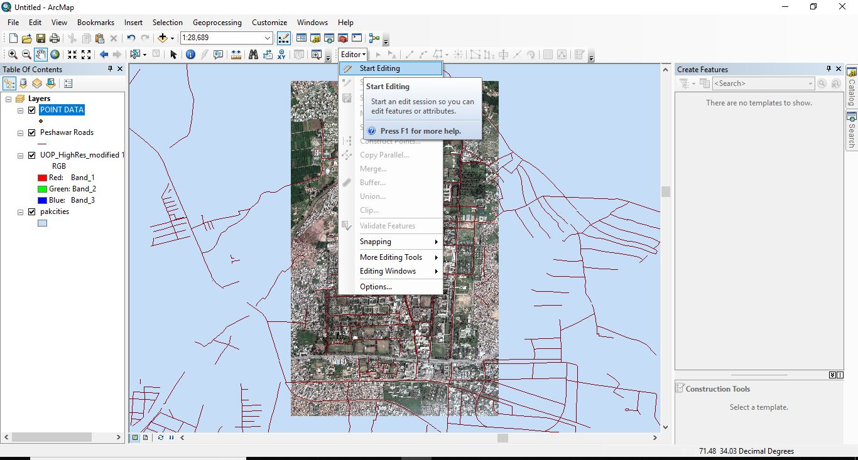
- Select on which layer to be edited
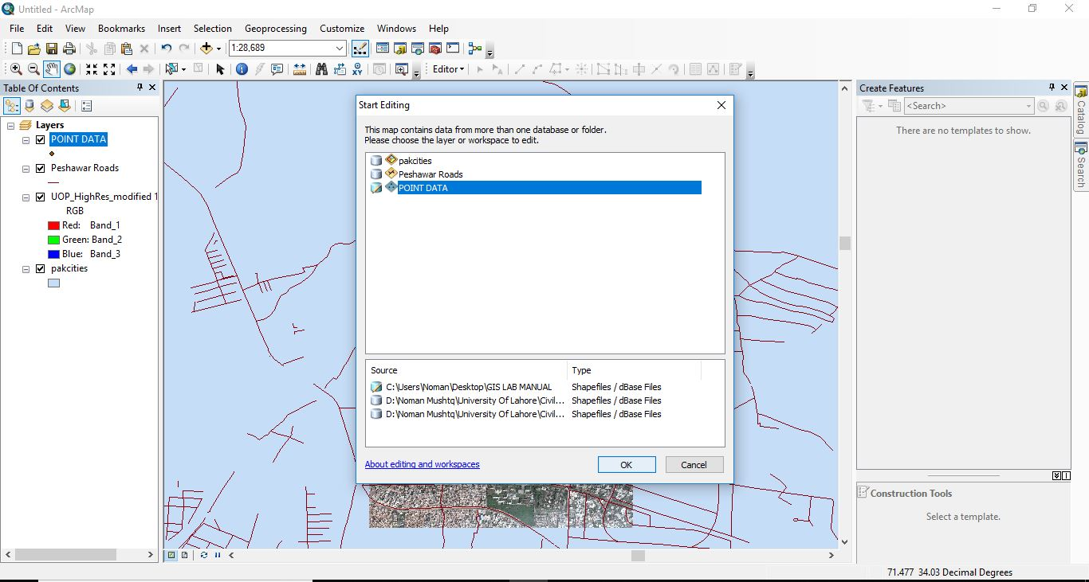
- Again select the layer on right most edge.
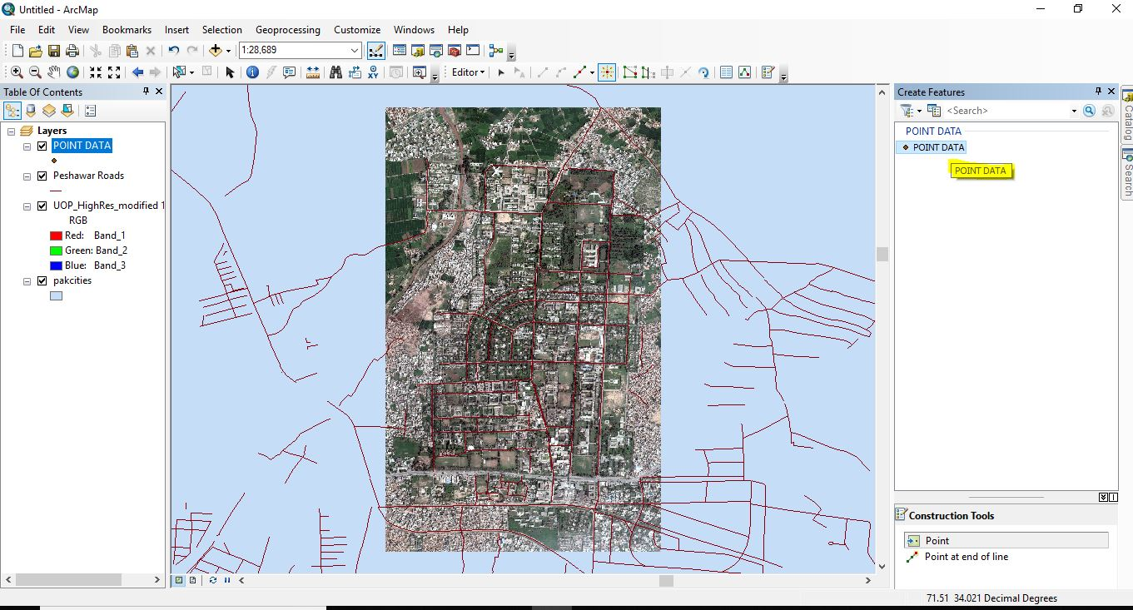
- Mark Points on desired places.
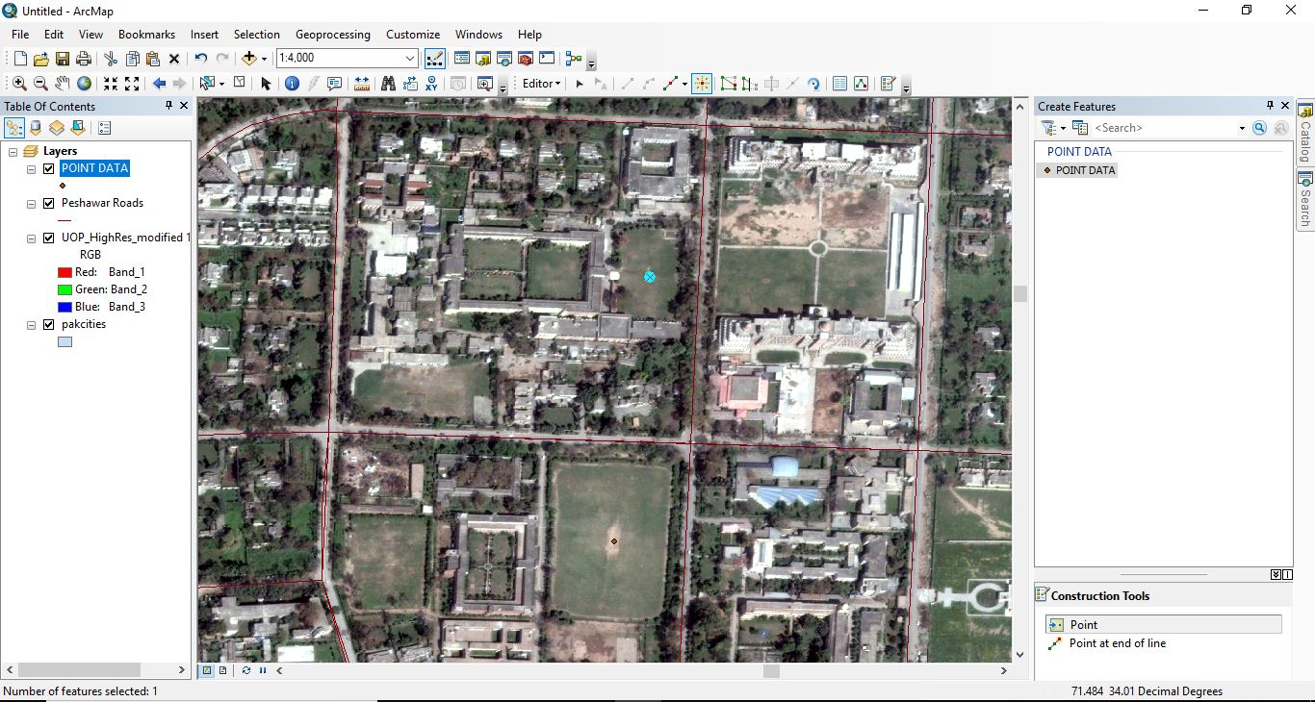
- Now Right click on POINT DATA LAYER
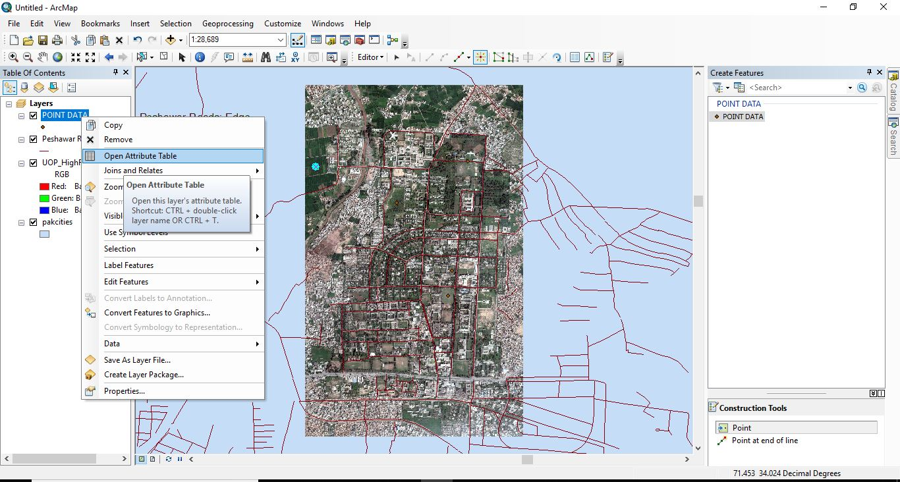
- Auto Attribute Table for this Layer will be Generated
- Now Click on Edit Tool Bar and select Save Edits.
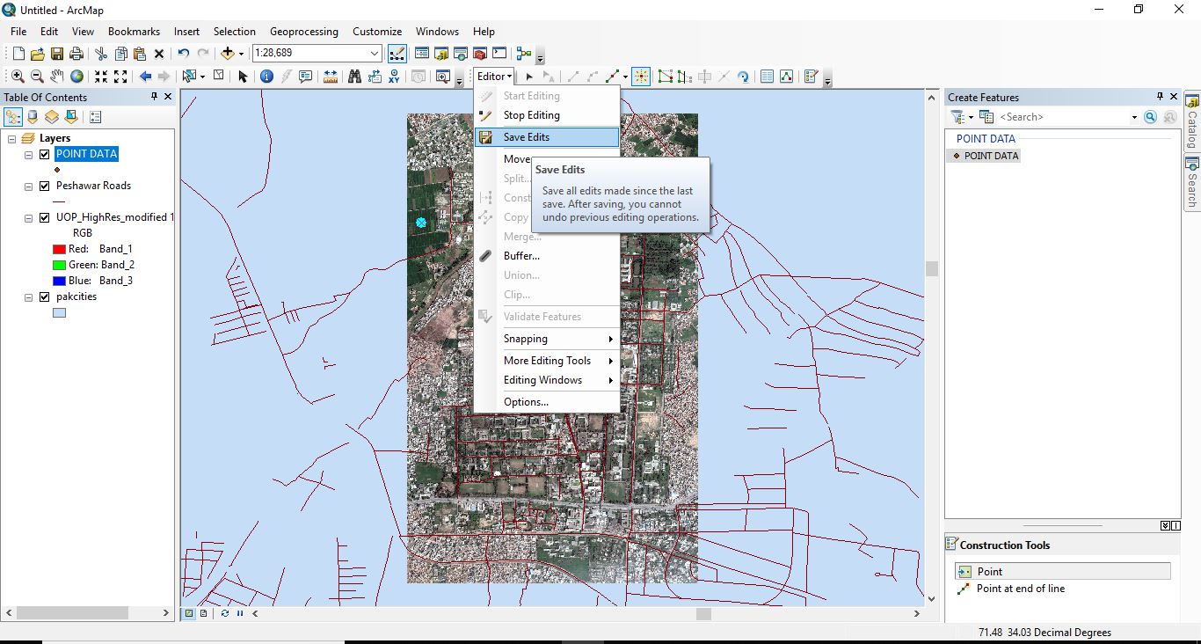
- Now stop this Editing
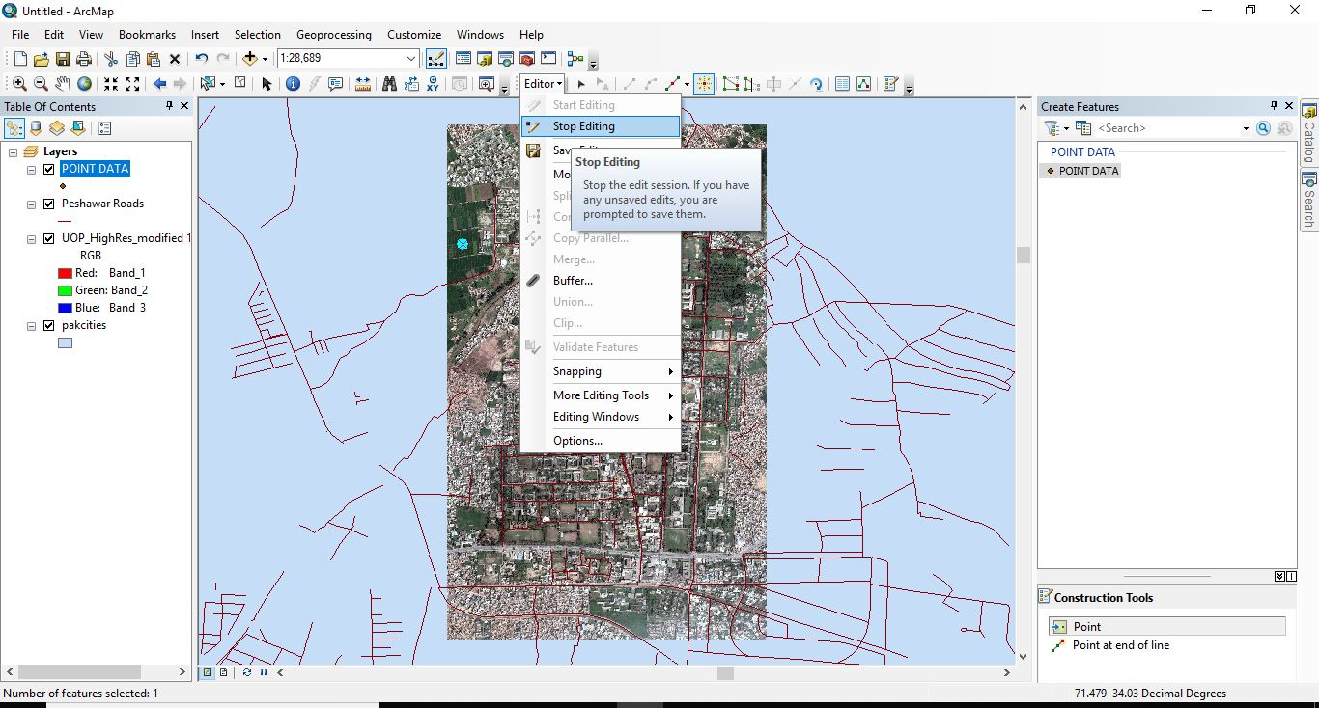
- Now open Attribute Table and click on Left Most Corner.
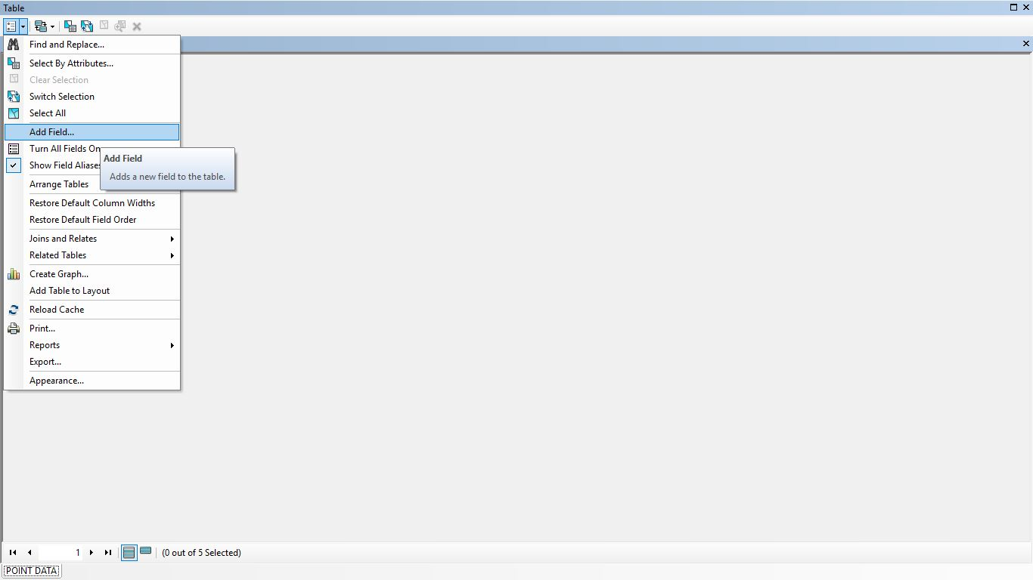
- Add Fields as per Required.
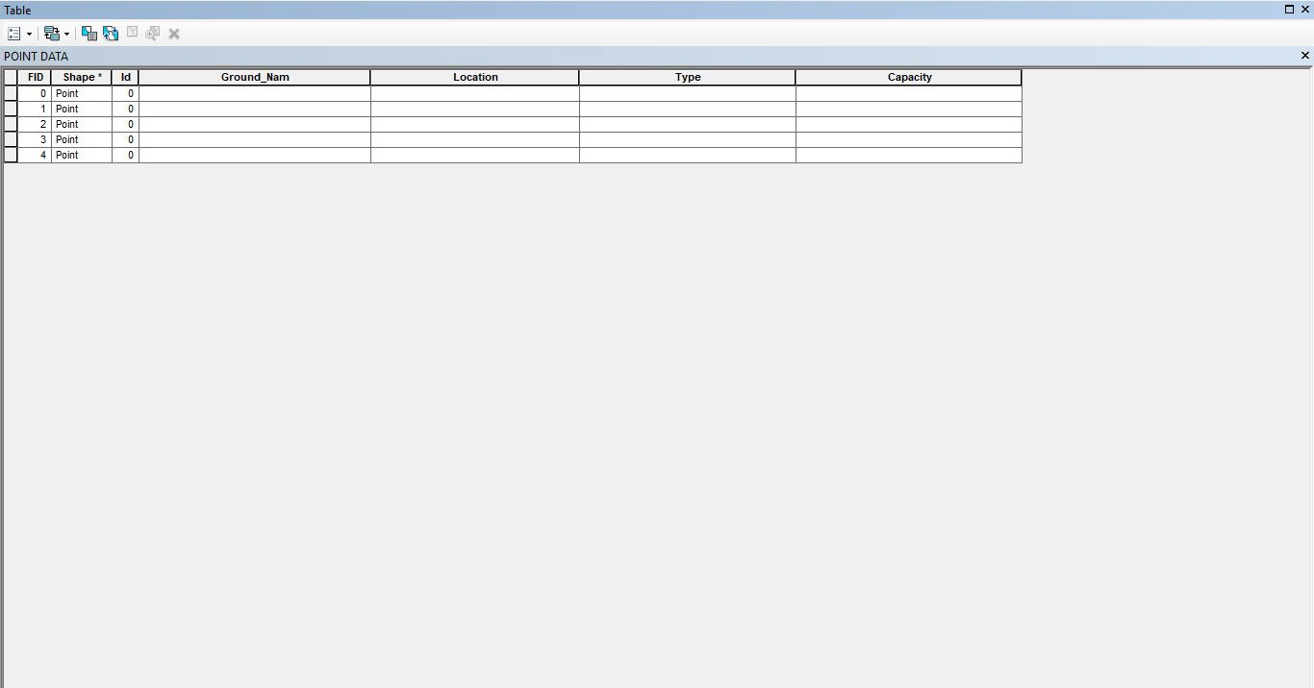
- Now Start Editing Again and Fill those Table
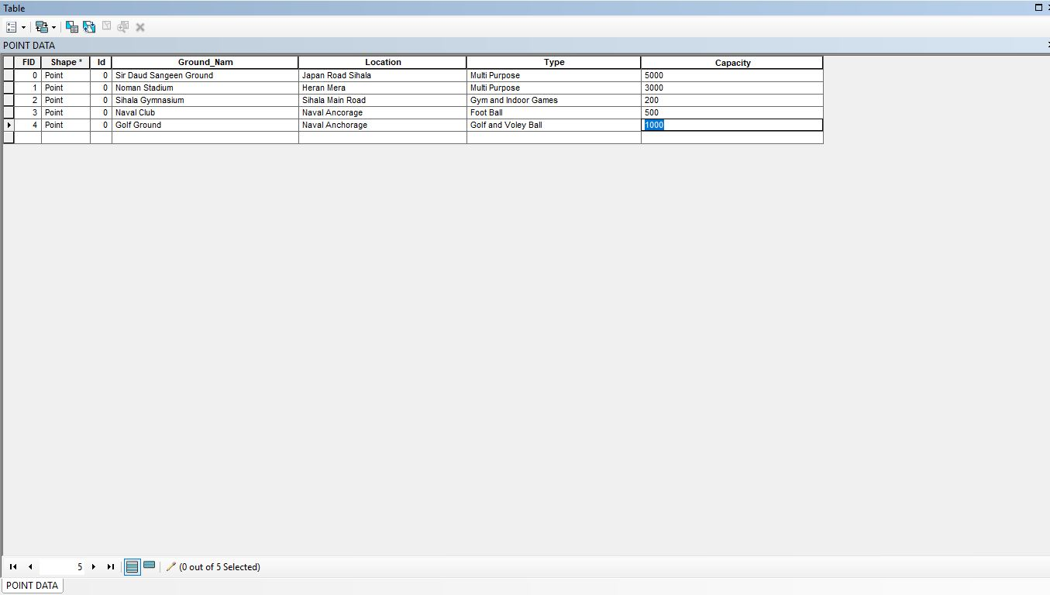
- Now View your Points
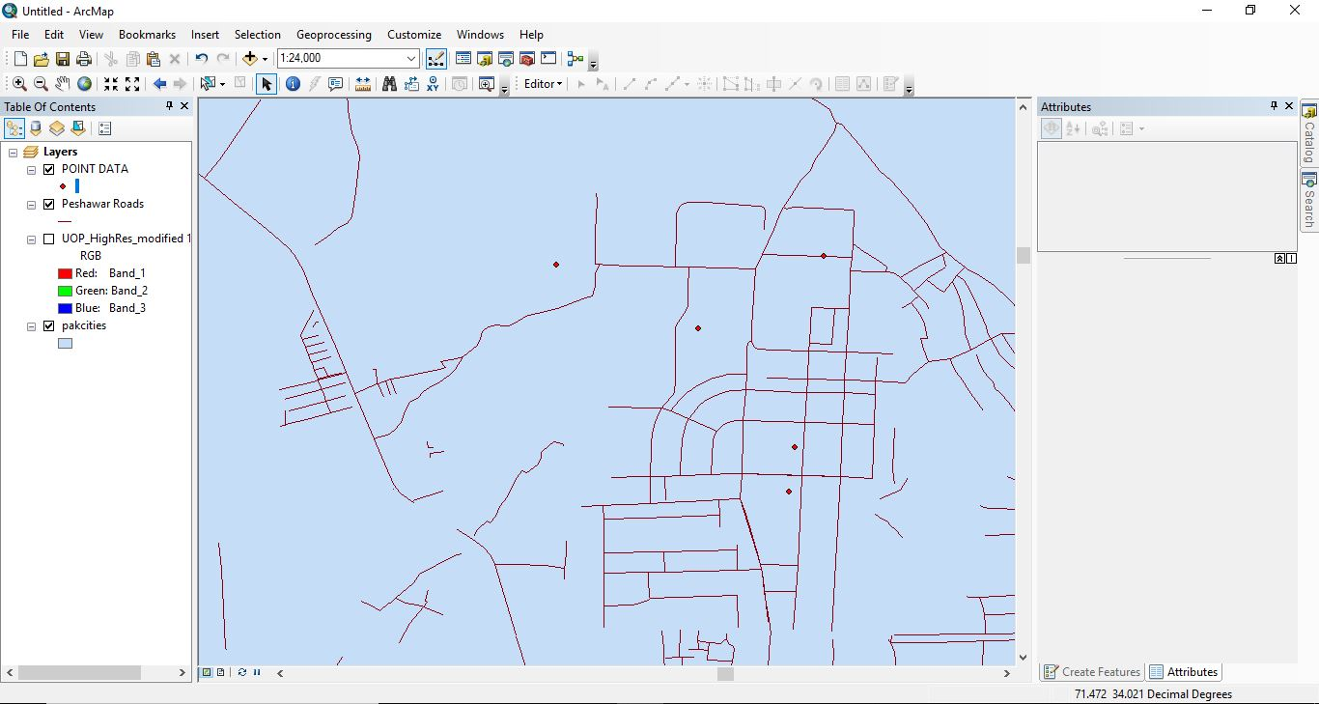

PRACTICAL No.6
How to Add Polyline Data in Arc Gis
- Add Shape file
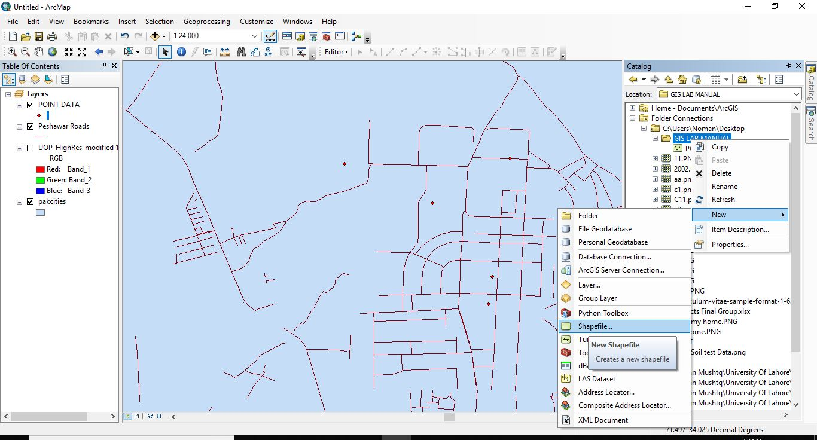
- Select Polyline
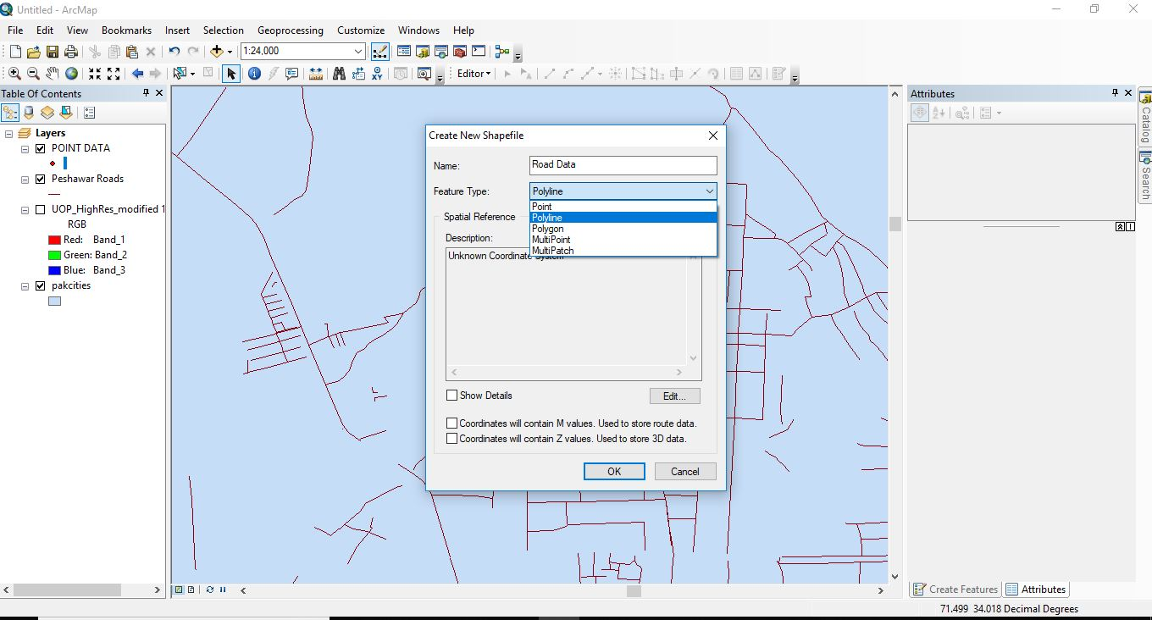
- Now Give it Reference Coordinates.
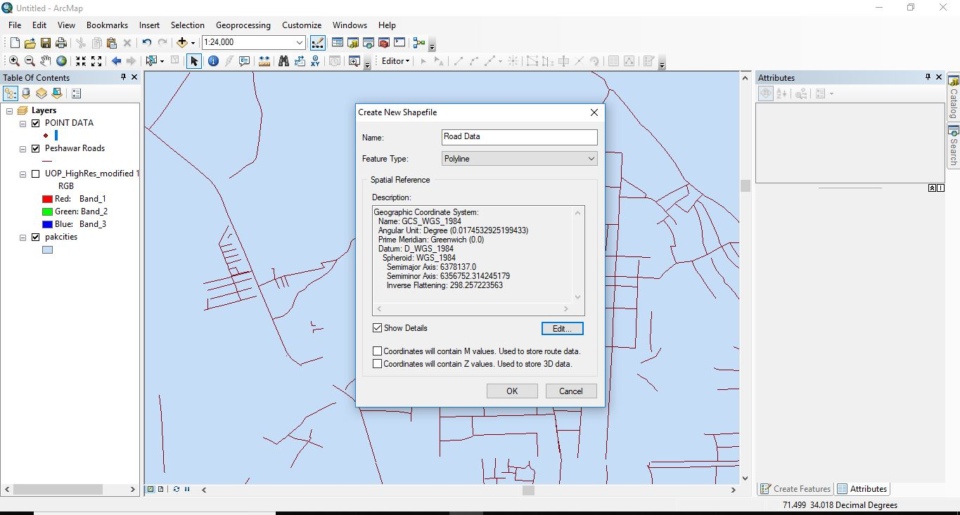
- Now Start Editing and Select Road Data Layer.
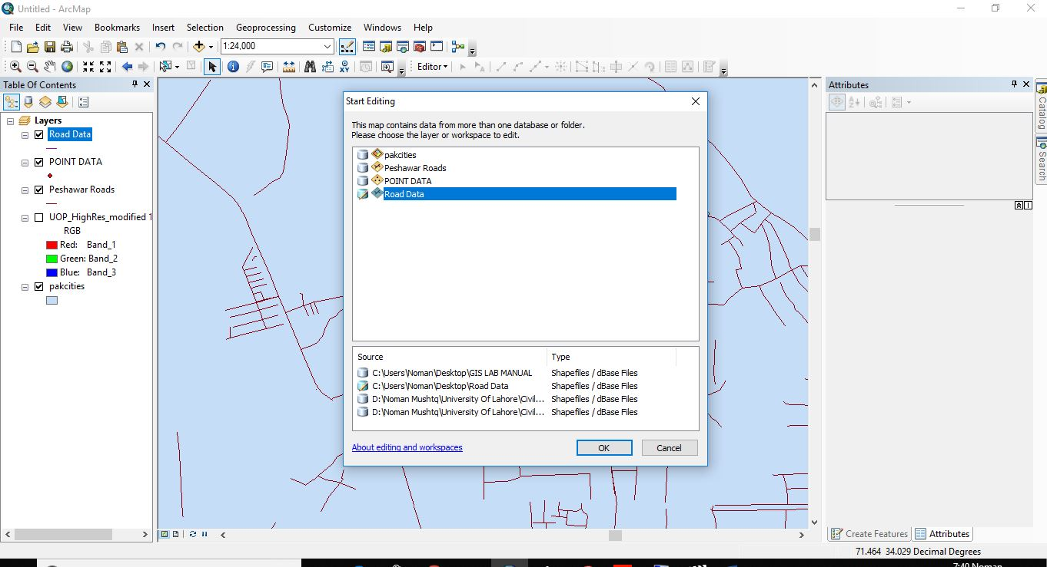
- Now Take a point and mark a line where you want to make a road or something else.
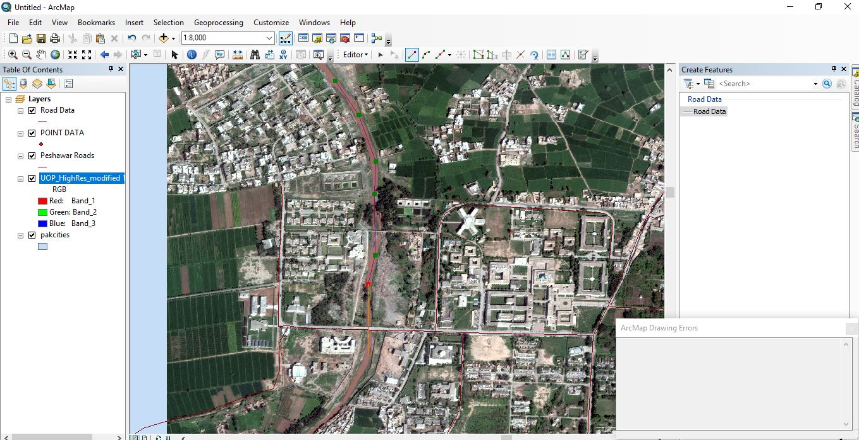
- Right click and select finish sketch if you have completed your line.
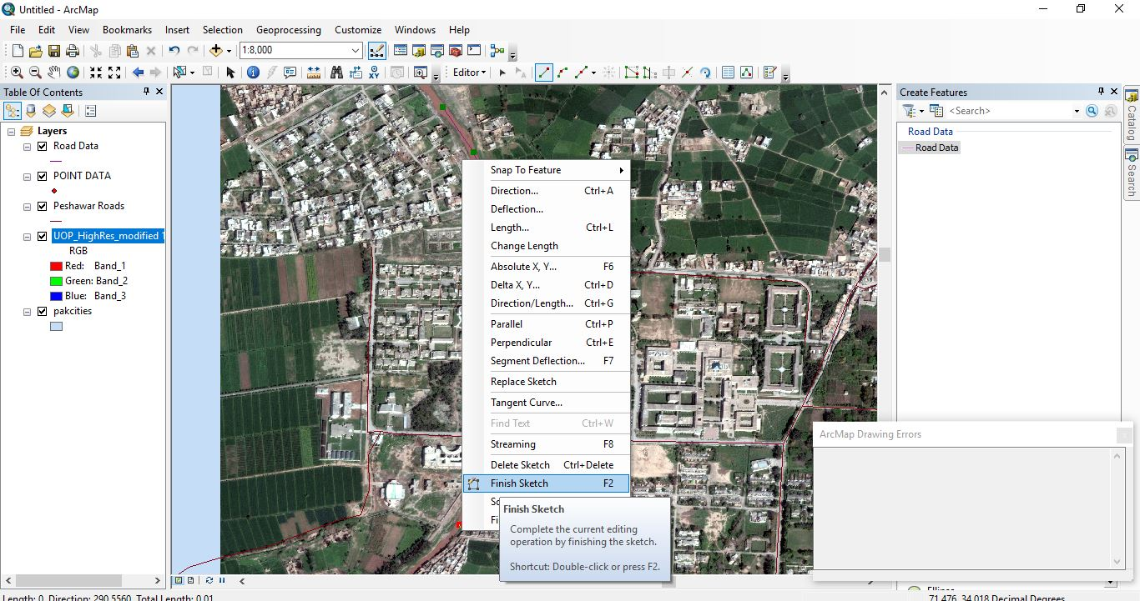
- You can view what you have drawn.
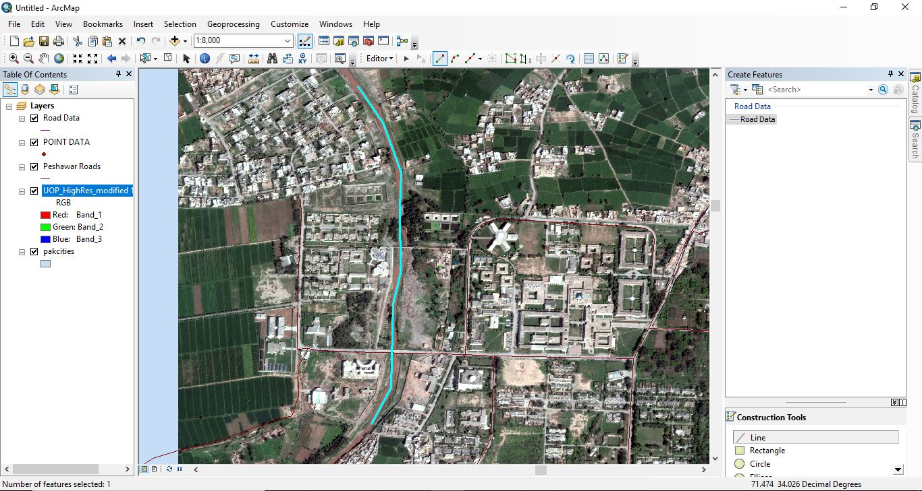
- Same again
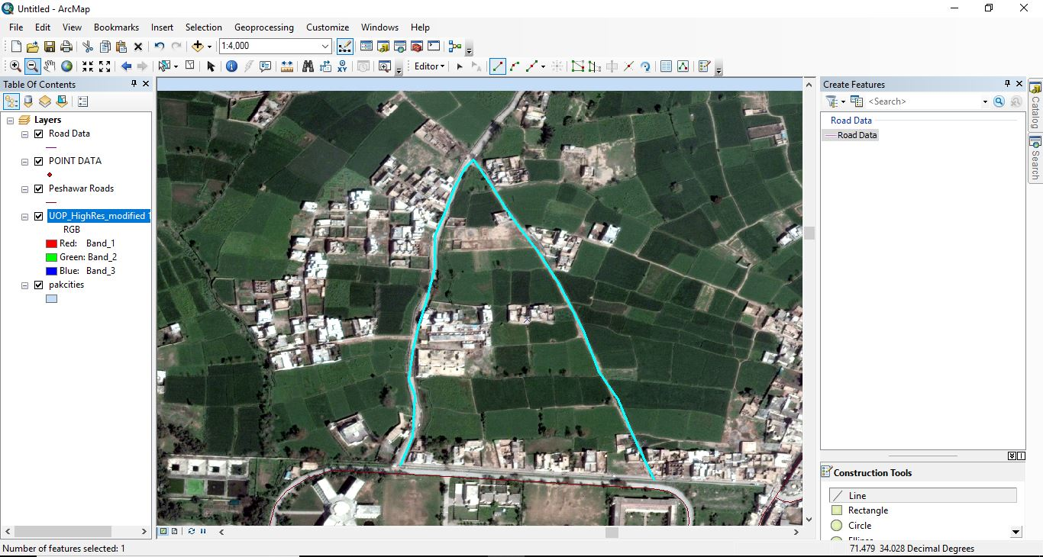
- Go to Attribute Table and click on Add Field
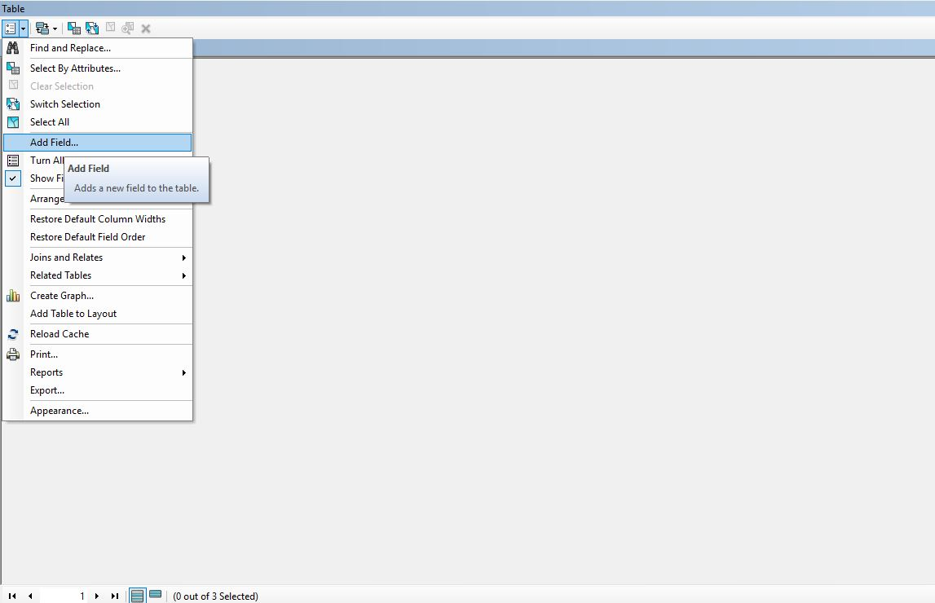
- Now add titles as per required and fill them
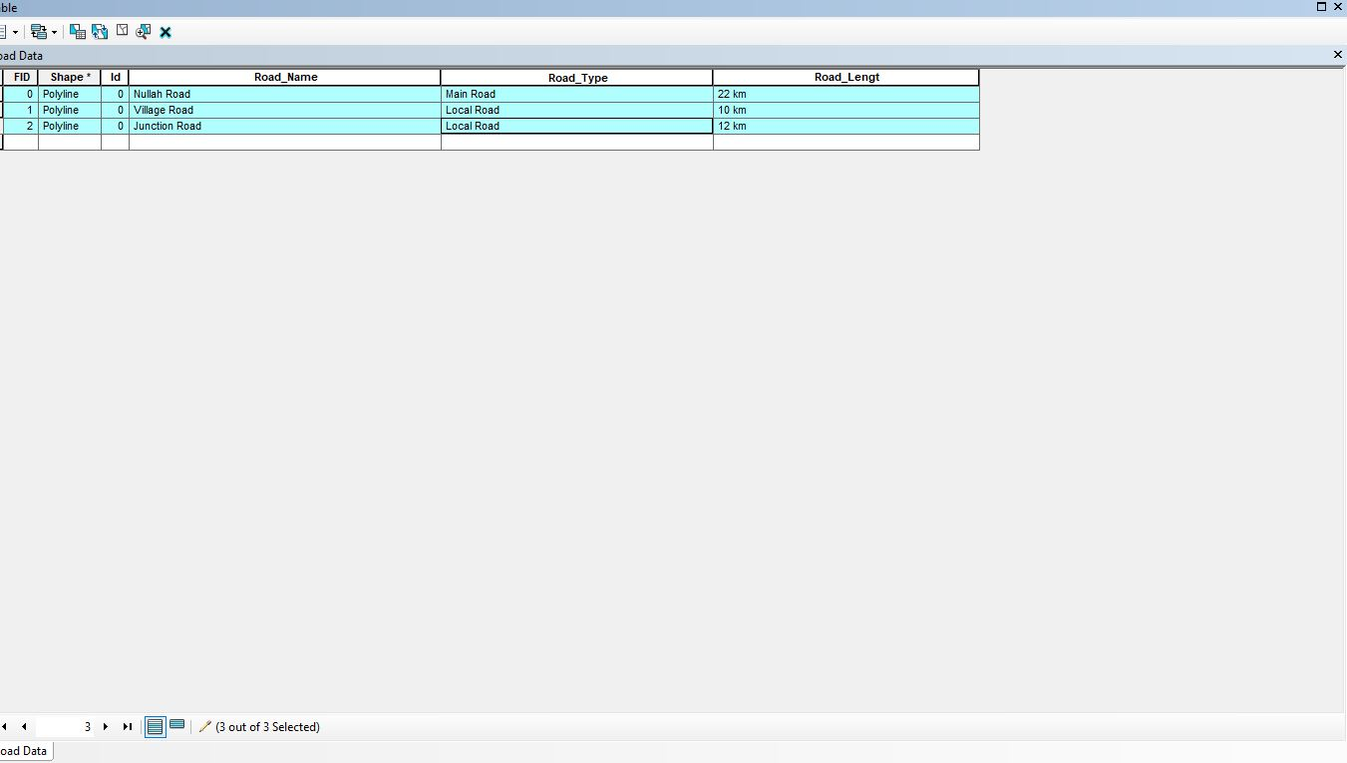
- Un Mark the Layer
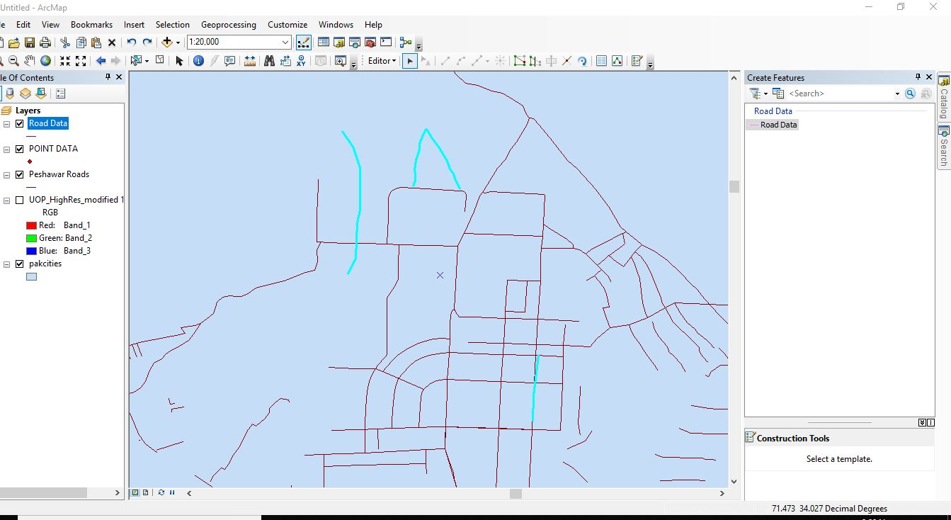

How to add Polygon in Arc Gis

- Add a shape file
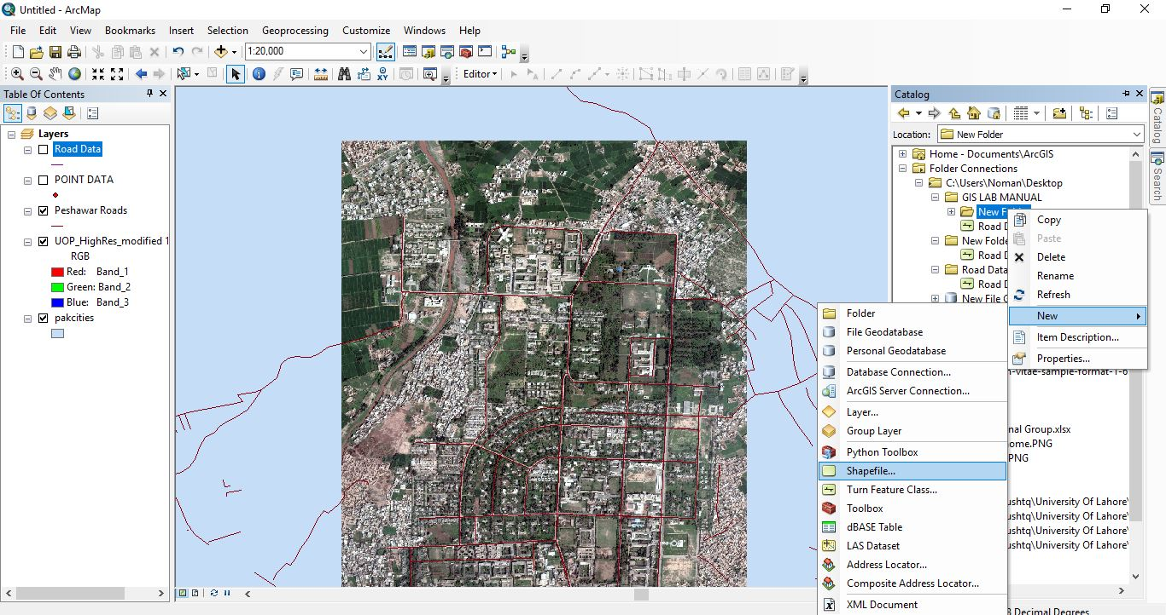
- Select Polygon and give it name
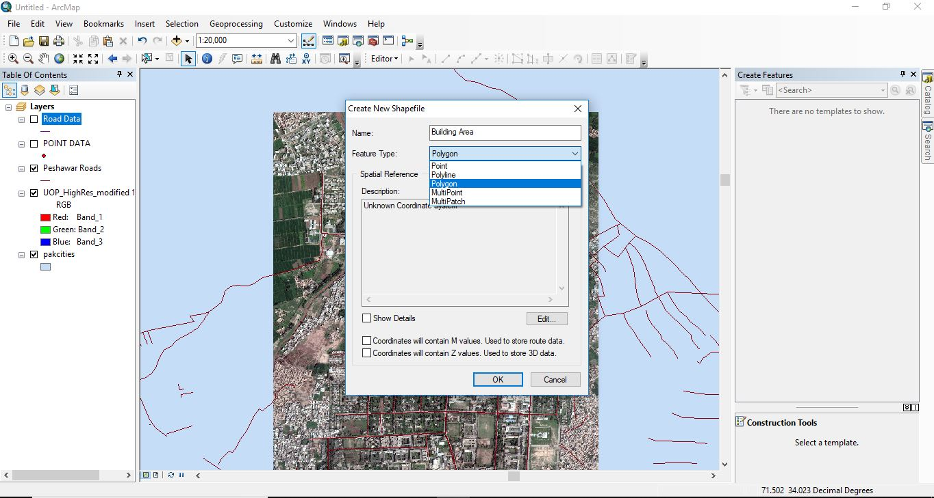
- Start Editing and select Building Area
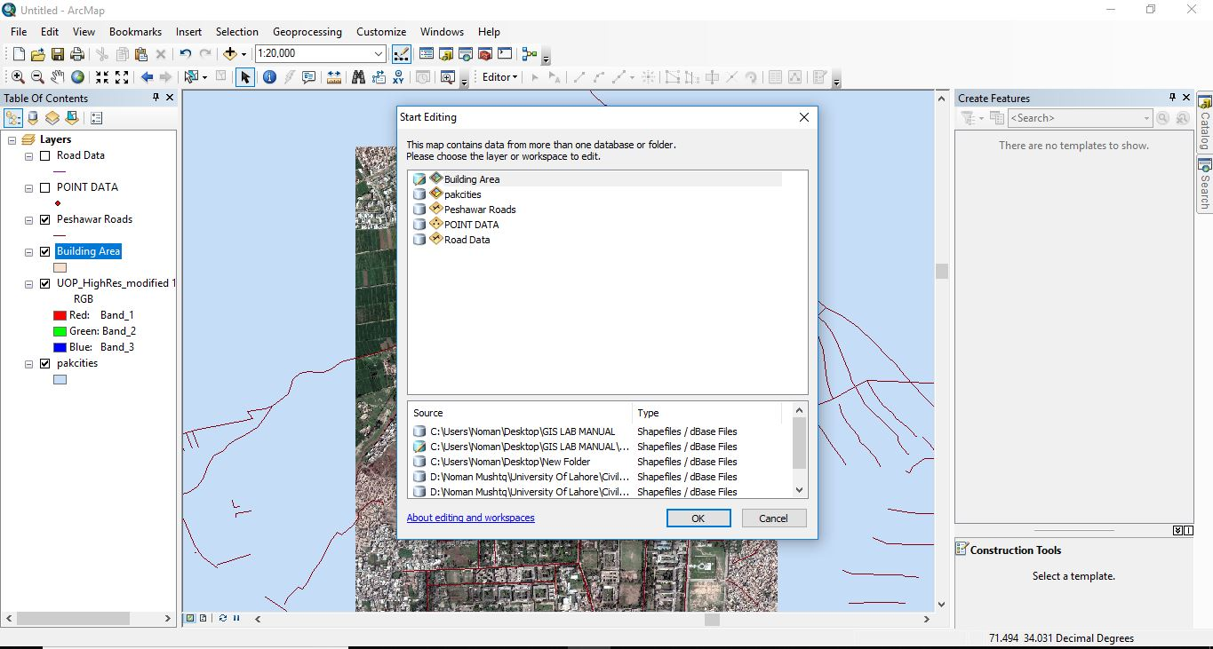
- Mark a boundary along a building.
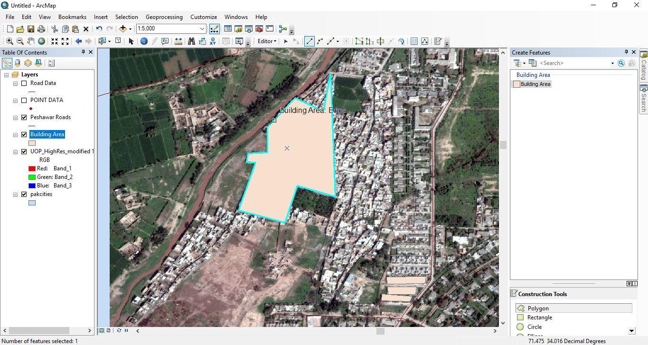
- Open Attribute table and Add Field and Fill it.
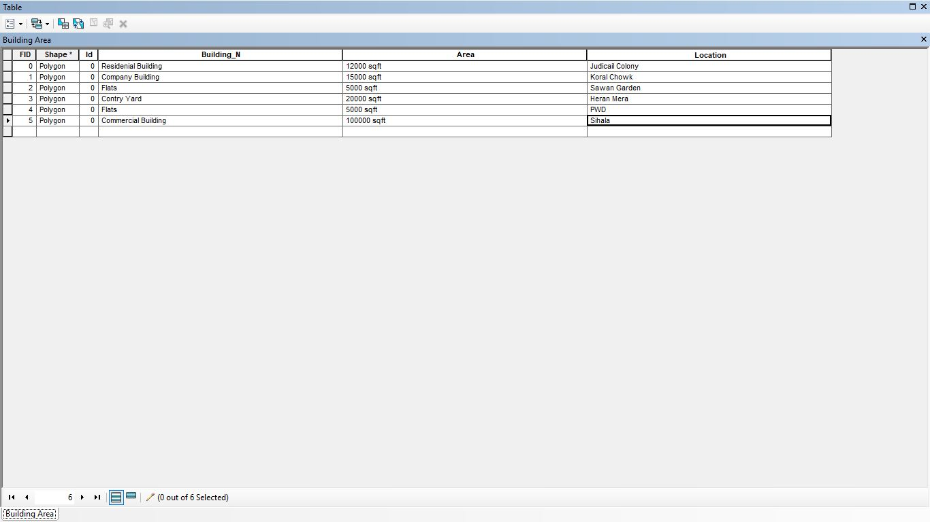
- Unmark all other layers and see the marked boundaries.
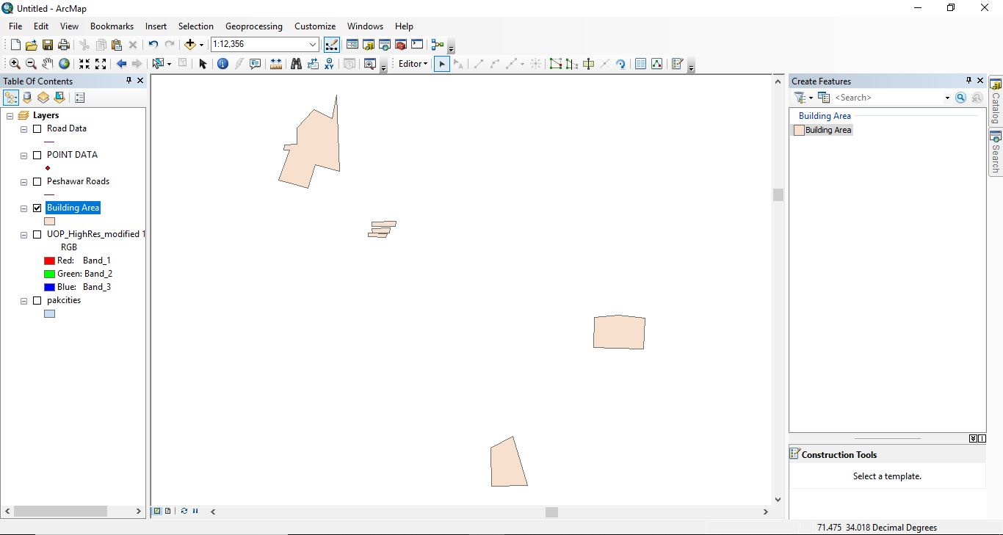

Practical No.7
GEORFERECING

- Open GIS and import three layers i.e Continents , Pak cities and UOP High
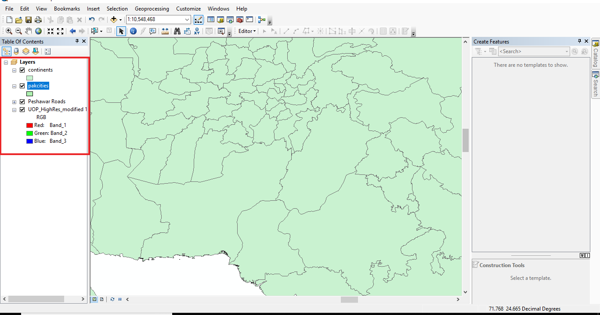

- Now Export desired Image from Google Earth .
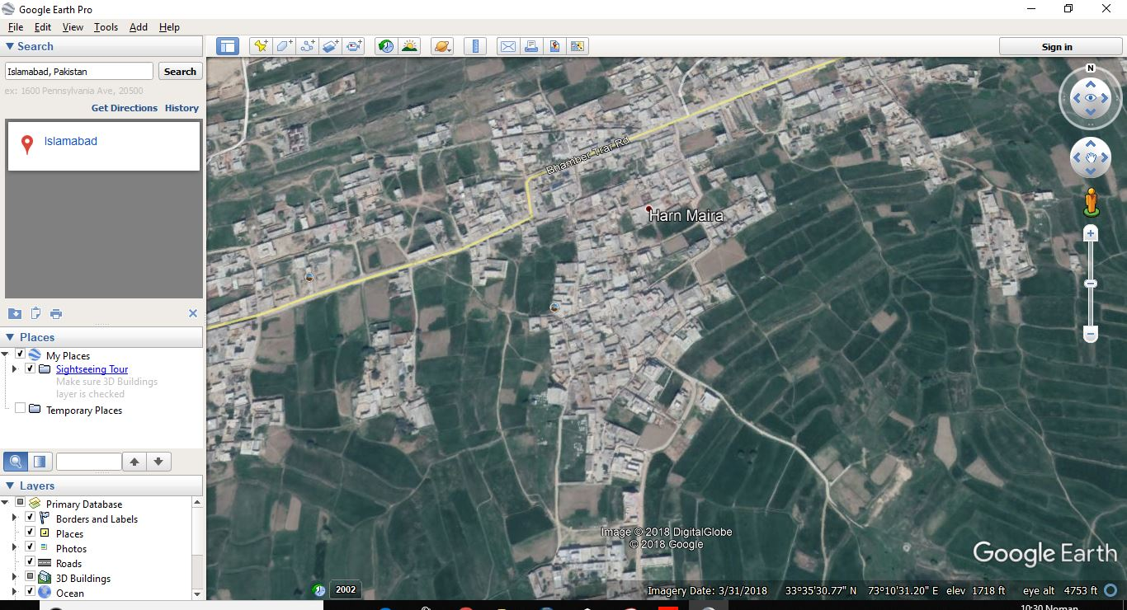

- Now import this image in GIS File.
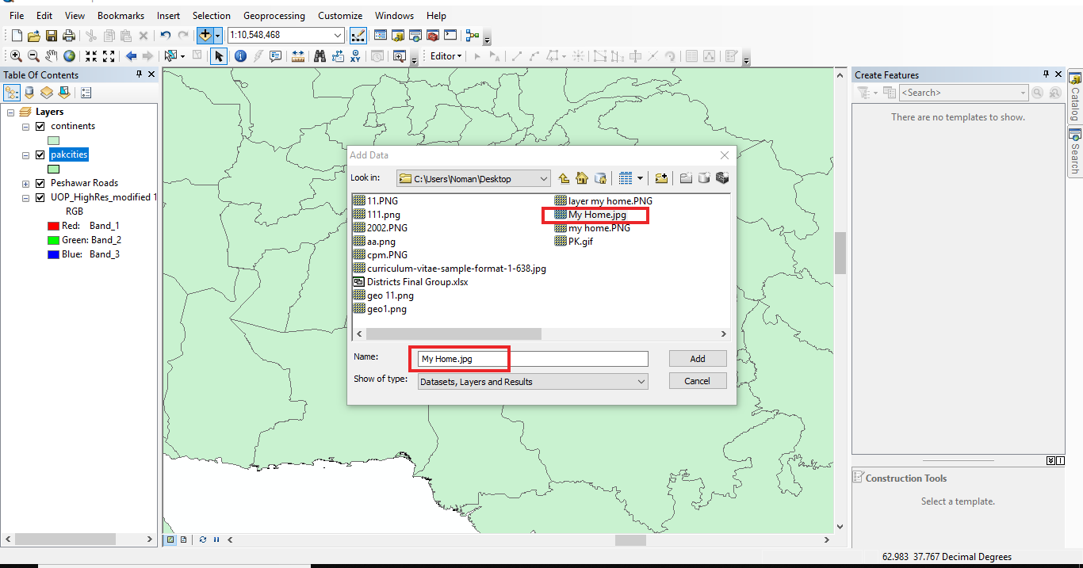

- It will be displayed as :
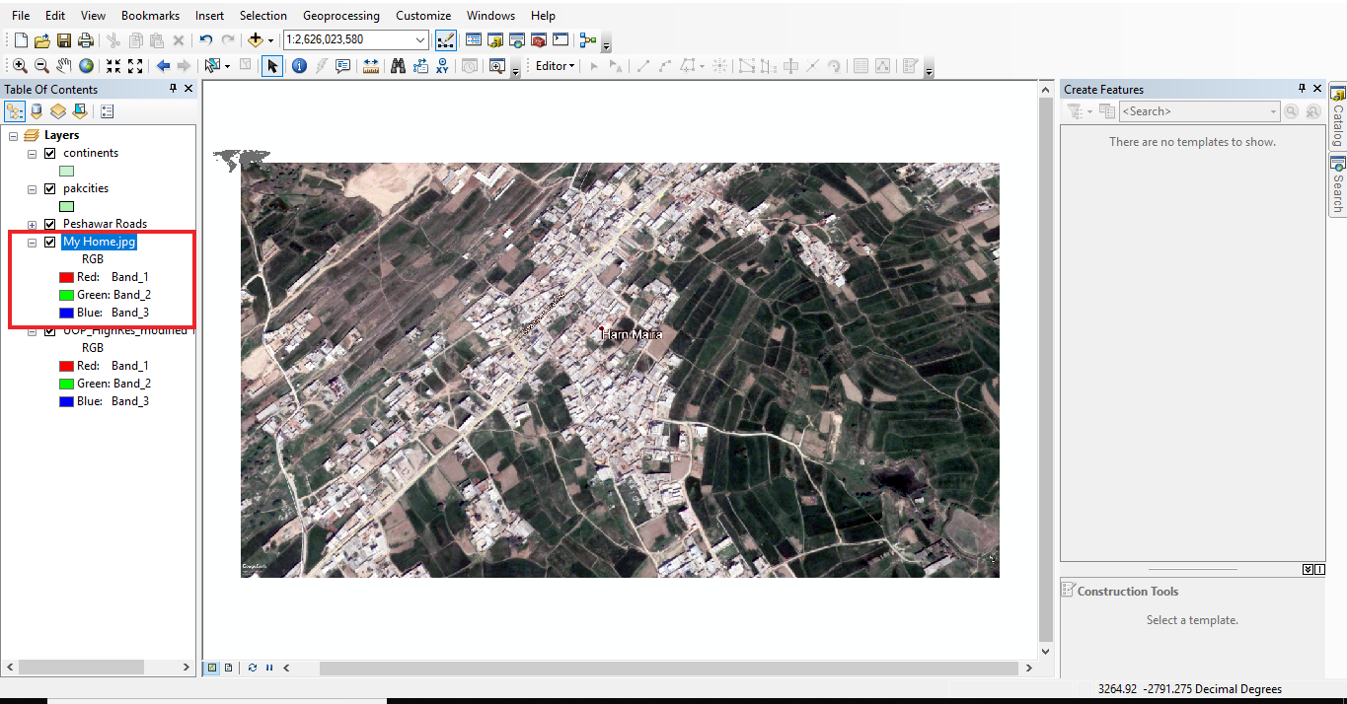

- Right Click on top most and select Georefrencing.
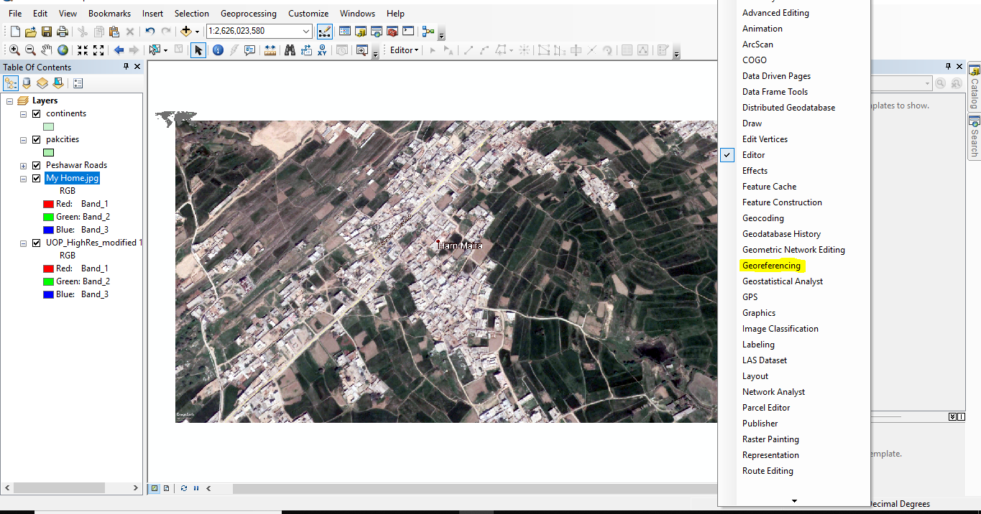

- Geo referencing Bar will be displayed.
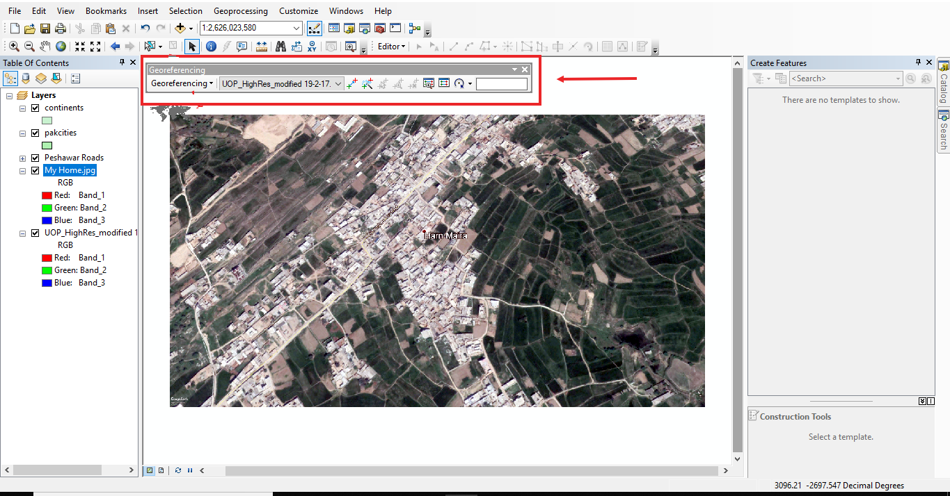

- Click on Add Control icon.
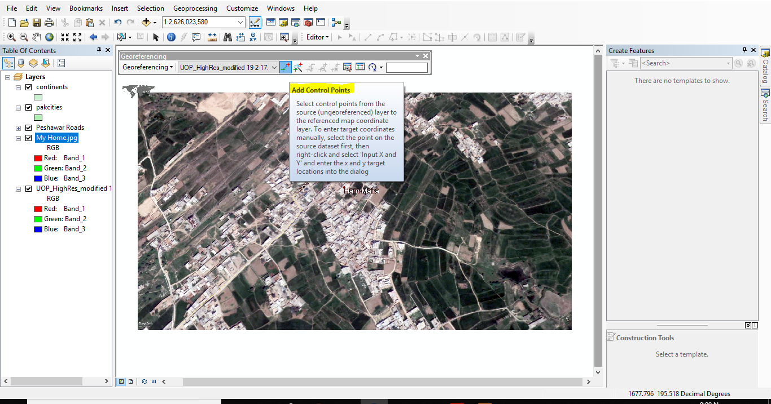

- Select a point and right click.
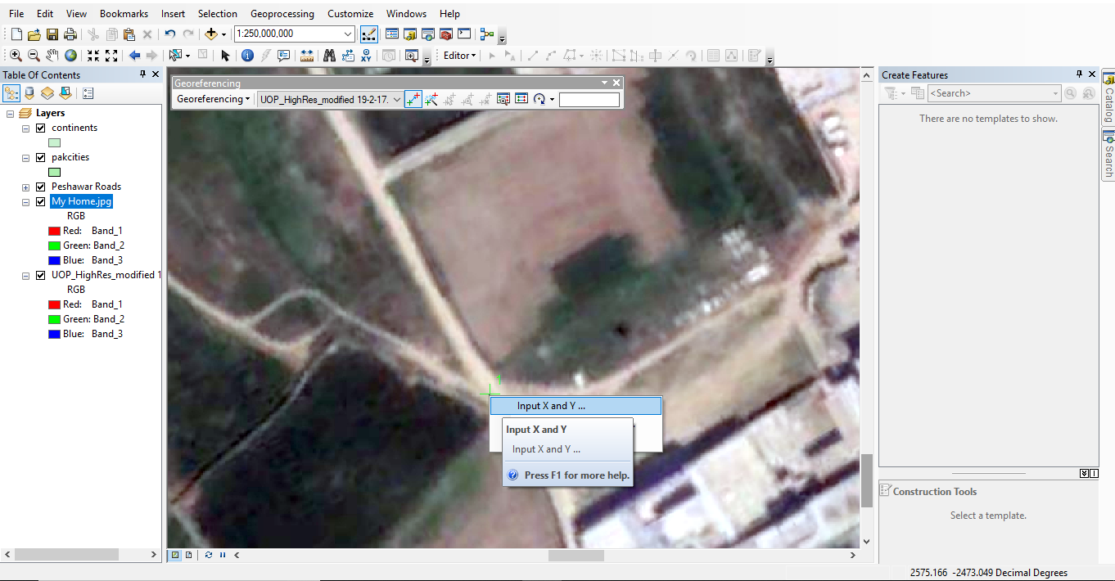

- Enter Coordinates of that point.
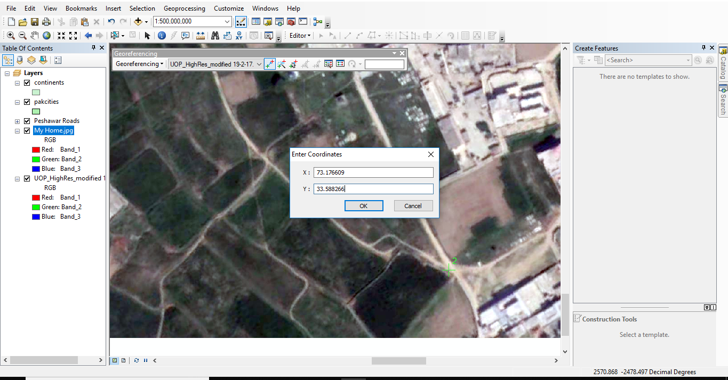

- The Picture will automatically go where it belongs according to its coordinates.
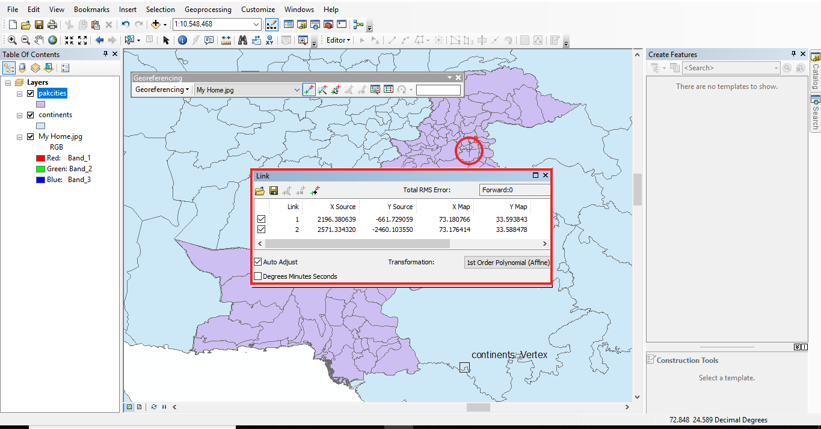

- Now if we click on zoom to layer the picture will tell us on which angle the satellite is taking the imagery.
