IQRA NATIONAL UNIVERSITY

Midterm assignment.

Course: Object Oriented Programming

Name: Nooriya ilyas

ID: 15770

Semester: 2nd

Section: A

BS (SE)

QUESTIONS:
Q.1) What is Class and role of object in a Class, explain in detail with the help of a
suitable program ?
Answer:
Class is the fundamental component of all java programs. From a single class, many objects can be created. A class is composed of variables that hold data for each object and methods that provide functionality.
A class defines a specific set of variables and methods, and eventually objects are created from these definitions. When you instantiate a class, an object is created.

An object is a software module that has a state and behavior. An object's state is contained within its member variables and its behavior is implemented through its methods. In simple words, object is a combination of data and methods. An object is an instance of a class, and there could be multiple instances in a single class. All the instances share the same attributes and behavior of the class, but the values of those attributes, that is, the states are unique for each object.

Role of objects in a class:

Objects in java represents real life things. When we do work in Java, we use objects to get the job done. We create objects, modify them, move them around, change their variables, call their methods, and combine them with other objects. Object has a specific memory location allocated, whereas class is only a template for making objects, and doesn’t take up any space in the memory.

Example:

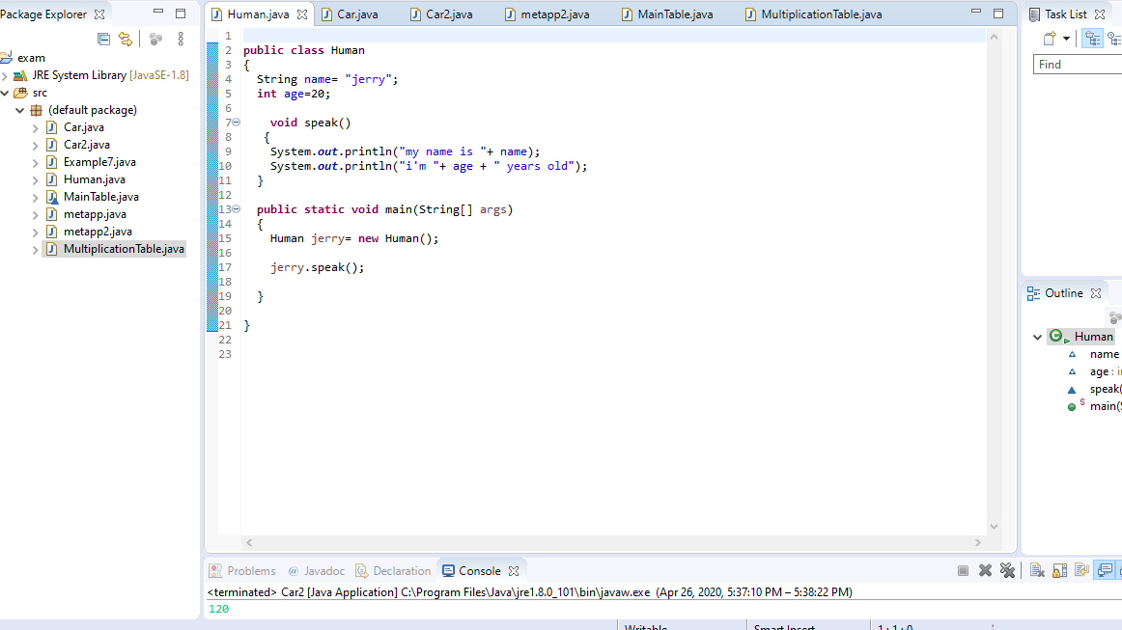

Explanation:

- In this example, I created a class with the name of "Human".
- I declared and assigned values to the two variables; String and int for name and age respectively.
- i created a method with the name speak() with the return type void because i don't want any value to be returned.
- System.out.println() is used to print an argument that is passed to it. The concatinated variables "name" and "age" along with the statements would be printed to the console, but the values assigned to the variables would be shown on the console.
- in the main method I made an instance of the class "Human" that is, i made an object named "jerry".
- in the last step I called the speak() method that would result in the printing of the statements present in the speak() method.

In this example the class human has an object jerry, which has the data assigned to it (variables; name and age) and a functionality (method; speak) .

Q2.) . Write a program about table printing which takes input from the user on the
basis of OOP and explain in detail.

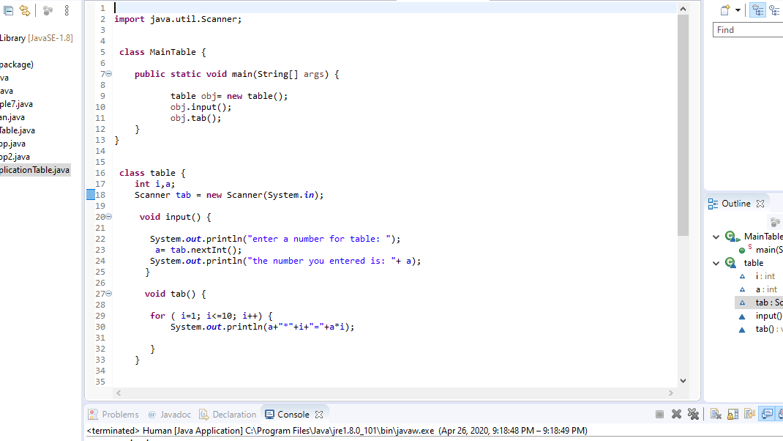

Explanation:

- Scanner is a class in java.util package used for obtaining the input of the primitive types like int, double etc. In this program it will take the int input from the user.

- I created a class with the name "MainTable" which contains the main method that will excecute the code written inside it. I made an object "obj" which would later call the methods that I'm going to explain in the next few steps.

- I made another class named table and declared two variables ‘i’ and ‘a’ in this class.

- In order to use the Scanner class, you must first instantiate (declare) a Scanner object and associate it with a data source. The data source specifies the input device that will be used for this Scanner object. The data source we will use will be the keyboard, which is called System.in

- I created a method named input() with the return type void which will ask and take the user's input.

- I created another method in the same class "table" that contains the for loop which will calculate the table upto 10 and print it.

- then up in the main method, I called both of these methods obj.input() and obj.tab() and then the code is executed.

Q.3) . Write a program about any 2 cars which can calculate the performance of
both of them and explain in detail.

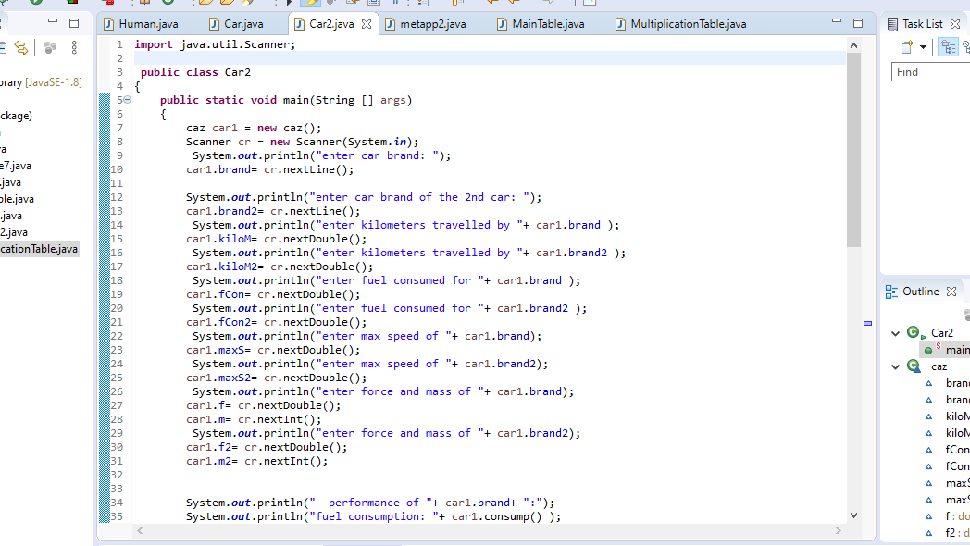
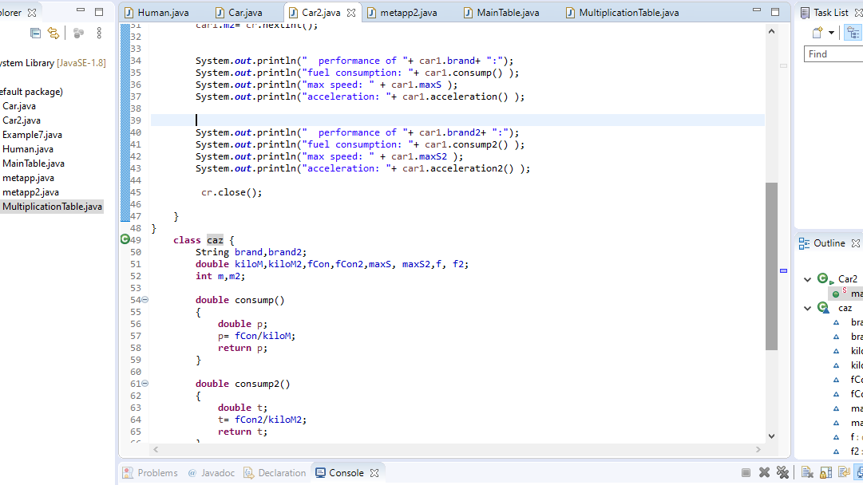
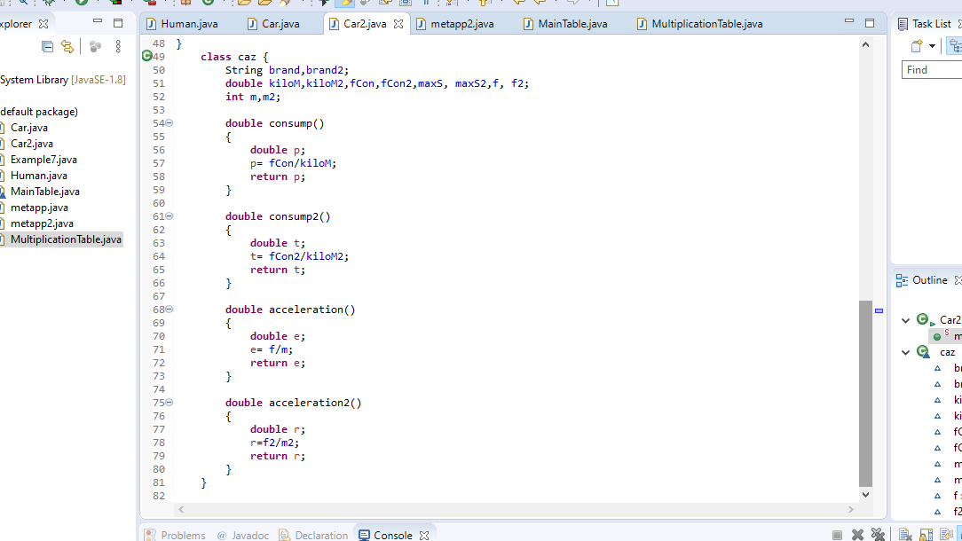
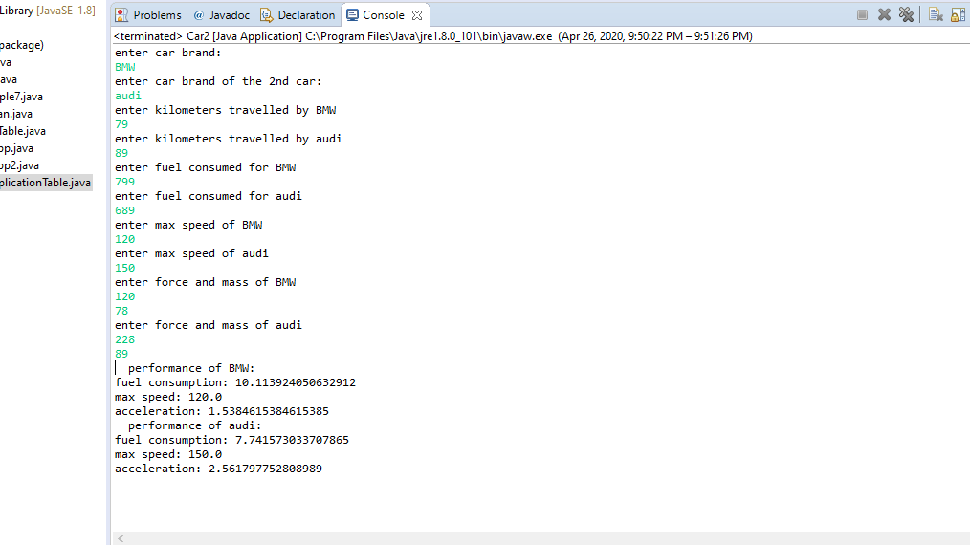

Explanation:

- This code is designed to calculate the fuel consumption, max speed, and acceleration of two different car brands of the user’s choice.

- First I created ‘ public class Car2 ‘ containing the main method, whatever you instruct the
main () method to do , it is carried out at the time you invoke the java program.
- The ‘public’ keyword is an access modifier. This particular modifier indicates a specific class is designed to be used by anyone anytime and is not hidden.

- car1 is the object, and would aid in getting input from the user.

- .nextLine() is used for getting input from the user in the form of a string. The user would enter the brand of the car as a string into the program.

- For closing the scanner to prevent the memory leak , we need to write cr.close() at the end of the class. Not closing the scanner would not result in any error, and the code would run just fine but it should be closed to remove warning.

- Another class with the name of caz contains declared variables and 4 methods that are called in the main method and hence print the cars’ performance to the console after taking the user’s input.

