NAME: Awais Anwaar
ID: 16509
TEACHER: shuala rasheed
SUBJECT: Principles of Marketing

Q.1 Explain a five-stage Buying decision process in detail? Must be in your own words.
ANS) The five stages of buying decision process are listed below:
1. Problem Recognition
2. Information Search
3. Evaluating of alternatives
4. Purchase Decision
5. Post Purchase Evaluation.
1. PROBLEM RECOGNITION:
During need of anything consumer analyze the problem. The consumer recognizes a problem or a basic need that could be satisfied by a product or service in the market. And problem recognition is the first stage of the buyer decision process.
2. INFORMATION SEARCH:
The second stage of buying process is information search in this stage the consumer is aroused to seek more information and moves into the information stage. After the recognition the consumer try to find goods for satisfying such needs they search for information about the goods they want.
PERSONAL SOURCES
COMMERCIAL SOURCES
EXPERIMENTAL SOURCES
3. EVALUATING OF ALTERNATIVES
With the information in the hand the consumer proceeds to alternative evaluation during which the information is used to evaluate. Evaluation of alternative is the third stage of the buying process various points of information collected from different sources are use in diferent alternative for their better needs or to satisfy there in amount as well as their attractiveness.
4. PURCHASE DECISION
After the alternatives has been evaluated consumers take the decision to purchase all kinds of products and services as they decide to buy the best one.
5. POST PURCHASE EVALUATION
This is the final and last stage of the buyer decision process in which the buyer take his decision based on all kind of satisfaction or dissatisfaction.
Q.2 . Enlist different kinds of Segmentation? Explain the difference between geographic, demographic and geodemographic segmentation in detail with examples
ANS) Different kind of segmentations are listed below
1. GEOGRAPHICAL SEGMENTATION
2. DEMOGRAPHICAL SEGMENTATION
3. FIRMOGRAPHIC SEGMENTATION
4. BEHAVIROL SEGMENTATION
5. PSYCHOGRAPHIC SEGMENTATION
DIFFERENCE BETWEEN GEOGRAPHIC AND DEMOGRAPHIC SEGMENTATION
While typically a subset of demographic geographic segmentation is typically the easiest. Geographic segmentation creates different target customer group based on geographical boundires. Geographic regions customer groups can help determine where to sell and advertise as well as where to expand your business.
DEMOGRAPHICAL SEGMENTATION
Demographical segmentation sorts a market by demographic elements such as age education income family size race gender occupation nationality and more demographic segmentation is one of the simplest abd most commonly used because the products and service we buy use those products and how much we willing to spend on them.
Q.3Explain the new Product Planning and development process in detail.
ANS) Ones ideas emerge and are analyzed through the opportumity analysis plan they will need further development and refinement. This refining process the product planning and development process is divided into five major stages idea, stage, concept stage, product development stage test marketing stage and commercialization. These stages result in the start of the product life cycle.

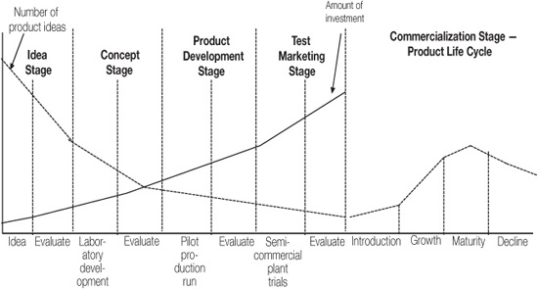

IDEA STAGE: To start any business the idea is the first step to establish the product the idea should be unique.
CONCEPT STAGE: Second stage is concept stage in this stage we analyze that the idea which has been choose is benifitial or not useful or not does this idea has a future or not.
PRODUCT DECVELOPMENT STAGE
In this stage the idea is now converted into the shape of hardcopy which means product.
TEST MARKIETING STAGE
In this stage they check either this product is good enough to run in markets or not.
COMMERCIALIZE STAGE:
In this stage the product is commercialized.
Q.4 What is a product? Explain its different types in detail with examples.
ANS) PRODUCT:
A product can be classified as tangible or intangible. A tangible product is a physical object that can perceived by touch such as a building vehicle or gadget most goods are tangible products for example a soccer ball is tangible product or ideas are intangible.
TYPES OF PRODUCTS:
There are four types of product:
1 Consumer product
2 Convenience product
3 Shopping product
4 Specialty product
1 CONSUMER PRODUCT:
A product can be a business product. Or a consumer product. If the end user of the product is the consumer then the product is a consumer product if the end user is a business then it is categorized as a business product.
2 CONVENIENCE PRODUCT:
A convenience product is a consumer product that takes little thought, is routine, purchased often, appeals to a large target market, and the consumer purchases with little planning. Our favorite Ninja decides that he is in need of a snack. He finds the closest convenience store and rushes in and picks up his favorite Ninja Energy Bar for one dollar. Other items that would fit a convenience product example would be if the Ninja purchases candy, soda, water, or a hairbrush. These types of products still have some brand loyalty to their consumers. After all, most consumers want a specific brand of soda or type of candy bar.

3. SHOPPING PRODUCT:
Are those products which consumer buys on and off which is a basic demand these days these consist different kind of products electric products food clothing cell phone fruits vegitables etc.
4.SPECIALTY PRODUCTS:
Specialty product are products where consumers are concerned with brand image and the quality of their purchases. Consumers really do not want substitutes and are brand loyal.

