**NAME: HAMZA MEHMOOD ID:12715**

**QUESTION NO 1:**

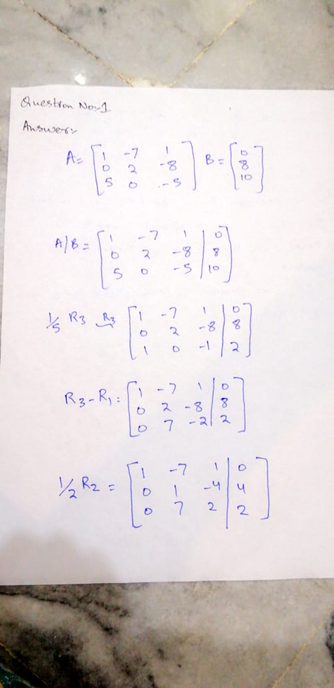**ANSWER:**

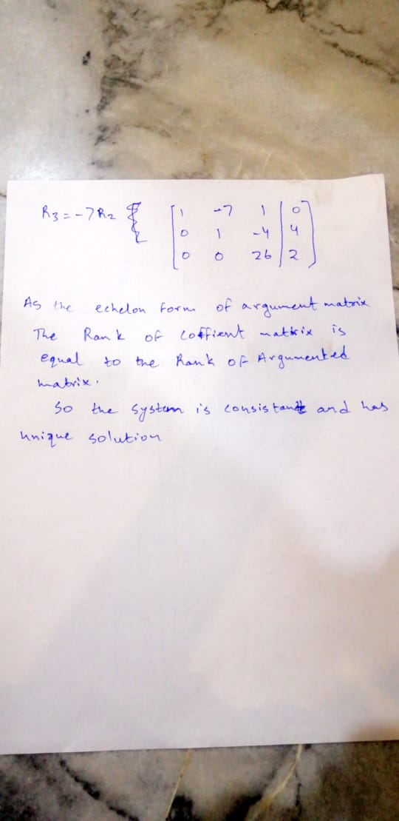

**QUESTION NO 2:  
ANSWER:**

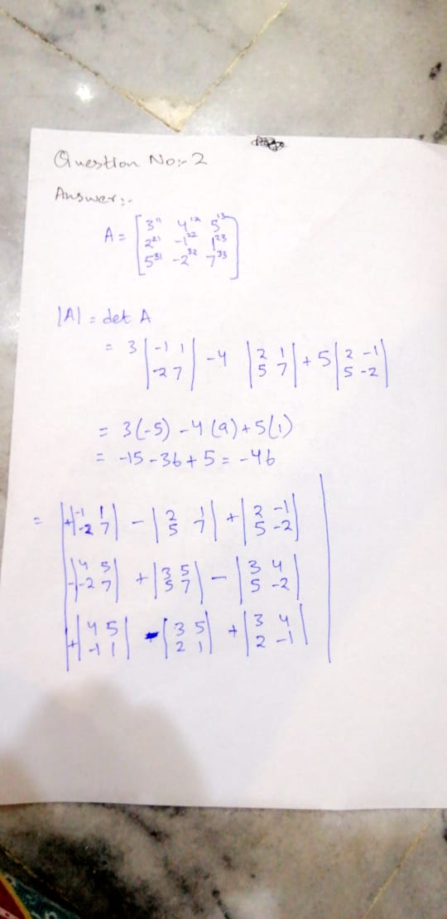

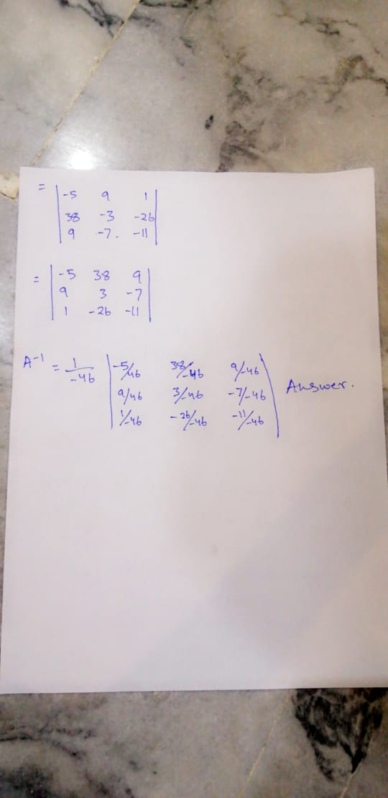

**QUESTION NO 3:**

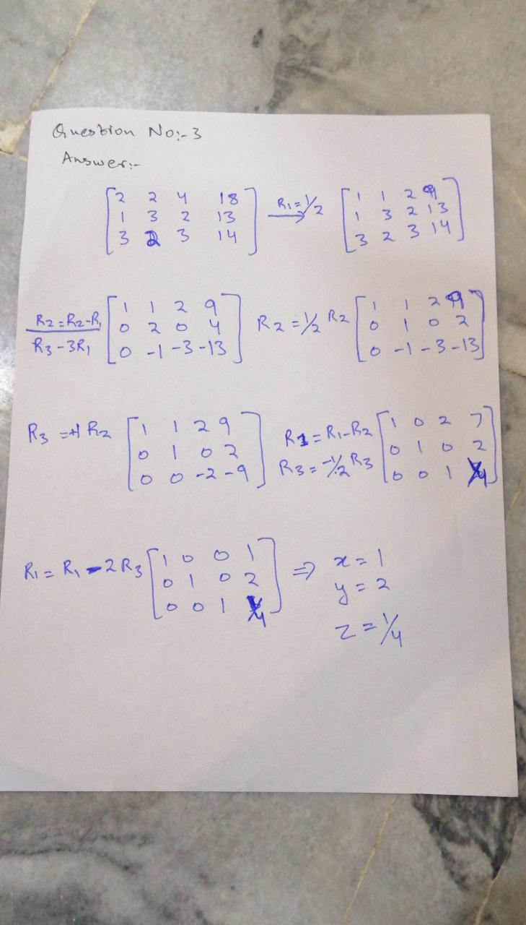 **ANSWER:**

**QUESTION NO 4**

**ANSWER:**

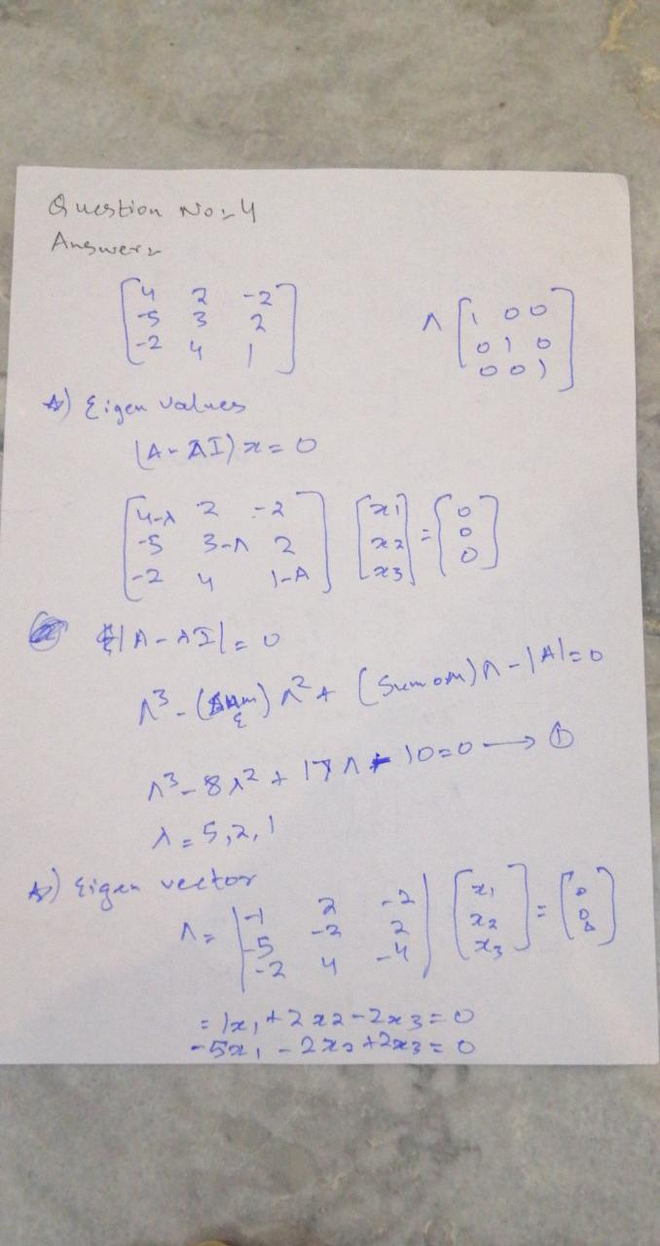

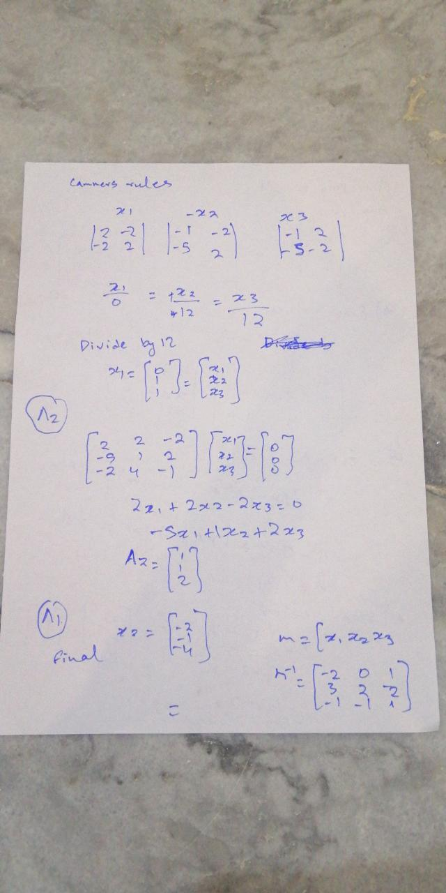

**QUESTION NO 5**

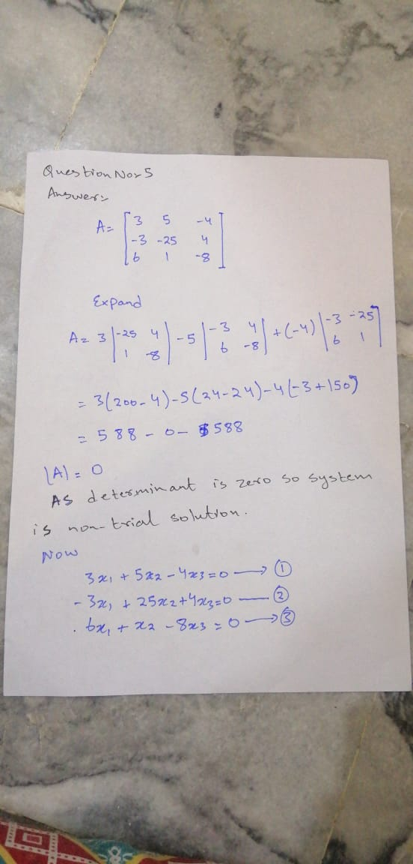**ANSWER:**

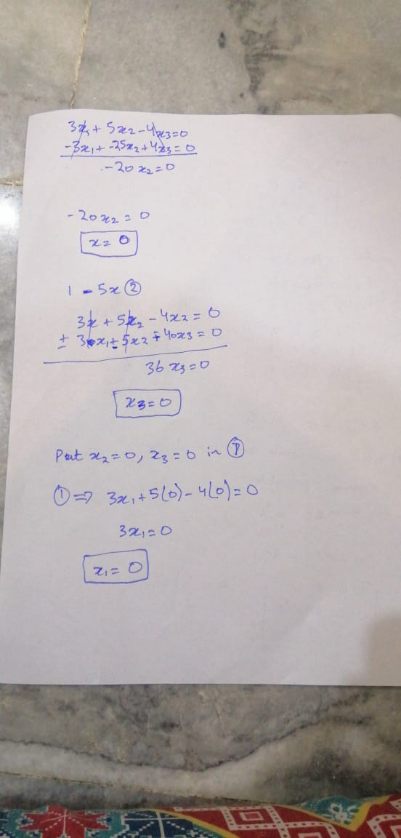

**QUESTION NO 6**

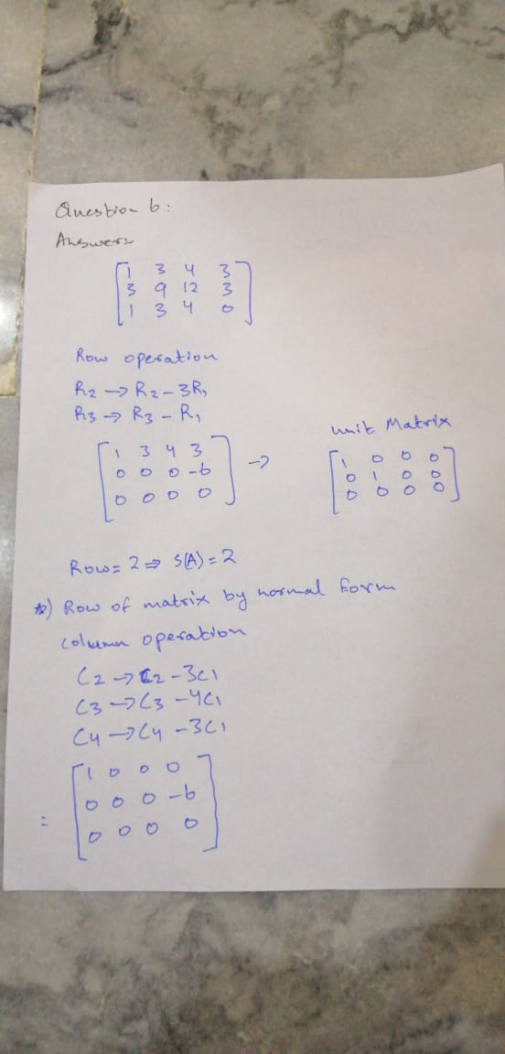**ANSWER:**

