ID NO: 16069
Name: Shah Fahad
Department: BE(C)
Semester: 2nd
Section: A
Subject: Engineering geology

Part: A
Question 1
Rock is broken down by frost, rain and sun at A. What name is given to this process?
Answer: 1
The above process is physical weathering.
And in physical weathering it is a frost wedging process.
By which rock is brock by freezing and thawing of water in rock cracks.

Question: 2
How is sediment grains in a river changed during transport from A to B? State two differences in the likely appearance of the grains.
Answer: 2
The sediments shape changes when transport from A to B. due to erosion and weathering the sediments change from bolder shape to cobbles and then change to pebbles and sand and last it change to clay.

Question: 3
How do loose sediments at C become changed into solid rock?

Answer: 3
Sediments are fragments of rocks that are broken down as a result of weathering.
The sediment are accumulate with other minerals or organic particles on the floor of ocean or river, and make a sedimentary rocks by the cementation of minerals.

Question: 4
Rocks that are deeply buried in the Earth’s crust may undergo metamorphism. Describe two changes that happen in rocks during metamorphism & explain point D?
Answer: 4
Metamorphic rock is form when the igneous rock is heated and pressurize.
During this process the rock undergoes two changes, first the rock is heated by the heat of magma due to which the shape of rock is changes and it got physical and chemical changes.
Explanation of point D:
The point D is a place where the magma is form by different minerals and iron due to the most heat of earth and this magma is form the igneous rocks and also the metamorphic rocks this magma also melt the sedimentary and igneous rocks form molten form of rocks and then the circle of formation of rocks continuous.

Part: B
Question: 1
In each box, write down the most likely number from the Deposit produced column in the table above.
Answer: 1
1: Clay mud
2: Rounded pebbles and sand
3: Sloping sand layers
4: Angular boulders

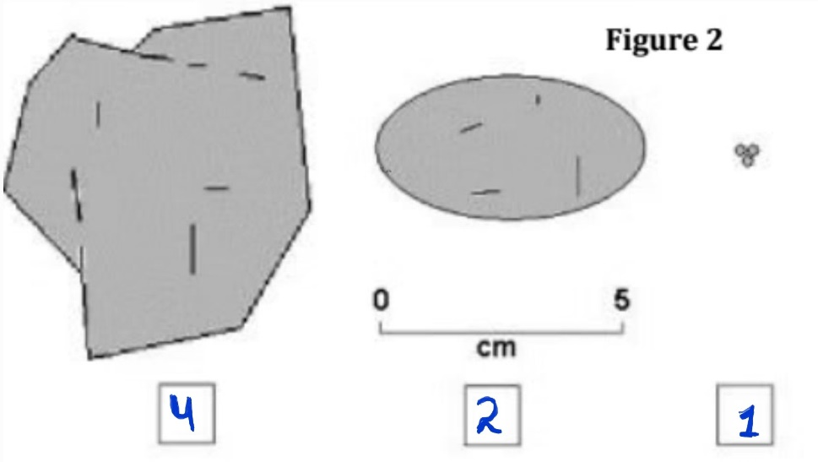
Question: 2
In your own words, explain how sediment particles change as they are transported downstream by a river
Answer: 2
When the erosion of particles occur downstream by river. Then the sediments change along some periods of transportation and deposit in various places, these sediments changes from borders to cobbles and after sometime of more weathering and erosion it change into pebbles and sands and then silt and clay which is present in the mouth of river.
Part: C

Question: 1
what type of volcano is shown in the figure by shape and if eruption is more often, which category it fits?
Answer: 1
The type of volcano in the figure is a “Composite volcano” because of side vent as show in figure, and the eruption is a “Plinian Eruption”, because it release large amount of ash which is about thousands of miles away from volcano. The eruption column are usually like a mushroom shape of plinian eruption.
Question: 2
The eruption shown in Figure 3 is producing an “Ash Column” that rises thousands of meters above the volcano summit.
(a):
Explain how gases trapped in the magma help produce the ash column.
Answer: (a)
Volcanic ash is formed during explosive volcanic eruptions when gases dissolved in magma, due to these gases the magma expand with high pressure and escape violently into the atmosphere.
The composition of gases in magma is H2O and CO2 mostly.
Minor amount of sulfur chlorine and florine.

(b):
Many people around the World live close to volcanoes so, when a volcano erupts, thousands of lives may be at risk.
(i): Suggest ONE sign that might indicate if a volcano is about to erupt.
Answer: (i)
A small earthquakes start before the volcano erupt and increase emission of heat and gas from vents on the volcanos. This sign indicate the eruption of volcano.
(ii): Suggest TWO dangers that might result from Ash Fall near a volcano.
Answer: (ii)
Ash fall contain tiny rocks and natural glass blasted into the air by volcano.
Ash can threaten the health of people and livestock, pose a hazard to flying jet aircraft, damage electronics and machinery.

Part: D

Question: 1
In the table below are statements that refer to either Weathering or Erosion. Complete the table by writing Weathering or Erosion in the spaces provided.

Answer: 1
Statement | Weathering OR Erosion
Breakdown of rock without it being moved | Weathering .
Wearing away of rock during transport of rock particles | Weathering .
A process caused by wind, running water and moving ice | Erosion .
An effect of plant roots growing in rock joints and fractures | Weathering .

Question: 2
A statue was made from limestone. Rain makes limestone weather more quickly than sandstone. What substance in the rainwater causes this?
Answer: 2
These substances are carbonic acid, which can be found in rain it won’t actually do too much damage sandstone but weather limestone more quickly.

Question: 3
Why igneous rocks never contain fossils?
Answer: 3
Igneous rocks never contain fossils, because it is form from magma. Any fossils in original rock will melted when the rock melted to form magma.

Question: 4
Granite takes much longer to cool deep underground than basalt lava at the Earth’s surface. How and why is the size of the crystals in granite different from the size of the crystals in basalt?
Answer: 4
Granite:
Granite is an intrusive igneous rock, intrusive rocks form from magma underground, it cools slowly due to which large crystal forms.
Any crystal bigger than 1mm.
Basalt:
Basalt is an extrusive igneous rock, extrusive rock form from lava at the surface of earth, it fast cool in contact with air due to which small or no crystal are found in it.

Question: 5
Describe one process that might be responsible for producing the large, angular, poorly sorted fragments in the Scree sediment collecting at the bottom of the cliff?

Answer: 5
Gravity:
Gravity pull loose rocks and soil down a slope, causing a landslide where the tumbling rocks will bump into other and break into smaller pieces.
Due to this process the large rocks strike the other on its way and break it which make the large amount of sediments and rocks on the bottom of clif.

