GIS/RS Application to Civil Engineering
Submitted by:
Mansoor Kamal Khan
ID: 7715
Section: A
Submitted to:
Engr. Syed Hamza Mustafa

IQRA NATIONAL UNIVERSITY PESHAWAR

Location for Hostel in Lahore

By Mansoor Kamal Khan

IQRA NATIONAL UNIVERSITY PESHAWAR

Introduction:
Lahore is the capital of the Pakistani province of Punjab, and is the country's 2nd largest city after Karachi, as well as the 18th largest city proper in the world. Lahore, like majority of the cities in Pakistan has both public and private educational institutions from primary to university level. Most educational institutions are gender based from primary to university level. All academic education institutions are the responsibility of the provincial governments.
Education gives us a knowledge of the world around us and changes it into something better. It develops in us a perspective of looking at life. It helps us build opinions and have points of view on things in life. People debate over the subject of whether education is the only thing that gives knowledge.
A hostel is a large house where people can stay cheaply for a short period of time. Hostels are usually owned by local government authorities or charities. Hostel, an establishment which provides inexpensive food and lodging for a specific group of people, such as students, workers, or travellers. During hostel stay, students learn to live with different types of individuals, and hostel life also increases the students' level of patience. It prepares students to accept challenges in practical life. Individual differences are very common among the hostel roommates.

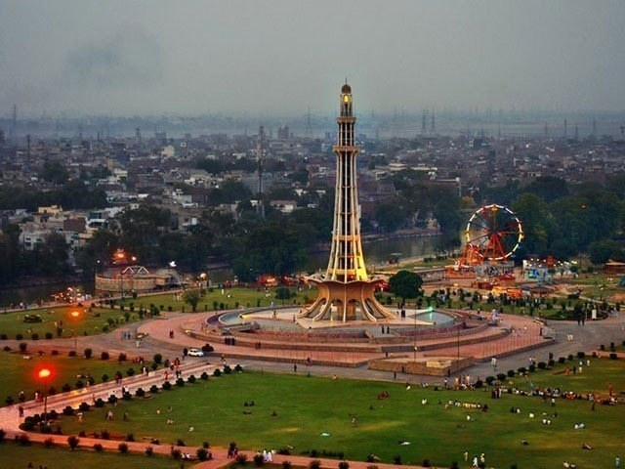
Figure 1.1 Lahore, Pakistan
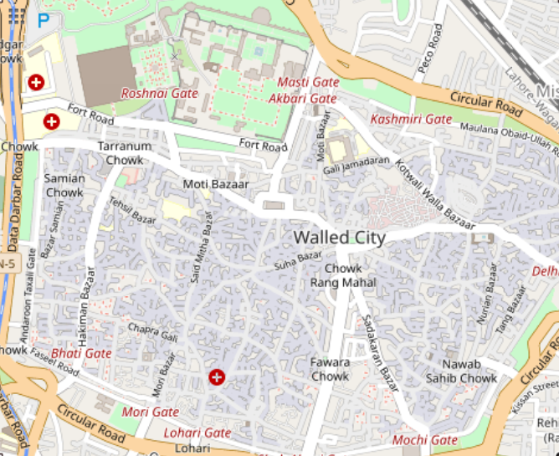
Figure 1.2 Walled City, Lahore, Pakistan

Problem Statement:
Nowadays education is one of the most fundamental aim and necessity of every person. But unfortunately, such educational facilities are very rare in Backward area of Pakistan. That’s why students move towards well developed cities of Pakistan i.e. Lahore, Peshawar, Islamabad etc. but there they face a lot of problems and issues, one of the main issues is residential area where they have to live with all facilities of life.

Objective:
The aim and objective of our project is to identified a location using QGIS for hostel in Lahore where students have all the facilities of life and is according to the following condition;
- Road with a range of 50m to hostel.
- University with a range of 1000 m to hostel.
- Collage with a range of 1000 m to hostel.
- School with a range of 500 m to hostel.
- Masjid with a range of 30 m to hostel.
- Hospital with a range of 1200 m to hostel.

Literature Review:
The project's first move was to undertake a study of literature. The literature review consisted of reviewing literature relating to common issues and their approaches found elsewhere, and as a result a technique was implemented to meet the project's goal.

Methodology:
The methods followed for achieving the project's goal is shown in the figure below;

Figure 5. 1 Methodology of the project

Data Collection:
The first stage of the project was collection of data and then computerization of the gathered data. Data was downloaded/obtained from OpenStreetMap.
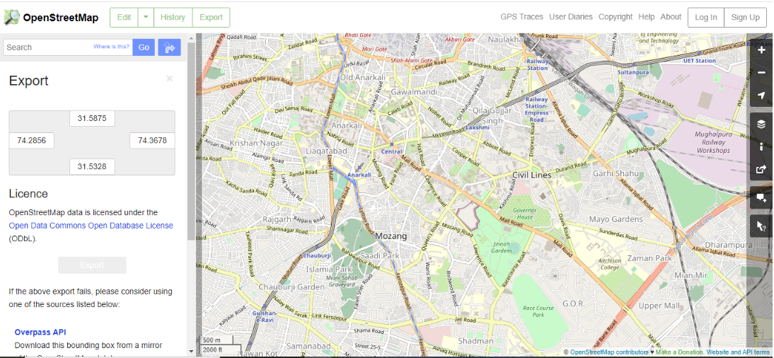
Figure 5. 2 OpenStreetMap data
  - Data Processing and Integration:
The data processing and integration consists of following steps;
- Installation of data into QGIS
- Converting of layers to 34S files
- Buffering of layers
- Intersection of layers

Installation of data into QGIS:
First of all, we put the OpenStreetMap data into QGIS in the form of shapefiles. In the installed data we keep the data of roods, universities, collages, schools, hospitals and Masjids as shown in figure;
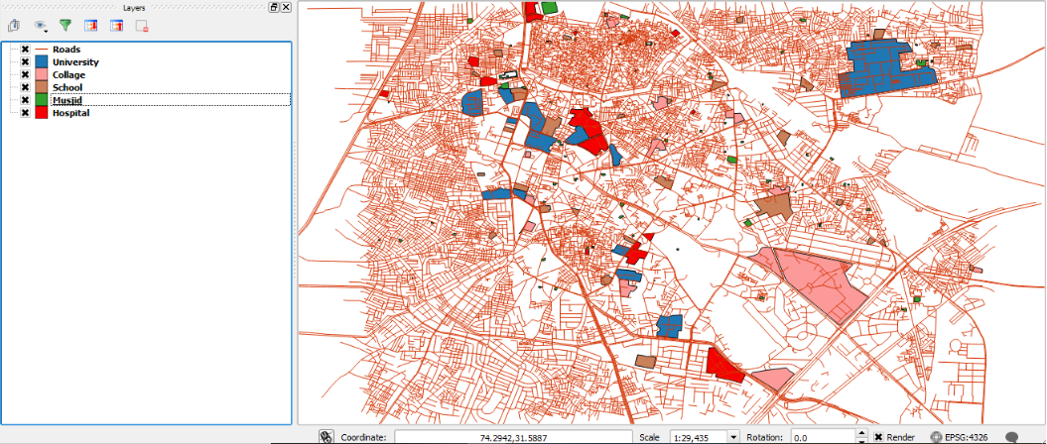
Figure 5. 3 Installed data in QGIS

Converting of layers to 34S files:
Layers are then converted to 34S file for proper buffering;
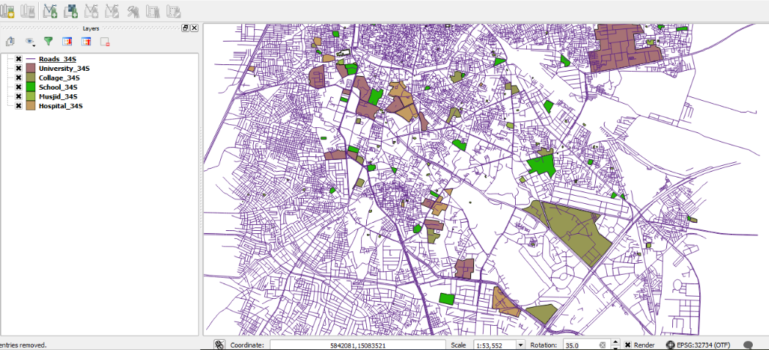
Figure 5. 4 34S files in QGIS

Buffering of layers:
After converting the layers to 34S files we buffer the layers one by one as;

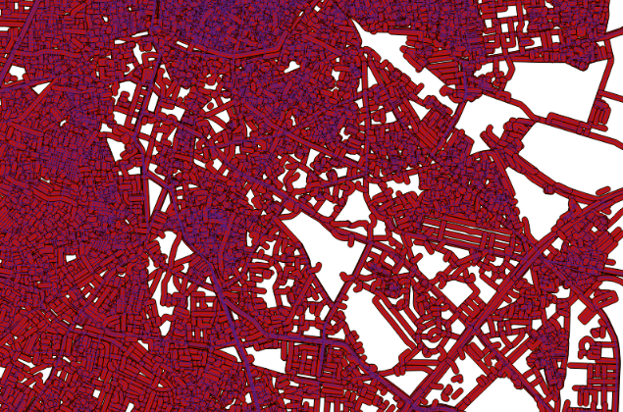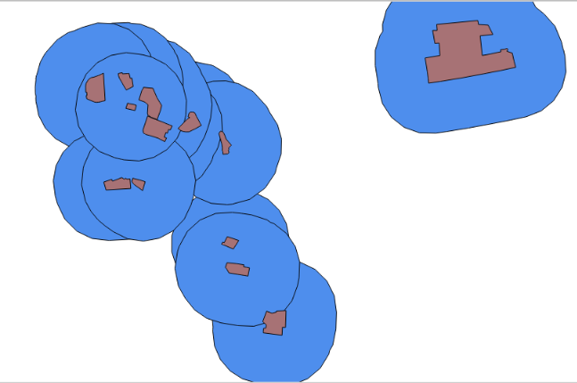
Figure 5. 5 Road Buffer Figure 5. 6 University Buffer
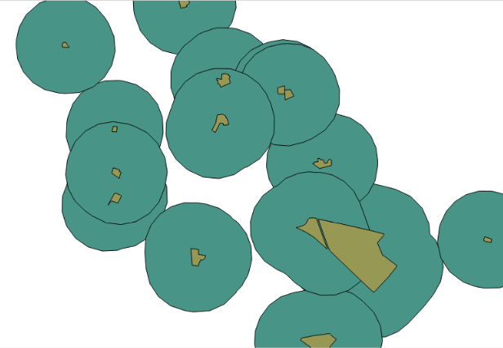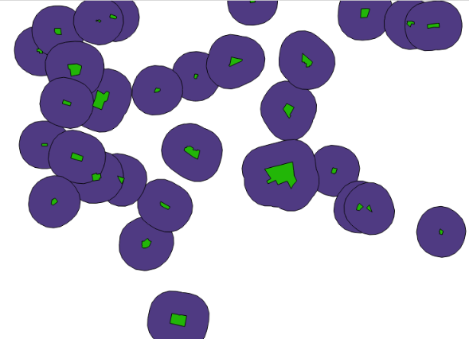
Figure 5. 7 Collage Buffer Figure 5. 8 School Buffer
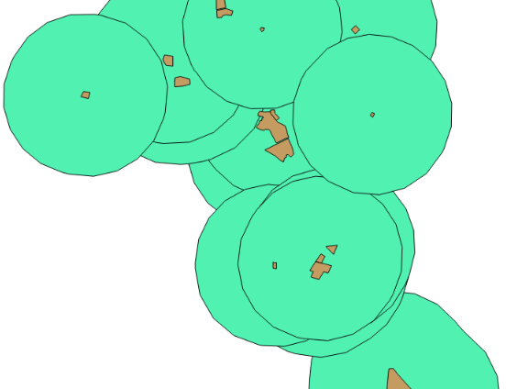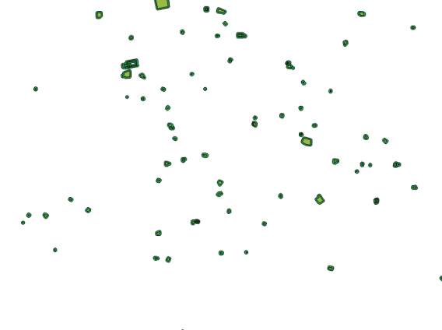
Figure 5. 9 Hospital Buffer Figure 5. 10 Masjid Buffer
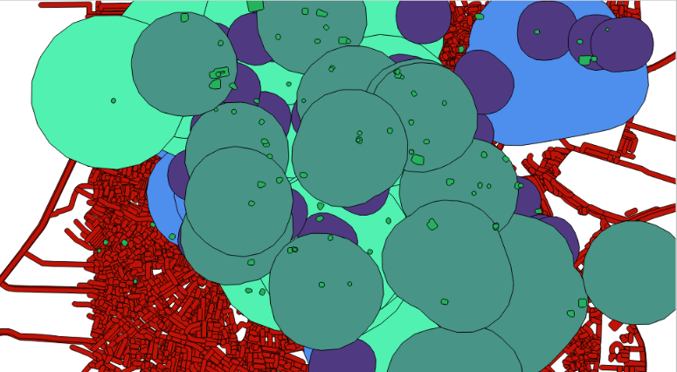
Figure 5. 11 Combined Buffer of All

Intersection of layers:
After intersecting the buffer layers, we get the location according to conditions which are shown with brown in figure;
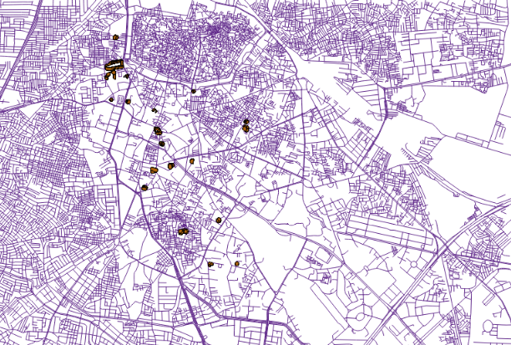
Figure 5. 12 Intersection of Layers

Data Output and Results:
After analysis of data in QGIS we get different areas according to condition mention in objective which are;
- Area 1 in Bilal Ganj
- Area 2 in Bati Gate
- Area 3 in Liaquat Abad
- Area 4 in Mall Road
- Area 5 in Anarkali
- Area 6 in Mozang
- Area 7 on Waris Road
- Area 8 in Qila Gujjar Singh
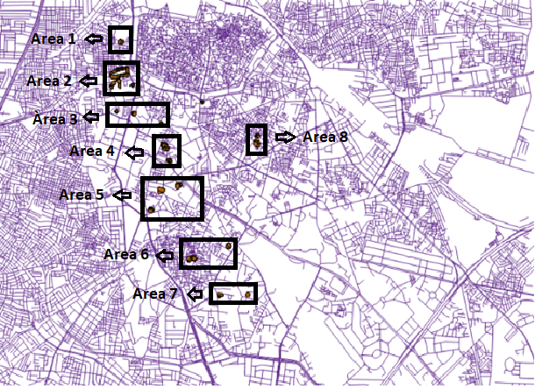
Figure 5. 13 Different Areas Location

Final Solution
Finally, after data processing we get the areas and their locations which is;
Area | Name | Location
1 | Bilal Ganj | Pir-Makki Road and Majid Nizami Road
2 | Bati Gate | Mohini Road, Zaildar Road, Kareemia Road, Kacha Rashid Street, Shishmahal Road, Data Dalbar Road, Gamay Shah Street and Bahram Street
3 | Liaquat Abad | Lower Mall
4 | Mall Road | Robert Road, Muhammad Naqi Road and Bank Square
5 | Anarkali | Fareed Road
6 | Mozang | Queens Road
7 | Waris Road | Waris Road
8 | Qila Gujjar Singh | Darbar Street

