NAME : MUNIBA IJAZ
ID NO : 15079
DEPARTMENT : DPT 4
PAPER : ANATOMY
SUBMITTED TO : MAM AROOBA
Q2 . Which type of stroke is common ? Write a complete note on Ischemic stroke .
A.COMMON TYPE OF STROKE :
Ischemic stroke is the most common type of stroke , according for almost 80% of all strokes is caused by a clot or other blockage within an artery leading to the brain.
ISCHEMIC STROKE :
Ischemic stroke is one of the three type of stroke . It’s also called as brain ischemia or cerebral ischemia. This type of stroke is caused by a blockage in an artery that supplies blood to the brain. The blockage reduced the blood flow and oxygen to the brain , leading to damage or death of brain cells .
SYMPTOMS :
Certain symptoms are common across most ischemic stroke , including :
. Vision problem like blindness in one eye or double vision
. Dizziness and confusion
. Loss of coordination
. Weakness or paralysis in your limbs , which may be on one or both sides , depending on the affected artery.
. Drooping of face on one side
CAUSES :
Ischemic stroke is caused by a fatty buildup happens when plaque breaks off from an artery and travels to the brain . Plaque can also build up in the arteries that supplies blood to the brain and narrow those arteries enough to cause ischemic stroke .
Ischemic stroke also caused when an artery that supplies blood to the brain is blocked by a blood clot or fatty build up called plaque . This blockage can appear at the neck or in the skull.
RISK FACTORS :
High blood pressure
High cholesterol
Atrial fibrillation
Sickle cell anemia
Clotting disorders
Congenital heart defects
Atherosclerosis
Smoking and diabetes
DIAGNOSED :
Doctor might perform a blood sugar test or usually use a physical exam and family history to diagnose ischemic stroke .
Cranial CT scan can also diagnosed ischemic stroke from other tissue .
TREATMENT :
Restore breathing , heartrate and blood pressure to normal .
Tissue plasminogen activator ( tPA) also called alteplase .
Q5 : Write a note on Autonomic Nervous System ? Difference between sympathetic and parasympathetic Nervous System .
A.AUTONOMIC NERVOUS SYSTEM :
The autonomic nervous system is the part of the nervous system that supplies the internal organs. Including blood vessels , stomach , liver, kidney lungs and heart and salivary and digestive gland .
Autonomic nervous system receive information about the body and external environment . It responds by stimulating body process, usually through sympathetic division or trough the parasympathetic division .
FUNCTION OF AUTONOMIC NERVOUS SYSTEM :
The autonomic nervous system control internal body processes such as :
• Blood pressure
• Heart and breathing rates
• Body temperature
• Digestion and metabolism ( thus affecting body weight )
• Balance of water and electrolytes ( such as sodium and calcium )
• The production of body fluids (saliva , sweat and tears)
• Urination
CAUSES :
Common causes of autonomic nervous system :
Diabetes , parkinson’ s disease , spinal cord disorders , disorder of neuromuscular junction , injury to neck , including that due to surgery .
SYMPTOMS :
Constipation
Orthostatic hypotension
Urine retention
Dizziness and light- headedness
Decrease blood pressure
TREATMENT :
Electrocardiography
Sweat test
A doctor’s evaluation
TYES OF AUTONOMIC NERVOUS SYSTEM :
There are two types of autonomic nervous system:
1.Sympathetic nervous system
2.Parasympathetic nervous system .
DIFFERENCE BETWEEN SYMPATHETIC AND PARASYMPATHETIC NERVOUS SYSTEM :
SYMPATHETIC NERVOUS SYSTEM :
•One of the main part or autonomic nervous system that control the body’s ‘fight or flight’ responses .
• Sympathetic nervous system prepare the body for emergency situation .
• It responsible for producing rapid and total metabolization to avoid danger .
• It’s preganglionic fibres arise from thoracic and lumber segments of spinal cord .
• It secretes adrenaline or noradrenaline at their synapse .
• Preganglionic fibres are shorter and postganglionic fibres are longer.
• Sympathetic nervous system increase the heart rate .
• Overall effect is excitatory .
PARASYMPATHEYIC NERVOUS SYSTEM :
• One major part of the autonomic nervous system that control the ‘ rest and digestion ‘ function of the body .
• Parasympathetic nervous system maintain conserving functions when the body is at rest .
• It restore the organism to its normal position .
• It’s preganglionic fibre arise from the midbrain and sacral ligaments of spinal cord .
• postganglionic fibres of parasympathetic nervous system secretes acetylcholine .
• Preganglionic fibres are longer and postganglionic fibres are shorter .
• Parasympathetic nervous system does the opposite that of decrease the heart rate .
• Overall effect is inhibitory .
Q3. What do you know about thalamus nuclei of brain ?
A.THALAMUS NUCLEI OF BRAIN :
The thalamus serves as the main relay station for the brain . Motor pathways , limbic pathways , and sensory pathways besides olfactory all pass through this central structure. The thalamus can divide into approximately 60 regions called nuclei. Each nuclei has unique pathway as input and various projection as output most of which send information to the cerebral cortex .
SYRUCTURE :
Thalamus is a paired structure located in the center of the brain . Each side can divide into 3 groups of thalamic nuclei : a lateral nuclear group , a medial nuclear group and an anterior nuclear group . These three groups get split by the internal medullary lamina , a Y- shaped structure present on each side of the thalamus . There is also an area of thin midline thalamic nuclei next to the third ventricle , and an enveloping thalamic reticular nucleus that cover each lateral thalamus .
CATEGORIZATION OF THALAMIC NUCLEI :
1.LATERAL NUCLEAR GROUP :
• Ventral posterolateral nucleus ( VPL)
• Ventral posteromedial nucleus (VPM)
• Lateral geniculate nucleus (LGN)
● Medial geniculate nucleus (MGN)
▪ Ventral Lateral Nucleus (VL)
● Ventral interior nucleus (VA)
● Pulvinar Lateral Dorsal Nucleus
● Lateral Posterior Nucleus
● Ventral Medial Nucleus
2.MEDIAL NUCLEUS GROUP
● Medio Dorsal Nucleus (MD)

3.Anterior Nuclear Group
● Anterior Nucleus
4.Midline Thalamic nuclei
● Periventricular
● Parataenial
● Interanterio Medial
● Intermediodorcal
● Rhomboid
● Medial Ventral
RETICULAR NUCLEUS :
INTRALAMINAR NUCLEI :
- Rostral intralaminar nuclei
• Central medial nucleus
• Paracentral nucleus
• Central lateral nucleus
2.Caudal intralaminar nuclei
• Centromedian nucleus
• Parafascicular nucleus
Thalamic lesions

Cerebrovascular lesions or tumors of thalamus lead to:

Loss of sensation in the contractual side of face by body following by distressing discomfort and burning and diffuse pain in the anesthetic area

Thalamic syndrome :abnormal vulontry movements with hemisensory disturbances

BLOOD SUPPLY :

Posterior communicating artery

Paramedian thalamic. Subthalamic Inferolateral arteries
Posterior chorodial artery .
Q4.write a note on the descending track of spinal cord ?
A.DESCENDING TRACK OF SPINAL CORD :
Descending spinal tracts

Originate from the cerebral cortex and brain stem

Concerned with;

Control of movements

Spinal autonomic functions

Spinal reflexes and equilibrium

Muscle tone

Modulation of sensory transmission to higher centers

Motor or descending tracts of the spinal cord

Name ; lateral corticospinal

Location; lateral column

Function; muscle of the limbs hand and feet

Name; Anterior corticospinal

Location; Anterior column

Function; Muscles of the axial skeleton

Name; Rubrospinal

Location; lateral column

Function ; skeletal muscle of the limbs hands and feet

Name; Tectospinal

Location; Anterior column

function; skeletal muscle of the hand and eyes in response to visual stimili

Name ;Vestibulospinal

Location; Anterior column

Function; muscle of maintaining balance in response to head movement

Name; Lateral reticulospinal

Location; Anterior column

Function; facilitates flexor reflexes inhibits extensor reflexes

Name; Medial reticulospinal

Location; Anterior column

Function; facilitates extendor reflexes inhibit flexor reflexes

The motor pathway are divided into two group:

Direct pathway

(Voluntary motion pathway)

The pyramidal tracts

Indirect pathway

(Postural pathway)

The extra pyramidal tracts

THE BASAL GANGLIA AND CEREBELLUM ARE INVOLVED IN PLANNING :
. The cerebellum is responsible for fine tuning movements therefore it is involved both planning and execution.
. Currently popular theories imlicate primarily in Action selection that is the decision of which several possible behaviora to execute at a given time.
PYRIMAIDAL SYSTEM
. Components’
. Corticospinal track
. Corticobulbar track
CORTICOSPINAL TRACK DIVISION
- Lateral corticospinal track
Made up of corticospinal fibres that have crossed in medulla . Supply all levels of spinal cord.
- Anterior corticospinal track
Made up of corticospinal fibres that cross near level of synapse with LMNs supply nech and upper limbs .
CORTICOSPINAL TRACK FUNCTIONS :
Add speed to conscious movements especially to hand.
Provide a high degree of motor control .
CORTICOBULBAR TRACK:
.Innervates the head
. Leave reticular formation and syanpse in cranial nerve nuclei .
. Synapse with lower motor neurons .
EXTRAPYRAMIDAL SYSTEM :
Includes descending motor tracks that do not pass through medullary pyramids or corticobulbar tracks includes:
. Rubrospinal track
. Vestibulospinal track
. Reticulospinal tracks
Tectospinal
RUBROSPINAL TRACK
Begins in red nucleus
Decussates in mid brain
Descends in lateral funiculus
Control the tone of limb flexor muscles being excitatory to motor neuron of these muscles .
VESTIBULOSPINAL TRACK
Originates in vestibular nuclei
Receive major input from vestibular nerve
Descends in anterior funiculus
Synapse with LMNs to extensor muscles
RETICULOSPINAL TRACK :
Originates in various regions of reticular formation
Descends in anterior portion of lateral funiculus
Thought to mediate larger movements of trunk and limbs
Origin : Pontine an Medullary reticular formation
Medial ( pontine ) reticulospine track descends ipsilaterally
Lateral ( medullary ) reticulospinal track descends bilaterally
Both tracks located in the ventral funiculus .
TECTOSPINAL TRACK
Mediates reflex movements of head and neck in response to visual stimuli.
ORIGIN : Superior colliculus
Descend in fissure , terminate mainly in cervical segments .
Desending autonomic fibers

The higher centers associated with the control of autonomic activity and situated mainly in the hypothalamus
the fibers run in the reticulospinal tracts
terminate on the autonomic neuron in the lateral horn of throcic and upper lumberand sacral segments levels of the spinal cord

Decending tract lesions

Pyramidal tract lesions ..

Loss of fine skilled movements
babinski sign presented
Cremasteric reflex absent
signs contralateral ispilateral or bilateral dependent or levels of lesions

Extra pyramidal tract

Paralysis
Not muscle wasting other than that due to disuse
Hyperreflexia develops or several days
Clasp knife rigidity.
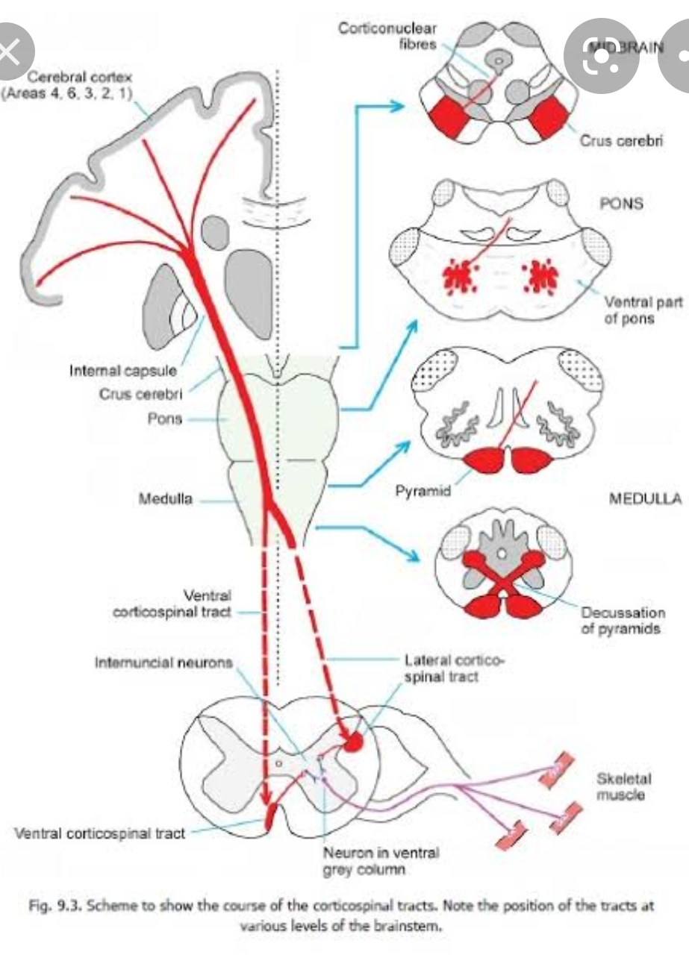
Q1.Write a comprehensive note on blood supply of brain ?
- Blood supply of brain :
: The brain receive arterial supply from two pairs of vessels vertebral and internal carotid arteries which are interconnected in the cranial cavity to produce arterial circle of Willi's.

Internal carotid Artery;
The most important running up the side of neck is called common carotid artery it splits into two branches, one of the branch is called the external carotid artery which supplies bloood to the neck and face the other branch of common carotid artery which supplies to the brain with oxygenated blood, is the internal carotid artery the internal carotid artery again is the branch of common carotid artery that supply to the brain oxygenated blood. Each side of the neck and head, has one internal carotid artery supplying blood to the brain. There have a grand total of two internal carotid artery.

The interior cerebral Artery;
As the internal carotid artery enters to brain, it gives off branch called the anterior cerebral Artery. The anterior cerebral Artery is the branch of interior carotid artery supplying the anterior or front portion of brain with oxygenated blood. This Artery also important because it provides another avenue by which brain can be supplied with blood just in case another passage way is closed off.

Posterior Cerebral Artery;
- Another artery entering to brain is called the posterior Cerebral Artery which supplies the posterior or structure at the rear of brain with oxygenated blood. There is one posterior artery on each side of body.furthermore each posterior artery connect to the internal carotid artery on the same side of brain in order to complete a very special structure in the brain.

The Circle of Willi's:
The important of blood supply to brain explain why there are so many pathways for oxygenated blood. As the internal carotid artery enters to head it gives off a branch to one side called the interior cerebral Artery the anterior cerebral Artery will then connect to the anterior cerebral Artery on the other side of head therefore by extension to the internal carotid artery on the other side of head as well as we also Know that the posterior Cerebral arteries will also connect to the internal carotid artery through small vessels

