Logic and Critical Thinking

Name; Bilal Ahmad
ID; 14318

Q1 What is Aristotelian logic? Discuss the four kinds of categorical propositions with at least five examples of each.
ANS ;The traditional system of psychology that Aristotle described and developed in the Middle Ages, was about rational understanding as expressed in syllogisms.
Aristotle's rational works have the first systematic study we have. It is noteworthy; therefore, that together they made a more advanced concept, which was able to give greater reverence for centuries.
Categorical proposition, in syllogistic or traditional logic, a proposition or statement, in which the predicate is, without qualification, affirmed or denied of all or part of the subject. Thus, categorical propositions are of four basic forms: “Every S is P,” “No S is P,” “Some S is P,” and “Some S is not P.” These forms are designated by the letters A, E, I, and O, respectively, so that
- “Every man is mortal” is an example A-proposition.
- “All Politicians are lairs” is an example A-proposition.
- “All tables are wooden” is an example A-proposition.
- “All Dogs bark” is an example A-proposition.
- “No man is mortal” is an example E-proposition.
- “No Politicians are lairs” is an example E-proposition.
* “No tables are wooden” is an example E-proposition.
* “No Dogs bark” is an example E-proposition.
- “Some man is mortal” is an example I-proposition.

- “Some Politicians are lairs” is an example I-proposition.
- “Some tables are wooden” is an example I-proposition.
- “Some Dogs Bark” is an example I-proposition.
- “Some man is not mortal” is an example O-proposition.
- “Some Politicians are not lairs” is an example O-proposition.
- “Some Tables are not wooden” is an example O-proposition.
- “Some Dogs not bark” is an example O-proposition.

2; Discuss the Venn Diagram technique for testing syllogism with the help of examples.
To test the validity of a categorical syllogism, one can use the method of Venn diagrams. Since a categorical syllogism has three terms, we need a Venn diagram using three intersecting circles, one representing each of the three terms in a categorical syllogism. A three term diagram has eight regions (the number of regions being 2^{n} where n is the number of terms).

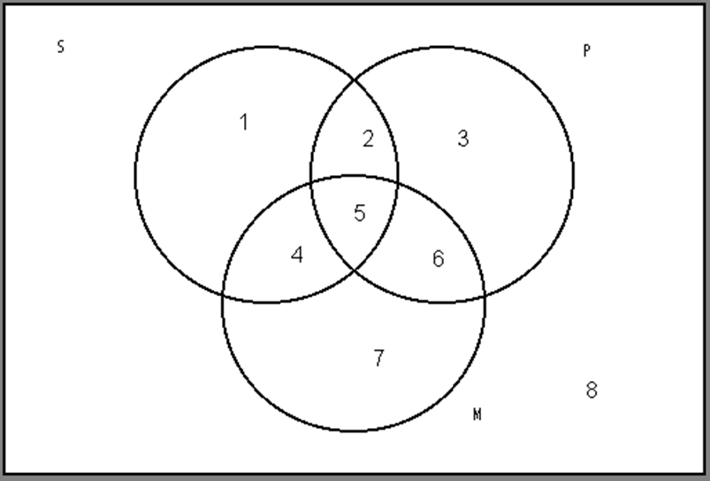

In order to use a Venn diagram to test a syllogism, the diagram must be filled in to reflect the contents of the premises. Remember, shading an area means that that area is empty, the term represented has no extension in that area. What one is looking for in a Venn diagram test for validity is an accurate diagram of the conclusion of the argument that logically follows from a diagram of the premises. Since each of the premises of a categorical syllogism is a categorical proposition, diagram the premise sentences independently and then see whether the conclusion has already been diagramed. If so, the argument is valid. If not, then it is not.

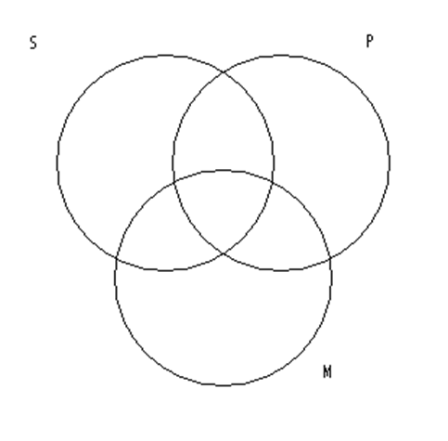

Consider the following argument:
All Greeks are mortal. (All M are P)
All Athenians are Greek. (All S are M)
So, all Athenians are mortal. (All S are P)
Next, diagram each of the premises. When doing this, act as if there are only 2 relevant circles. Begin with the first premise (frequently the premise involving the major term, sometimes called the major premise). In our example you need to diagram the proposition "All M are P". Ignoring for a moment the circle representing the minor term, your diagram sho8uld look like this:
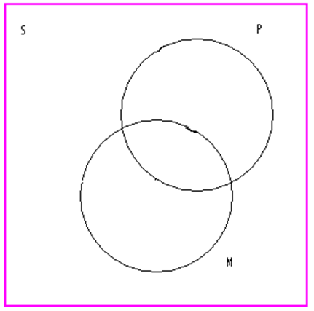

Following the standard conventions we get:
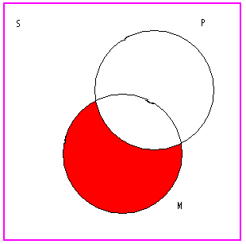
Next, diagram the second premise--"All S are M"-- to get:
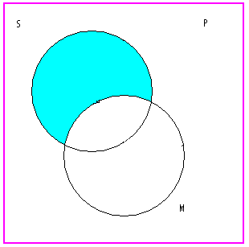
Now, if we overlap the diagrams of the premises we get a diagram of the argument, and we are ready to determine whether the argument is valid or not:
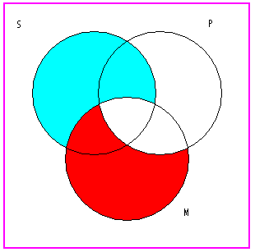

3; Discuss symbolic logic in terms of negation, conjunction and disjunction supplemented by examples. Also state the different symbols used in symbolic logic.

ANS ; Negation: In logic, negation, also called the logical complement, is an operation that takes a proposition to another proposition "not ", written, which is interpreted intuitively as being true when is false, and false when is true. Negation is thus a unary logical connective.
If A is the statement "I am rich" and B is the statement "I am happy,", then the negation of "A $\Rightarrow$ B" is "I am rich" = A, and "I am not happy" = not B. So the negation of "if A, then B" becomes "A and not B".
Conjunction: the truth-functional operator of logical conjunction; the and of a set of operands is true if and only if all of its operands are true. The logical connective that represents this operator is typically written as ∧ or ⋅. is true if and only if is true and is true.
p represents the sentence, "Ann is on the softball team," and statement q represents the sentence, "Paul is on the football team." The symbol is a logical connector which means "and." Therefore, the compound statement pq represents the sentence, "Ann is on the softball team and Paul is on the football team." The statement pq is a conjunction.
Disjunction: the truth-functional operator of (inclusive) disjunction, also known as alternation; the or of a set of operands is true if and only if one or more of its operands is true. The logical connective that represents this operator is typically written as ∨ or +.
In logic, or by itself means the inclusive or, distinguished from an exclusive or, which is false when both of its arguments are true, while an "or" is true in that case.
"Ann is on the softball team" and statement q represents, "Paul is on the football team." The symbol is a logical connector which means "or." Thus, the compound statement pq represents the sentence, "Ann is on the softball team or Paul is on the football team." The statement pq is a disjunction.
Definition: A disjunction is a compound statement formed by joining two statements with the connector OR. The disjunction "p or q" is symbolized by pq. A disjunction is false if and only if both statements are false; otherwise it is true. The truth values of pq are listed in the truth table below.

P | q | pq
T | T | T
T | F | T
F | T | T
F | F | F

Different symbols used in symbolic logic
Symbols | Name
⇒  →  ⊃ | Implies; if .. then
⇔  ≡  ↔ | if and only if; iff; means the same as
¬  ˜  ! | Not
≔  ≡  :⇔ | Is defined as
∧  ·  & | And
∨  +  ∥ | Or
⊕  ⊻ | Xor
⊤  T  1 | top, verum
⊥  F  0 | bottom, falsum, falsity
∀  () | for all; for any; for each
∃ | there exists

4; What are truth value, truth table and validity? Discuss and draw truth tables for negation, conjunction and disjunction.
ANS; In logic truth value, sometimes called a logical value, is a value indicating the relation of a proposition to truth.
A truth table is a mathematical table used in logic—specifically in connection with Boolean algebra, boolean functions, and propositional calculus—which sets out the functional values of logical expressions on each of their functional arguments, that is, for each combination of values taken by their logical variables . In particular, truth tables can be used to show whether a propositional expression is true for all legitimate input values, that is, logically valid.
Validity, In logic, the property of an argument consisting in the fact that the truth of the premises logically guarantees the truth of the conclusion. Whenever the premises are true, the conclusion must be true, because of the form of the argument.
Truth tables for
NEGATION
p | ~p
T | F
F | T
Opposite truth value from the statement.
Conjunction
p q | p ∧ q
T T | T
T F | F
F T | F
F F | F
Only true when both statements are true.
Disjunction
p q | p ∨ q
T T | T
T F | T
F T | T
F F | F
Only false when both statements are false.

5. Discussion argument by analogy, casual connection and cause and effect with the help of examples.
ANS; An analogy is a comparison between two objects, or systems of objects, that highlights respects in which they are thought to be similar. Analogical reasoning is any type of thinking that relies upon an analogy.

Causal relationships may be understood as a transfer of force. If A causes B, then A must transmit a force (or causal power) to B which results in the effect. Causal relationships suggest change over time; cause and effect are temporally related, and the cause precedes the outcome.

Cause and effect is a logical system that organizes evidence to show how something happened. Examples: We received seven inches of rain in four hours. - The underpass was flooded.

