Med Exam Paper: - Bio Statistics
Submitted by Nadir Ahmad
Student ID 6957
Submitted To Sir. Anwar Shamim
Paper Instructor Sir. Anwar Shamim
Department Allied Health Sciences
Degree BS (MLT)
Semester 6th

==============================================

Question No. 01
The data in the table are taken from a survey of the diet of 1308 men and 1540 women in total 2848 adults in a region of Pakistan. The numbers of men and women surveyed were divided, separately, into four equal parts on the basis of their fresh vegetable consumption.
These parts are shown as Q4, Q3, Q2 and Q1. The mean consumption in grams per day is given for each food type in each part, for men and women separately. For example, the mean consumption of fruit by men who ate the lowest amount of fresh vegetables is 31 grams per day. The columns headed SE give the standard errors of the mean food consumptions by all men and all women.

 | Men (sample size 1308) |  |  |  |  | Women (sample size 1540)
 | Q4 | Q3 | Q2 | Q1 |  | Q4 | Q3 | Q2 | Q1
 | Mean | Mean | Mean | Mean | SE | Mean | Mean | Mean | Mean | SE
Fresh veg | 204 | 259 | 266 | 317 | 0.9 | 178 | 235 | 266 | 304 | 0.8
Fruit | 31 | 45 | 69 | 105 | 0.5 | 28 | 46 | 70 | 121 | 0.4
Rice | 367 | 337 | 269 | 246 | 1.0 | 315 | 276 | 243 | 220 | 0.8
Wheat flour | 79 | 114 | 197 | 253 | 1.0 | 56 | 118 | 141 | 180 | 0.8
Whole grain | 2 | 2 | 6 | 27 | 0.1 | 1 | 3 | 6 | 22 | 0.1
Root veg | 7 | 11 | 16 | 29 | 0.1 | 6 | 12 | 17 | 28 | 0.1
Meat | 70 | 61 | 69 | 77 | 0.4 | 48 | 43 | 54 | 63 | 0.3
Fish | 23 | 28 | 31 | 44 | 0.2 | 19 | 21 | 28 | 46 | 0.2
Milk | 2 | 3 | 23 | 39 | 0.3 | 1 | 4 | 15 | 48 | 0.3

- Calculate the overall mean consumption of fresh vegetables fruits, rice, fish, and meat for men and women separately. Give the underlying standard deviation in each case. Calculate also the overall mean consumption of fresh vegetables, rice, fish, and meat for men and women combined.
Answer:-
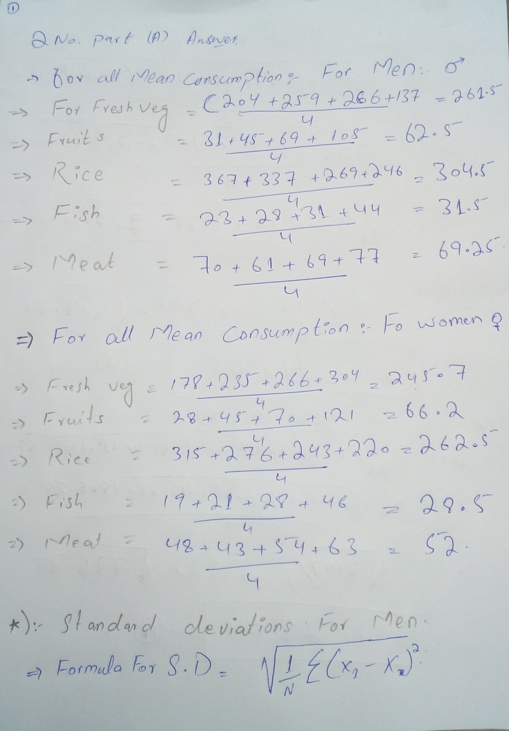
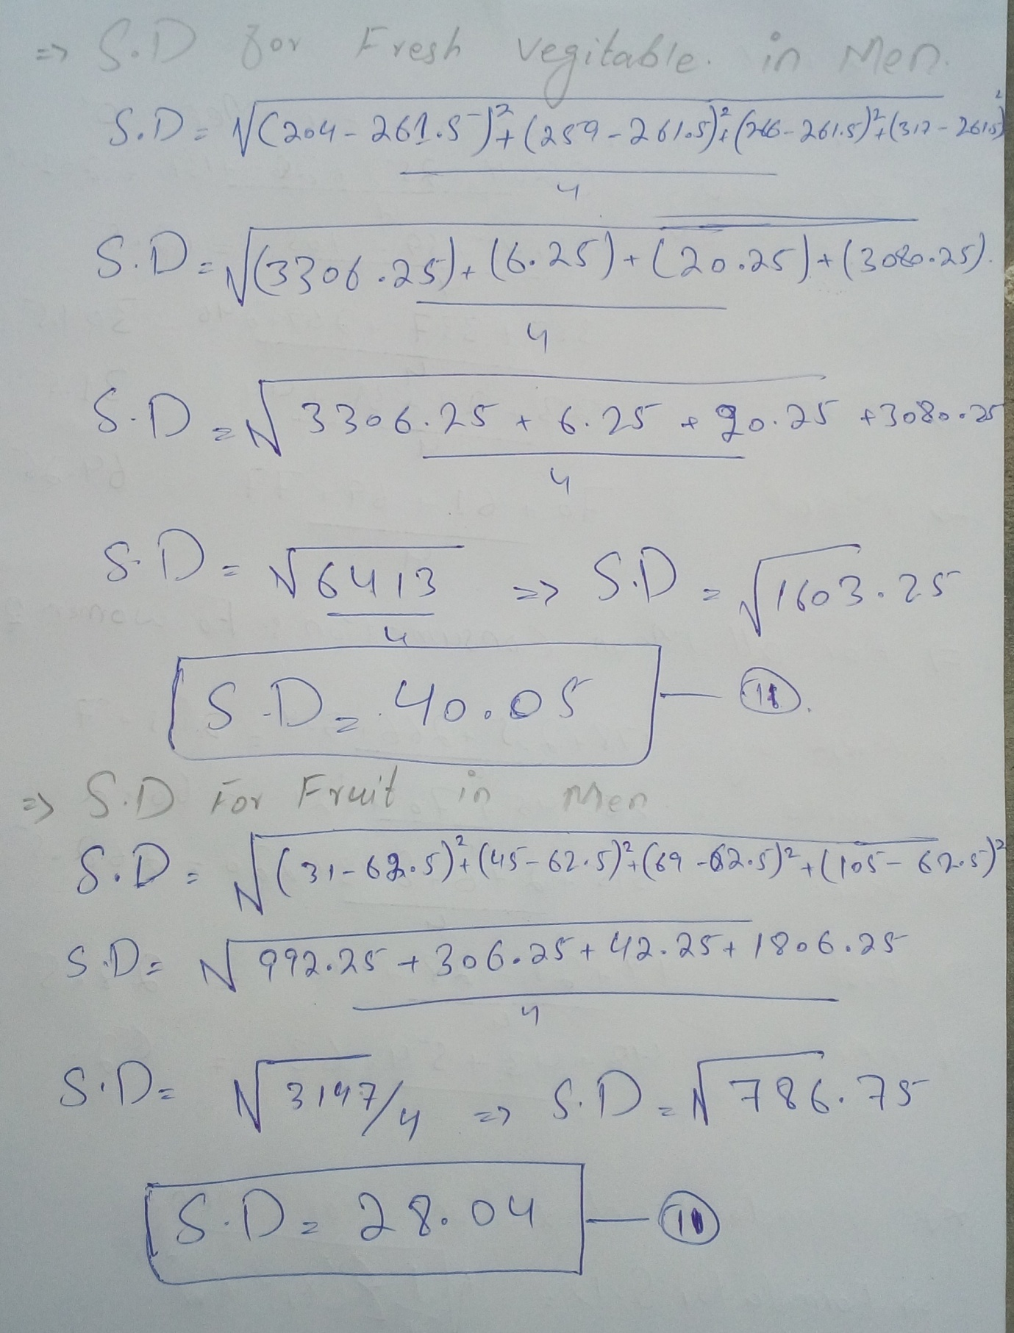
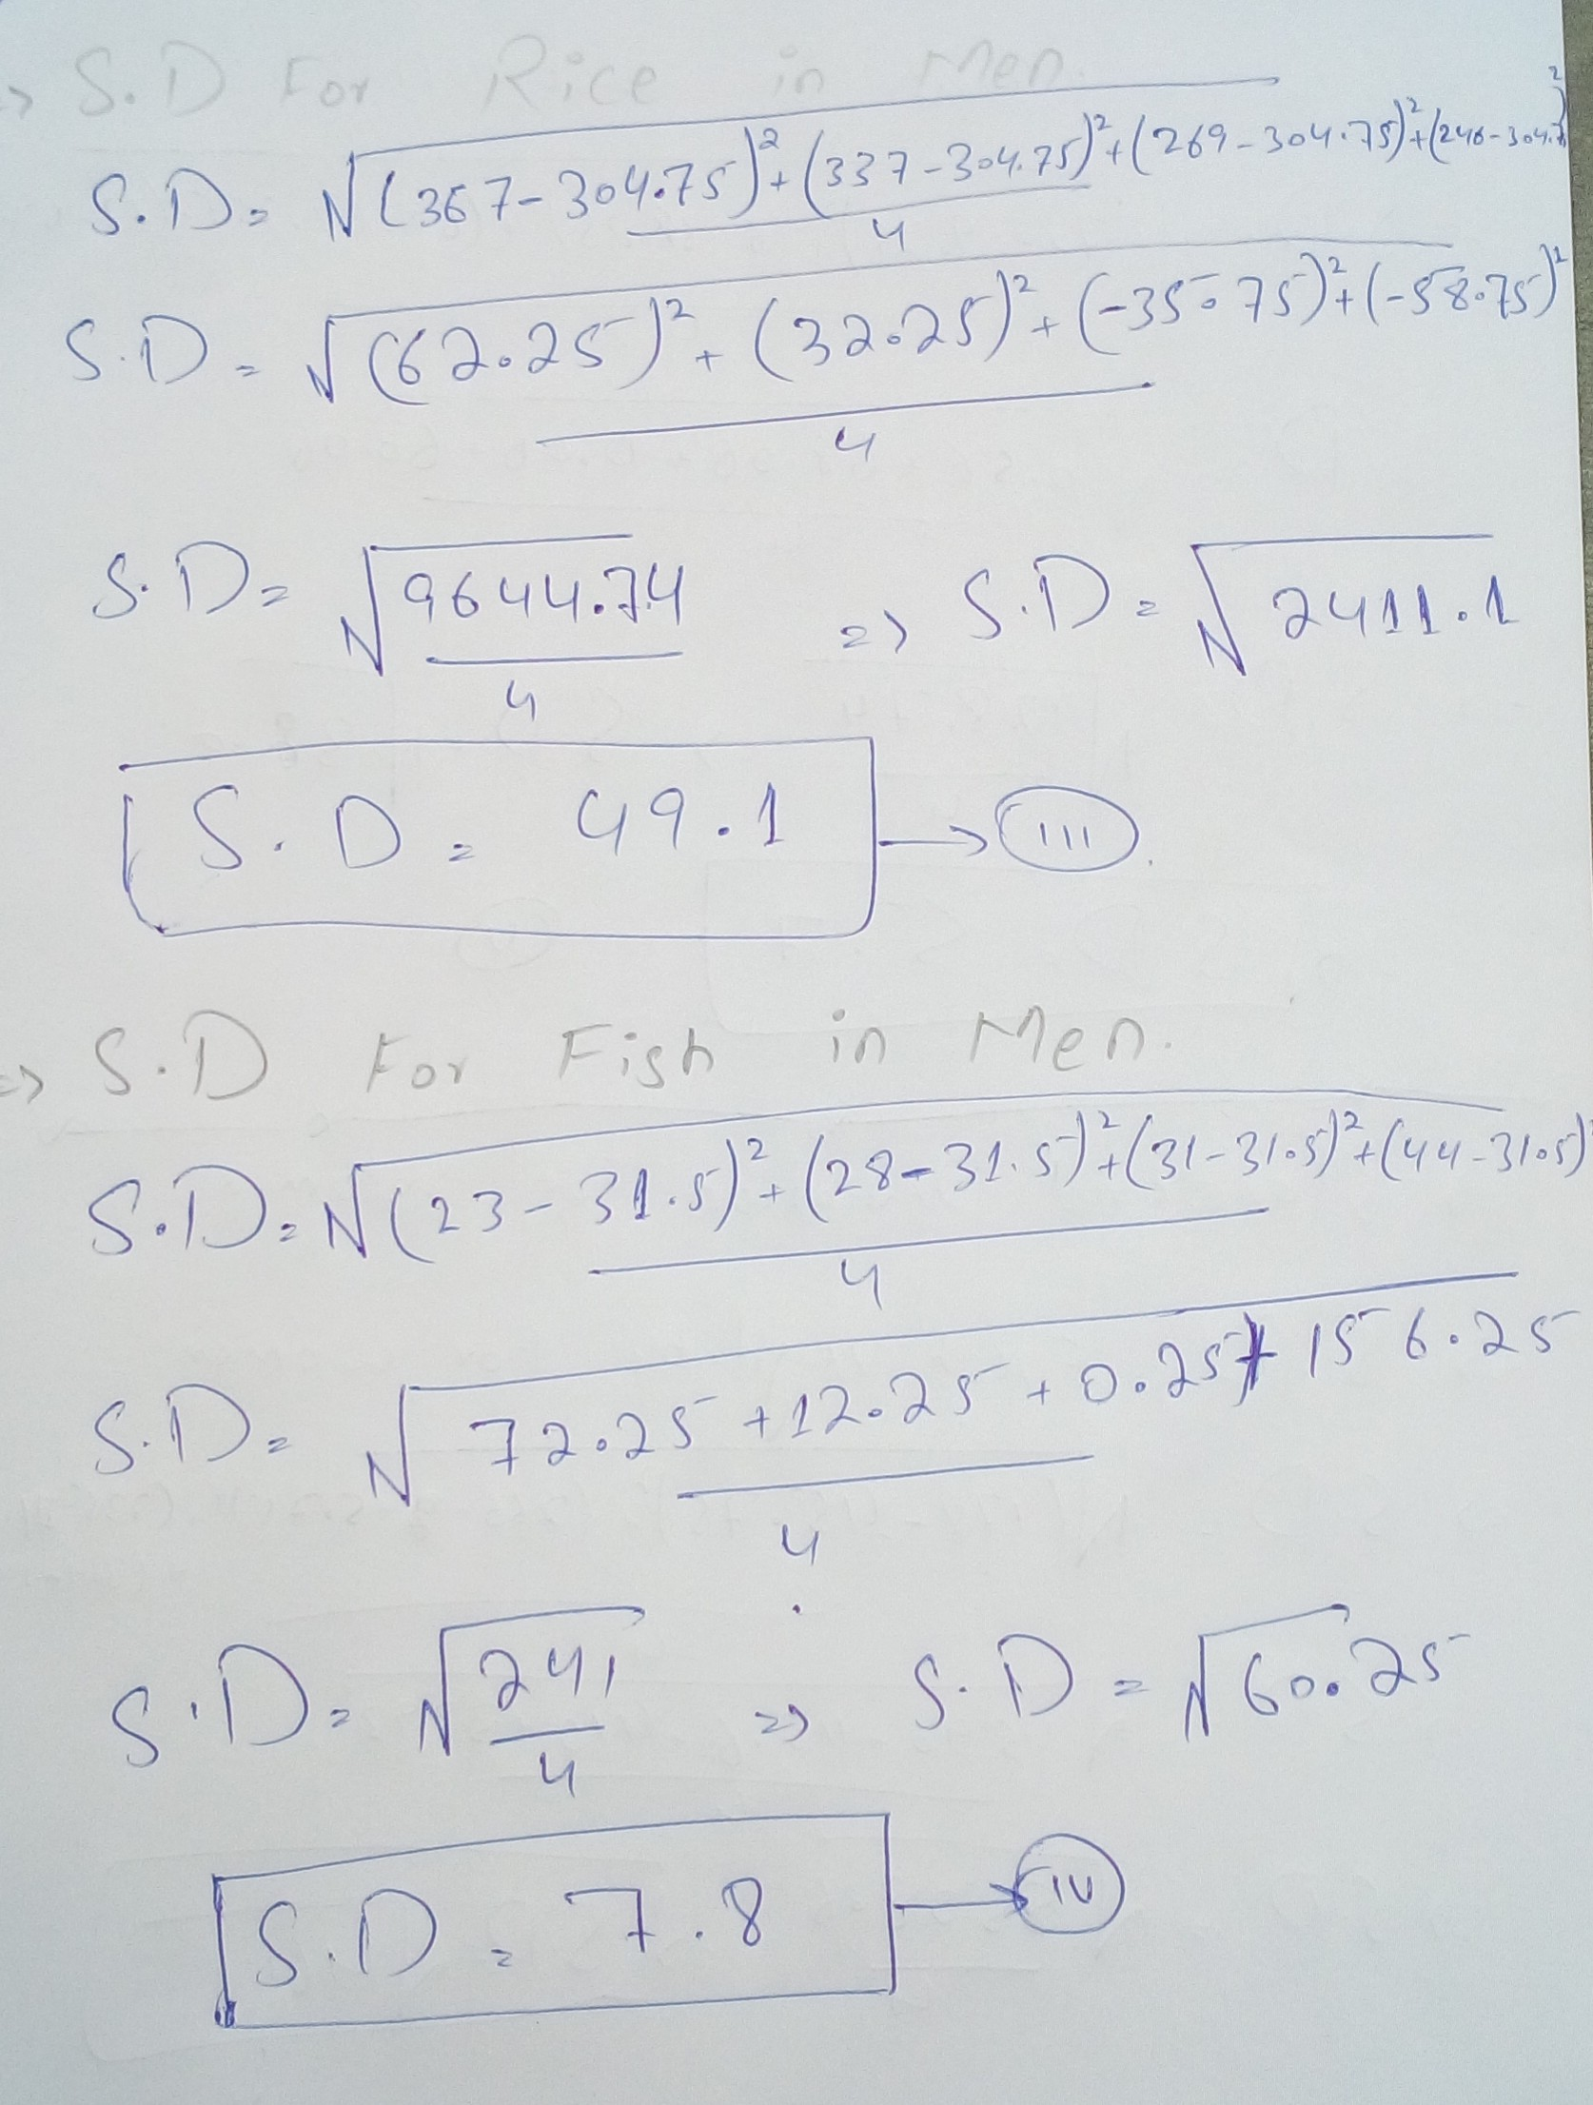
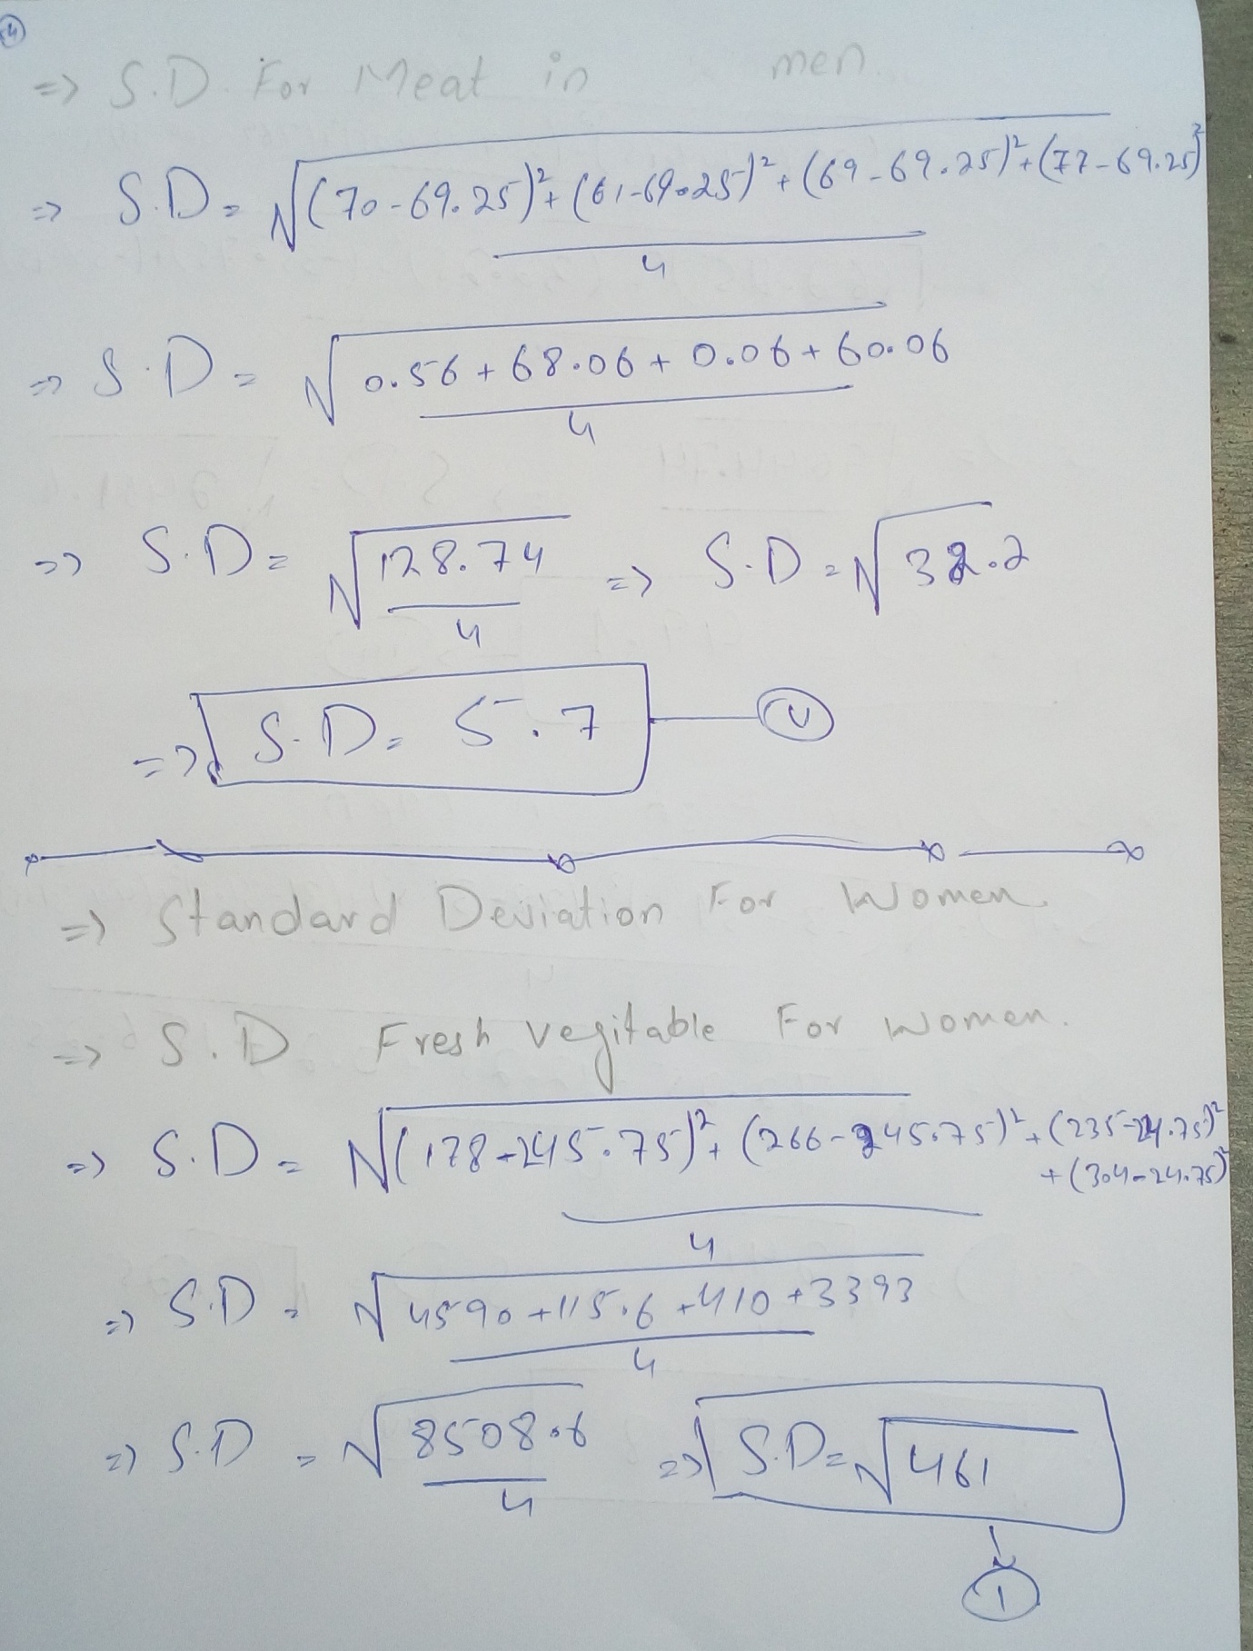
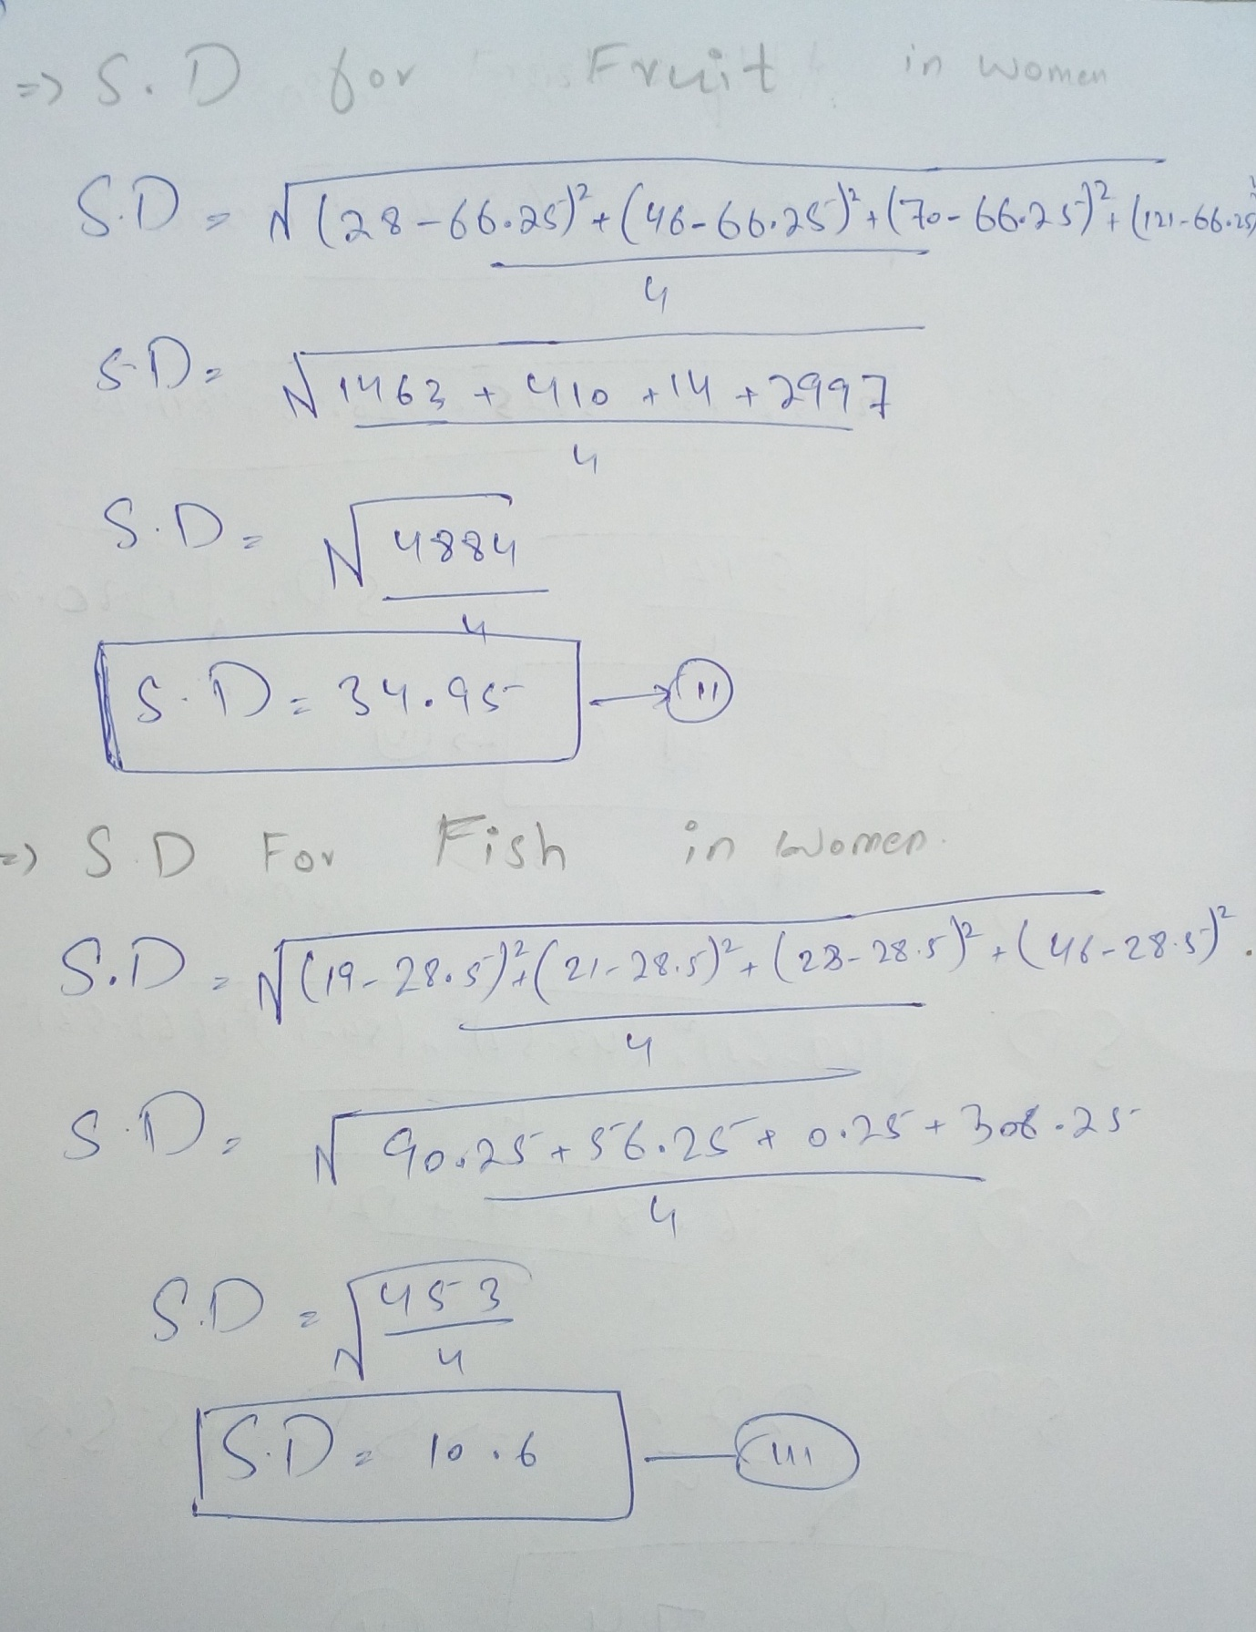
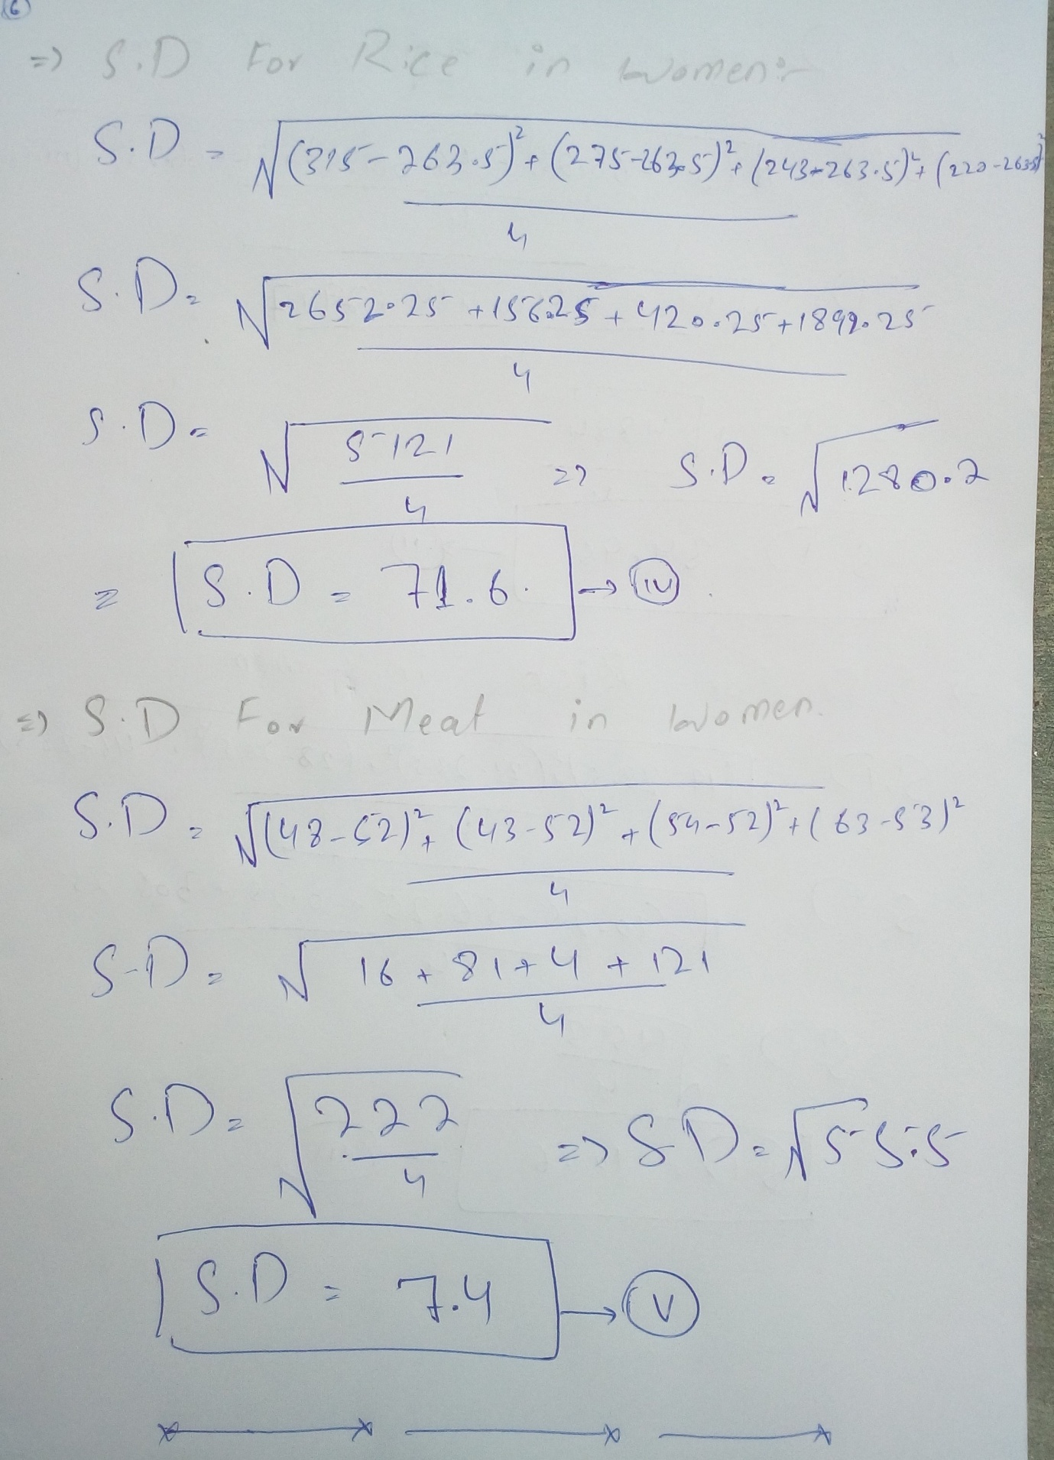
--------------------------------------------------------------------------------
- Describe in words what the figures for milk, root vegetable, wheat flour, consumption indicate.
Answer:-
Milk:-
Milk the date is given in the table indicates that intake of milk is very less for both gender men and women.
Root vegetable:-
The root vegetable is also intake in very loss amount for both gender but men consumption is greater than women.
Flour:-
The consumption of wheat flour is also below average milk, root vegetable and wheat flour are essential food.
--------------------------------------------------------------------------------
- What distinctive pattern is there, for both men and women, in rice, fruit, and fish consumption across the four parts, Q4 to Q1?
Answer:-
Rice:-
The men consumption of men is 304 gram while the woman is 363 gram which indicates that men consumption is higher than women.
Fruit:-
The mean is 62.5 gram while the mean consumption of women is 66.35 gram. It indicates that women consumed more than men.
Fish:-
The mean consumption for men is 31.5 gram while for women is 285 gram indicates the consumption of men is more women
That’s the reason that men immune are more than women.
--------------------------------------------------------------------------------

- Draw a suitable diagram to show the difference in consumption patterns of fish and fruits between men and women.
Answer:-
- Diagram to show the difference in consumption patterns of fish and fruits between men and women.

- Diagram to show the difference in consumption patterns of fish and fruits between men and women.

--------------------------------------------------------------------------------

- Men require, on average, about 20% more food per day than women to maintain energy levels. Use this information to compare the consumptions of the main food groups by men in Q4 and women in Q1. (You are not required to consider whole grains, root vegetables or milk.).
Answer:-
Fresh vegetable Q1 women are more than Q4 men. Each woman consumed 78 gram while men consumed 62 gram.
--------------------------------------------------------------------------------

- Explain in your own words what the standard deviation of the above commodities shows for men and woman and which one show better result.
Answer:-
- In fruits men standard deviation is less than women
- In rice standard deviation for women is less than men
- Fish and meat standard deviation for women is greater than men.
- Fresh vegetable standard deviation women are greater than men.

Question No. 02:-
In the United Kingdom there has been a national census every 10 years since 1801 (with the exception of 1941). At the time of the 2011 UK census, a government minister described the census as 'expensive, inaccurate and inefficient', and 'out of date almost before it's done'.
The minister also said that data held by the National Health Service, local councils, the postal service, the electoral register, tax returns, credit card firms and phone companies can do the job.
A proposal for the 2021 UK census is that it should be conducted online and that it should incorporate additional data held by government agencies.

- Describe the purpose of a census.
Answer:-
The purpose of a census is to give agent discoveries about the ebb and flow state and improvement of the population, economy, society, instruction, research, an area and condition. The Federal population evaluation gives significant data about these territories. The main purpose of census to formulate better policies for the people in the state
--------------------------------------------------------------------------------

- Explaining how it differs from a sample survey and from routine collection of data by government agencies.
Answer:-
Sample survey is normally used for experimental purpose and to know about certain relationship, cause and effects etc. it may be one time. While routine collection of data by government agencies is used to measure the progress of state by comparing the historical data of the same variables by the state at regular interval.
--------------------------------------------------------------------------------

- The 2011 UK census attracted a response rate of about 94% of the population. Discuss whether or not that is a problem for the accuracy of the census.
Answer:-
For whole population this rate is very good but attracting such rate leads us to certain questions about the surveys. As this may lead to certain incomplete information and one may not have
--------------------------------------------------------------------------------

- In the 2011 UK census, almost 170 000 people stated their religion as 'Jedi Knight'. (Jedi Knights are characters in the 'Star Wars' films.)
Discuss what responses of this type indicate about the attitudes of some members of the public to the census. Discuss also whether responses of this type invalidate asking a question about religion.
Answer:-
- The response indicates that people do not want to share the information related to their religion or maybe they do not want to be categorized on the basis of religion. One another possible reason would be that the people think that collecting such data is a joke and nothing else.
- This type of response invalidates the question about religion. If such responses are few in number then one can ignore this on the basis of probability of errors but it is high then the question about religion would be invalid due to fake information.
--------------------------------------------------------------------------------

- Discuss the potential problems in conducting the 2021 UK census online, and explain how these problems might be overcome.
Answer:-
- Online surveys has its own issues related to security of information and may be some hackers can exploit the information. One individual may fill the surveys for multiple times. Secondly, for a detailed survey there are chances majority of the responses would be partial as it is difficult for people to fill too much long surveys.
- These problems can be avoided by restricting one response from one individual that may be based on some national registration number. The survey need to be brief and individual should be able to fill the survey in installments
--------------------------------------------------------------------------------

- Discuss the potential problems in incorporating additional data held by government agencies.
Answer:-
Incorporating additional data held by government agencies leads in duplication of data. It also results in mismatch of data as response one individual may be matched with data of another individual.
============================================

Question No.03
- Find A.M,G.M,H.M,Median,Mode,Quartiles,Deciles,Percentiles,Range,M.D,Q.D,Varianc e,Standared Deviation, Coefficient of variation,Skewness for the following data.

Rainfall (inches) | Number of Years
20 - 24 | 1
25 - 29 | 3
30 - 34 | 5
35 - 39 | 8
40 - 44 | 5
45 - 49 | 2
50 - 54 | 0
- - 59 | 1
Answer:-
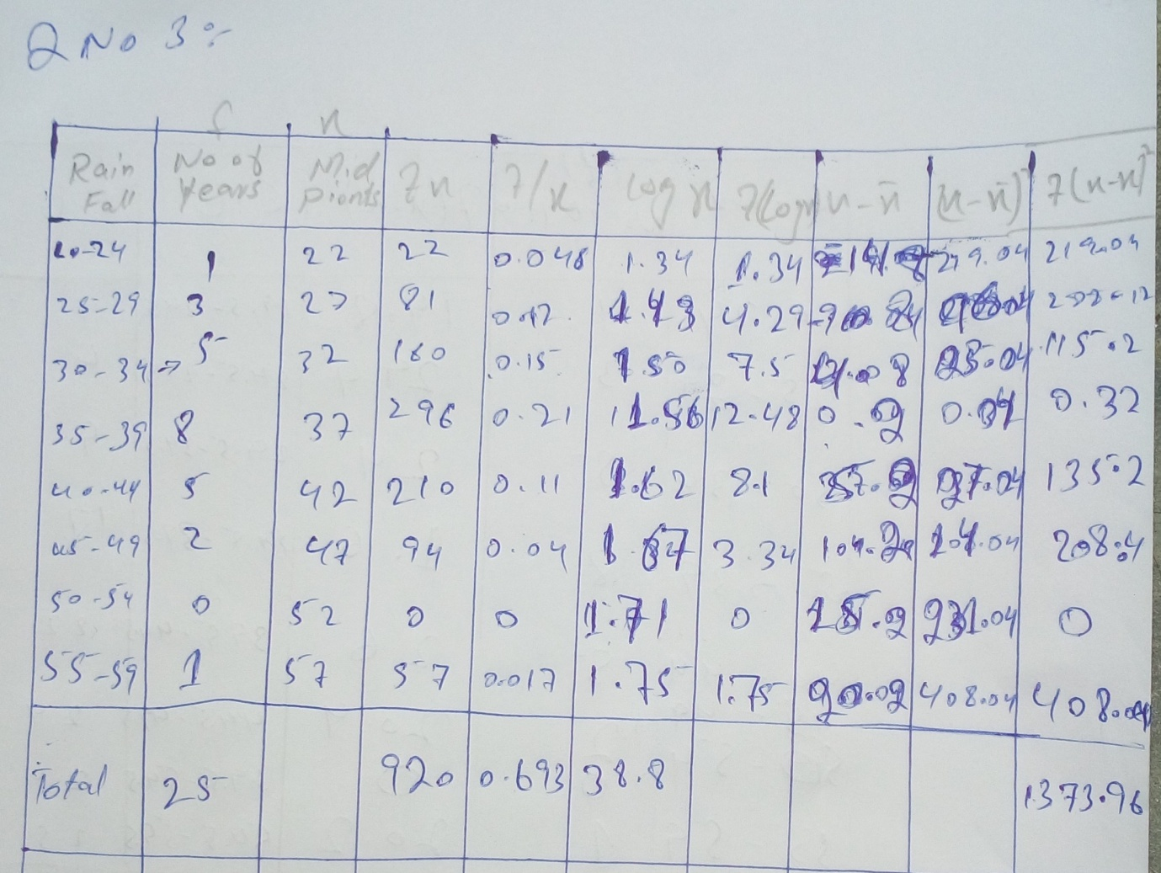
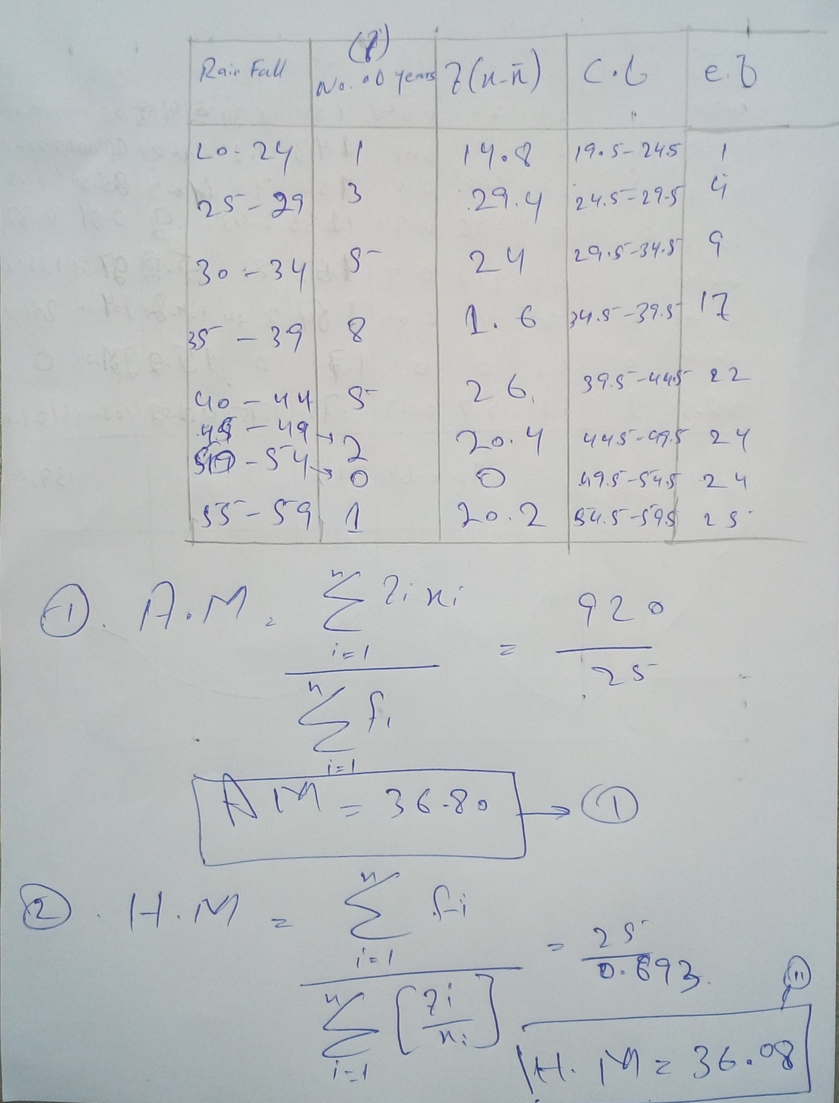
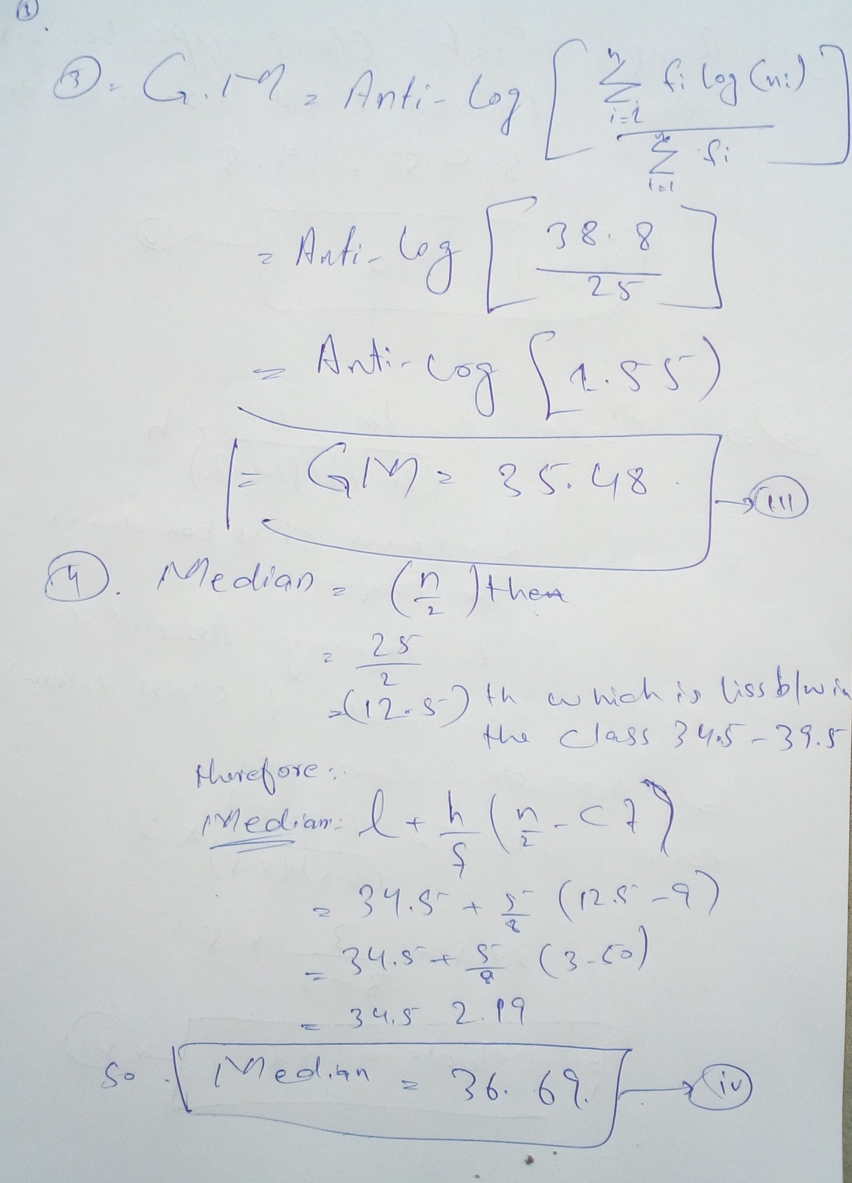
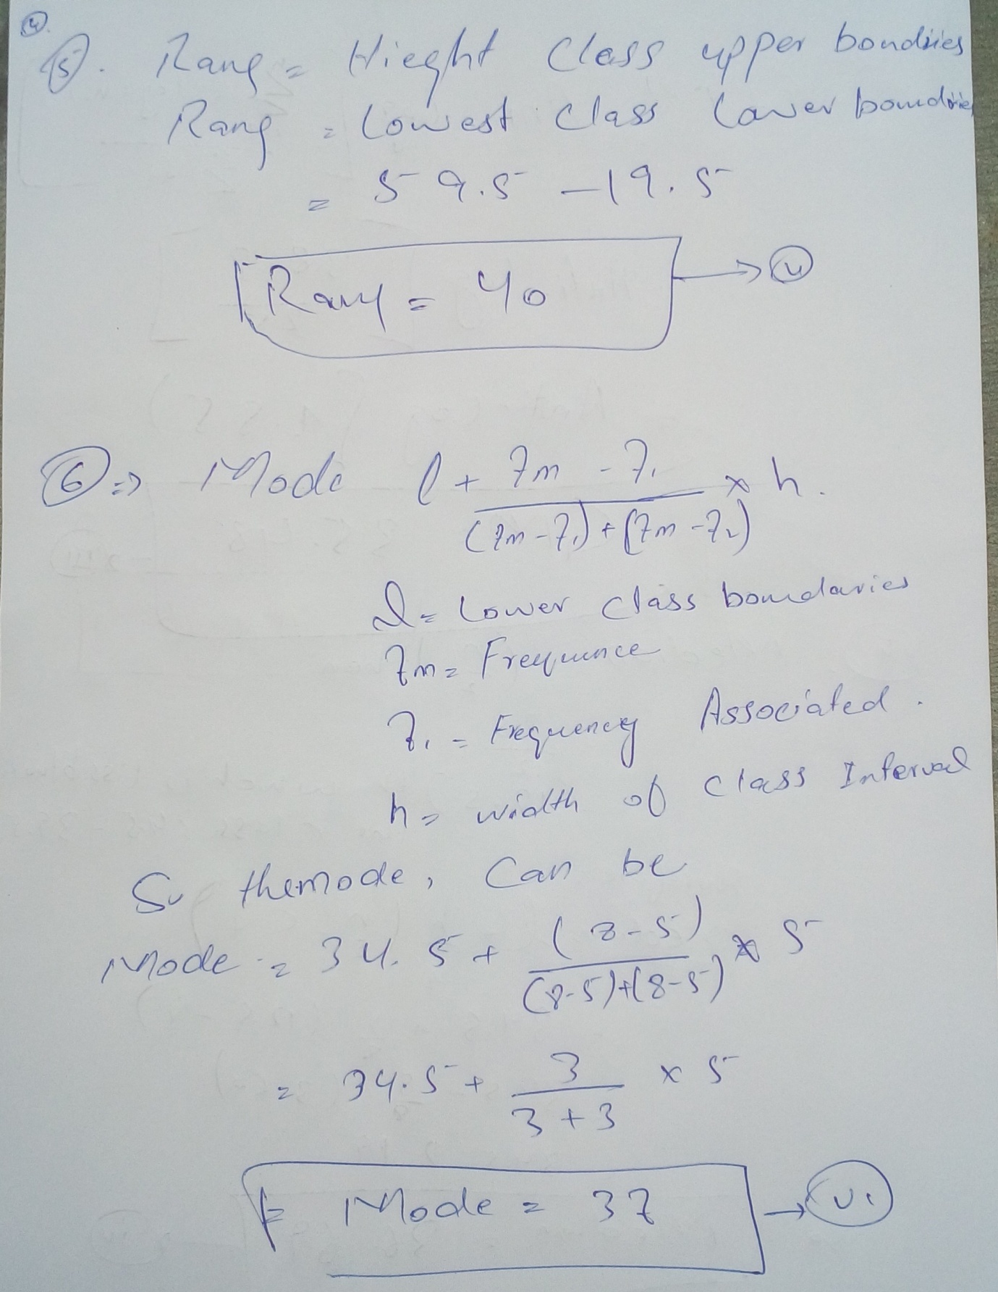
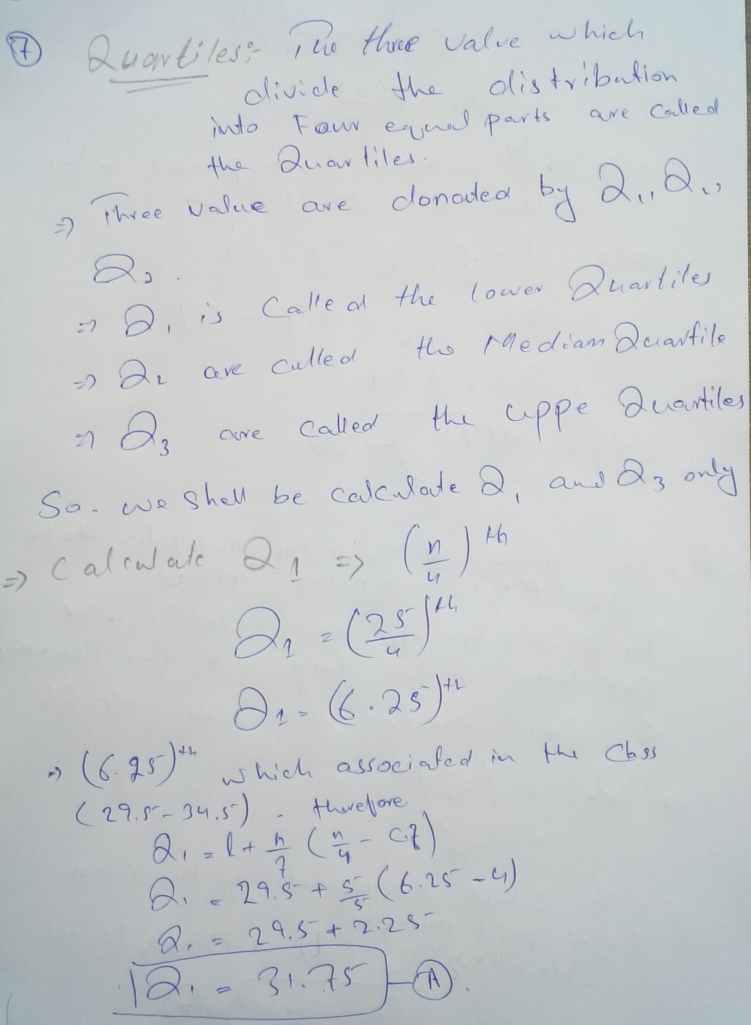
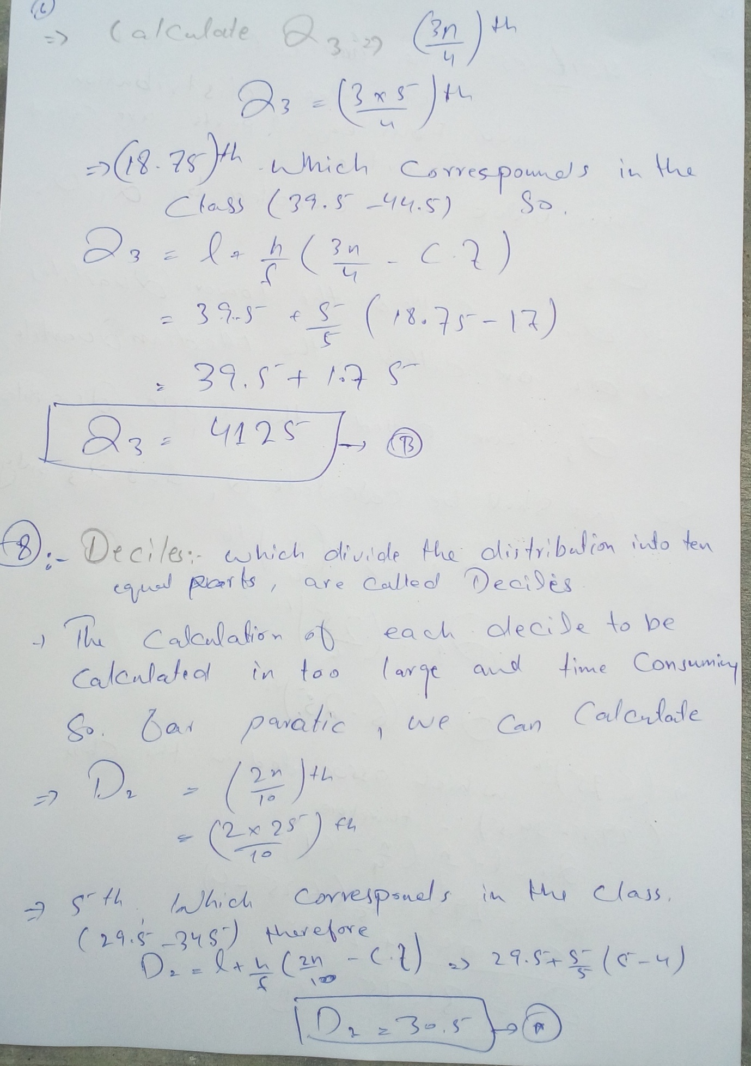
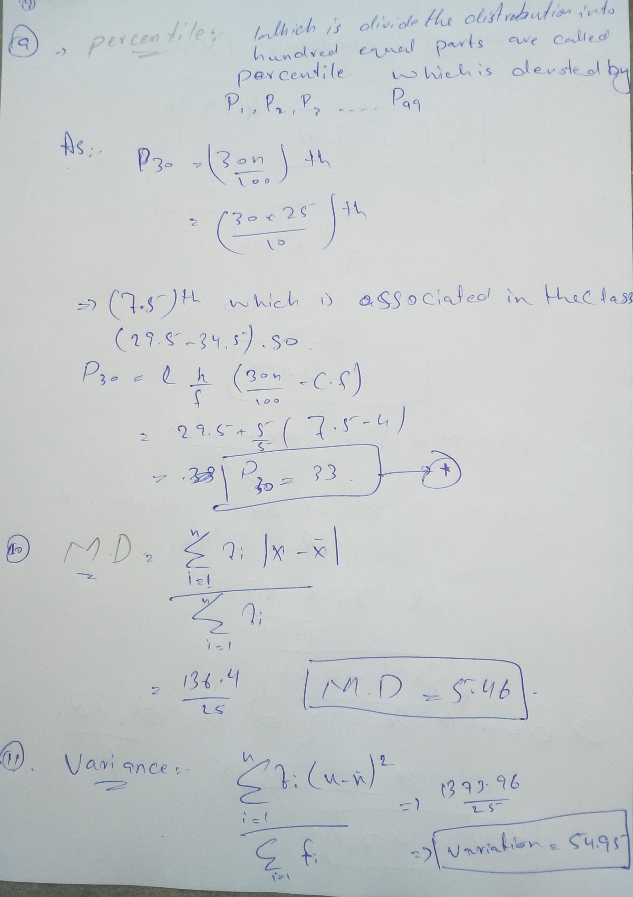
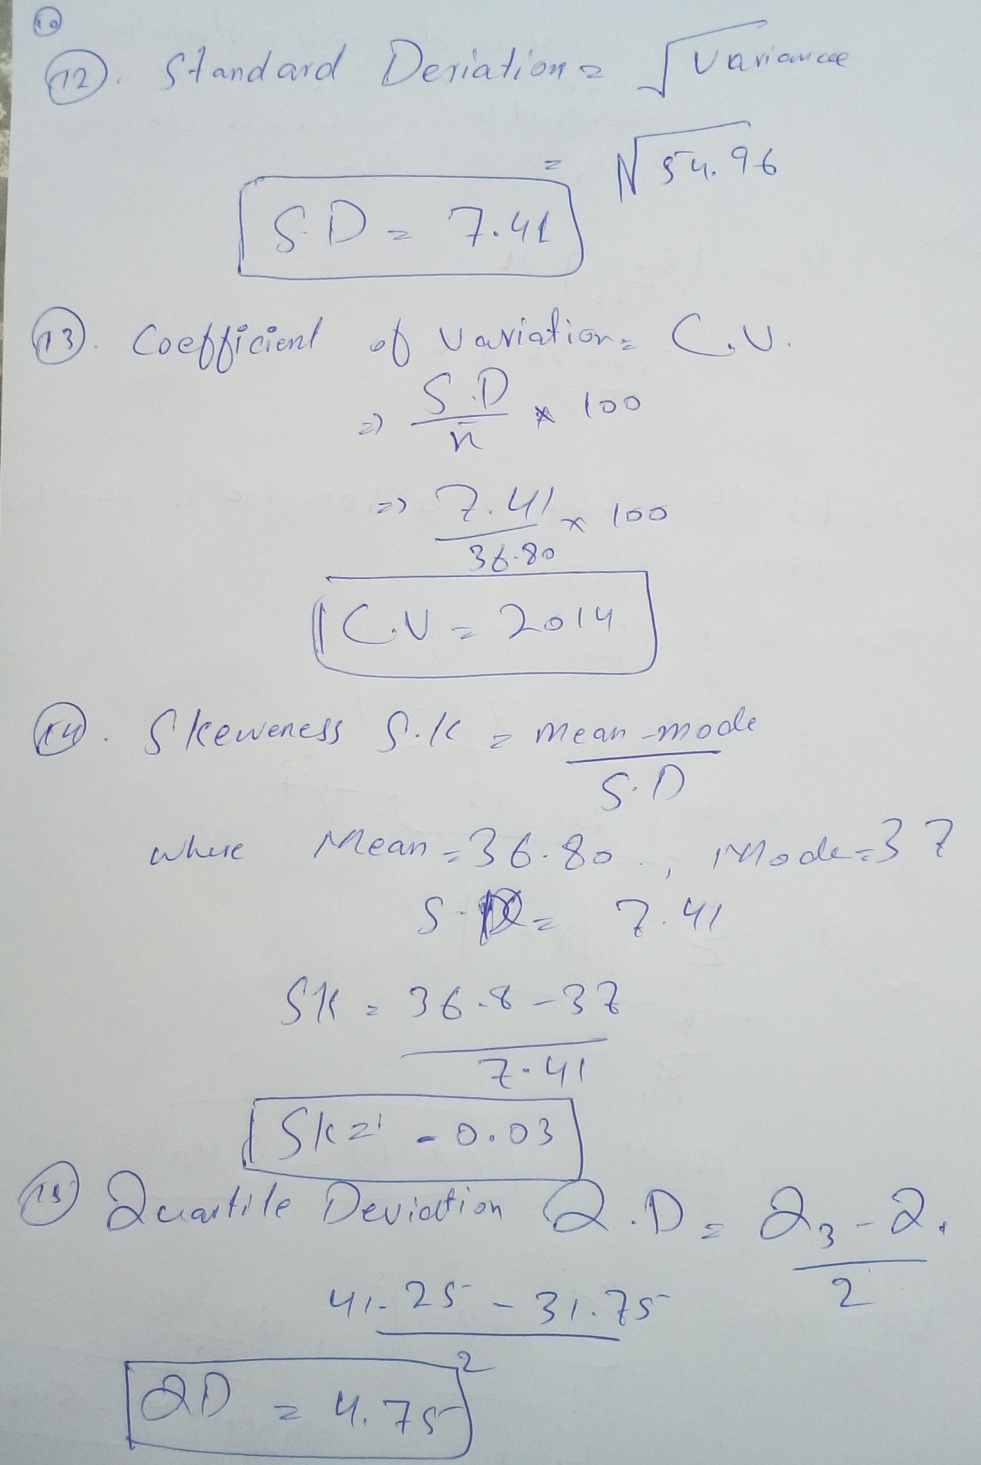
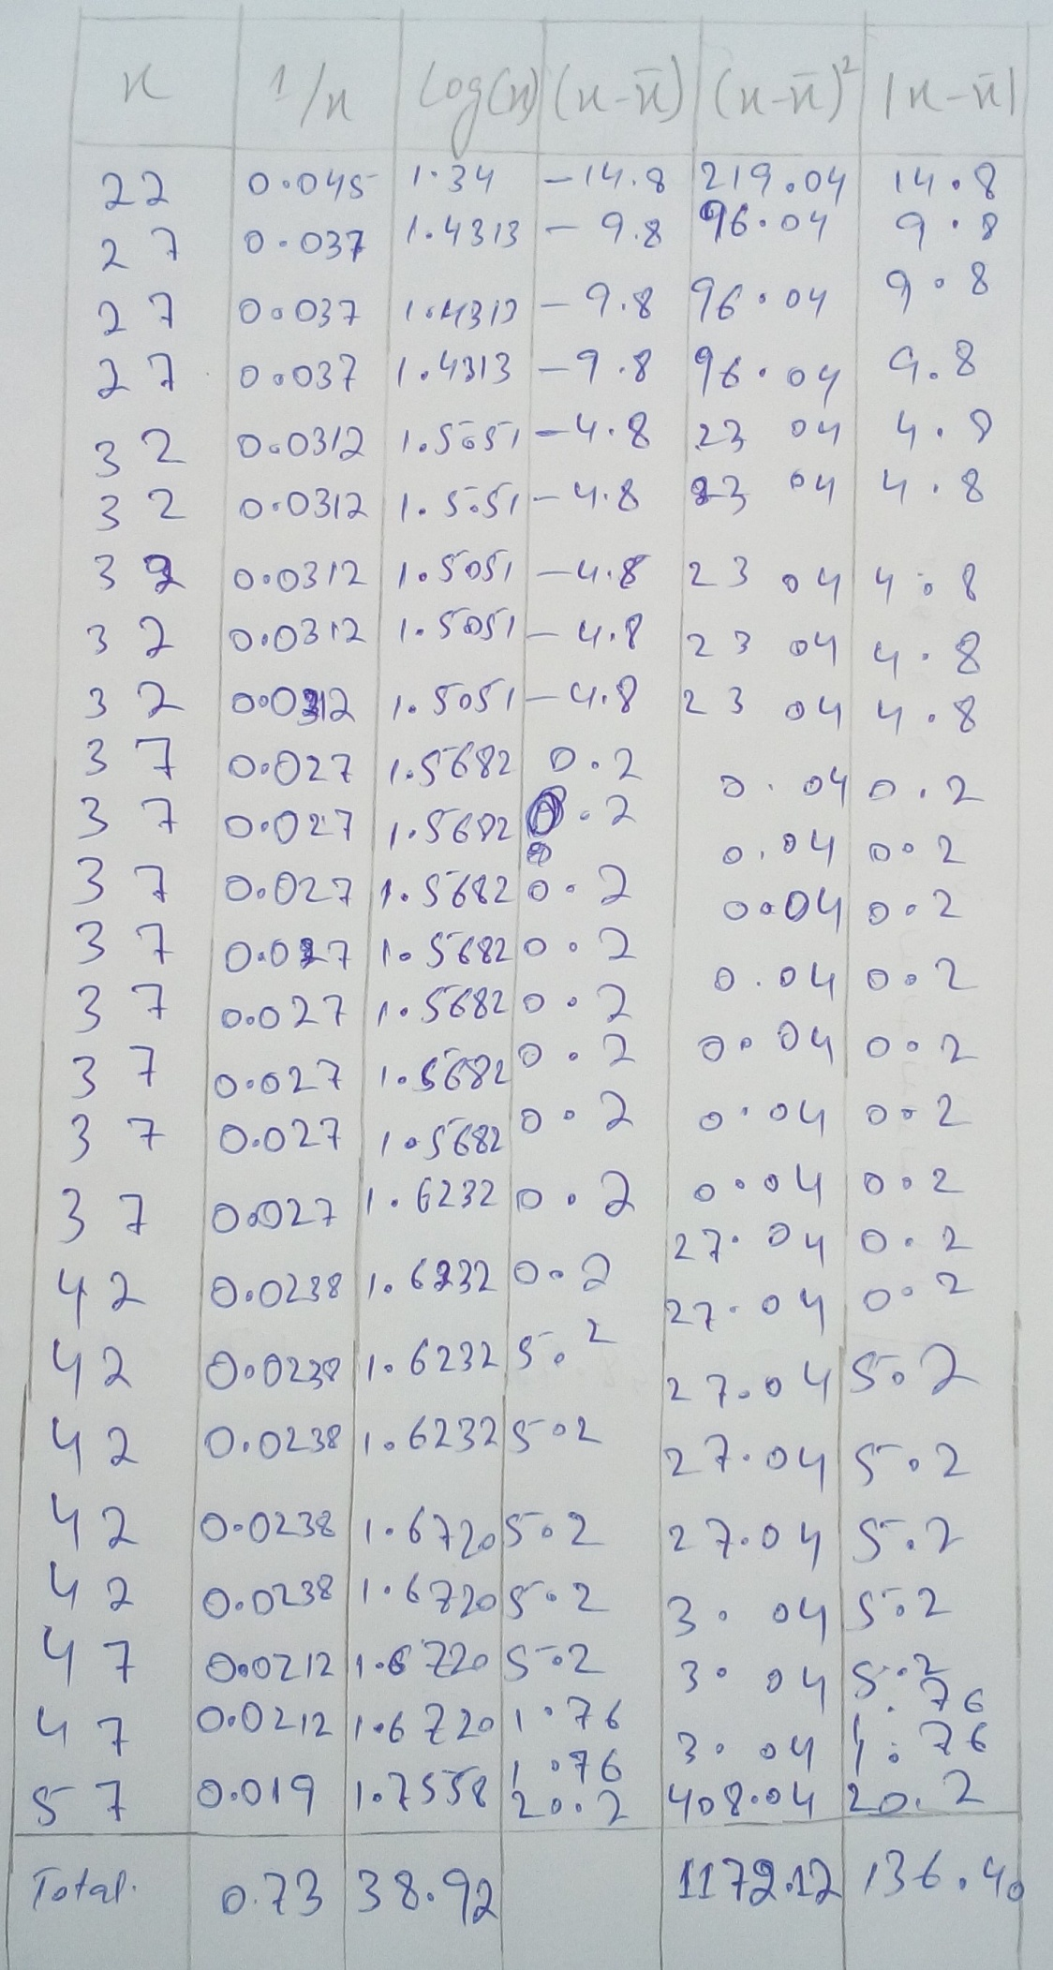
…………………………………………………
- Convert the above given data in the form of ungrouped and then find A.M,G.M,H.M,Median,Mode,Quartiles,Deciles,Percentiles,Range,M.D,Q.D,Variance,Standar ed Deviation, Coefficient of variation, Skewness for the converted data.
Answer:-
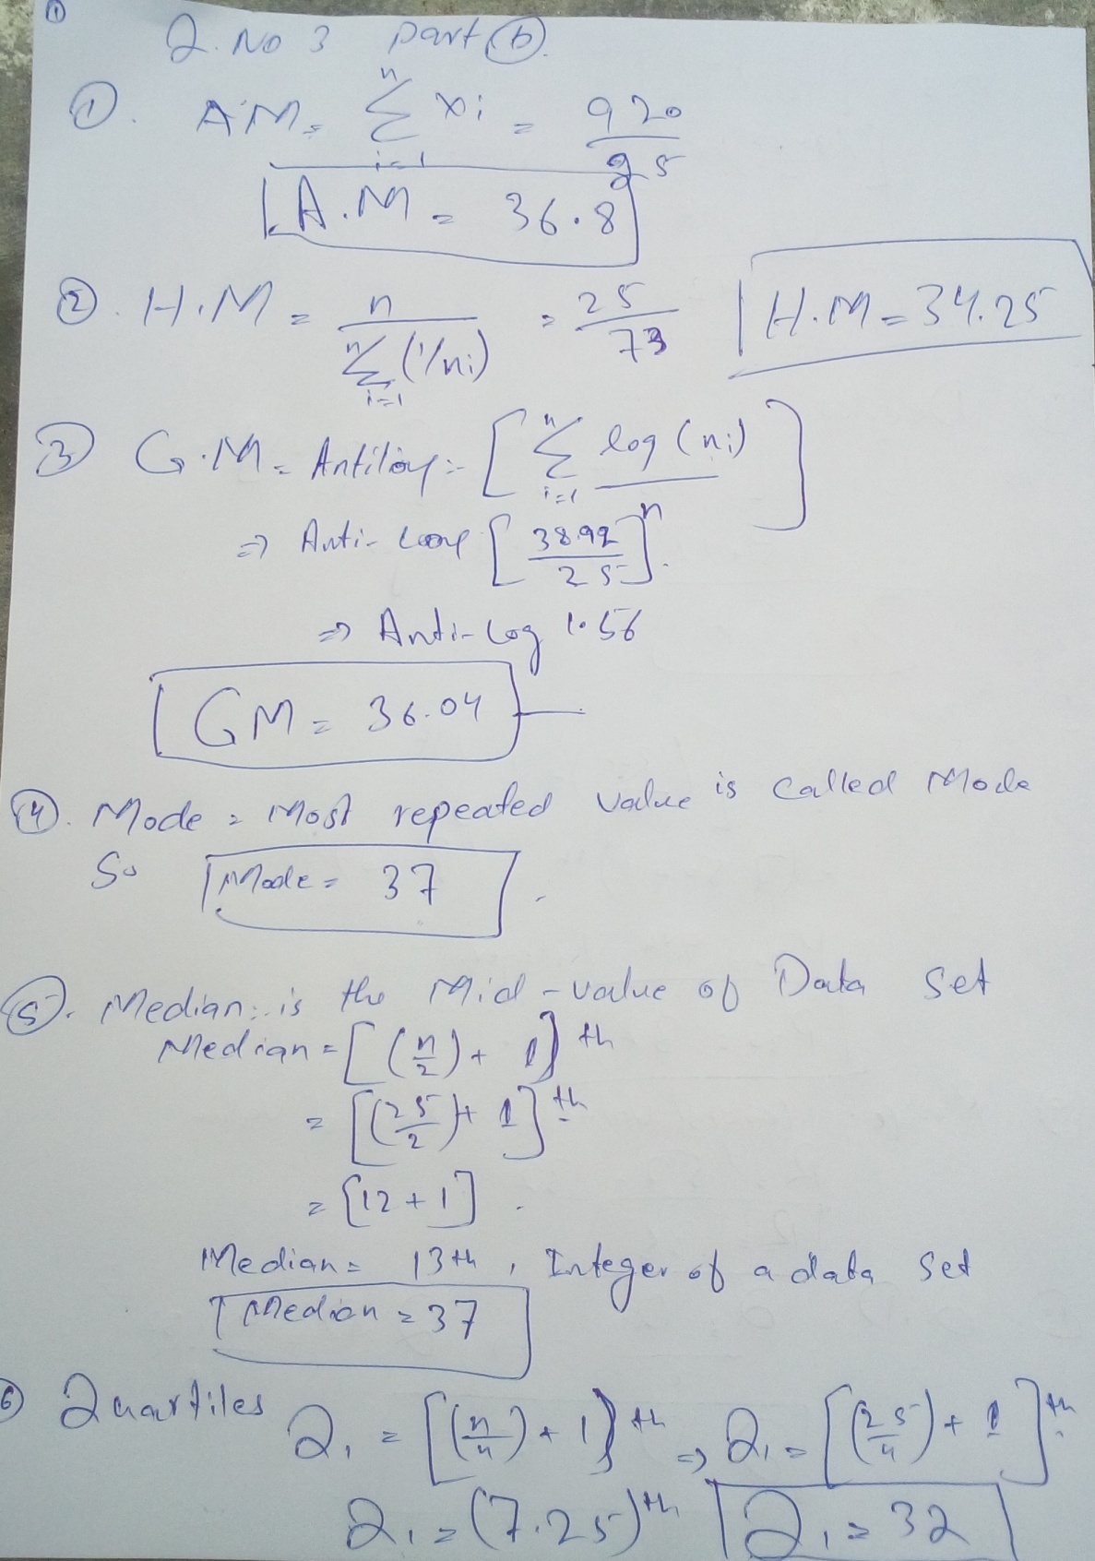
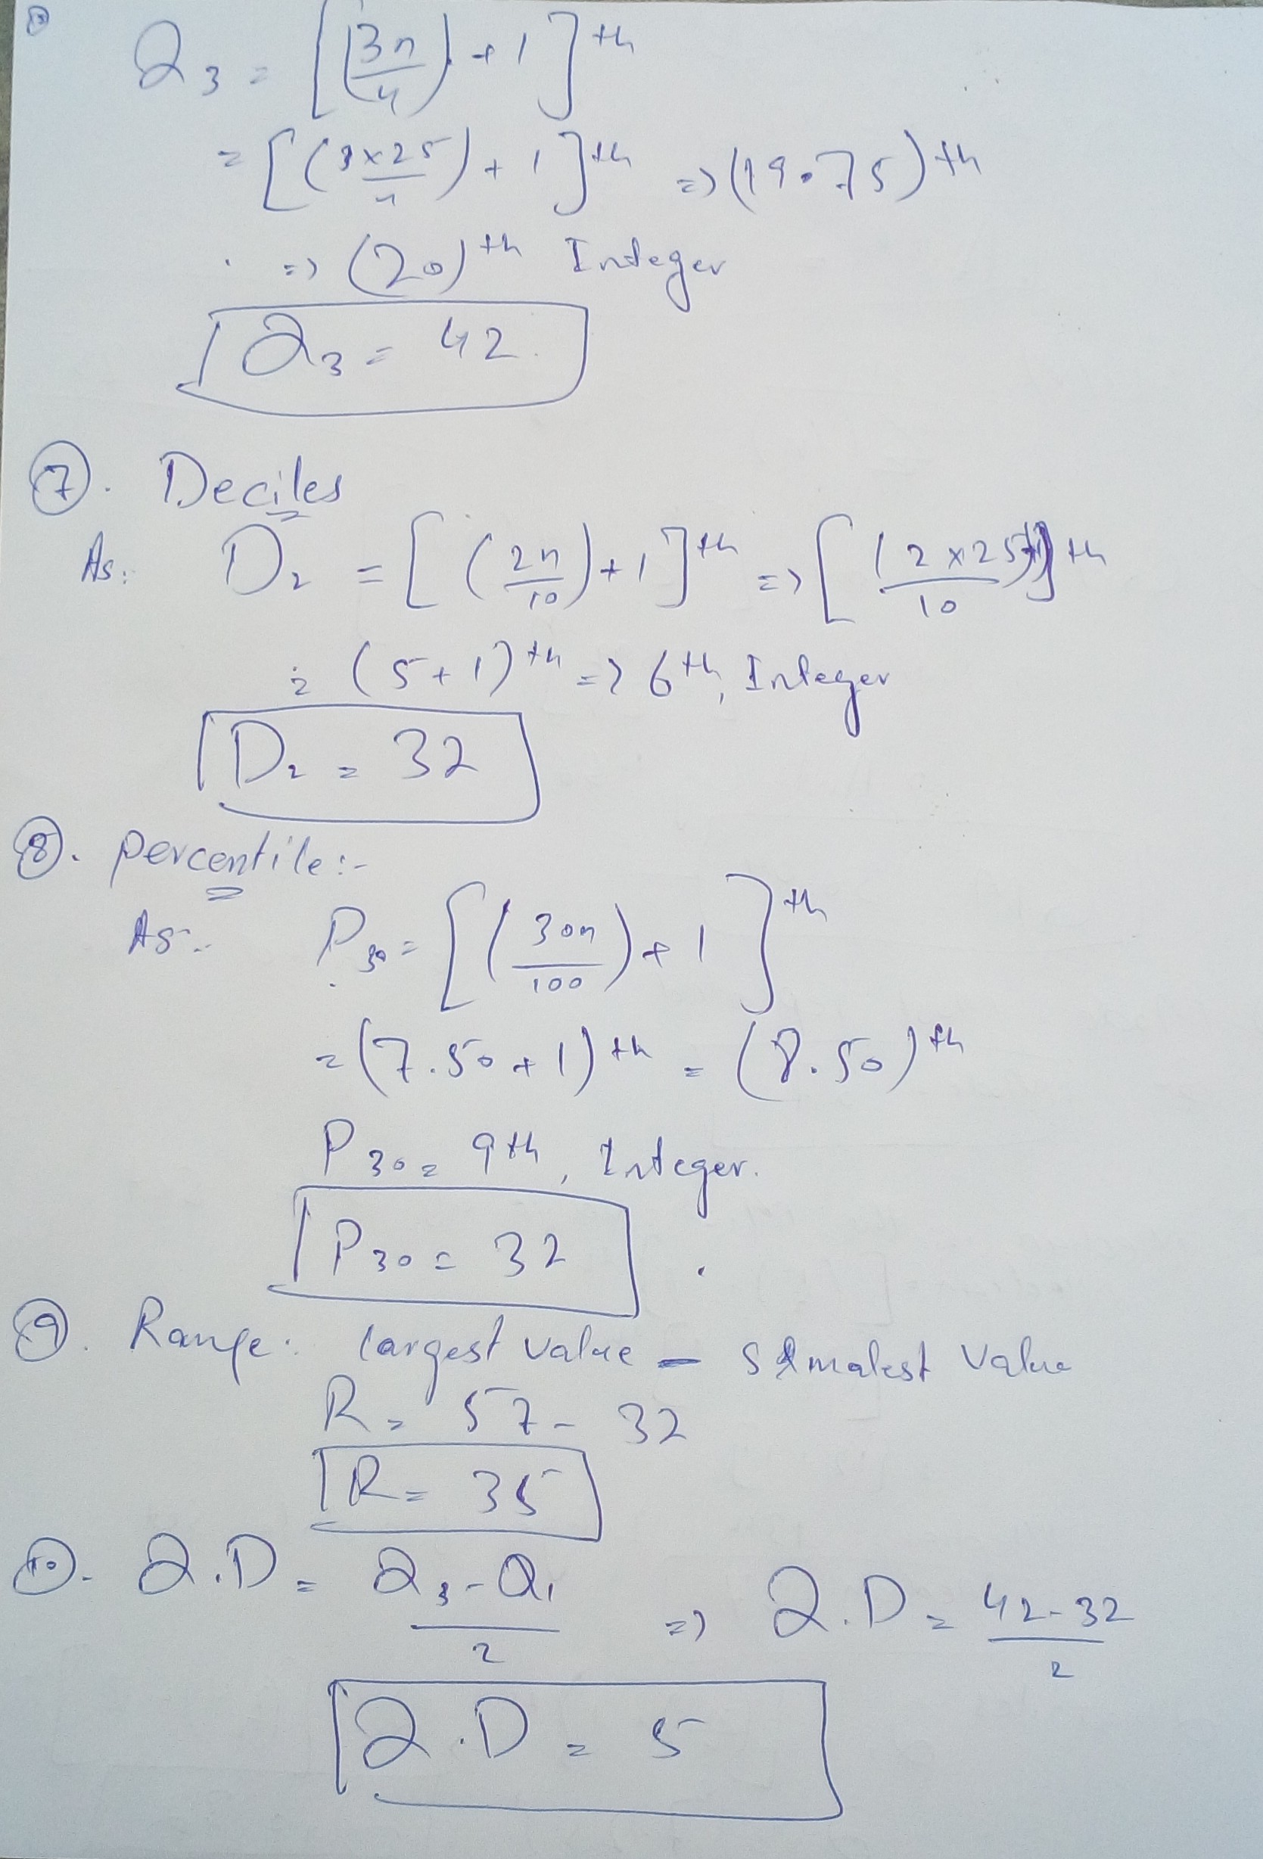
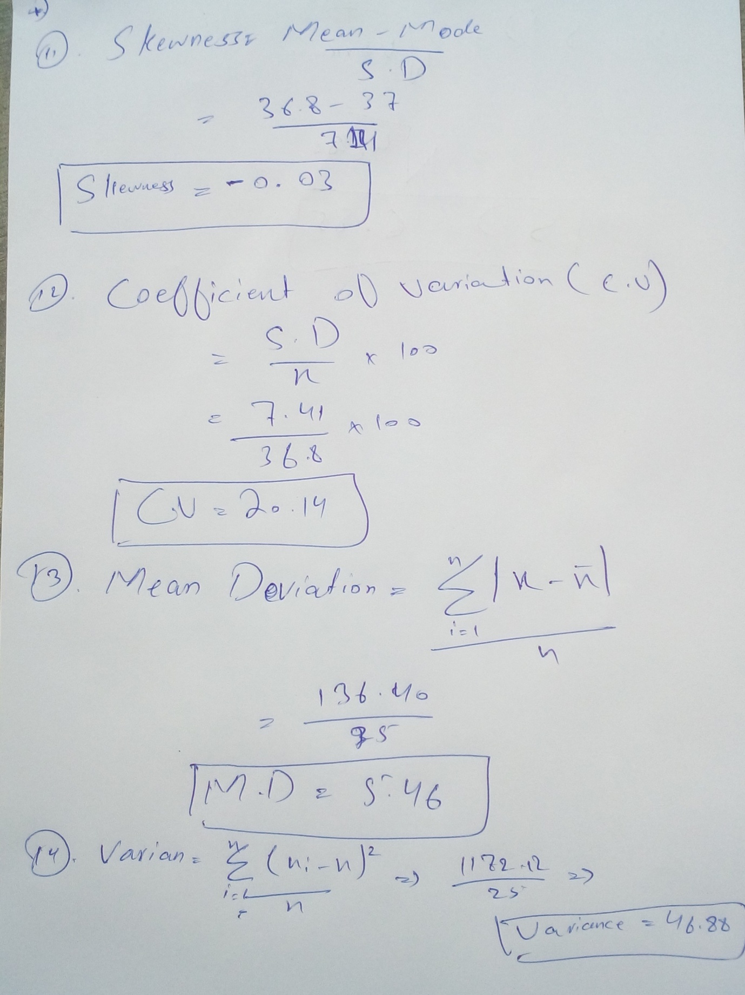
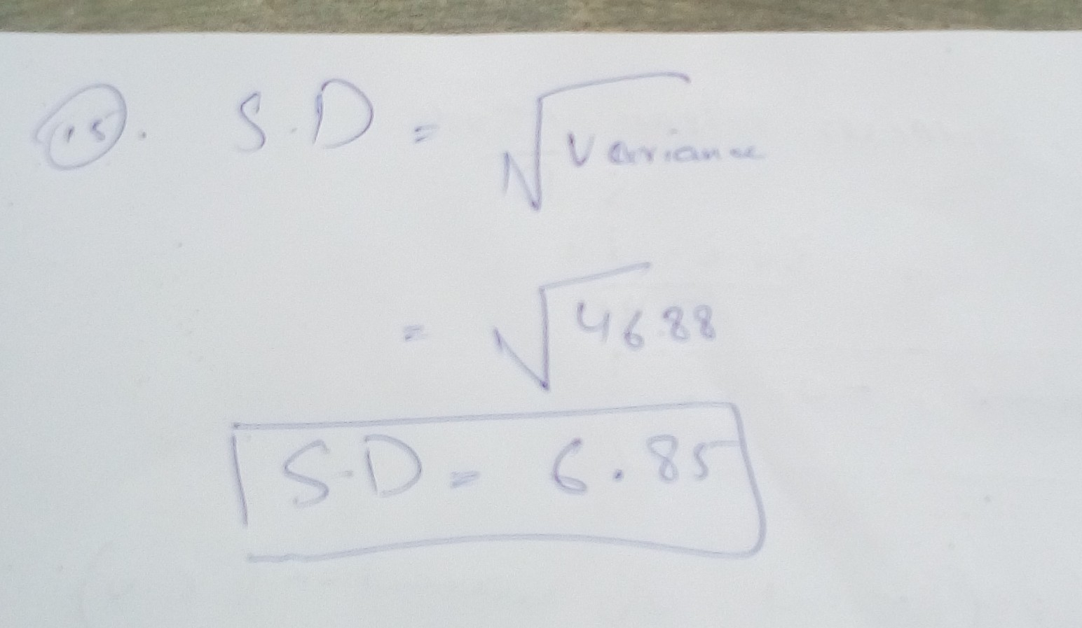

Paper end

