LAB ASSIGNMENT 3

Name: Muhammad Daniyal
ID NO: 17011
Subject: Digital Logic Design LAB
Instructor: Sir Muhammad Amin

FULL ADDER
AIM:
Design and verify the logic circuit of Half-Sustractor using logic gate.
OBJECTIVES:
• To understand the principle of binary addition.
• To understand full adder concept.
• Use truth table and Boolean Algebra theorems in simplifying a circuit
design.
• To implement full adder circuit using logic gates.
PROCEDURE:
• Collect the components necessary to accomplish this experiment.
• Plug the IC chip into the breadboard
• Connect the supply voltage and ground lines to the chips. PIN7 =
Ground and PIN14 = +5V.
• According to the pin diagram of each IC mentioned above, make the
connections according to circuit diagram.
• Connect the inputs of the gate to the input switches of the LED.
• Connect the output of the gate to the output LEDs.
• Once all connections have been done, turn on the power switch of the
breadboard
• Operate the switches and fill in the truth table (Write "1" if LED is ON
and "0" if LED is OFF.
• Apply the various combination of inputs according to the truth table
and observe the condition of Output LEDs.
FULL ADDER:
Full adder is a logical circuit that performs an addition operation on
three binary digits. The Full Adder produces a sum and Carry value, which are
both binary digits. It can be combined with other full adders or work on its
own.
OBSERVATION TABLE:
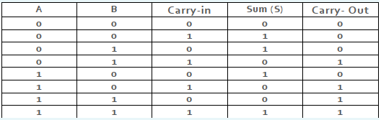
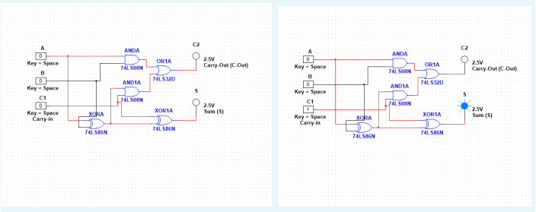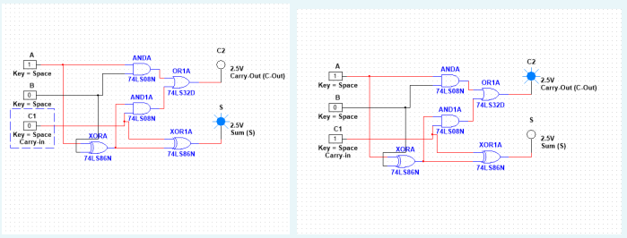

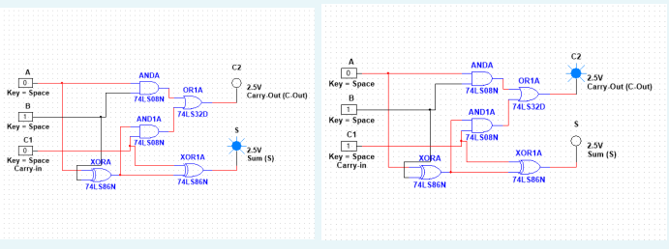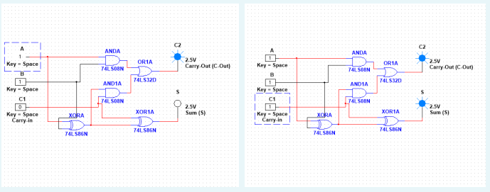
RESULTS AND ANALYSIS:
Verified the truth table as follows.
Full Adder: Verified the truth table of Full Adder as S = 1 i.e. LED which is
connected to S terminal glows when inputs are A, B, Ci Verified the truth
table of Full Adder as Co = 1 i.e. LED which is connected to Co terminal glows
when inputs are A, B, Co.
CONCLUSION:
• To add two bits, we require one XOR gate (IC 7486) to generate Sum
and one AND (IC 7408) to generate carry.
• To add three bits, we require two half adders.

