        - Computer Applications (Major Assignment)
Instructor:sir Zakir rahim
Name :Attiya Nawaz
Departement:microbiology
Second semister
Id :16045

Q. Different types of transmission media?
Your answer should include:
- Brief description of each media.
- Characteristics
- Benefits and limitations (if any)
Use appropriated diagram for each media type.
TRANSMISSION MEDIA:
Sending of data from one device to another is called transmission of data.
Medium use to transmit the data is called media. Transmission of data through
Medium is called transmission media.
- A transmission medium is something that can mediate the propagation of signals for the purpose of telecommunication.
In data communication technology a transmission medium is a physical path between the transmitter and the receiver that is it is the channel through which data is sent from one place to another.
Types of transmission media:
- Guided media.
- Unguided media.
Guided media:
The physical medium through which the signals are transmitted. It is also known as bounded media.
Benifits:
- Higher bandwith.
- Immunity to electromagnetic interference.
- Resistance to corrosive materials.
- Light weight.
- Less signal attenuation.
Types of guided media:
- Twisted pair cable.
- Coaxial cable.
- Optical fiber cable.

Twisted pair cable:
Twisted pair cable is type of cable made by putting two seperate insulated wires together in a twisted pattern and running them parallel to each other.
A twisted pair cable is a cable made by interwining two seperate insulated wires.
Thier are two twisted pair types shielded and unshielded.
Characteristics of twisted pair cable:
- Twisted pair cables are used to transmit signals in telecommunication systems and computer networks.
- Twisted pair cables that are design with two independent insulated wires wrapped around each other and with the goal to help to combat electromagnetic interference.
- Twisted pair cables are used in telephone lines to provide voice and data chennels.
Benifits:
- A twisted pair cable reduce electromanetic radiation from the pair and crosstalk between neighbouring pairs.
- Improve rejection of external electromagnetic interference.
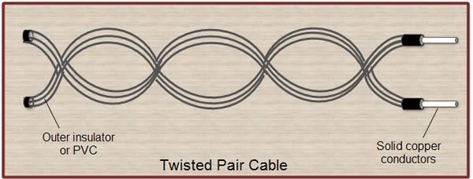

Coaxial cable:
Coaxial cable are the cabels that are use to transmit electrical energy,or signals ,from one location to another.
Characteristics:
- Long distance coaxial cable was use to connect radio networks.
- Coaxial cable are also widely use in local area network.
- Microcoaxial cables are used in a range of consumer device,militry equipments, and also in ultra sound scanning equipments.
Benifits:
- The main benifit of using a coaxial cable is that it is the defualt cable of its type this means that most electronics is already compatible with coaxial.
- It have ability to shield television from out side interference. This can minimize picture quality and help to avoid statics.
- It is inexpensive also.
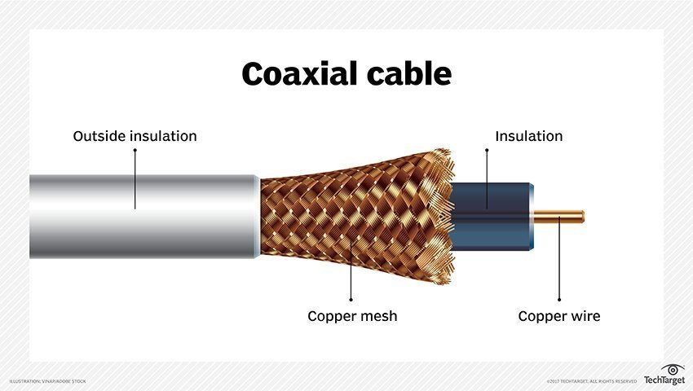

3: optical fiber cable:
Optical fiber cable is a thin cylindrical fiber of glass or any transperent dilectric medium. That are use for optical communication are wave guide made of transparent dielectrics.
Characteristics:
- An optical fiber is essentially wave guide for light.
- It consist of a core and cladding that soround the core.
- It is use in educational instituition.
- Protect terminator from damage.
- Use for safety and well managed environment of optic splices.
Limitations:
- The actual loss of light as it travels through the fiber.
- The maximum limitations of the band width of the signals that can be carried.
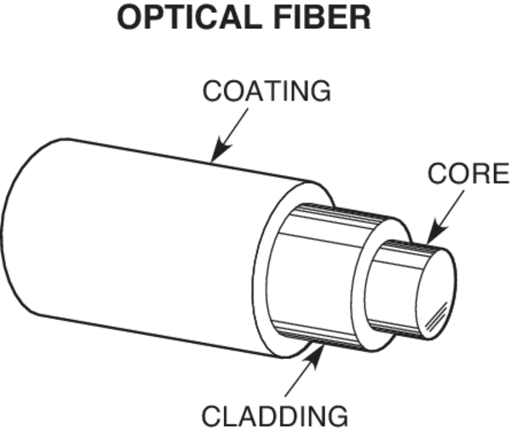
2: unguided media:
Unguided medium transport electromagnetic waves without using a physical conductor.this type of communication is often referred to as wireless communication .
Signals are normally braod cast through free space and thus are available to any one who has a device capable of receiving them.
Unguided media can travel long distances.
Benifits of unguided media:
- The signal is transmitted through free space.
- Unguided signals can travel in several ways:
Sky propagation ,ground propagation, and line of sight propagation.

Types:
- Radiowaves.
- Microwaves.
- Infrared.

Radio waves:
- Radio waves are the electromagnetic waves that are transmitted in all the direction of free space.
- Radiowaves are omnidirectional.
- Radio wave are the type of the eletromagnetic spetrum with the longer waveleght.
Benifits of radio waves:
- Radiowaves have enabled better navigation on aircraft and ships.
- They send signals and then they recieve them from the reflection.
- The third benifit is increase in accuracy.
- By using radiowaves peoples are able to monitor and control cartain industrial environments.
Characteristics:
- radio waves are a type of electromagnetic radiation with wavelengths in the electromagnetic spaectrum.
- They have frequences from 300GHZ to as low as 3KHZ, and corresponding wavelengths from 1 millimeter to 100 kilometers.
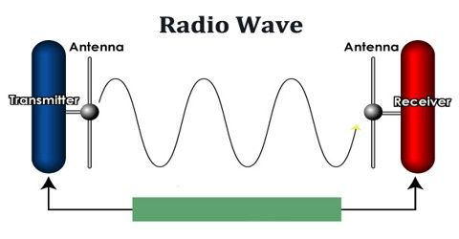
Microwaves:
Microwave is define as the part of the electromagnetic spectrum with large infrered waves and short radio waves.
An oven that cooks food very quickly or made to cook in one of these ovens.
This may not be possible for long distance transmission because signals become weaker and unique power amplification.
Types of microwaves:
Microwaves have two types:
- Terrestrial microwave.
- Satellite microwave communication.
Characteristics:
Frequency range:
The frequency range of terrstrial microwave is from 4-6GHz to 21-23GHz.
Bandwidth:
It support the bandwidth from 1 to 10 Mbps.
Short distance:
It is inexpensive as it requires a higher tower for a longer distance.
Long distance:
It is expensive as it requires a higher tower for a longer distance.
Attenuation:
Attenuation means loss of signals.it is affected by environmental conditions and antenna size.

Benifits of microwaves:
- Microwave transmission is cheaper than using cables
- It is free from land acquisition as it does not requires any land for the instituition of cable in terrain is quite a difficult task.
- Communication over oceans can be achied by using microwave transmission.

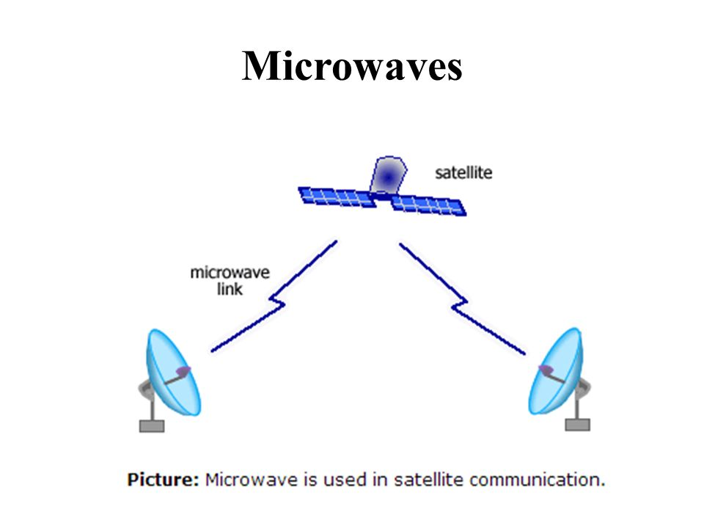

Infrared:
An infrared transmission is a wireless technology used for communition over short ranges.
The frequency of the infrared in the range from 300GHz to 400THz.
It is used for short range communication such as data transfer between two cell phones,Tv remote operation, data transfer between a computer and cell phones resides in the same closed area.
Characteristics:
It supports high bandwidth, and hence the data rate will be very high.
Infrared waves cannot panetrates the walls therefore,the infrared communication in one room cannot be intruppted by the near by rooms.
An infrared communication provides better security with minimum interference
Infrared communication is unreliable outside the building because the sun rays will interfere with the infrared waves.
Benifits:
- cheap
- easy to use
- compact and use low power
- very high data rate.

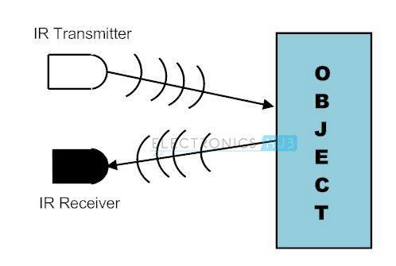

THE END

