Final-Term Assignment

Course Title: Human Physiology II
Rad 2nd semester section A
Instructor: Dr.M.Shahzeb khan (PT)
NAME: HABIBA
ID: 16272
Marks: 50

Note:
- Attempt all questions, all questions carry equal marks.
- Answer Briefly and to the point, avoid un-necessary details

Q1: (A) How stimulus of smell moves from nostril to brain? Make a Diagram as well
ANSWER:
STUCTURE OF SMELL RECEPTORS:
The olfactory mucosa is located inside the nasal cavity and is the site of olfactory transduction. The olfactory mucosa contains olfactory receptor neurons. Olfactory receptor neurons have cilia(little hair like projections) which contains the olfactory receptor proteins. There are about 1,000 different types of receptor.
HOW PHYSIOLOGY OF SMELL WORKS:
- Like the sense of taste, it’s a chemical sense.
- They are called chemical senses because they detect chemicals in the environment,
- Vaporized odor molecules (chemicals) floating in the air reach the nostrils and dissolve in the mucus (which is on the roof of each nostril).
- Underneath the mucus, in the olfactory epithelium, specialized receptor cells called olfactory receptor neurons detect the odor.
- These neurons are capable of detecting thousand of different odors.
- The olfactory receptor neurons transmit the information to the olfactory bulbs, which are located at the back of the nose.
- From the olfactory bulbs, the sensations are carried through olfactory tract to olfactory area in the temporal lobe of cerebral cortex.
- These brain centers perceive odors and access memories to remind us about people, or events associated with these olfactory sensation. 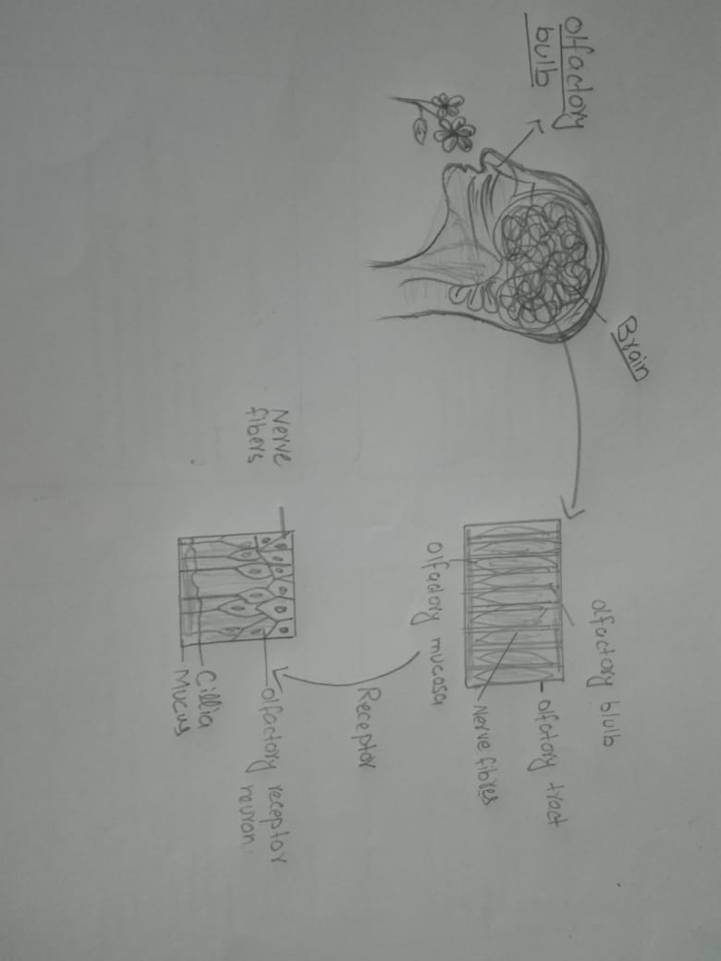

Q 2:(A) What is difference between Haemostasis, Haematopoiesis and Homeostasis?
ANSWER:
DIFFERENCE BETWEEN HAEMOSTASIS AND HAEMATOPOIESIS:
HAEMOSTASIS:
- Haemostasis is defined as arrest or stoppage of bleeding. When a blood vessel is injured, the injury initiates a series of reactions, resulting in haemostasis.
HEMATOPOIESIS:
- The process of formation of blood cells i.e. RBC’S WBC’S and platelets is called as haematopoiesis.
- Haematopoiesis are occurs in tissues and organs (bone marrow, liver, spleen).
- Cells responsible to do function of hemopoiesis are first seen in yolk sac of embryo in third week of embryonic development and these cells are known as hematopoietic stem cells.
(B) What is Erythroblastosis fetalis?
ANSWER:
ERYTHROBLASTOSIS FETALIS (HEMOLYTIC DISEASE OF THE NEWBORN)
- Erythroblastosis fetalis is a disease of the fetus and newborn child characterized by agglutination and phagocytosis of the fetus’s red blood cells.
- In most instances of erythroblastosis fetalis, the mother is RH negative and the father RH positive. The baby has inherited the RH positive antigen from the father, and the mother develops anti-RH agglutinins from exposure to the fetus’s RH antigen.
- An antibody, lectin, or other substances that causes agglutination.
- In turn the mother’s agglutinins diffuse through the placenta into the fetus and causes red blood cell agglutination.
Symptoms and signs in the fetus:
- Enlarged liver spleen or heart.
- Fluid buildup in the fetus’ abdomen seen via ultrasound.
Symptoms and sings in the newborn:
- Anemia that creates the newborn’s pallor (pale appearance).
- Jaundice or yellow discoloration of the newborn’s skin.
- Severe edema of the entire body.
- Dyspnea or difficulty breathing.
- Enlargement of the newborn’s liver and spleen.
Q3: (A) What is Immunity? Explain different types of immunity
ANSWER:
IMMUNITY:
INTRODUCTION:
- The immune response is how your body recognizes and defends itself against bacteria, viruses, and substances that appear foreign and harmful. Immunology is one of the branch of biology which is the study of our protection from foreign macromolecules or invading organisms and our responses to them. These invaders include viruses, bacteria, protozoa or even larger parasites. In addition, we develop immune responses against our owan proteins( and other molecules) in autoimmunity and against our own aberrant cells .organisms must find a means of defense against antigens otherwise bacteria, fungi and viruses would replicate out of control and results in the destruction of the body.
- Immunity is the ability of the body to protect against all type of foreign bodies like bacteria, virus, toxic substances etc. which enter the body. Or
- the term immunity refers to the resistance exhibited by the host towards infection caused by micro organism and their products (toxins).
- Lake of immunity is known as susceptibility.
TYPES OF IMMUNITY:
There are two types of immunity:
- Innate immunity
- Acquired immunity
INNATE IMMUNTIY:
- It is also called natural or native immunity, consist of mechanism that exist before infection and are capable of rapid response to microbes.
- Its natural resistance with which person is born.
- It is come because of genetic and constitutional make up.
- It acts as first line of defence against infections, micro organisms their products before they cause disease.
TYPES OF INNATE IMMUNTIY:
It is of three types.
- Species immunity
- Racial immunity
- Individual immunity
- Species immunity: is the total immunity shown by all members of a species against pathogen; e.g birds immune to tetanus. Or humans don’t get plant disease.
- Racial immunity: is that in which various races show market difference in their resistance to certain infections disease E.g 1) Negroid are more prone to TB. 2) Plasmodium falciparum malaria is resistance in Africa.
- Individual immunity: is very specific for each and every individual resistance to infection is varies with different individual of same race and species.
- E.g homozygous twin exhibit similar resistance and suitability to TB and leprosy.
ACQUIRED IMMUNITY:
- Acquired or adaptive immunity is the immunity that is developed by the host in its body after exposure to suitable abtigen or after transfer of antibodies or lymphocyte from an immune donor.
Types of acquired immunity:
- Active immunity
- Passive immunity
ACTIVE IMMUNITY:
- It is the production of immunity against particular organism after exposure.
- Natural active immunity:
- This immunity develops by natural processes like infections Example: The infection like small pox are cured by the active function of the immune system.
- Artificial active immunity:
- Here instead of natural infections. Infections is created artificially by using various types of vaccines. Example: polio vaccine, cholera vaccine etc.
PASSIVE IMMUNITIY:
- Acquiring of the antibodies passively from immunized donor to a non-immunized recipient is known as passive immunity.
- Natural passive immunity:
- It occurs when anti bodies are transferred from the donor to the recipient in a natural manner. Ex: transfer of anti bodies from the mother to the feotus through the placenta.
- Artificial passive immunity:
- The transfer anti bodies and sensitized lymphocytes from immunized donor to the nonimmunized recipient artificially. Ex: antibodies produce in the horse serum.

(B) What is difference between Antigen and Antibody?
ANSWER:
ANTIGEN:
- An antigens is a molecule that stimulates an immune response.
- Antigen is a substances which when introduced into a body evokes an immune response to produced a specific a specific antibody with which it reacts specifically.
- For example: an antigen is a common cold virus causes the body to make antibodies which helps the person from getting sick.
Antigen are of two types:
Exogenous: those antigens have entered the body from outside.
For example: ingestion, injection , inhalation.
Endogenous: That have been within the cells as a normal metabolism.
ANTIBODY:
- These are substances which are formed in the serum and tissue fluids in response to antigen and react with that antigen specifically and in some observable manner.
- Chemically they are globulins, hence they are named immunoglobulins.
- They constitute about 20- 25% of the total serum proteins and are mainly synthesized by plasma cells.

Q4: (A) Write down different functions of Antibody
ANSWER:
FUNCTION OF ANTIBODIES ARE:
- Neutralization of infectivity.
- Phagocytosis.
- Antibody- dependent cellular cytotoxicity (ADCC)( whereby an effector cell of the immune system actively lyses a target cell, whose membrane- surface antigens have been bound by specific antibodies).
- Complement- mediated lysis of pathogens or of infected cells: Antibodies activate the complement system to destroy bacterial cells by lysis.
- ADCC is independent lysis complement system that also lyses targets but does not require any other cell. ADCC an effector cell which classically is known to be natural killer (NK) cells.
(B) Write difference between Primary and secondary response to an antigen
ANSWER:
DIFFERENCE BTWEEN PRIMARY AND SECONDARY RESPONSE OF ANTIGEN:
PRIMARY RESPONSE TO AN ANTIGEN:
- His occurs as a result of primary contact with an antigen.
- Responding cell is naïve B-cell and T-cell.
- Lag phase is often longer (4-7 day ) , sometimes as long as weeks or months.
- Level of antibody reaches peak in 7 to 10 days.
- It takes longer time to establish immunity.
- First antibody produced is mainly lgM. although small amount of lgG also produced.
- Amount of antibody produced depends on nature of antigen. Usally produced in low produced amount.
- Antibody level declines rapidly.
- Primary response appears mainly in the lymph nodes spleen.
- Affinity of antibody of lower for its antigen.
SECONDARY RESPONSEN OF AN ANTIGEN:
- This occurs as a result of second and subseguent exposure of the same antigen.
- Responding cell is memory cell.
- Lag phase is shorter (1-4 days) due to the presence of memory cell.
- Level of antibody reaches peak in 3 to 5 days.

- Mainly IgG antibody is produced. Although sometimes small amount of IgM are produced.
- Usually 100-100 times more antibodies are produced.
- Antibodies level remain high for longer period.
- Secondary response appears mainly in the bone marrow , followed by the spleen and lymph nodes.
- Antibodies have greater affinity for antigen.

Q5: Write difference between cell mediated and Antibody Mediated Immunity
ANSWER:
CELL MEDIATED IMMUNITAY:
- Cell mediated immunity is second line of defence.
- This is main defence against interacelluiar bacteria.
- In the following example cell mediated immunity will be explained.
- Mycobacterium tuberculosis enters the body.
- Ingested by macrophage.
- Bacterium broken down and fragment of it called antigen or epitopes appear on surface of macrophage in association with class major histocompatibility complex (MHC) protein complex interact with an antigen specific receptor on surface of helper T lymphocyte.
- Activation and clonal proliferation of this antigen- specific helper T cell occur as result of the production of interleukins, the most important of which are interleukin I and II.
- These activated helper T cell, aided by activated macrophages and these cells are mediate one important component of cellular immunity i.e delayed hypersensitivity reaction specifically against myco bacterium tuberculosis.
- Cytotoxic T lymphocytes are also specific effectors of cellular immune response, particularly against virus infected cells. E.g influenza virus.
ANTIBODY MEDIATED IMMUNITY:
- Main defence against extracellular encapsulated pyogenic bacteria like staphylococci and streptococci.
- It comes in third line of defence.
- Helper T cells
- Macrophage
- B cells
- After processing by macrophages, fragements of antigen appear on surface of macrophage in association with class II MHC protein.
- the antigen- class II MHC protein complex binds to specific receptor on surface of helper T cell which then produce interlukins 2, 4, 5.
- These factors activate the B cell capable of producing antibodies specific for that antigen.
- The activated B cell proliferates and differentiates to form many plsma cells that secrete large amounts of immunoglobulins (antibody).
- In this T cell independent response, only IgM IS produced by cells.
- While for IgA, IgG and IgE require helper T cell to be produced.

THE END

