Course Title: Prosthodontic Instructor: Ms. Salma Ishaq
Max Marks: 30
NOTE:
Mid term assignment
Answers Submitted by Husna Parvez

Q1: Label the below diagram and describe the component of RPD?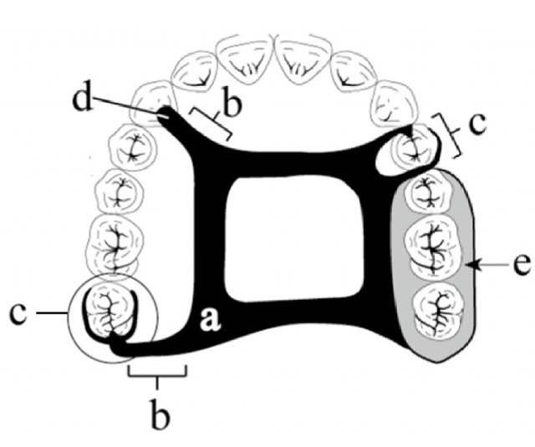
Answe No.1:
Label Sequence
- Major Connector
- Minor Connector
- Direct Retainer
- Indirect Retainer
- Denture Base

Description of each component of RPD:
- Major Connector:
The unit of Rpd that connect the parts of one side of the dental arch to those of the other side. Its principle functions are to provide unification and rigidity to denture.
- Minor Connector: A unit of partial denture that connects the other component (direct retainer, indirect retainer, Denture base) to the major connector. Its principle functions are to provide unification and rigidity to denture.
- Direct Retainer:
A unit of partial denture that provides retention against dislodging forces.A direct unit is called clasp or clasp unit and is composed of a rest, reciprocal arm, retentive arm and minor connector.
- Indirect Retainer:
A unit of class I or class II partial denture that prevent or resist the moment of the base away from residual ridge. The indirect retainer is usually composed of one component, a rest.
- Denture Base:
A unit of partial denture that covers the residual ridge and supports the denture teeth.

Q2: Why denture should be of low density? Give reasons.
Answer No.3:
Retention, stability and support are the basic principles on which the success of a complete denture relies. The severely resorbed maxillary and mandibular edentulous arches that are narrow and constricted with increased interarch space provide decreased support, retention and stability. To decrease the leverage, reduction in the weight of the prosthesis was recommended and also found beneficial.
Light weight hollow dentures provide healthy and comfortable living for the geriatric edentulous patient.
Extreme resorption of the maxillary denture-bearing area may lead to problems with prosthetic rehabilitation. These may be due to a narrower, more constricted residual ridge as resorption progresses, decreased supporting tissues and a resultant large restorative space between the maxillary residual ridge and opposing mandibular teeth. The latter may result in a heavy maxillary complete denture that may compound the poor denture-bearing ability of the tissues and lead to decreased retention and resistance.
The success of a complete denture relies on Retention, stability and Support. Extreme resorption of the maxillary denture-bearing area leads to a narrower, constricted residual ridge with decreased supporting tissues and a larger restorative space between the maxillary and mandibular residual ridge. Rehabilitation in such cases may result in increased weight and height of the prosthesis further compromising its retention, support and stability. So, to prevent further resorption of ridges, the weight of the prosthesis needs to be reduced which can be achieved by making hollow prosthesis.
Hollow maxillary complete denture considerably reduces the weight of the prosthesis, which in turn prevents transmission of detrimental forces by reducing leverage action. This results in increased retention and stability and up to some extent it also preserves the existing residual alveolar ridge.
Reducing the density and weight of a maxillary prosthesis, also has been shown to be beneficial when constructing an obturator for the restoration of large maxillofacial defects (Cleft lip and palate).
Low density denture resist against gravitational downward forces provide retention and aid to provide ease in mastication/chewing and muscular functions.
It’s also resist high muscular forces thus help in stability and retention of prosthesis.
Low density of denture has a dual action of reducing the weight of the denture as well as reducing the leverage action of the same. This ultimately results in increased retention and stability and to some extent it is also possible to preserve the existing residual alveolar ridge.

Q3: Briefly explain the types of major connector?
Answer No.3:

Mandibular Major Connectors
The six types of mandibular major connectors include the following:
1. Lingual bar
2. Linguoplate
3. Sublingual bar
4. Lingual bar with cingulum bar (continuous bar)
5. Cingulum bar (continuous bar)

1. Lingual Bar
The basic form of a mandibular major connector is a half-pear shape, located above moving tissue but as far below the gingival tissue as possible. It is usually made of reinforced, 6-gauge, half-pear–shaped wax or a similar plastic pattern
2. Linguoplate
If the rectangular space is bounded by the lingual bar, the anterior tooth contacts, and the cingula, and the bordering minor connectors are filled in, a linguoplate results

3. Sublingual Bar
A modification of the lingual bar that has been demonstrated to be useful when the height of the floor of the mouth does not allow placement of the superior border of the bar at least 4 mm below the free gingival margin is the sublingual bar. The bar shape remains essentially the same as that of a lingual bar, but placement is inferior and posterior to the usual placement of a lingual bar, lying over and parallel to the anterior floor of the mouth. It is generally accepted that a sublingual bar can be used in lieu of a lingual plate if the lingual frenum does not interfere, or in the presence of an anterior lingual undercut that would require considerable blockout for a conventional lingual bar. Contraindications include interfering lingual tori, high attachment of a lingual frenum, and interference with elevation of the floor of the mouth during functional movements.

4. Cingulum Bar (Continuous Bar)
When a linguoplate is the major connector of choice, but the axial alignment of the anterior teeth is such that excessive blockout of interproximal undercuts must be made, a cingulum bar may be considered. A cingulum bar located on or slightly above the cingula of the anterior teeth may be added to the lingual bar or can be used independently. In addition, when wide diastemata exist between the lower anterior teeth, a continuous bar retainer may be more esthetically acceptable than a linguoplate.

5. Labial Bar
Fortunately, in only a few situations does extreme lingual inclination of the remaining lower premolar and incisor teeth prevent the use of a lingual bar major connector. With the use of conservative mouth preparations in the form of recontouring and blockout, a lingual major connector can almost always be used. Lingually inclined teeth sometimes may have to be reshaped by means of crowns. Although the use of a labial major connector may be necessary in rare instances, this should be avoided by resorting to necessary mouth preparations rather than by accepting a condition that is otherwise correctable. The same applies to the use of a labial bar when a mandibular torus interferes with placement of a lingual bar. Unless surgery is definitely contraindicated, interfering mandibular tori should be removed so that the use of a labial bar connector may be avoided.

TYPES OF MAXILLARY MAJOR CONNECTORS
1. Palatal bar
2. Palatal strap
3. Anteroposterior palatal bar
4. Anteroposterior palatal strap
5. Complete palate
6. U-shaped Palatal MC (horse-shoe)
- Palatal Bar
A narrow half oval with its thickest point at the center. The bar is gently curved and should not form a sharp angle at its junction with the denture base.
Advantages:
For many years, the palatal bar was one of the most widely used. Today, palatal bar major connectors are used primarily in interim applications. The palatal bar has few advantages and should be avoided.
Disadvantages:
To provide the necessary rigidity, a palatal bar major connector must be bulky. So, patients find the palatal bar uncomfortable. Palatal bar derives little vertical support from the bony palate. As a result, a palatal bar major connector must derive nearly all its support from rests on the remaining teeth. Should be limited to short-span Class III applications should not be placed anterior to the second premolar position, otherwise its bulk may produce noticeable discomfort and alteration of speech.
2. Palatal Strap
The palatal strap is the most versatile MC. Wide band of metal with a thin cross-sectional dimension. The anteroposterior dimension of a palatal strap should not be less than 8 mm to avoid compromise of its rigidity. The width of a palatal strap should increase as the edentulous space increases in length. Thus, ensuring rigidity & permitting greater support from the hard palate.
Indication: Tooth borne partial denture when anterior teeth are missing tooth borne partial denture when anterior teeth and posterior teeth are massing when palatal torus can't be covered
Advantages.
It is in two or more planes great resistance to bending and twisting. This theory is similar to the "L-beam" principle. It has little interference with normal tongue action, so it’s well accepted by patients. The increased tissue coverage helps distribute applied stresses over a larger area.
Disadvantages
1. Patient may complain of excessive palatal coverage this may be due to improper positioning of the strap borders. Anterior border positioned posterior to the palatal rugae. If this is not possible, the anterior border should be terminated on the posterior slopes of prominent rugae. Posterior border positioned anterior to the junction of the hard and soft palates.
2. May predispose the patient to papillary hyperplasia when the partial denture is worn 24 hours a day.
4. Combination AnteroPosterior Palatal Strap
The anterior and posterior components are joined together by longitudinal connectors on either side. Form a square or rectangular frame. Each component braces the others against possible torque and flexure. Flexure is nonexistent in such a design A posterior palatal strap should be flat and a minimum of 8 mm wide. Located as far posterior as possible to avoid interference with the tongue but anterior to the line of flexure formed by the junction of the hard and soft palates. Anterior connector may be extended anteriorly to support anterior tooth replacements Properties .Lying in two different plane increase rigidity. Lack of support it covers less of horizontal hard palate. Should cross the midline at right angle rather than on a diagonal.
5. Palatal Plate (Complete Palate)
Indications: 1) Class I partially edentulous arches with residual ridges that have undergone little resorption and will lend excellent support. 2) V- or U-shaped palates. 3) Strong abutments (single or made by splinting). 4) More teeth in arch than six anterior teeth. 5) Direct retention not a problem. 6) No interfering tori. The anatomic contours of the palate will be faithfully reproduced in the finished denture
The palatal plate may be used in any one of three ways: It may be used as a plate of varying width that covers the area between two or more edentulous areas, as a complete Partial cast plate that extends posterior to the junction of the hard and soft palates. The form of an anterior palatal connector with a provision for extending an acrylic resin denture base in a posterior direction
6. U-shaped Palatal MC (horse-shoe):
It is the least desirable of maxillary major connectors
Indications: When a large inoperable palatal torus exists, when several anterior teeth are to be replaced.
Disadvantages:
Its lack of rigidity allows lateral flexure under occlusal force leading to torque or direct lateral force to abutment teeth. May permit impingement of underlying tissue when subjected to occlusal loading (no good support) Bulk results in increased thickness in areas that are irritant to the tongue

_________________________________________________________________________________

