ASSIGNMENT POSITIONING
- IdeN NAME HAJIRA BIBI
- ID 15304
SEMESTER 4TH
^{DATE 11/07/2020}

CASE 1 LATERAL RADIOGRAPH OF WRIST JOINT WITH A FRACTURE OF DISTAL RADIUS.ALSO CALLED WRIST FRACTURE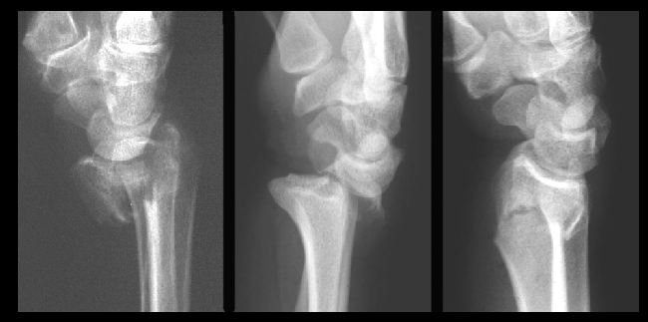

CASE-2 ANTERO-POSTERIOR SUPINE RADIOGRAPH OF CLAVICLE SHOWING FRACTURE AT MIDDLE AND DISTAL REGION.
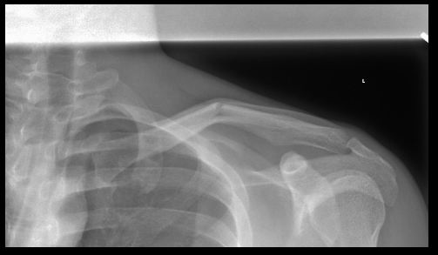
CASE 3
ANSWER
LATERAL POSTION OF THE PATIENT SHOWING TRANSVERSE FRACTURE OF PATELLA AND JOINT EFFUSION IN SUPRAPATELLAR BURSA.

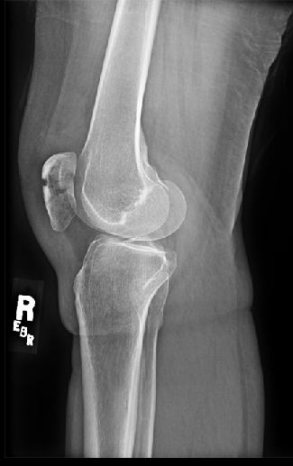

CASE 4
ANSWER
ANTERIO-POSTERIOR POSITION OF THE PATIENT SHOWING WITH A FRACTURE OF BOTH PUBIC BONE WITH THE DEPRESSION OF SHELTON LINE

