Final -Term Assignment (spring-2020)

IQRA NATIONAL UNIVERITY
ALLIED HEALTH SCIENCE

Course Title: - lab instrumentations Id No: -14059
Name: -Yasir Iqbal Instructor: - Saima hadi

Q1. Define the following terms.
- PH Meter
- Vortex Mixer
- Balance
- Water still
- Deionizer

PH Meter: -The PH meter was discovered in 1934 by the American chemist Arnold O. The PH acts as a volt meter which are measured the electrical potential different between the PH electrode and a reference electrode and display the result in term of the PH value of the solution.
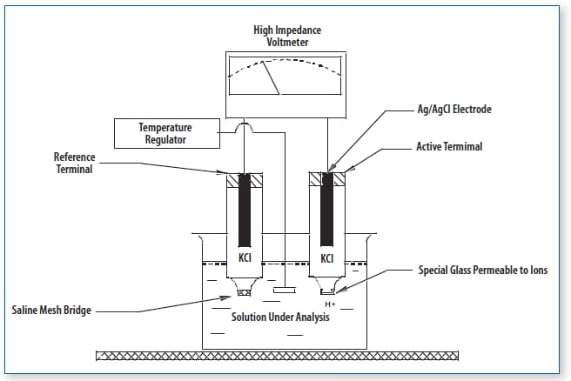
Vortex Mixer: - Also called vortexer is a sample device which are used commonly in laboratory to max small vials of liquid. The vortex meter consists of an electric motor with the drive shaft oriented vertically and attached and attached to a cupped rubber price motinented slightly center.
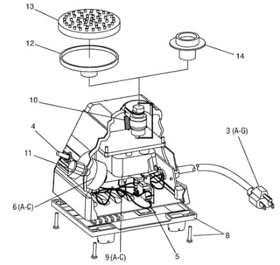

Balance:-It is instrument which are used in the laboratory for the measurement of different mass.
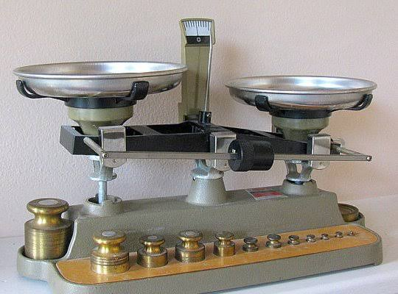
Water still
A section of stream that flate. Also called slack tide.it is also used for a water under lee of hand land
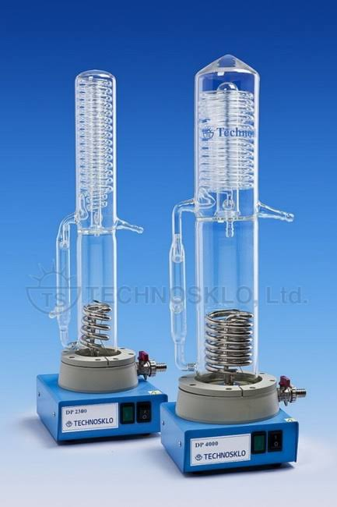
Deionizer: -It is an instrument used in laboratory for purification.

Q2: Explain Autoclave, its uses, and components?
AUTO CLAVE: Auto clave is a pressure chamber instrument used for sterilization
Physical method of sterilization. This instrument is also termed as sterilizer in pharmaceutical industries. The instrument was first developed in its crowd by DR Denis pain in 1676 and named it as a stream digester. The stream digesters were the for runner of the laboratory Auto clave invented in 1879 by DR Charles while working with Louis pasture

USES: -
1: - To sterilized material for culture
- Test tube
- Pupates
- Petridishes
2: - To sterilize contaminated material before disposal
- Culture plates
- Syringes
- Glassware
- Gloves
3: -Also used to sterilized dental instrument and surgical instrument
Compouments: -
1: -Chamber: It is a place where the item to be sterilized. The chamber consists of racks to hold article and allow for steam penetration from all angles.
2: - Control Panel: Allow the control over the Auto clave process
3: - Air Pump system: this is required to remove the air in the Chamber and create the vacuumed, steam generated by boiling The water
4: - pressure gauge: This is the gauge on which the Pressure s shown PSI. It is like sphygnomen meter.
5: - Pressure knob: sample knob used to discharge the Pressure after discreet time and temperature is attached.
6: - Safety Handle: This is attached to safety lid.
Used for safety.
.Q3: Describe Electrophoresis and its importance?
HISTORY: ELECTROPHORESIS Was proposed first time in 1807 by prof. FERIDINAND observed the clay particles dispersed in water to migrate on applying electric field "current”. The name of ELECTROPHORESIS was coined by DR. Michalis almost 100 years’. TERM: The term ELECTROPHORESIS means migration with electricity or Migration of charge particles under the influence of electricity.
DEFINITION: ELECTROPHORESIS Is the study of movement of charge particles in a electric field (DNA-RNA-PROTEIN)

IMPORTANCE OF ELECTROPHORESIS:
1: - IT is used in DNA fingerprinting.
2: - It is Also used in peternity testing.
3: - In Forensic study (cimmology).
4: - Very useful in genetic and study of molecular biology.
5: Commonly used in DNA sequencing.
7: -Purification and analysis of vaccine

Q4. What do you know about Beer Lambert law (uses, principle)?
Beer Lambert law: -This law state that the quantity of light absorbed by the substance dissolved in fully concerted of substance which are directly proportional to the construction of substance and path of light through the solutions
Mathematically: -$A=∑CL$ .
Principle: -
when a monochromatic light passes through a colored solution some specific wavelength of light absorbed which is related to color intensity the amount of light absorbed.
USES: -
Read the user manual carefully. Use the correct type of cuvette is clean and its optical surfaces are dry and free from finger marks and scratch. Bring filter in to place before switching on the colorimeter. Before reading the absorbance of a solution, check that is clear, there are no bubbles in it remove the cuvettes from the instrument.

Q5. Write a note on Flow Cytometery?
Flow Cytometery?
According to Sager aryl who’s wrote an article on flow cytometry.
Flow cytometry is a standard laser based technology that is used in the detection and measurement of physical and chemical characteristics of cell or particles in the heterogeneous fluid mixture. The properties that can be measured by This process include a particle, size, granularity or internal complexity and florescence intensity. The use of flow cytometry has increased over the as it provides a rapid analysis of multiple characteristics (both qualitative and quantitative) of the cells. The characteristics are determined using an optical to electronic coupling system that detects the cell based on laser scattered by the cells. A flow cytometer, despite its name, doesn't necessarily deal with cells, it deal with cells quite often, but it can also bind with chromosomes or molecule or such other particle which can be suspended in a fluid.

