- Name: Asfand yar awan
- Id number :14395
- Instructor Name: Nadeem Ullah
- Course Title: Water Demand Supply
and Distribution
- Date: April 21, 2020
- ASSIGNMENT NO 1

Q1. What is “Hydrological Cycle”? Now-a-days there is general discussion that Hydrological Cycle has been disturbed. Is this a myth or reality? Briefly explain.
ANS. HYDROLOGICAL CYCLE:
Water cycle, also called hydrologic cycle, cycle that involves the continuous circulation of water in the Earth-atmosphere system. Of the many processes involved in the water cycle, the most important are evaporation, transpiration, condensation, precipitation, and runoff. Although the total amount of water within the cycle remains essentially constant, its distribution among the various processes is continually changing.
The water cycle can't really be disturbed, but it can change where water is distributed on the planet. it provides our earth with precipitation. If evaporation does not take place or it is disturbed, precipitation and other natural things will not take place and the water lost by evaporation from seas and rivers will not be replenished
There are following factors which effect the hydrological cycle
Ecosystem changes.
Climate change.
Farming practices
Deforestation.
Land use change.
Water abstraction.
global warming.

Q2. Briefly describe “Ground water Sustainability”? How can “Rainwater Harvesting” be linked to ground water sustainability?
ANS. GROUND WATER SUSTAINBILTY:
Groundwater sustainability is the development and use of groundwater resources to meet current and future beneficial uses without causing unacceptable environmental or socioeconomic consequences and is also defined as how much water can be withdrawn from an aquifer system, where and for how long, with acceptable physical, economic, environmental, social, cultural, institutional, and legal consequences
RAINWATER HARVESTING:
Rainwater harvesting is a multipurpose way of supplying usable water to consumers during a crisis period, recharging the groundwater and finally reducing the runoff and water logging during the season of heavy rainfall. Traditional knowledge, skills, and materials can be used for this system. During the rainy season, an individual can collect water on his rooftop and manage it on his own. Reserved rainwater on rooftops can be used for self-purposes or domestic use. Water from different rooftops of a lane can also be collected through a piped network and stored for some time. This water can be then channeled to deep wells to recharge groundwater directly, to ponds to replenish groundwater slowly, and to reservoirs to dilute reclaimed water for nonportable use. Figure shows the schematic view of a rainwater harvesting system.
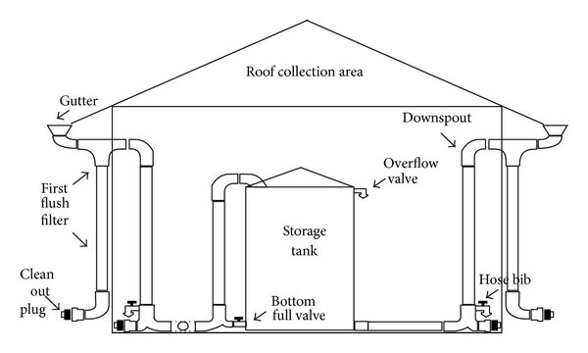
Q3. What “Quality Parameters” should be considered in designing water supply system for a community?
ANS.QUALITY PARAMETERS:
Water quality refers to the chemical, physical, biological, and radiological characteristics of The various water quality parameters namely pH, Total dissolved solids (TDS), Electrical conductivity (EC), Turbidity, Total hardness (TH), Calcium (Ca2+) Magnesium (Mg2+), Sodium (Na+), Potassium (K+), Chloride (Cl-), Sulphate (SO42-), Nitrate (NO3-) and Nitrite (NO2-) were determined by using standard classical and instrumental methods of analysis. The Dissolved oxygen (DO) and Biological oxygen demand (BOD) of water samples were also measured to evaluate the biochemical characteristics of water. The results for the analysis of water quality parameters were compared with the values provided by WHO and PSQCA guidelines in order to access the quality of water. The water quality parameters for the water supply in all the community complied with the WHO and PSQCA guidelines.

