Name: Asif Shah
ID: 14742
Subject: General Pathology
Q1. Differentiate between hypertrophy and hyperplasia.
Q2. What is the difference between coagulative and liquefactive necrosis?
Q3. Write a note on labile and stable cells.
Q4. Differentiate between healing by primary intention and healing by secondary intention.
Q5. Write briefly about the cellular response to adverse effects.
Question No 1 Answer
Hyperplasia | Hypertrophy
Increase in the amount of a tissue due to cell proliferation. | Increase in the volume of an organ or a tissue due to the enlargement of cells
Occurs in labile cells or stable cells | Occurs in permanent cells
Provoked due to excessive cell stimulation | Provoked due to increased demand
Increases the size of the tissue by cell division. | Stromal and cellular components are enlarged by increasing their size without multiplying

Question No 2 Answer
Coagulative
- Coagulative necrosis is a type of accidental cell death typically caused by ischemia or infarction.
- Coagulative necrosis will result in the development of a semi-solid (coagulated) debris due to degeneration of proteins fibers.
- Coagulative necrosis is chronic.
Liquefactive
- Liquefactive necrosis is a type of necrosis which results in a transformation of the tissue into a liquid viscous mass.
- Liquefactive necrosis will digest necrotic tissue into liquid form, pus.
- Liquefactive necrosis is acute.

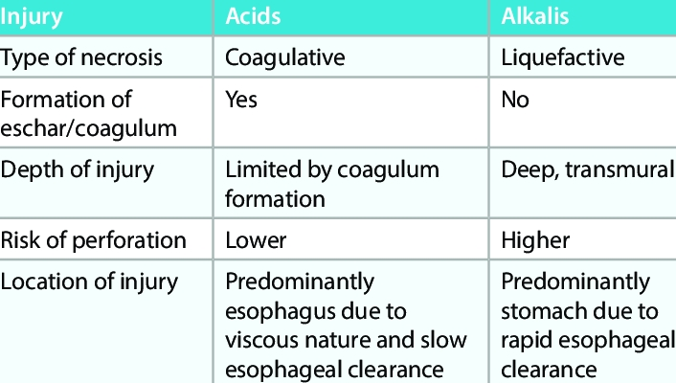

Question No 3 Answer
Labile Cells
In cellular biology, labile cells are cells that multiply constantly throughout life. The cells are alive for only a short period of time. Due to this, they can end up reproducing new stem cells and replace functional cells. Especially if the cells become injured through a process called necrosis , or even if the cells go through apoptosis. The way these cells regenerate and replace themselves is quite unique. While going through cell division, one of the two daughter cells actually becomes a new stem cell. This occurs so then that daughter cell can end up restoring the population of the stem cells that were lost. The other daughter cell separates itself into a functional cell in order to replace the lost, or injured cells during this process. Labile cells are one type of the cells that are involved in the division of cells.
In labile cells, it is not a speed-up in the segments of the cell cycle (i.e. G1 phase, S phase, G2 phase and M phase), but rather a short or absent G0 phase that is responsible for the cells' constant division.
Stable Cells
In Cellular Biology, stable cells are cells that multiply only when needed. They spend most of the time in the quiescent G0 phase of the Cell Cycle but can be stimulated to enter the cell cycle when needed. Examples include the Liver, the Proximal Tubules of the kidney and Endocrine Glands.
Question No 4 Answer
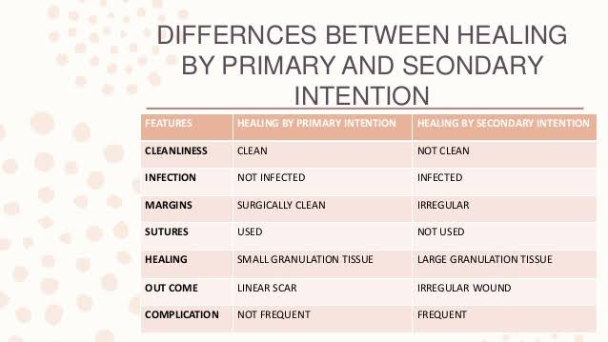

Question No 5 Answer
