

***NAME: JABIR ALI SHAH***

***ID: 14669***

***SUBJECT: Business mathematics***

***SEMESTER: 4***

***SUBMITTED TO: DR. LIAQAT ALI***

***DATED: 26/8/2020***

***IQRA NATIONAL UNIVERSITY***

***PESHAWAR***

***Mid Exam for Summer Semester BBA***

***Business Mathematics Max Time: 4 Hrs. (Part –I Time: 1Hr) Marks: 20***

***Roll No: ____________________Section: ____________ _________Date: _______________***

***Note: Attempt all questions. Mobile phones and Programmable calculators are not allowed.***

***Question No.1 30***

i The solutions of  are

***(e) None of them*** 

ii A man is going from the point  to the point then the increments in the x- and y-coordinates are

***( b ) ***

iii A stair make an angle of inclination  with the horizontal then its slope is

***d) None of them***

iv A painter can paint 100 wall in 10 hours. Then the time required to paint 4000  wall will be .

***(e) None of them***

v If  of sale price  is equal to 50% of cost price then the cost price will be

***(d) None of Them***

vi If  and then  is

***(e) ) None of them***

vii The domain of a curve 

***(e) None of them***

viii The net cost equivalent for 

***(e) None of them***

ix The equation shows

***(a)Linear cost function***

x The sum of two numbers is 30 and difference is 10 then the numbers are =

***(e)None of them***

***IQRA NATIONAL UNIVERSITY***

***PESHAWAR***

***Mid paper for Summer Semester BBA***

***Business Mathematics Max Time: 4 Hrs (Part –II Time: 3 Hr) Marks: 40***

***Note: Attempt all questions. Mobile phones and Programmable calculators are not allowed.***

***Question No.2 (5+5)=10***

1. Bismark Tractor put a markup of 26% on cost on some parts for which they paid $4.50. Find (a) selling price as % of cost (b) the selling price (c) the markup..

**Solution: (a)**  Markup = Sale Price – Cost Price

26%of $4.50 = Sale Price - $4.50

$1.17+$4.50 = Sale Price

* Sale Price = $5.67
* Selling Price as % of Cost = 0.26%

**(b)** Selling Price = $5.67

**(c)** Markup = $1.17

1. Solve for x in the following equation



**Solution:** 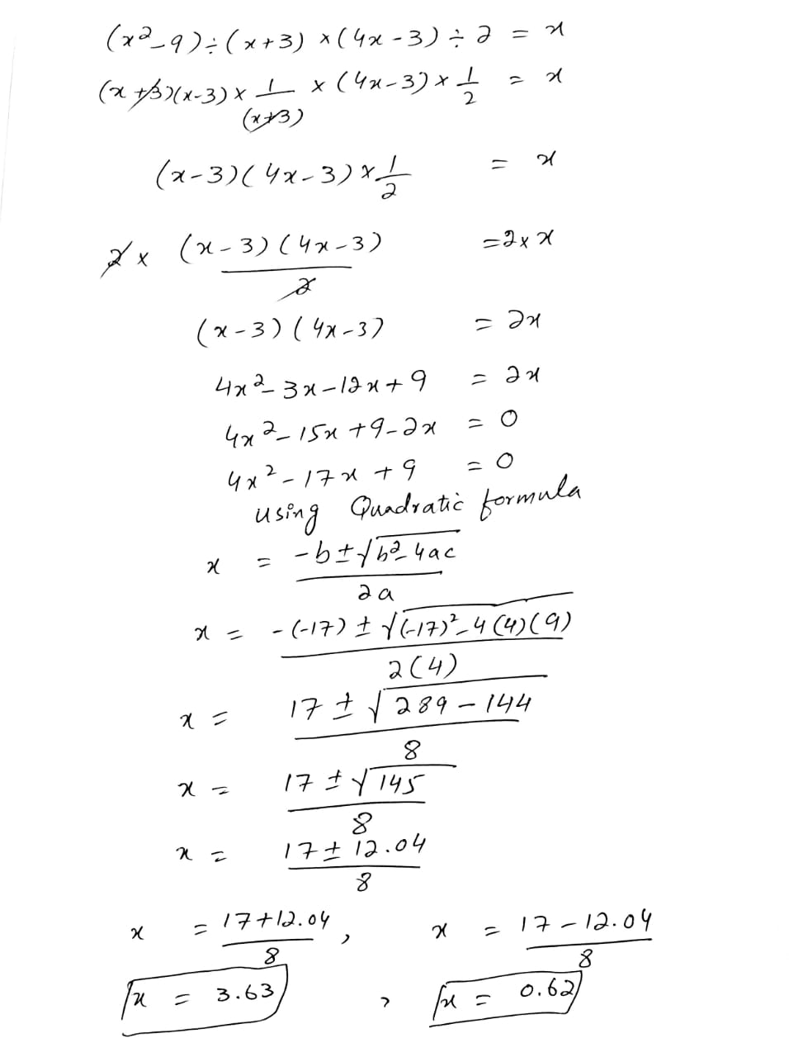

***Question No.3 (5+5=10)***

1. The sum of the ages of a girl and her brother is 60 years. Two years ago her age was three times the age of her brother. Find the present age of girl and her brother.

**Solution: :** Let girl be x and boy be y.  
 x+y=60  
 x=60-y  
 2 years ago;  
 boy was y-2  
 girl was x-2  
 since girl was 3 times age of girl,  
 x-3=3(y-3)  
 x-3=3y-9

since x=60-y  
 (60-y)-3=3y-9  
 57-y=3y-9  
 57+9=3y+y  
 66=4y  
 y=16.5  
 x=60-16.5  
 x=43.5  
 hence girl is 43.5years and boy is 16.5years.

1. Selling price = $18.75

Cost = $15

Markup based on cost = ?

Percent markup based on cost = ?

**Solution:** Markup Cost = Sale Price – Cost Price

**=** $18**.**75-$15

**=**$3.75

Markup Percentage = Markup Cost /Unit Cost 🗙100 = $3.75/$18.75 x 100 = 20%

***Question No.4 (5+5)=10***

1. List price = $150

Trade discount = 20%

Find the net cost.

**Solution:** Trade Discount 20% = 20/100*150

**= $30**

**Net Cost = $150-$30**

**=$120**

1. Heat and electricity together cost a company Rs: 1080 for the month of January. If the consumption for heating purposes is three times as much as light, how much each expense cost to the company?

**Solution:** Total Cost = Rs. 1080

Heat: Electricity

3 : 1

Sum of ratios = 3+1

= 4

Heat Expense = 3/4 x 1080

= Rs. 810

Electricity Expense = 1/4 x 1080

= Rs. 270

***Question No.5 (5+5)=10***

1. 4 men and 6 boys can finish a piece of work in 5 days while 3 men and 4 boys can finish it in 7 days. Find the time taken by 1 man alone or than by 1 boy alone.

**Solution:**   Let 1 man alone can finish the work in X days and 1 boy alone can finish it in Y .  
Then,  
1 man's 1 days work = 1/X  
And,  
1 boy's 1 day's work = 1/Y  
(4 men's 1 day's work )+(6 boys 1 day's work )= 1/5  
=> 4/X + 6/Y = 1/5  
=> 4U + 6V = 1/5 [ Where 1/X = U and 1/Y =V]  
=> 4U + 6V = 1/5 --------(1)  
Again,  
( 3 men's 1 day's work ) + ( 4 boys 1 day's work ) = 1/7  
=> 3/X + 4/Y = 1/7  
=> 3U + 4V = 1/7 -------(2)  
On multiplying (1) by 3 and ,(2) by 4 we get,  
12U + 18V = 3/5 --------(3)  
And,  
12U + 16 V = 4/7 --------(4)  
Subtracting (3) and (4) we get,  
2V = ( 3/5 - 4/7)  
2V = 1/35  
V = 1/35 ×2  
V = 1/70  
1/Y = V  
1/Y = 1/70  
Y = 70 days  
Putting V = 1/70 in equation (1) we get,  
4U + 6V = 1/5  
4U = ( 1/5 - 6V )  
4U = ( 1/5 - 6/70 )  
4U = ( 14 - 6 /70)  
4U = ( 8/70)  
U = 8/70 × 1/4  
U = 1/35  
1/X = U  
1/X = 1/35  
X = 35 days  
Therefore,  
One man alone can finish the work in 70 days and One boy alone can finish the work in 35 days.

1. List price = $150

Trade discount = 20%

Find the net cost.

**Solution:** Trade Discount 20% = 20/100*150

**= $30**

**Net Cost = $150-$30**

**=$120**